<그래프 구현법>

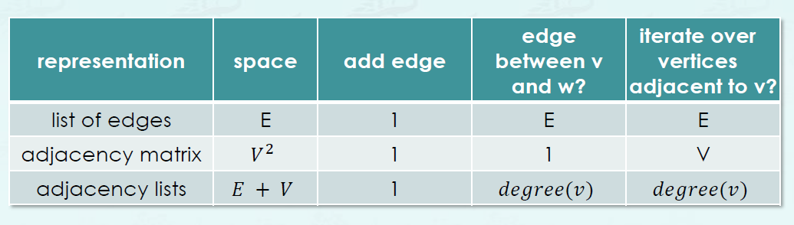

<Time Complexity>

1. Graph

* DFS, BFS – O(V+E)
* Shortest Paths (BFS) – O(V+E)
* IsConnected (After DFS) – O(1)
* PathfromStoV (After DFS) – O(length)

1. BST

* h = floor(log2(N)) + 1
* Grow – O(h)
* Trim – O(h)
* Search – O(h)

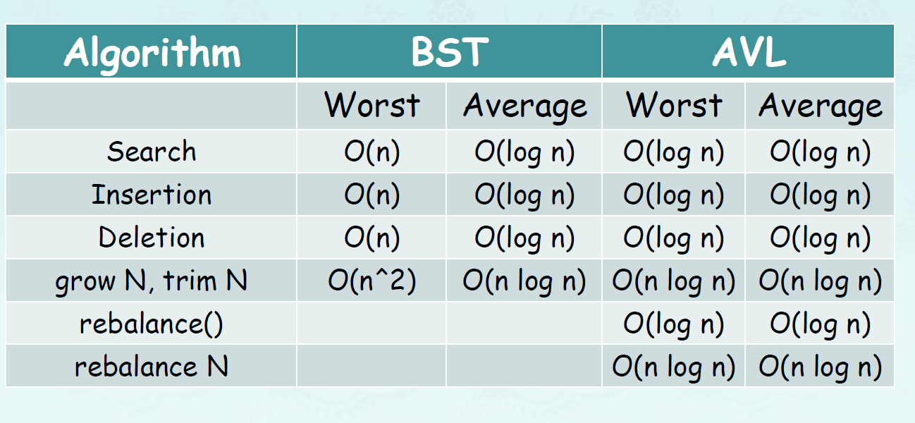

1. Heap

* Insert, delete, decreaseKey, increaseKey, remove, min/max – log2(N)
* Level of heap – floor(log2(N))
* Heapify – O(n)
* Sink – (nlogn) 🡪 heapify + sink = heapsort 🡺 O(nlogn)

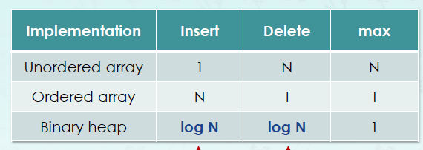

1. Double Linked List

* Push_sortedN – O(nlogn)

