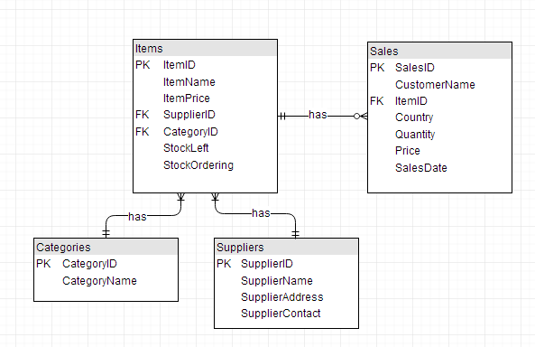
DP2 DB_Scripts
CREATE SCHEMA PHPSRES;
USE PHPSRES;

CREATE TABLE Categories(
CategoryID INT UNSIGNED NOT NULL,
CategoryName VARCHAR(50) NOT NULL,
PRIMARY KEY (CategoryID)
);

CREATE TABLE Suppliers(
SupplierID INT UNSIGNED NOT NULL,
SupplierName VARCHAR(50) NOT NULL,
SupplierAddress VARCHAR(70) NOT NULL,
SupplierContact VARCHAR(20) NOT NULL,
PRIMARY KEY (SupplierID)
);

CREATE TABLE Items(
ItemID INT UNSIGNED NOT NULL,
ItemName VARCHAR(50) NOT NULL,
ItemPrice DECIMAL(6,2) UNSIGNED NOT NULL,
SupplierID INT UNSIGNED NOT NULL,
CategoryID INT UNSIGNED NOT NULL,
StockLeft INT UNSIGNED NOT NULL,
StockOrdering INT UNSIGNED NOT NULL,
PRIMARY KEY (ItemID),
FOREIGN KEY (SupplierID) REFERENCES Suppliers(SupplierID),
FOREIGN KEY (CategoryID) REFERENCES Categories(CategoryID)
);

CREATE TABLE Sales(
SalesID INT UNSIGNED NOT NULL,
CustomerName VARCHAR(50) NOT NULL,
ItemID INT UNSIGNED NOT NULL,
Country VARCHAR(30) NOT NULL,
Quantity INT UNSIGNED NOT NULL,
Price DECIMAL(6,2) NOT NULL,
SalesDate DATE,
PRIMARY KEY (SalesID),
FOREIGN KEY (ItemID) REFERENCES Items(ItemID)
);

INSERT INTO Categories VALUES(1, "Pills");
INSERT INTO Categories VALUES(2, "Drugs");
INSERT INTO Categories VALUES(3, "Shots");
INSERT INTO Categories VALUES(4, "Contraceptives");

INSERT INTO Suppliers VALUES(11, "Livington Pharmacy.", "299 Route 9 Livingston, NJ 07039", "+1888-697-2037");
INSERT INTO Suppliers VALUES(12, "Reconnaices Reincarnated", "8014 Railroad Street
Glendale Heights, IL 60139", "+1082-253929");
INSERT INTO Suppliers VALUES(13, "Japanese Herba Limited", "1227 Church Street South
Vista, CA 92083", "+1646-454-3200");
INSERT INTO Suppliers VALUES(14, "Walgreens", "724 Canal Street
Piedmont, SC 29673", "+1888-222-4346");
INSERT INTO Suppliers VALUES(15, "CVS Limited", "2864 Route 2
Quakertown, PA 18951", "+1888-222-4226");
INSERT INTO Suppliers VALUES(16, "Saveway", "1901 Hanover Court
Barberton, OH 44203", "+1888-678-3688");
INSERT INTO Suppliers VALUES(17, "Riteland.","479 Cleveland Avenue
Yorktown Heights, NY 10598", "+1800-999-3355");
INSERT INTO Suppliers VALUES(18, "Shopko", "165 Columbia Street
Hermitage, TN 37076", "+1800-254-3692");
INSERT INTO Suppliers VALUES(19, "Walmart", "659 Delaware Avenue
Bear, DE 19701", "+1866-600-2367");

INSERT INTO Items VALUES(6589, "Acetaminophen", 450.99, 13, 1, 70, 0);
INSERT INTO Items VALUES(3478, "Adderall", 150.99, 14, 2, 5, 23);
INSERT INTO Items VALUES(1129, "Alprazolam", 460.99, 13, 2, 29, 5);
INSERT INTO Items VALUES(5025, "Amitriptyline", 322.99, 13, 2, 1, 2);
INSERT INTO Items VALUES(5423, "Amoxicillin", 2248.99, 19, 2, 54, 32);
INSERT INTO Items VALUES(4776, "Ativan", 7.99, 17, 1, 20, 12);
INSERT INTO Items VALUES(4221, "Ciprofloxacin", 23.99, 18, 1, 40, 16);
INSERT INTO Items VALUES(1576, "Citalopram", 250.50, 17, 1, 60, 11);
INSERT INTO Items VALUES(5377, "Doxycycline", 32.70, 17, 2, 17, 13);
INSERT INTO Items VALUES(3465, "Gabapentin", 333.20, 17, 1, 9, 24);
INSERT INTO Items VALUES(7687, "Hydrochlorothiazide", 435.20, 14, 2, 18, 34);
INSERT INTO Items VALUES(3456, "Ibuprofen", 765.99, 16, 1, 70, 8);
INSERT INTO Items VALUES(7569, "Lexapro ", 756.99, 13, 3, 32, 7);
INSERT INTO Items VALUES(9786, "Metformin ", 157.20, 12, 2, 12, 5);
INSERT INTO Items VALUES(5458, "Condom/Lube", 4234.50, 12, 3, 43, 2);
INSERT INTO Items VALUES(6754, "Viagra", 98.20, 11, 3, 11, 33);
INSERT INTO Items VALUES(8754, "Xanax", 18.20, 11, 3, 4, 65);
INSERT INTO Items VALUES(8514, "Zoloft", 228.20, 11, 3, 7, 19);

