TacoTime Game Engine Programmer’s Reference

Written I. Yulaev 2012-08-12  
Contact [ivan@yulaev.com](mailto:ivan@yulaev.com) for questions

# Overview

This document outlines the TacoTime game. A description of the game mechanics as well as a high-level overview of the code organization is provided. The intended audience is for a game developer or designer that wishes to use, understand, and perhaps extend the TacoTime game engine.

# Game Mechanics

The basic premise of the TacoTime game is that the player acts as a service employee employed in a café/restaurant/food truck. She operates some machinery (like a coffee machine or an oven), putting together various food/food-like items. A queue of customers forms in front of the establishment, and the customers voice their requests. The player must guide their service employee actor to prepare the necessary foodstuffs. Fulfilling customer requests provides some sort of reward (money and heart-points); the faster the requests are filled the more points the employee obtains.

Each level brings with it a new set of food creation machines and hence customer menu options. Additionally between levels the user may choose to buy various upgrades that can assist with more quickly serving Customers.

# Code Structure

## Entry Point, Game Launch, and Game Flow

The top-level file of the game is TacoTimeActivity.java. This Activity brings up a menu allowing the user to either launch a new game or load a saved game (for the selected player profile). Otherwise, this Activity does very little except for instantiating TacoTimeMainGameActivity. This latter class instantiates MainGamePanel, which creates the Canvas (the 2D area where the game will be drawn), instantiates the game elements, and launches all of the threads.

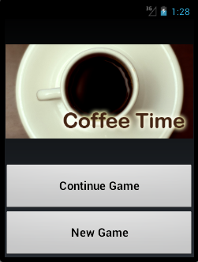

Figure 1 - Main Menu

While in play (during a game level), pressing the back button brings up a dialog that allows the user to retry the level or return to the main menu. See TacoTimeMainGameActivity.onBackPressed(); this is the method that gets invoked (via a Handler, in response to a message sent by the MessageRouter) when the back button gets pressed during game play.

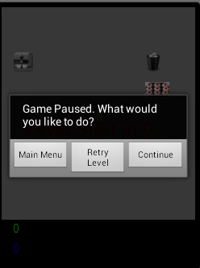

Figure 2 - During-Level Dialog

Upon completing a level, the user is presented with the between-level menu (BetweenLevelMenuActivity). Here, aside from retrying the level and saving & continuing, the user may elect to buy upgrades (via UpgradeMenuActivity). Upgrades allow the user to modify game behavior and introduce new GameItems into the game (see section 3.3).

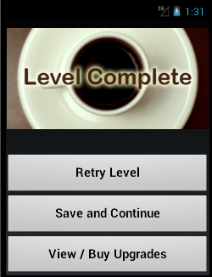

Figure 3 - Between Level Menu

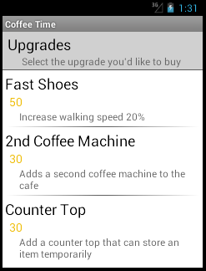

Figure 4 - Upgrade Menu

## Thread and Game Control

Several threads operate simultaneously for TacoTime. They are

1. ViewThread – this thread is responsible for re-drawing all of the game items. Also it has awareness of the game grid (relative position of all items) so it can detect physical item interaction.
2. TimerThread – Does nothing currently. Intended for use to track game time and allow other threads and Objects to deal with time-dependent events.
3. InputThread – receives user input and sends messages to GameItems describing what input occurred
4. GameLogicThread – receives messages from ViewThread; determines the outcome of interactions between the Actor (CoffeeGirl) and GameItems and in general drives game logic.

Also, a MessageRouter exists to allow different objects to pass messages to each other. Message types are typically Thread-specific and are defined using “hard enums” at the top of each of the Threads. MessageRouter defines valid message types and explicitly defines the semantics for passing messages.

## Game Objects & State

There are several types of game objects: GameActor, GameItem, GameFoodItem, and GameUpgrade.

GameActor are mobile game objects. These include Customers (whose orders are fulfilled by the player) and CoffeeGirl, which is the player-controlled actor. The former each have their own state machine and “order” which gets progressively fulfilled. CoffeeGirl’s state machine is defined separately in GameLogicThread.

CoffeeGirl’s state transition table is determined by GameLogicThread.coffeeGirlNextState(). This method takes the previous state of CoffeeGirl, the name (ID) of the GameItem that she interacted with, and the state of that GameItem. It then determines the next state of CoffeeGirl. Each CoffeeGirl state has an associated bitmap (later, sprite).

GameItems track state internally. A GameItem (logically) operates as a state machine. State may change due to two reasons: sufficient time has passed and/or interaction with CoffeeGirl has occurred. The state gets then updated. States get updated when GameItem.onUpdate() or Gameitem.onInteraction() by ViewThread and GameLogicThread respectively; GameItems will check whether sufficient time has passed and whether interaction has occurred and determine whether or not to change states. Each GameItem state has an associated bitmap that signals to the user the state of this GameItem.

The State object describes a state. It identifies a State with a name, a bitmap to draw the GameItem with, and the criteria for advancing to the next state(interaction or time sensitivity, delay time).

GameFoodItems are mostly ‘data’ classes that simply define a particular food item and an associated point/money value.

GameUpgrade objects define upgrades that the user can purchase between levels. Otherwise very little data is provided in the classes themselves; mostly the GameUpgrade functionality is sprinkled throughout the program, depending on what the GameUpgrade affects. For example, the FastShoesUpgrade, which increases CoffeeGirl’s speed, is checked for and dealt with in the CoffeeGirl constructor.

GameUpgrades that have been bought are recorded in GameInfo.upgradesBought.

## Adding Game Objects

To add a new FoodItem, such as coffee or cupcake:

1. Create an icon for it, add it to the relevant sprites so they can be shown carrying/holding it
2. Create a new type representing that food item (extends GameFoodItem); make sure to run GameLogicThread.addNewFoodItem
3. Update MainGamePanel
4. Update GameLogicThread.coffeeGirlNextState() so that CoffeeGirl can get the relevant food item when necessary
5. Add a new state to CoffeeGirl, both in the Class definition (final int) and in the constructor

Adding a new game item, such as a Coffee Machine or a Blender:

1. Create an icon for it
2. Create a new type representing that game item (extends GameItem)
3. Update MainGamePanel to initialize and place the game item, and add it to all of the Threads
4. Update GameLogicThread.coffeeGirlNextState() to show how interactions with the gameItem should work

To add a new GameUpgrade:

1. Add upgrade to UpgradeMenuActivity constructor
2. Add upgrade rules to the relevant class (either a GameLevel_n or CoffeeGirl or Customer)
3. If the Upgrade adds a new GameItem create that GameItem

## Diagram of Project Structure

The below diagram illustrates how these threads and game objects fit together (possibly outdated)



# References

Below are some useful references for Android game development.

[Writing real-time games](http://www.google.com/events/io/2009/sessions/WritingRealTimeGamesAndroid.html)

[Android Game Development](http://www.javacodegeeks.com/search/label/Android%20Games) - I lifted some of the code from the beginning parts of this tutorial, although it’s mostly been stripped except for the boilerplate.

[Android hardware acceleration](http://developer.android.com/guide/topics/graphics/hardware-accel.html#hardware-model)

[Android using nine-patch](http://developer.android.com/guide/topics/graphics/2d-graphics.html#nine-patch)