installation method  
**1st way**

* 1. Find emmc.uImage, rescue.emmc.dtb and rescue.root.emmc.cpio.gz_pad.img **by decompressing** **install.img，**
* 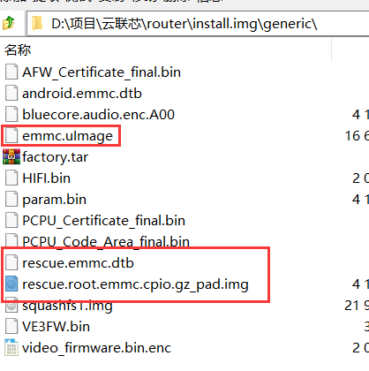
* 2. put install.img, emmc.uImage, rescue.emmc.dtb and rescue.root.emmc.cpio.gz_pad.img into usb pen-drive(FAT32 format)
* 3. plug USB pen-drive into any one usb port
* 4. press "ESC" button and power up
* 5. execute "go ru" command

将emmc.uImage、rescue.emmc.dtb、rescue.root.emmc.cpio.gz_pad.img、install.img放入U盘的根目录下

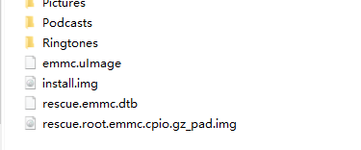

按住ESC按键，然后板子上电进入bootcode中，如下：

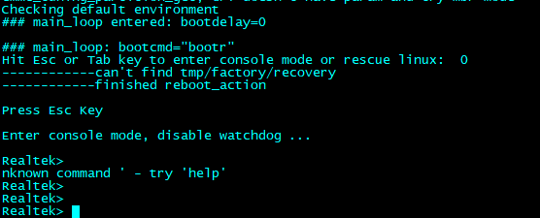

**然后执行go ru即可开始烧录image**

**2nd way**

1. put install.img into usb pen-drive(FAT32 format)

2. plug USB pen-drive into any one usb port

3. press "Tab" button and power up