Report “Customer details”

-Comparison of Total Orders and Sales by Customer Group

1. Identifying High-Value Customers:

Visualizations quickly pinpoint customer segments that contribute significantly to order volume or sales revenue. This allows businesses to focus their efforts on nurturing relationships with these valuable customers through targeted marketing, loyalty programs, or personalized offers.

2. Understanding Customer Behavior:

By comparing order volume and sales across different groups, businesses can uncover distinct purchasing patterns. This knowledge helps tailor strategies for each segment. For instance, high-volume, low-value customers might benefit from upselling or cross-selling initiatives, while low-volume, high-value customers might require a more personalized approach.

3. Optimizing Marketing and Sales Efforts:

Visualizations reveal which customer groups or regions have the most potential for growth. Businesses can then allocate marketing and sales resources effectively, targeting specific segments with tailored campaigns or promotions.

4. Data-Driven Decision Making:

Instead of relying on intuition or guesswork, visualizations provide concrete evidence for making informed decisions about pricing strategies, product development, inventory management, and overall business growth.

5. Monitoring Performance and Trends:

Regularly updating and reviewing visualizations helps track changes in customer behavior over time, identify emerging trends, and adapt strategies accordingly to stay ahead of the competition.

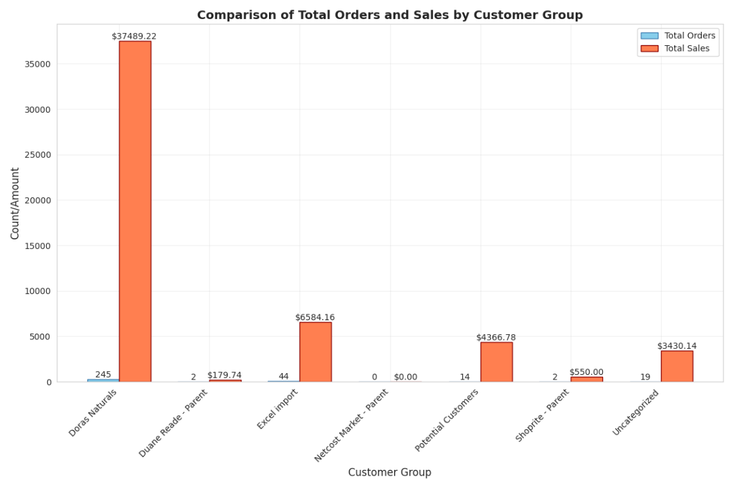

-Distribution of clients by 'Payment terms'

1. Cash Flow Management:

Knowing the dominant payment terms helps businesses optimize their cash flow. For example, if most clients prefer "Net 30" terms, the company can anticipate a delay in receiving payments and plan accordingly to ensure sufficient working capital.

2. Customer Segmentation:

Different payment term preferences may reflect distinct customer segments or industries. Businesses can use this information to tailor their marketing or service offerings. For example, offering extended payment terms might be more attractive to larger businesses, while smaller clients might prefer shorter terms or upfront payments.

3. Negotiation and Flexibility:

Understanding the prevalence of various payment terms provides a basis for negotiation with clients. While a standard term might be preferred, businesses can evaluate offering more flexible options on a case-by-case basis to secure deals or accommodate specific customer needs.

4. Risk Assessment:

The distribution of payment terms can be an indicator of potential credit risk. A higher concentration of clients using longer payment terms might necessitate stricter credit checks or more proactive collection efforts to mitigate the risk of late or non-payment.

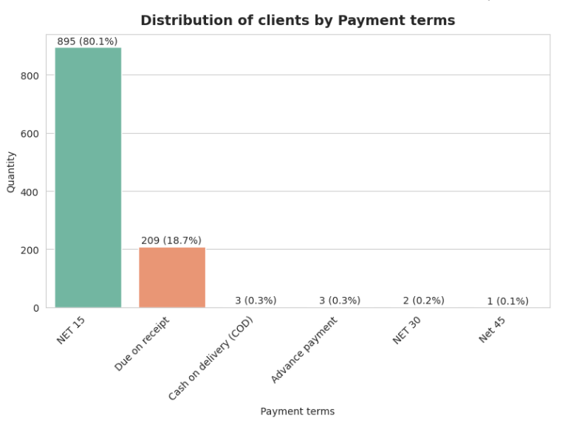

-Average total sales by customer group and billing state

The heatmap provides valuable insights into the distribution of average total sales across different customer groups and states. Here's how a business can leverage this information:

1. Identifying Key Customer Groups and Geographic Areas:

Focus on "Potential Customers":Understanding their characteristics and needs is crucial for further growth.

Analyze High-Performing States: NY and CA demonstrate higher average sales across multiple customer groups. Investigating the factors driving these sales can help replicate success in other states.

Evaluate Underperforming Segments: Several cells show minimal or no sales. Analyze the reasons behind this (e.g., lack of market penetration, competition) and consider strategies for improvement or resource reallocation.

2. Sales and Marketing Strategies:

Targeted Marketing: Tailor marketing campaigns based on the performance of customer groups and states. Allocate more resources towards high-performing segments like "Potential Customers" in NY.

Expansion Opportunities: Explore potential expansion into states with high average sales like NY and CA, focusing on successful customer groups.

Customer Acquisition and Retention: Develop targeted strategies to acquire new customers in underperforming states and customer groups. Implement retention programs to maintain strong relationships with existing high-value customers.

3. Resource Allocation and Operations:

Optimize Sales Team Structure: Align sales teams based on the geographic distribution of sales and customer groups. Consider dedicated teams or specialists for high-performing segments.

Inventory Management: Analyze the sales distribution to optimize inventory management and distribution strategies. Ensure sufficient stock availability in high-demand states and for key customer groups.

Pricing and Promotions: Evaluate the effectiveness of current pricing strategies and promotional activities based on their impact on sales in different segments. Consider tailored pricing or promotions for specific customer groups or regions.

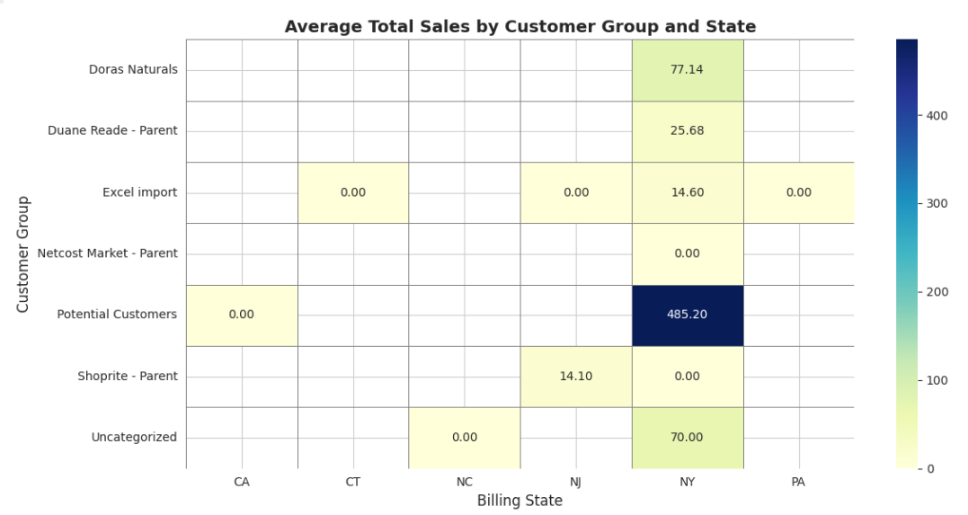

-Email analysis

1. Pie Chart: High-Level Overview

This visualization instantly reveals the dominant trend.

Businesses can quickly grasp the limited penetration of email communication and recognize the need for strategies to improve email capture rates.

2. Bar Chart: Granular Insights

The horizontal bar chart delves deeper, showcasing the distribution of email domains among those who have provided their information.

This allows for identifying potential customer segments based on email providers, such as specific companies or industries.

It also highlights the concentration of email addresses within certain domains, indicating potential areas for targeted marketing efforts.

Customer Segmentation: Analyze email domains to infer customer demographics, company affiliations, or industry segments. Tailor marketing campaigns and content accordingly.

Email Acquisition Strategies: Recognizing the low overall email penetration, businesses can implement strategies to encourage email sharing. This could involve offering incentives, highlighting the value proposition of email communication, or streamlining data collection processes.

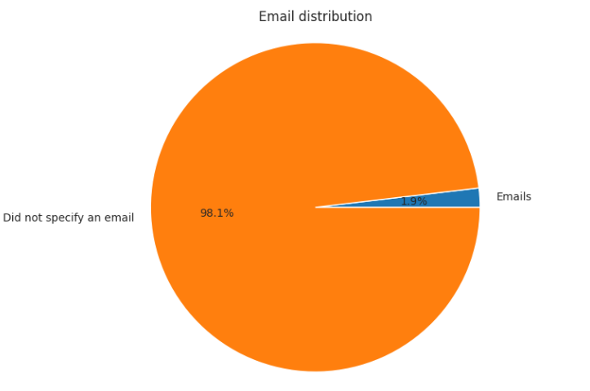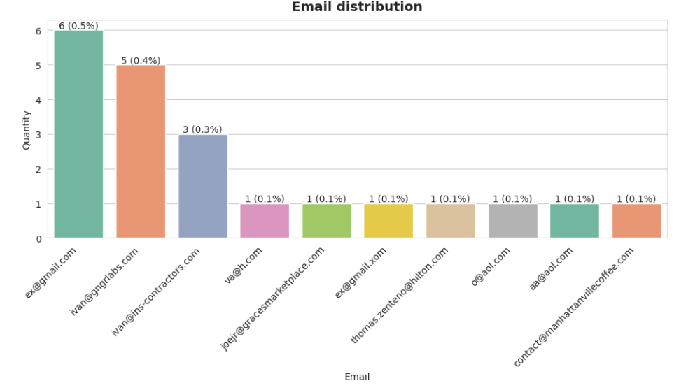

-Distribution of non-zero Total sales

1. Pricing and Promotion Strategies:

Evaluate the distribution of sales values to assess the effectiveness of current pricing strategies. This may involve analyzing price points, discounts, and promotional offers to optimize revenue and profitability.

Consider developing targeted promotions or pricing tiers based on identified customer segments and their spending patterns.

2. Sales Performance and Forecasting:

Analyze historical trends in the distribution of sales values to identify seasonality, cyclical patterns, or other factors influencing sales performance.

Utilize the insights to improve sales forecasting and inventory management, ensuring adequate stock availability for products with high demand or frequent purchases.

3. Product Management and Development:

Investigate the relationship between sales value and product categories or features. This can inform product development decisions, pricing strategies, and marketing efforts.

Consider developing new products or bundles targeted towards specific customer segments based on their purchasing power and preferences.

4. Risk Management:

Analyze the distribution of sales values to assess potential risks associated with concentrated sales within specific customer segments or product categories.

Develop strategies to diversify the customer base and product portfolio to mitigate risks and ensure business stability.

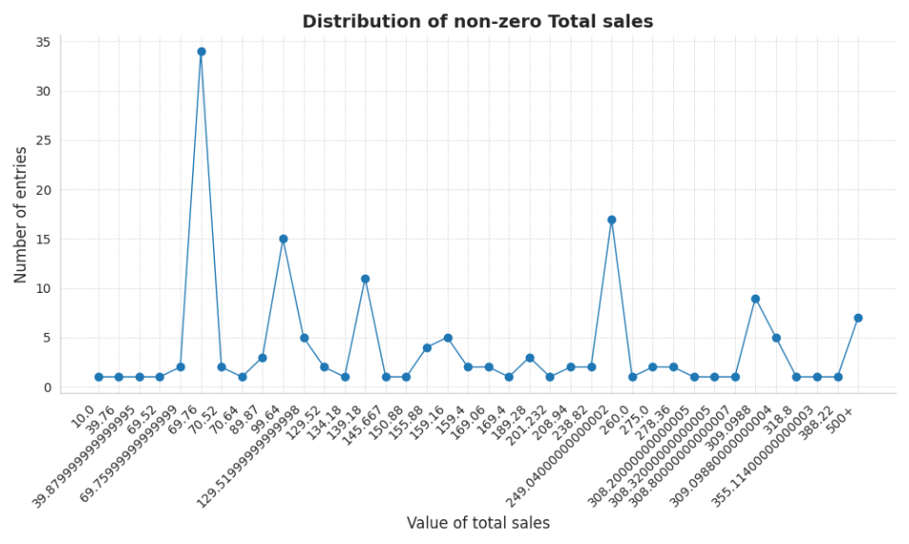

Report “Top customers”

-Distribution of clients by Payment terms

1. Cash Flow Management:

The prevalence of "Net 15" terms necessitates effective cash flow management strategies. Businesses must anticipate a delay in receiving payments and plan accordingly to ensure sufficient working capital.

Offering early payment discounts could incentivize faster payments and improve cash flow.

2. Customer Segmentation and Targeting:

Analyze the characteristics of clients who prefer different payment terms to identify potential customer segments. This information can be used to tailor marketing campaigns, credit policies, and collection strategies.

Consider offering more flexible payment options for specific customer segments, such as longer terms for larger businesses or shorter terms for smaller clients.

4. Competitive Analysis and Pricing Strategies:

Evaluate industry benchmarks and competitor offerings regarding payment terms to ensure competitiveness. Businesses may need to adjust their policies to remain attractive to clients while balancing cash flow considerations.

Explore the possibility of offering more favorable payment terms for high-value clients or strategic partnerships.

5. Operational Efficiency and Technology:

Streamline invoicing and payment processing systems to ensure efficiency and accuracy.

Invest in technology solutions that automate payment reminders, collections, and reporting processes.

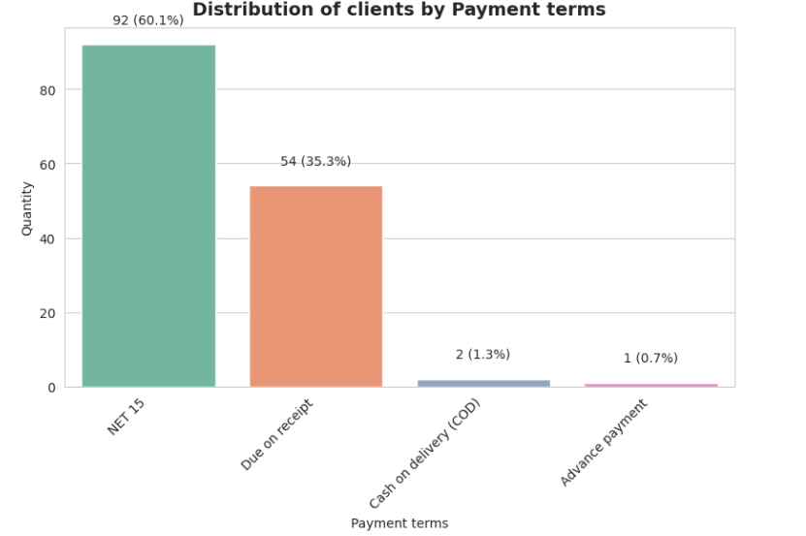

-Distribution of clients by Groups

Easy Comparison: The varying heights of the bars enable immediate visual comparison between the sizes of different customer groups. This allows businesses to quickly identify the most prominent segments and those that represent a smaller portion of their clientele.

Proportion Visualization: Including percentages alongside the quantities further enhances understanding. It provides a clear picture of each group's relative contribution to the total customer base.

Identifying Key Segments: This visualization aids in pinpointing the groups that require the most attention, whether due to their size, potential value, or unique needs. For instance, a large bar might signify a core customer group deserving focused marketing efforts, while a smaller bar could represent a niche segment with high-value potential.

Data-Driven Decision Making: By understanding the composition of their customer base, businesses can make informed decisions regarding resource allocation, marketing strategies, product development, and customer relationship management.

Monitoring Trends: Tracking changes in the distribution over time can reveal shifts in customer demographics, preferences, or market trends.

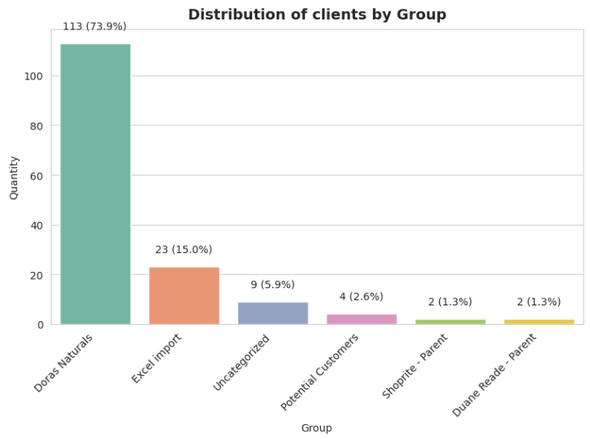

-It is also possible to analyze the distribution by emails and the distribution of non-zero total sales

Report “Order sales summary”

-Distribution of orders by product and Total sales by product

Direct Comparison: The side-by-side placement enables immediate visual comparison between two related metrics, such as sales amount and number of orders. This allows for a quick understanding of how products perform across different dimensions.

Identifying Trends and Discrepancies: By observing the relative heights of the bars in each chart, businesses can easily identify products that are performing well in both areas, those that excel in one metric but lag in another, and those that underperform across the board. This helps pinpoint areas for further investigation and potential optimization.

Comprehensive Insights: Analyzing sales amount alone might highlight high-revenue products, but it wouldn't reveal the volume of sales or the popularity of a product. Conversely, focusing solely on the number of orders might overlook the revenue generated. Comparing both metrics provides a more holistic understanding of product performance and market dynamics.

Data-Driven Decision Making: The insights gleaned from this visualization can inform various business decisions, such as product development, pricing strategies, marketing campaigns, inventory management, and resource allocation.

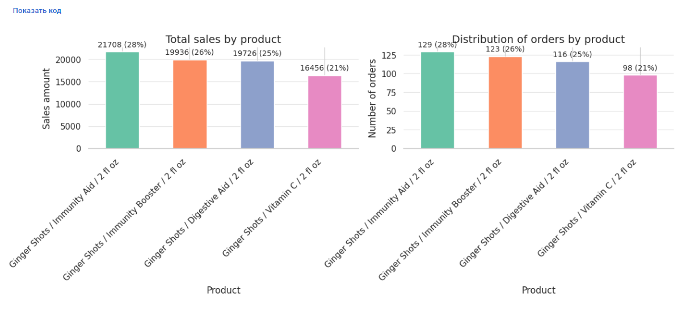

-Total sales by customer (top 10)

Identifying High-Value Customers: The chart instantly highlights the customers who contribute the most to overall revenue. This allows businesses to focus their attention and resources on nurturing relationships with these key clients.

Sales Performance Evaluation: The visualization offers a quick snapshot of sales performance across the top customer segment. Businesses can easily compare the relative contribution of each customer and identify any significant gaps or disparities.

Segmentation and Targeting: The chart can serve as a starting point for further customer segmentation analysis. By grouping customers based on similar sales amounts or other characteristics, businesses can develop targeted marketing campaigns and tailor their offerings to specific customer needs.

Tracking Changes Over Time: Monitoring this chart over different periods can reveal trends in customer behavior, such as changes in purchasing patterns or the emergence of new high-value clients. This information is crucial for adapting sales strategies and maintaining strong customer relationships.

Sales Goal Setting: The visualization can aid in setting realistic sales goals and targets based on the performance of top customers.

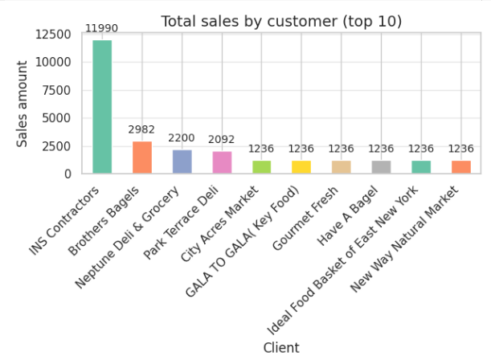

-Amount of sales by month

Identifying Trends and Patterns: The line clearly shows the overall trajectory of sales, whether it's increasing, decreasing, or remaining stable. This allows businesses to quickly identify periods of growth, decline, or seasonality.

Pinpointing Specific Data Points: The plotted points on the line correspond to the sales amount for each month. This enables easy identification of months with exceptionally high or low sales, prompting further investigation into the factors influencing those results.

Performance Monitoring: Businesses can use this chart to track sales performance over time and evaluate the effectiveness of sales strategies, marketing campaigns, or other initiatives.

Forecasting and Planning: By analyzing the trend and seasonality observed in the line chart, businesses can make more informed forecasts about future sales and plan their inventory, production, and resource allocation accordingly.

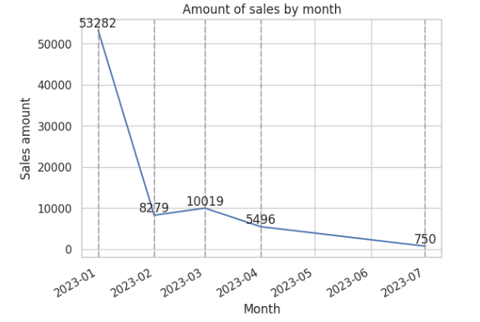

-Distribution of the discount amount by type

Identifying Dominant Discount Type: The chart clearly shows which type of discount is most frequently applied. In this case, it highlights the prevalence of "Invoice Total Discount" compared to other options.

Evaluating Discount Strategy: Businesses can assess the effectiveness of their current discount strategy based on the distribution of discounts. This may prompt further analysis into the impact of different discount types on sales, profitability, and customer behavior.

Cost Analysis: The chart provides insights into the overall cost of discounts, which can be valuable for budgeting and financial planning.

Comparing Discount Options: Businesses can use this visualization to compare the usage and impact of various discount types and identify potential areas for optimization or experimentation.

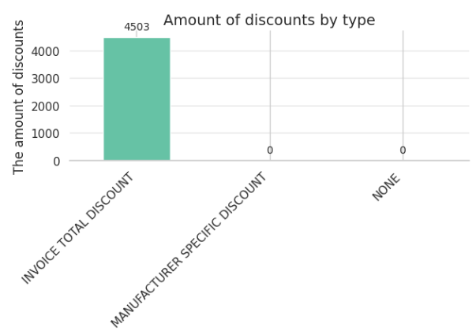

-Amount of discounts by customer (top 10)

Identifying Top Discount Recipients: The chart clearly shows which customers receive the most discounts, allowing businesses to assess if these discounts align with their customer relationship strategies or if any adjustments are needed.

Discount Distribution Analysis: Businesses can evaluate how discounts are distributed among their top customers and identify any significant disparities or patterns. This may lead to insights about specific customer negotiations, pricing agreements, or potential customer segmentation based on discount utilization.

Customer Relationship Management: The information can be used to inform customer relationship management strategies. Businesses may choose to offer loyalty programs or targeted discounts to specific customers based on their past discount usage or value to the company.

Sales and Pricing Strategies: Analyzing discount distribution can help refine sales and pricing strategies. Businesses might consider adjusting pricing structures, negotiating bulk discounts, or exploring alternative promotional offers based on the observed patterns.

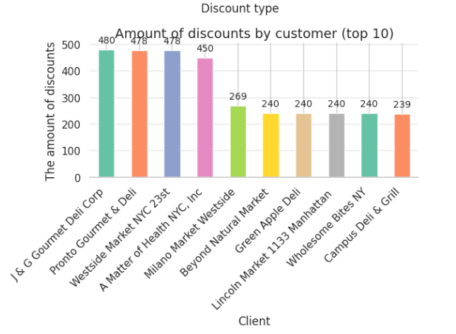

-Number of orders by delivery status

Identifying Fulfillment Issues: The chart quickly reveals any potential problems with order fulfillment. A high number of unfulfilled orders could indicate bottlenecks in the delivery process, inventory management issues, or other logistical challenges that require attention.

Performance Monitoring: Businesses can track the rate of order fulfillment over time and identify any trends or patterns. This information can be used to evaluate the efficiency of the delivery process and identify areas for improvement.

Customer Service Insights: Understanding the number of unfulfilled orders can inform customer service strategies. Businesses may need to proactively communicate with customers about delays, offer alternative solutions, or adjust delivery expectations.

Operational Efficiency: The chart highlights the importance of optimizing the order fulfillment process to ensure timely deliveries and customer satisfaction. This may involve streamlining logistics, improving inventory management, or investing in delivery technology.

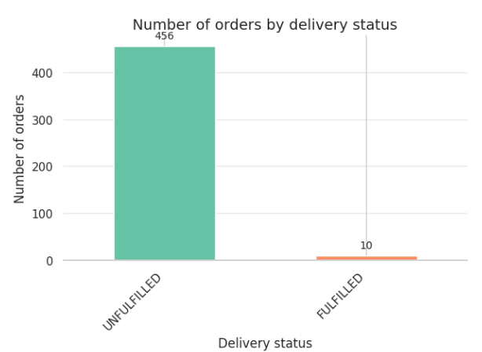

-Number of orders by delivery method

Identifying Popular Delivery Options: The chart clearly shows which delivery methods are preferred by customers. This information can inform business decisions regarding logistics, partnerships with delivery providers, and pricing strategies for different delivery options.

Resource Allocation: Businesses can allocate resources effectively based on the demand for each delivery method. For instance, if local delivery is the dominant choice, optimizing local delivery routes and investing in local delivery infrastructure may be a priority.

Customer Segmentation: Analyzing delivery preferences can reveal insights into customer demographics or behaviors. This information can be used to create targeted marketing campaigns or develop specialized delivery options for specific customer segments.

Service Expansion: Businesses can evaluate the potential for expanding their delivery services based on customer demand and market trends. For example, if there's a growing preference for a particular delivery method that's not currently offered, it may be worth considering adding it to the service portfolio.

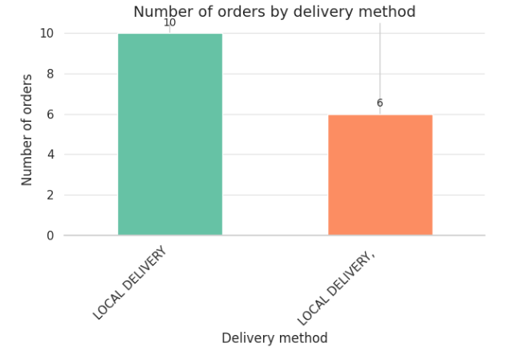

-Number of orders by payment status

Identifying Payment Issues: The chart instantly reveals potential problems with payment processing or collection. A high number of unpaid orders may indicate issues with the payment gateway, customer billing errors, or a need for more efficient payment collection procedures.

Monitoring Payment Trends: Businesses can track the proportion of paid and unpaid orders over time to identify any trends or patterns. This information can be used to assess the effectiveness of payment collection efforts and identify areas for improvement.

Refund Analysis: The chart provides insights into the frequency of refunds. This may prompt further investigation into the reasons behind refunds, such as product quality issues, customer dissatisfaction, or errors in order processing.

Financial Management: Understanding the distribution of payment statuses is crucial for effective financial management. Businesses can use this information to forecast cash flow, manage outstanding payments, and ensure accurate financial reporting.

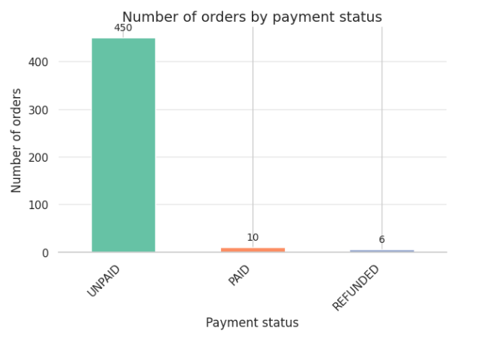

-Dependence between quantity and amount (by product)

Identifying Trends: The scatter plot helps identify any potential trends or correlations between quantity and sales amount. For instance, it can reveal whether higher quantities generally lead to higher sales amounts, or if the relationship is more complex.

Outlier Detection: The visualization makes it easy to spot outliers, which are data points that deviate significantly from the general pattern. This could indicate unusual sales events, bulk purchases, or potential data entry errors that require further investigation.

Product Performance Comparison: Businesses can compare the performance of different products by observing their distribution on the plot. This can reveal insights into pricing strategies, product popularity, and potential areas for improvement.

Sales Analysis: The scatter plot helps analyze the distribution of sales across different quantity levels. This can inform inventory management, pricing strategies, and sales forecasting.

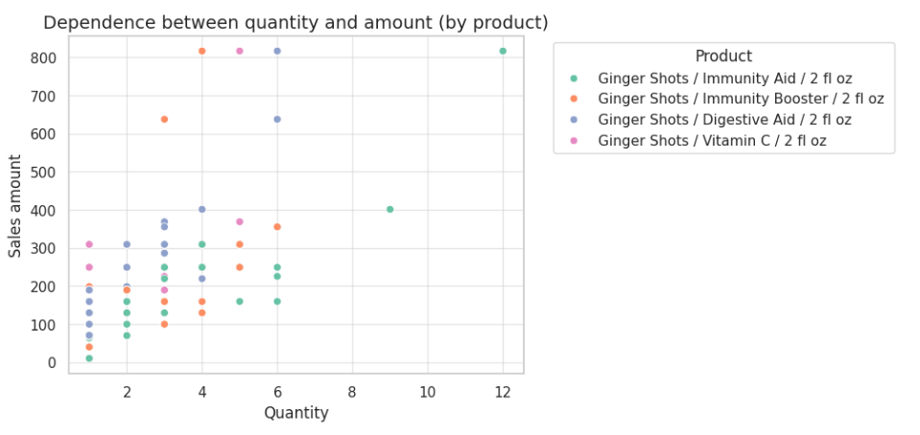

-Number of orders by product and delivery status

Comparison Across Products: Businesses can directly compare the number of orders and fulfillment rates for different products. This allows for identifying products with potential fulfillment issues, such as a higher proportion of unfulfilled orders compared to others.

Identifying Bottlenecks: If a specific product consistently shows a higher number of unfulfilled orders, it may indicate bottlenecks or challenges in the production, inventory, or delivery process related to that particular item.

Inventory Management: The insights gained can inform inventory management strategies. Businesses can ensure sufficient stock for products with high order volumes and prioritize fulfillment for products with a backlog of unfulfilled orders.

Customer Service and Communication: Understanding the fulfillment status for each product allows for proactive customer service. Businesses can communicate with customers about potential delays or provide updates on the status of their orders.

Product Performance Analysis: The chart offers insights into the overall demand and popularity of different products based on the number of orders received. This information can be valuable for product development, marketing, and sales strategies.

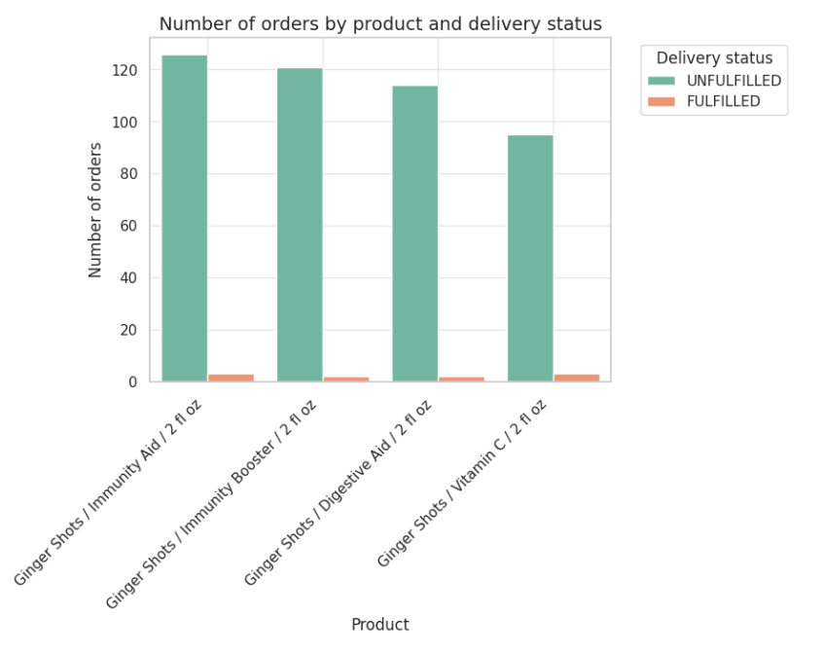

Report “Low stock inventory”

-Distribution of Low Stock Items by Category

Identifying Inventory Issues: The chart immediately highlights which categories have the most items with low stock levels. This allows businesses to prioritize inventory replenishment for those categories to avoid stockouts and potential lost sales.

Category Management: Businesses can assess the effectiveness of their category management strategies based on the distribution of low-stock items. This may prompt further analysis into demand forecasting, supplier relationships, or product assortment within specific categories.

Inventory Optimization: The insights from the chart can guide inventory optimization efforts. Businesses may consider adjusting reorder points, safety stock levels, or supplier lead times for categories with frequent low-stock issues.

Preventing Stockouts: By proactively identifying low-stock items, businesses can take steps to prevent stockouts, which can lead to lost sales, customer dissatisfaction, and potential damage to brand reputation.

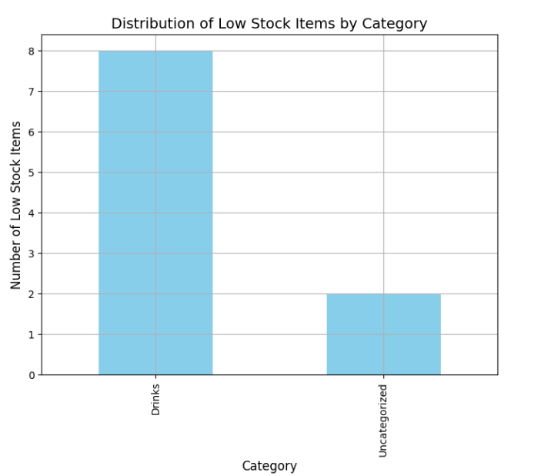

-Wholesale Price vs. Available Quantity

Identifying Pricing Trends: The plot helps visualize any potential correlations or patterns between wholesale price and available quantity. For example, it may reveal whether higher-priced items tend to have lower stock levels or if there's no clear relationship between the two variables.

Inventory Management: Businesses can use the insights to inform inventory management decisions. For instance, if high-value items have low stock, it might be necessary to prioritize their replenishment to avoid stockouts and potential lost sales.

Pricing Strategy Evaluation: The scatter plot can help assess the effectiveness of pricing strategies in relation to inventory levels. Businesses may consider adjusting prices or exploring promotional offers for items with high stock levels to stimulate demand and optimize inventory turnover.

Category Analysis: By incorporating color-coding or other visual cues to represent different categories, businesses can analyze how pricing and inventory levels vary across different product groups.

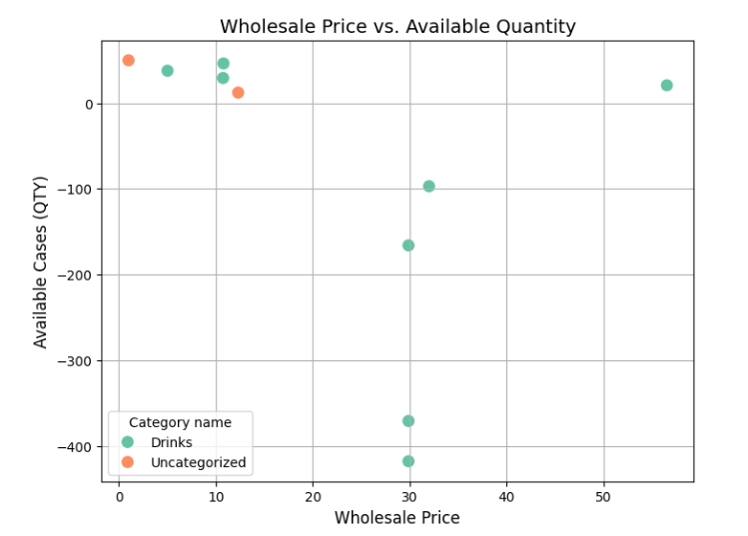

-Profit Margins of Low Stock Items

Prioritizing Inventory Replenishment: The chart highlights which low-stock items have the highest profit margins. This information can help businesses prioritize inventory replenishment for those items to maximize profitability and avoid potential lost revenue.

Pricing Strategy Evaluation: Businesses can assess the pricing strategies of low-stock items in relation to their profit margins. This may lead to insights on potential price adjustments or promotional offers to optimize profitability while managing inventory levels.

Product Performance Analysis: The chart helps identify low-stock items that are high-performing in terms of profitability. This information can inform decisions related to product development, marketing, and sales strategies.

Inventory Management: The insights gleaned from the chart can inform inventory management practices. Businesses may consider adjusting reorder points or safety stock levels for high-margin items with low stock to prevent stockouts and ensure availability for customers.

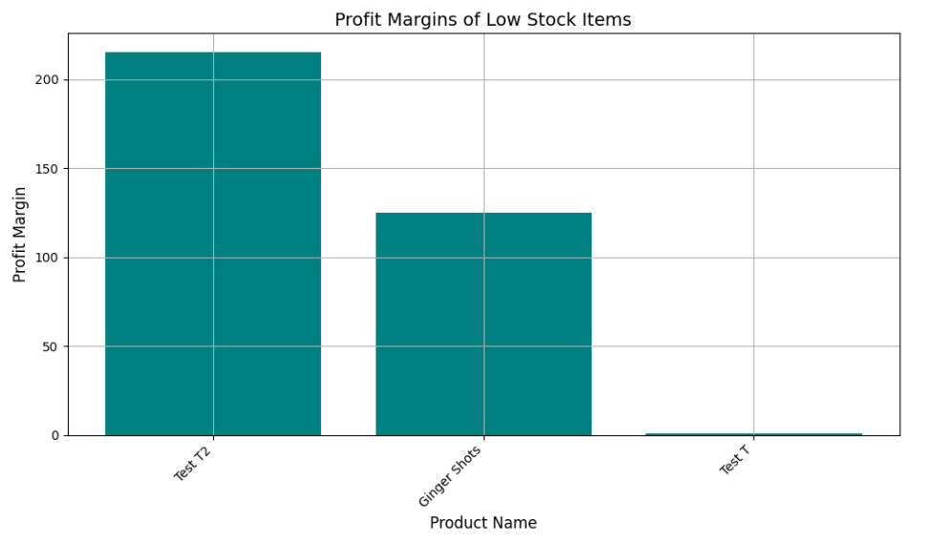

-Distribution of Wholesale Prices for Low-Stock Items

Identifying Price Ranges: The histogram clearly shows the range of wholesale prices for low-stock items and the frequency of items falling within different price ranges. This helps businesses understand the overall pricing structure of their low-stock inventory.

Inventory Valuation: The visualization provides insights into the value of low-stock inventory based on the distribution of wholesale prices. This information can be valuable for financial planning and analysis.

Pricing Strategy Evaluation: Businesses can assess the pricing strategies of low-stock items in relation to their frequency. This may lead to insights on potential price adjustments, promotions, or inventory management decisions based on the price distribution.

Category Analysis: By comparing histograms for different categories, businesses can identify how the distribution of wholesale prices varies across different product groups. This information can inform category management and pricing strategies.

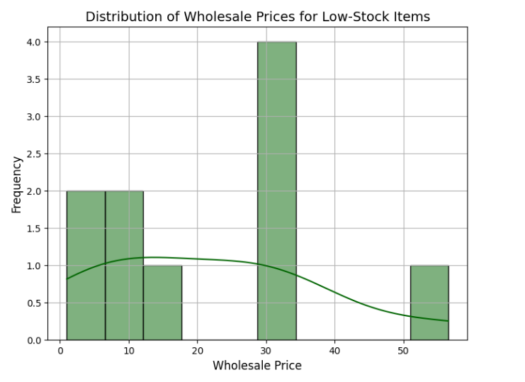

-Wholesale Price vs. Available Quantity for Low-Stock Items

Identifying Trends and Correlations: The scatter plot helps visualize any potential trends or correlations between wholesale price and available quantity for low-stock items. The trendline further summarizes the overall direction of the relationship, indicating whether there's a positive, negative, or no clear association between the variables.

Inventory Management Insights: Businesses can gain insights into how pricing might influence the availability of low-stock items. This information can inform inventory management decisions, such as prioritizing replenishment for specific price ranges or adjusting pricing strategies to manage stock levels.

Pricing Strategy Evaluation: The visualization helps assess the effectiveness of pricing strategies for low-stock items. Businesses may consider adjusting prices or exploring promotional offers for certain price ranges based on the observed trends and available quantities.

Predictive Potential: The trendline provides a potential basis for predicting available quantity based on wholesale price, allowing businesses to anticipate inventory needs and proactively manage stock levels.

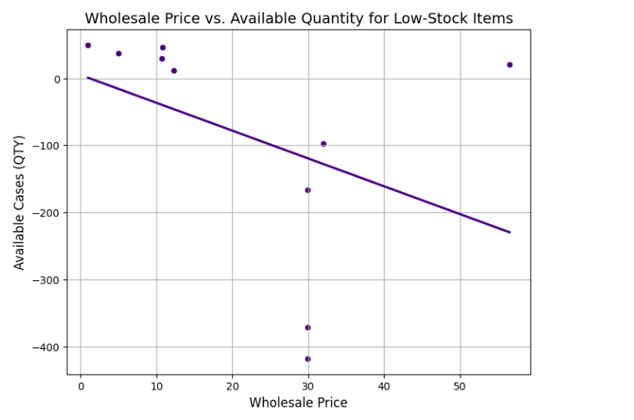

-Ratio of Available Quantity to Retail Price for Low-Stock Items

Identifying Potential Issues: The plot immediately draws attention to items where the ratio of available quantity to price is significantly different from the majority. For instance, the item with a high ratio (Ginger Shots) might indicate overstocking or pricing issues, while items with very low ratios may suggest potential stockouts or high demand.

Visual Comparison: By presenting the information visually, it becomes much easier to compare the ratios across different products than it would be by looking at a table of numbers. This allows for quick identification of outliers and patterns.

Decision Making: For businesses, this type of plot can be instrumental in making informed decisions about inventory management, pricing strategies, and marketing efforts. It helps in prioritizing which products require attention and action.

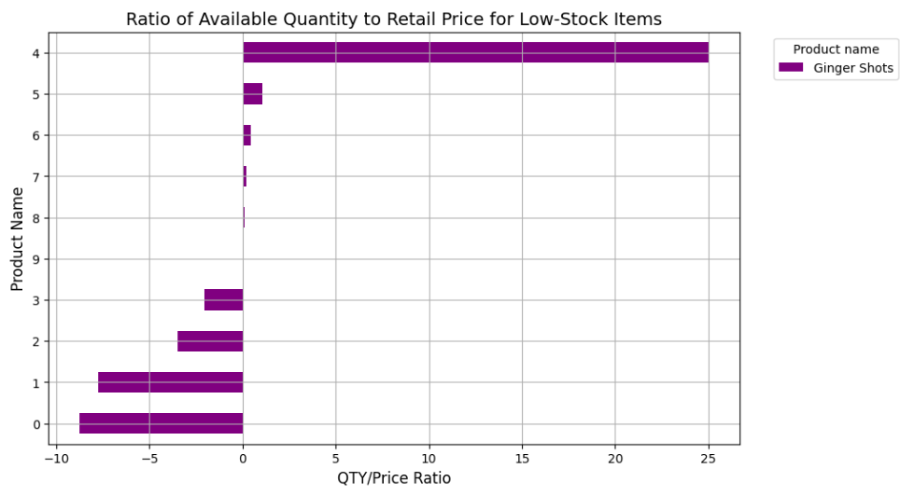

Report “Best sellers”

-Available cases (QTY)

Visualizing Trends: The plot allows us to quickly grasp the overall trend of available cases for each product. We can easily identify periods of high and low inventory, as well as any sudden changes or fluctuations.

Comparing Products: With all products displayed on a single chart, it's simple to compare their inventory levels and identify any significant differences or similarities in their stock patterns.

Identifying Potential Issues: Products with consistently low or negative inventory levels (like "Ginger Shots" in this example) may indicate potential stockouts or supply chain problems that require attention.

Decision Making: For businesses, this plot can be a crucial tool for making informed decisions about inventory management, production planning, and sales strategies. It provides insights into which products need restocking, potential overstock situations, and overall inventory health.

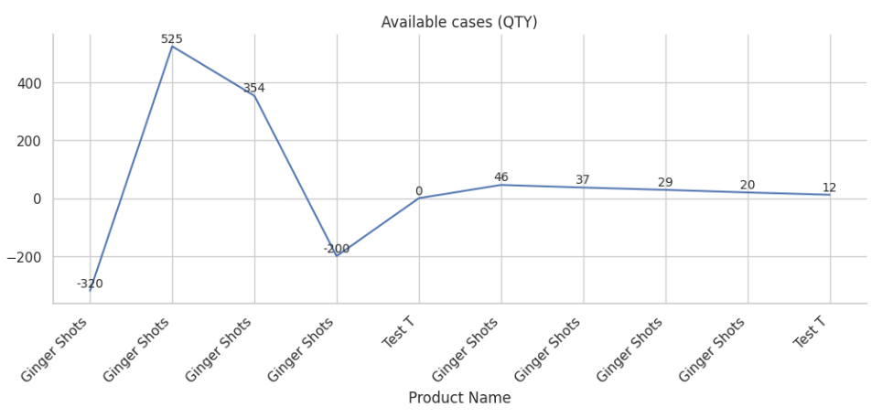

-Total Cases Sold by Product and Total Revenue by Product

Comparison of Key Metrics: By placing the "Total Revenue" and "Total Cases Sold" charts side-by-side, we can easily compare these two crucial metrics for each product. This helps us understand the relationship between sales volume and revenue generation.

Identifying Top Performers: The bar charts quickly reveal which products are generating the most revenue and selling the most cases. In this example, "Ginger Shots" clearly stands out as the top performer in both categories.

Assessing Product Contribution: The inclusion of percentages on each bar provides valuable context by showing each product's contribution to the total revenue and sales volume. This helps in understanding the relative importance of each product to the business.

Decision Making: Businesses can utilize this information to make informed decisions about product focus, marketing strategies, and resource allocation. For instance, they might invest more in promoting "Ginger Shots" or explore ways to improve the performance of "Test T".

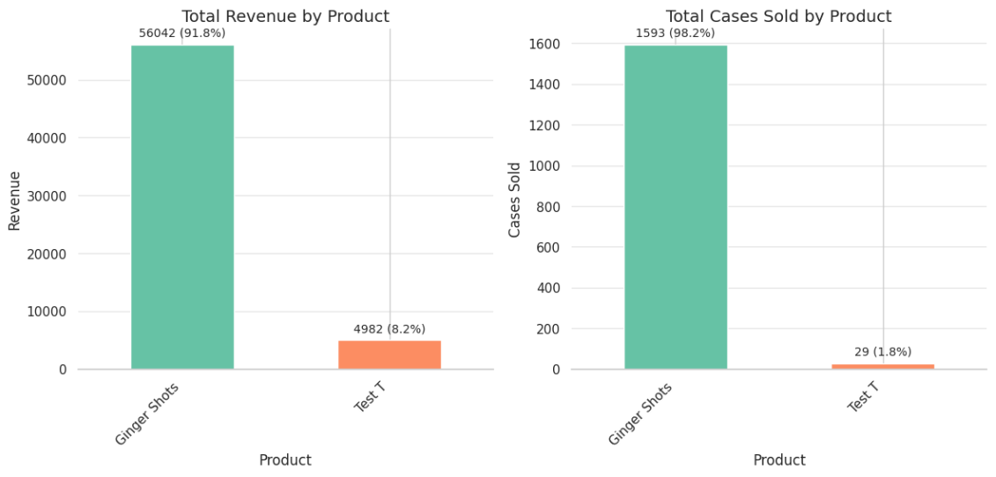

-Relationship between cases sold and total revenue

Visualizing Correlation: The chart allows us to visually assess whether there is a correlation between the number of cases sold and the total revenue generated. In this example, we can observe a general trend where higher case sales tend to correspond with higher revenue, although some variations exist.

Identifying Outliers: The plot helps pinpoint any data points that deviate significantly from the overall trend. For instance, the bar representing 240 cases sold with 4050 in revenue appears lower than what the general trend might suggest. This could prompt further investigation into the cause of this discrepancy.

Understanding Sales Performance: Businesses can utilize this chart to gain insights into their sales performance and identify areas for improvement. They can analyze which sales volumes contribute the most to overall revenue and strategize accordingly.

Predictive Potential: While this chart uses historical data, it can also provide a basis for predicting future revenue based on projected sales volumes. This can be helpful for budgeting, forecasting, and setting sales targets.

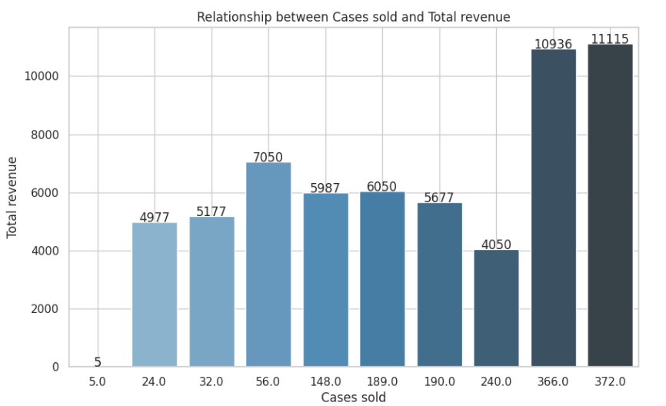

-Average wholesale Price by category

Comparing Averages: The chart allows for a direct visual comparison of the average wholesale prices between different categories. This makes it easy to identify which categories have higher or lower average prices.

Category Analysis: Businesses can use this chart to analyze the pricing structure of their products across different categories. It helps identify potential areas where pricing adjustments might be necessary.

Profitability Insights: By understanding the average wholesale price per category, businesses can gain insights into potential profitability and margins for each category. This information can guide decisions related to product sourcing, pricing strategies, and inventory management.

Identifying Discrepancies: In cases where certain categories show significantly higher or lower average prices, further investigation can be conducted to understand the underlying reasons. This could reveal opportunities for cost optimization or pricing adjustments.

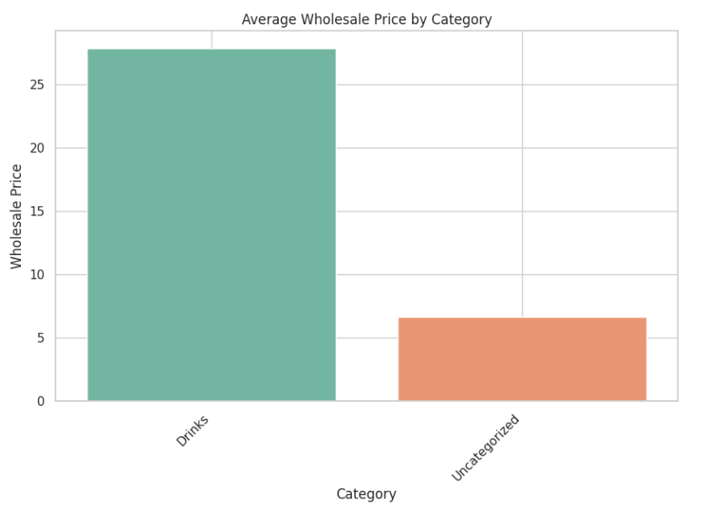

-The relationship between cases sold and available cases for each product  
Inventory Management Insights: The plot provides a clear overview of the inventory situation for each product. We can see which products have high sales relative to their available inventory, potentially indicating the need for restocking. Conversely, products with low sales and high available cases might suggest overstocking or slow-moving inventory.

Identifying Trends: While this particular example primarily features "Ginger Shots," in a real-world scenario with diverse products, the scatter plot could reveal trends or patterns. For instance, it might show whether there's a general correlation between the number of cases sold and the available inventory across different products.

Product Performance Comparison: The plot allows for a visual comparison of product performance in terms of sales and inventory levels. This can help identify top-selling products, products with potential stock issues, and those that might require adjustments in production or sales strategies.

Decision Making Support: Businesses can use this information to make data-driven decisions regarding inventory management, production planning, and marketing efforts. It helps identify which products need restocking, those with potential overstock situations, and areas where sales strategies might need improvement.

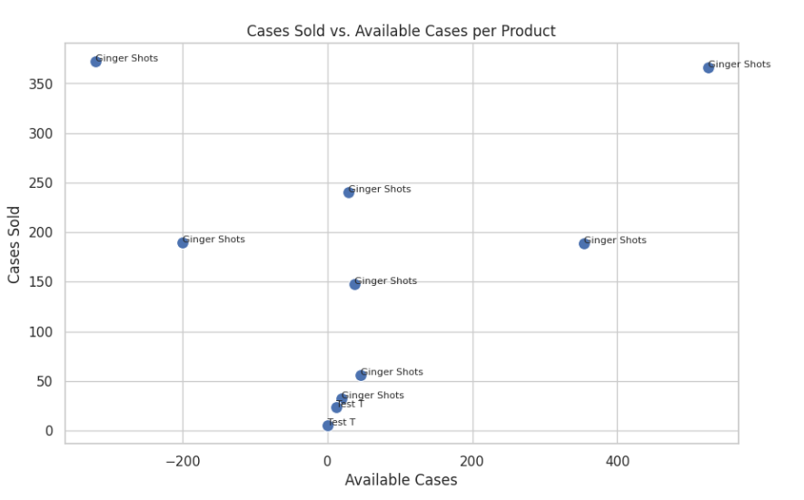

-The relationship between total revenue and profit for different products

Profitability Analysis: The plot allows us to quickly assess the profitability of each product by visualizing its profit in relation to its total revenue. This helps identify which products are high-performing in terms of generating profit and which ones might require attention.

Identifying Trends: While the provided example mostly showcases "Ginger Shots," a real-world scenario with diverse products could reveal trends or patterns in the data. For instance, it might show whether there's a general correlation between total revenue and profit, or if certain product categories tend to be more profitable than others.

Outlier Detection: The plot helps pinpoint any data points that deviate significantly from the overall trend. This could be a product with high revenue but low profit, indicating potential pricing or cost issues that require further investigation.

Decision Making Support: Businesses can utilize this information to make strategic decisions regarding product pricing, cost management, and marketing efforts. It can help identify products with high-profit potential, those that require adjustments to improve profitability, and areas where resources should be allocated for maximum return.

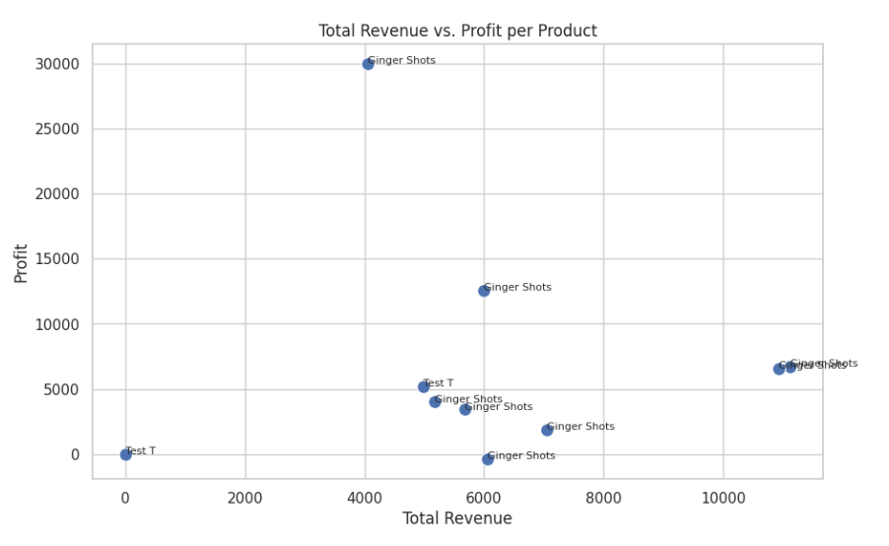

-The distribution of revenue across different categories

Proportion Visualization: The pie chart excels at showcasing the proportion of each category's contribution to the total revenue. With a quick glance, we can grasp the relative sizes of each slice and understand which categories generate the most significant portion of the revenue.

Category Comparison: It provides a clear visual comparison between different categories. In this example, we can easily see that the "Drinks" category dominates the revenue generation compared to the "Uncategorized" category.

Identifying Key Drivers: Businesses can use this information to identify the key drivers of their revenue. This knowledge is essential for strategic decision-making related to product development, marketing, and resource allocation.

Tracking Changes Over Time: By creating pie charts for different time periods, businesses can track how the revenue distribution across categories evolves over time. This can reveal valuable insights into shifts in consumer preferences, market trends, and the effectiveness of sales strategies.

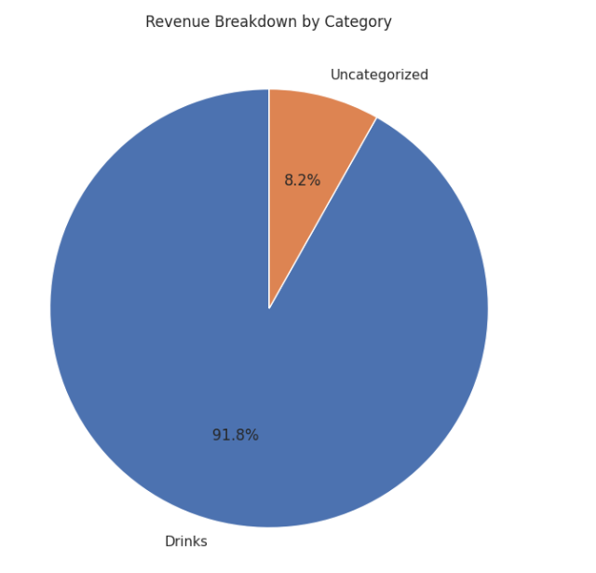

Report “Current inventory”

-comprehensive visualization of the relationship between available quantity, retail price, category, and wholesale price

Multiple Variable Analysis: This plot allows us to analyze the interplay of several variables simultaneously. We can observe how available quantity relates to retail price, while also considering the influence of category and wholesale price.

Color-Coding for Insights: The use of color to differentiate categories helps identify any potential patterns or trends within each category. For instance, we might observe that one category tends to have higher retail prices or larger available quantities compared to others.

Size as an Indicator: Varying the size of the points based on wholesale price adds another layer of information. This allows us to assess whether there's a relationship between wholesale price and the other variables, such as if products with higher wholesale prices also tend to have higher retail prices or larger available quantities.

Identifying Outliers: The plot makes it easy to spot any outliers or data points that deviate significantly from the general patterns. This could prompt further investigation to understand the reasons behind such deviations and potentially uncover valuable insights.

Decision Making Support: Businesses can utilize this information to make informed decisions about pricing strategies, inventory management, and product assortment. It helps identify potential areas for optimization, such as adjusting pricing for certain products or categories, managing stock levels based on demand and wholesale costs, and understanding the profitability of different products.

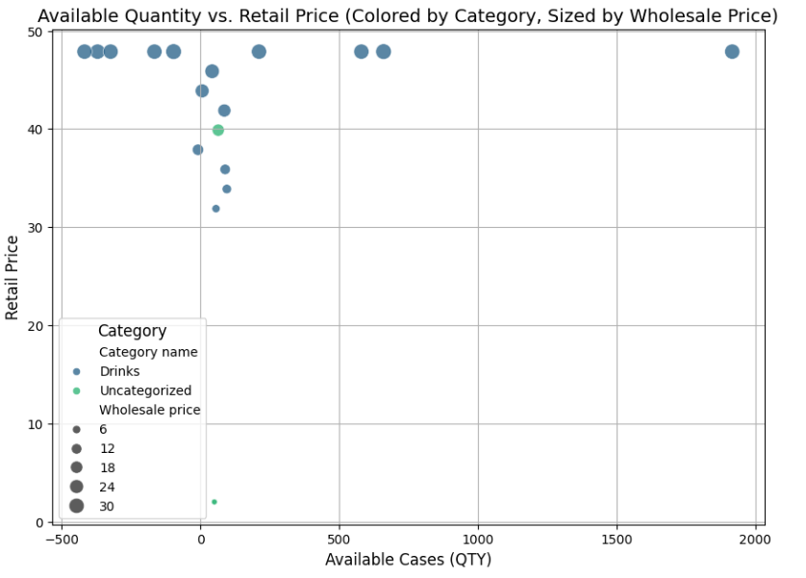

-Trends between retail price and wholesale price for different categories

Visualizing Price Relationships: The plot allows us to easily visualize how retail price changes in relation to wholesale price for each category. This helps us understand the pricing strategies and potential markups applied to products within each category.

Comparing Categories: By plotting the trends for different categories on the same graph, we can quickly compare their pricing structures. We can see whether one category tends to have a steeper price increase compared to another as wholesale prices rise.

Identifying Patterns: The plot can reveal potential patterns or trends in pricing strategies. For example, it might show that one category has a more consistent markup across different wholesale prices, while another might have a more variable markup.

Decision Making Support: Businesses can utilize this information to make informed decisions about pricing strategies for different categories. They can analyze the relationship between wholesale and retail prices, assess the competitiveness of their pricing, and identify potential areas for adjustment.

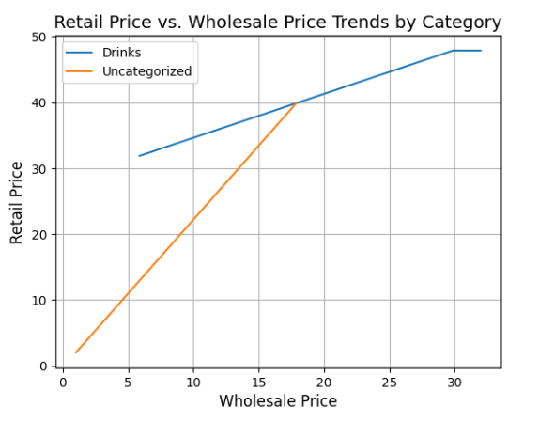

-Also report can:  
1)Analyzing Inventory Value Distribution Across Manufacturers

2)Analyzes and visualizes the average inventory value per unit for each product

3)Comparing Average Retail Prices Across Categories

Report “SKU`s not ordered”

-Effectively visualizes the number of unordered products across different categories

Identifying Stock Issues: The chart immediately draws attention to categories with a higher number of unordered products. This can signal potential stock outs or supply chain issues that need to be addressed to avoid lost sales and customer dissatisfaction.

Category Comparison: By presenting the data for each category side-by-side, we can easily compare their performance in terms of maintaining sufficient stock levels. This helps identify which categories might require more attention or adjustments in ordering processes.

Inventory Management Insights: Businesses can utilize this information to gain insights into their inventory management practices and identify areas for improvement. It helps prioritize which products or categories need reordering and prevent stockouts of popular or essential items.

Demand Forecasting: The data on unordered products can also be used in conjunction with sales data to improve demand forecasting and ensure that sufficient inventory is available to meet customer demand.

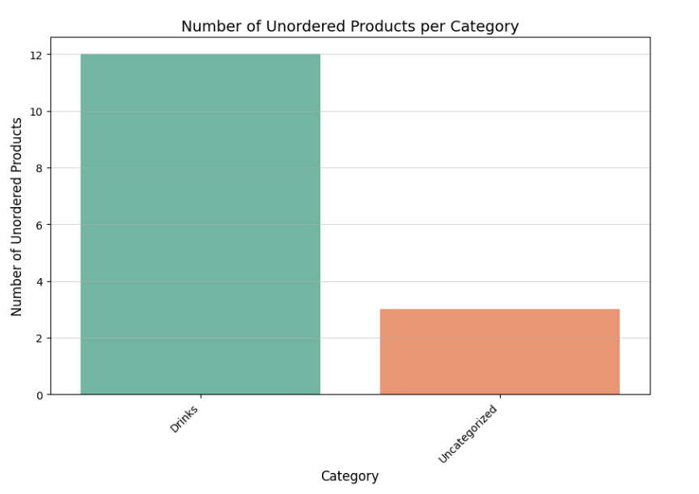

-Effectively showcase the average available cases for products within different retail price ranges for each category

Inventory Analysis by Price Range: The charts allow us to analyze inventory levels for different price ranges within each category. This helps identify potential stock imbalances, such as overstocking in certain price ranges and understocking in others.

Category Comparison: By presenting the data for each category separately, we can easily compare their inventory distribution across different price ranges. This helps identify if certain categories have a higher concentration of inventory in specific price ranges compared to others.

Pricing Strategy Insights: The plots can provide insights into the effectiveness of pricing strategies. For example, if a category has a high number of available cases in a lower price range and low availability in a higher price range, it might suggest the need for adjustments in pricing or product assortment within that category.

Demand and Supply Alignment: Businesses can use this information to ensure that their inventory levels are aligned with customer demand across different price points within each category. This helps optimize stock levels, reduce carrying costs, and avoid stockouts or overstocks.

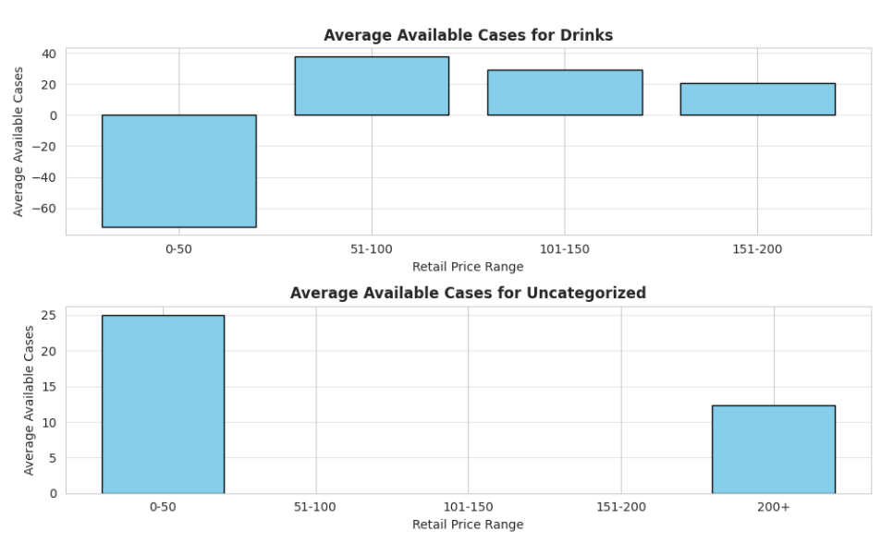

-Number of unordered products within different price ranges

Identifying Problem Areas: The heatmap instantly reveals areas with a higher concentration of unordered products through color intensity. This allows businesses to quickly pinpoint specific categories and price ranges that require immediate attention to prevent stockouts and potential loss of sales.

Category and Price Analysis: The combination of category and price range on a single plot enables a comprehensive analysis of inventory issues. Businesses can identify whether certain categories are more prone to stockouts within specific price ranges, potentially indicating underlying issues with supplier relations, demand forecasting, or pricing strategies.

Visualizing Trends: While this example is limited, a heatmap with more data can reveal trends or patterns in unordered products. This could highlight seasonal fluctuations, shifts in customer preferences, or the impact of marketing campaigns on product demand.

Inventory Management Optimization: Businesses can utilize this information to optimize their inventory management practices. By focusing on categories and price ranges with a higher number of unordered products, they can prioritize reordering, adjust stock levels based on demand, and implement strategies to prevent future stockouts.

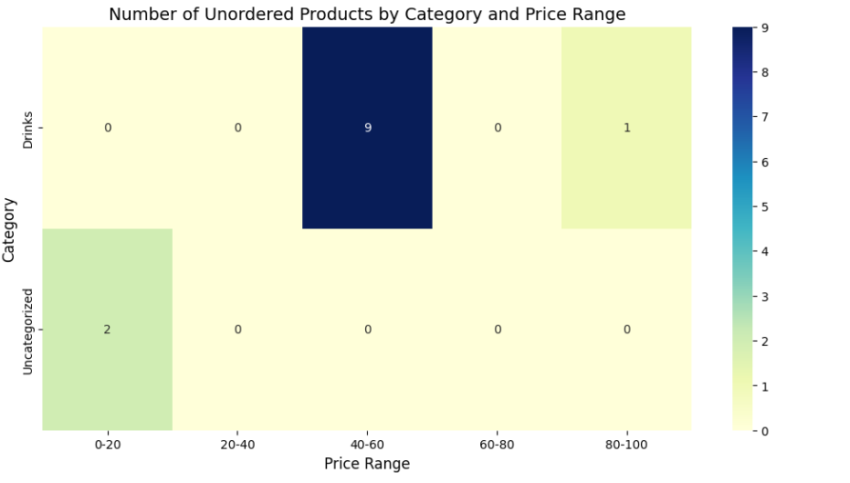

-Potential profitability of unordered products

Profitability Insights: The height of each bar represents the potential profit margin for each product, giving businesses a clear understanding of the potential profitability associated with reordering these unordered items.

Uncertainty Visualization: The error bars depict the variability or uncertainty associated with the profit margin estimates. This acknowledges that the actual profit margin may deviate from the estimated value due to various factors, such as fluctuating costs, competitor pricing, and market demand.

Prioritizing Reorders: Businesses can use this information to prioritize reordering decisions. Products with higher potential profit margins and lower variability might be prioritized for reordering to maximize profitability and reduce risks.

Identifying Risks and Opportunities: Products with high variability in their profit margins might require further investigation to understand the source of the uncertainty. This could reveal potential risks that need to be mitigated or opportunities to improve pricing strategies and cost management.

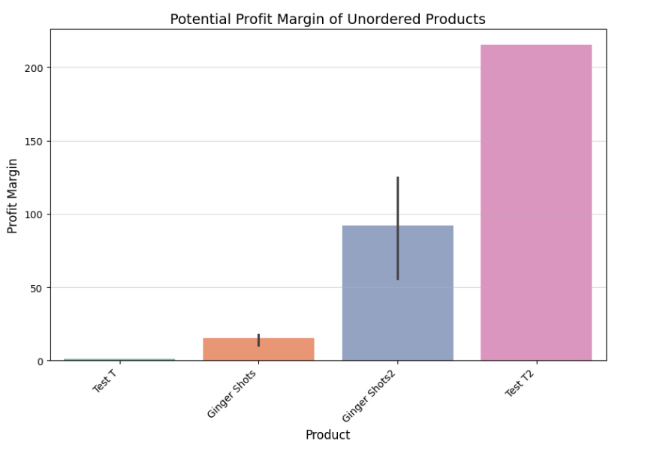

-Effectively visualizes the relationship between available cases and profit margin percentage for unordered products

Inventory and Profitability Analysis: The plot allows us to analyze the relationship between available cases and potential profit margins for unordered products. This helps identify if there's a correlation between the current stock levels of unordered products and their potential profitability.

Category-Specific Insights: By using different colors for each category, we can easily identify any patterns or trends within each group. This helps understand if certain categories tend to have higher profit margins for unordered products or if there's a relationship between available cases and profitability within specific categories.

Identifying Reordering Opportunities: Businesses can use this plot to identify potential reordering opportunities. Products with high profit margins and low or negative available cases might be prioritized for reordering to capitalize on profitability and prevent stockouts.

Inventory Optimization: The plot can guide inventory management decisions by revealing which categories or products require adjustments in stock levels based on their profit potential and current availability. This helps prevent overstocking of low-profit items and ensures sufficient inventory for high-profit products.

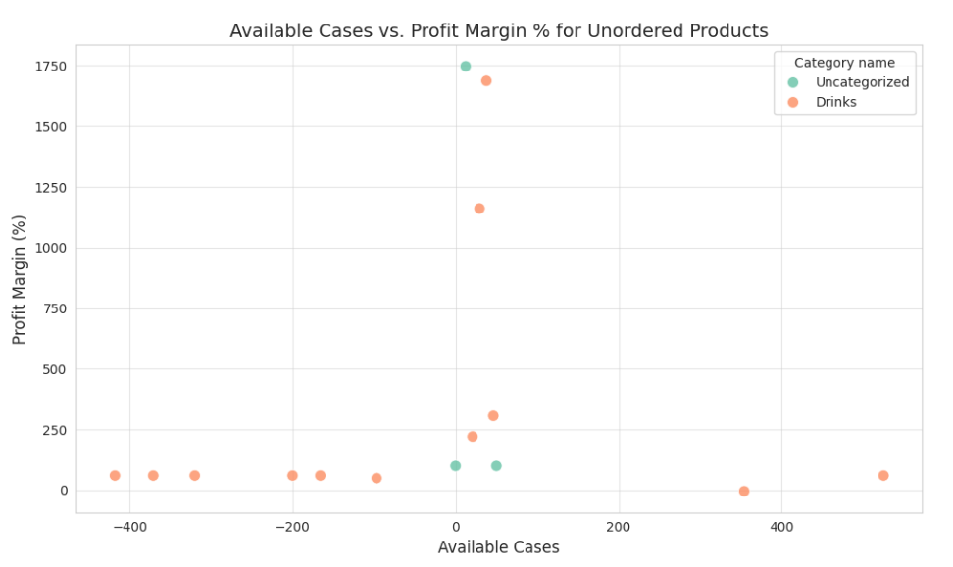

Report “Rep details”

-Showcases the median efficiency metrics for different roles based on "Visits per Working Hour" and "Customers per Visit

Comparing Efficiency Across Roles: The chart allows for a direct visual comparison of efficiency between different roles based on the chosen metrics. This helps identify which roles are performing better in terms of visit frequency and customer engagement per visit.

Identifying Performance Gaps: By visualizing the median values, businesses can quickly spot any significant performance gaps between roles. For instance, if one role has a substantially lower number of visits per working hour, it might indicate a need for further investigation and potential process improvements.

Resource Allocation and Training: The insights from this plot can guide decisions related to resource allocation and training programs. Roles with lower efficiency metrics might benefit from additional training, support, or adjustments in workload distribution to improve their performance.

Tracking Performance Over Time: Creating similar bar charts for different time periods allows businesses to track changes in efficiency metrics over time. This helps assess the effectiveness of implemented strategies and identify areas for continuous improvement.

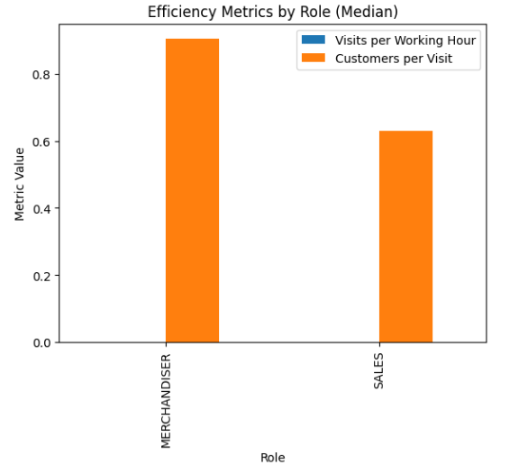

-Visualizing Customer Engagement: Active Customers vs. Total Visits

Relationship Visualization: The plot allows us to explore the relationship between the number of active customers a sales rep handles and the total number of visits they make. This can reveal potential correlations or patterns, such as whether reps with more active customers tend to make more visits.

Individual Performance Comparison: By plotting each sales rep's data as separate points and using different colors, we can easily compare their individual performance. This helps identify high-performing reps who manage many active customers with a relatively lower number of visits and those who might need additional support or training.

Trend Line Insights: The inclusion of a trend line provides a general overview of the overall relationship between the two variables. This can help identify if there's a positive correlation, suggesting that more active customers generally lead to more visits.

Resource Allocation and Goal Setting: Businesses can use this information to make informed decisions about resource allocation, sales territories, and individual goals for sales reps. It helps identify reps who might be overburdened or have the capacity to handle more clients, leading to optimized workload distribution and improved sales performance.

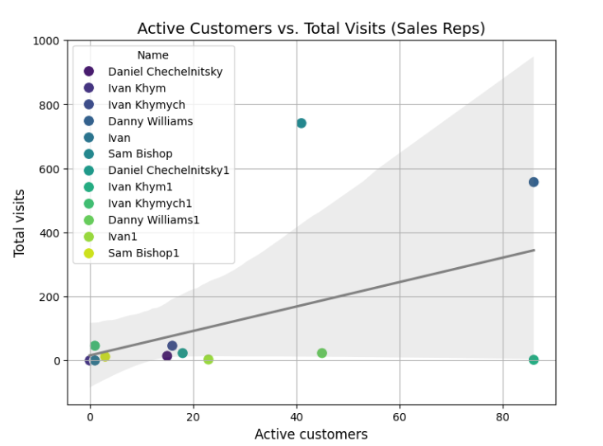

-Travel Distance vs. Number of Visits plot

Travel Efficiency Analysis: The plot allows us to analyze the relationship between the distance traveled and the number of visits conducted by individuals in different roles. This helps assess the efficiency of travel routes and whether there's a correlation between travel distance and the number of visits.

Role Comparison: By plotting the data for each role on the same graph using different line styles, we can easily compare their travel patterns. We can see if one role tends to travel longer distances for a similar number of visits compared to another, potentially indicating differences in territory size, visit frequency, or scheduling efficiency.

Identifying Outliers: The plot helps identify any outliers or data points that deviate significantly from the general trend. This could indicate inefficient travel routes, scheduling issues, or other factors affecting the relationship between travel distance and the number of visits.

Optimizing Travel Routes: Businesses can use this information to optimize travel routes and schedules for their sales and merchandising teams. By identifying areas where travel distance is high relative to the number of visits, they can explore ways to reduce travel time and costs, potentially leading to increased efficiency and productivity.

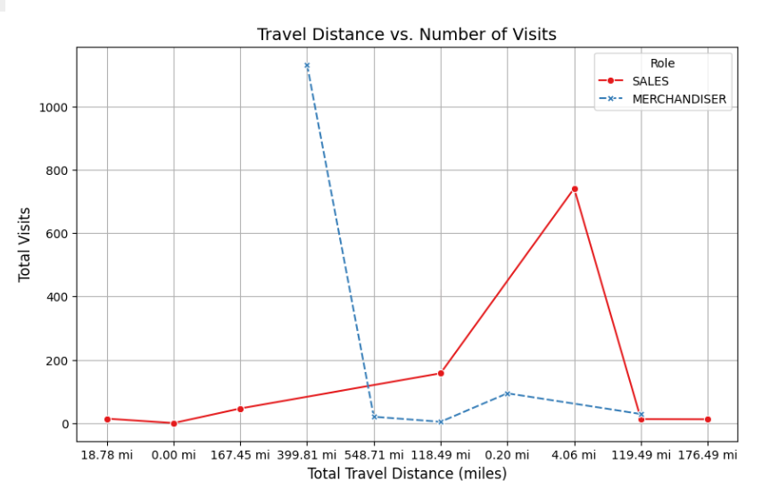

-Effectively visualizes two key metrics per employee: "Pure Work Hours" and "Total Travel Distance."

Comparing Workload Distribution: The "Pure Work Hours" chart provides a clear comparison of workload distribution among employees. It helps identify individuals with significantly higher or lower work hours, potentially indicating imbalances in task allocation or scheduling.

Analyzing Travel Patterns: The "Total Travel Distance" chart reveals the travel patterns of each employee. This helps identify individuals who travel more extensively, which could be due to larger territories, specific roles requiring more travel, or inefficient route planning.

Identifying Potential Issues: By comparing the two charts, businesses can identify potential issues or areas for improvement. For instance, an employee with high work hours and extensive travel distance might be at risk of burnout, suggesting a need for workload adjustments or travel optimization.

Resource Allocation and Planning: This information can guide decisions related to resource allocation, territory assignments, and travel planning. Businesses can optimize travel routes, adjust workloads to ensure balance, and implement strategies to improve employee well-being and overall productivity.

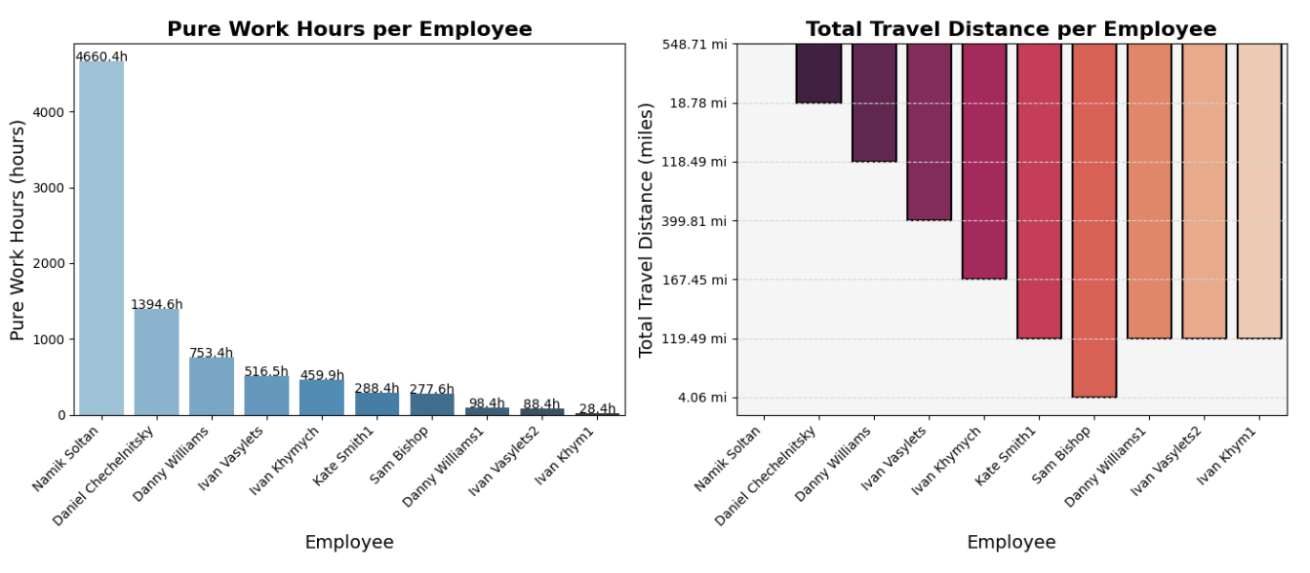

-Relationship between total visits and total photos taken for the SALES role

Activity Tracking: The plot allows us to track the activity of sales representatives by visualizing the number of photos taken in relation to the total number of visits. This helps understand if there's a correlation between visit frequency and photo-taking activity, potentially indicating the level of engagement during visits.

Identifying Patterns: The plot can reveal patterns or trends in photo-taking behavior. For instance, it might show that the number of photos taken increases with the number of visits up to a certain point and then plateaus, suggesting a potential limit to photo-taking activity even with increased visits.

Performance Evaluation: Businesses can use this information to evaluate the performance and engagement of their sales representatives. It helps identify individuals who consistently take photos during visits and those who might require additional training or motivation to document their activities.

Data Collection Analysis: The plot can be used to assess the effectiveness of data collection processes and identify areas for improvement. For example, if the number of photos taken is consistently low despite a high number of visits, it might indicate issues with the photo capture process or the need for clearer guidelines on when and how to take photos.

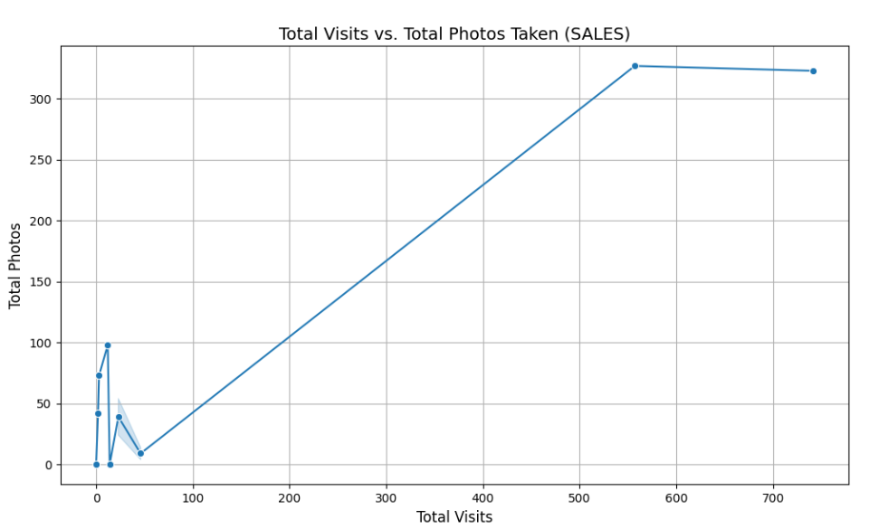

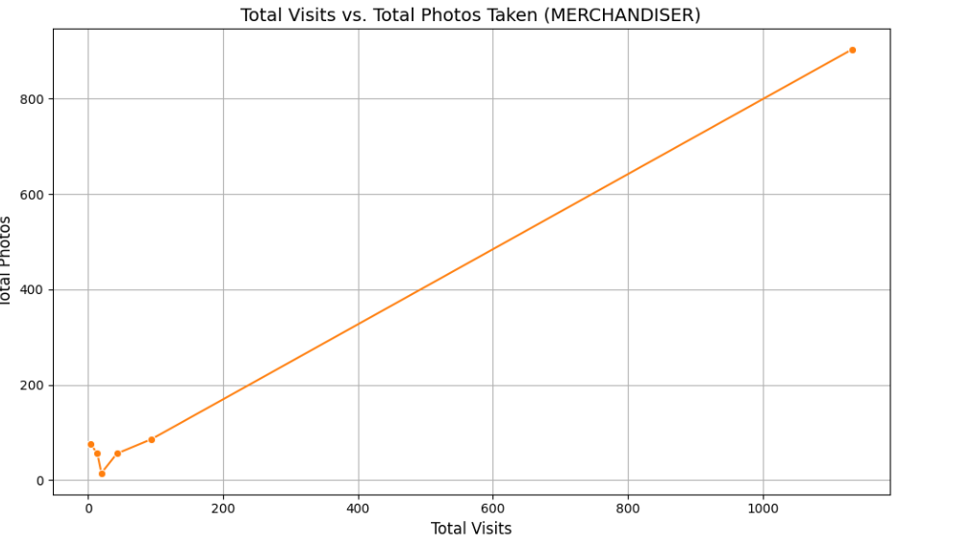

The report also includes:

-Customer Distribution Across Sales Representatives

Report “Reps Summary”

-Visualizes the relationship between revenue and two key sales metrics: "Orders" and "Cases Sold."

Revenue Driver Analysis: The plots allow us to analyze how revenue is influenced by both the number of orders placed and the number of cases sold. This helps identify which metric has a stronger correlation with revenue generation and provides insights into the sales dynamics of the business.

By presenting the data for each metric in separate plots, we can easily compare their individual relationships with revenue. This helps understand if there's a difference in the impact of order volume versus sales volume on overall revenue.

The plots can reveal patterns or trends in the data. For example, we might observe that revenue increases steadily with the number of cases sold, while the relationship with the number of orders might be more variable or less pronounced.

Businesses can use this information to optimize their sales strategies. If the number of cases sold has a stronger impact on revenue, they might focus on strategies to increase sales volume per order, such as upselling or cross-selling. Conversely, if order volume is more crucial, they might focus on acquiring new customers or encouraging repeat purchases.

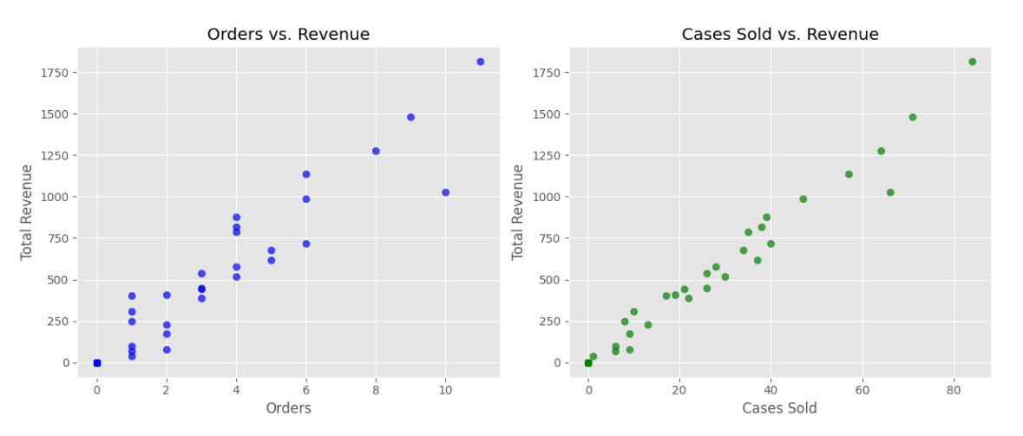

-Revenue generated by month and role (MERCHANDISER and SALES)

Revenue Trend Analysis: The chart allows us to analyze revenue trends over time for each role. This helps identify periods of high and low revenue generation, potentially revealing seasonal fluctuations, the impact of marketing campaigns, or changes in sales performance.

Role Comparison: By presenting the data for each role side-by-side, we can easily compare their revenue contributions over different months. This helps identify which role generates more revenue and if there are any significant differences in their performance patterns.

Identifying Performance Gaps: Businesses can use this information to identify potential performance gaps between roles or periods of underperformance. For instance, a significant drop in revenue for a particular role might indicate a need for further investigation and potential interventions to improve sales or address underlying issues.

Sales Strategy and Goal Setting: The insights from this plot can guide decisions related to sales strategies, resource allocation, and goal setting. Businesses can identify months or roles that require additional support, adjust sales targets based on historical trends, and develop targeted strategies to boost revenue during periods of lower performance.

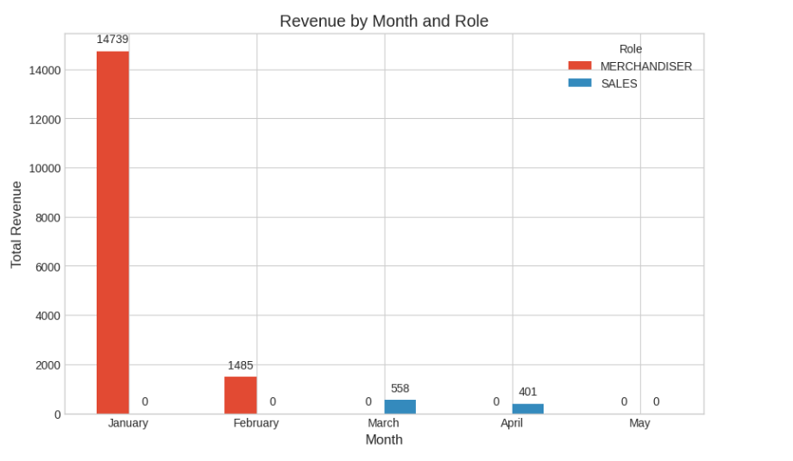

-Number of cases sold for each day of the week

Identifying Sales Patterns: The chart allows us to quickly identify any patterns or trends in sales volume throughout the week. We can see which days have higher or lower sales, potentially revealing days with peak demand or slower periods.

Resource Allocation: Businesses can use this information to optimize resource allocation, such as staffing levels or marketing efforts, based on the expected sales volume for each day.

Sales Strategy Planning: Understanding the daily sales patterns can help businesses develop targeted sales strategies. For instance, they might consider running promotions or offering special deals on slower days to boost sales.

Customer Behavior Insights: The plot can provide insights into customer behavior and preferences. For example, if sales are significantly higher on weekends compared to weekdays, it might suggest that customers have more time for shopping during those days.

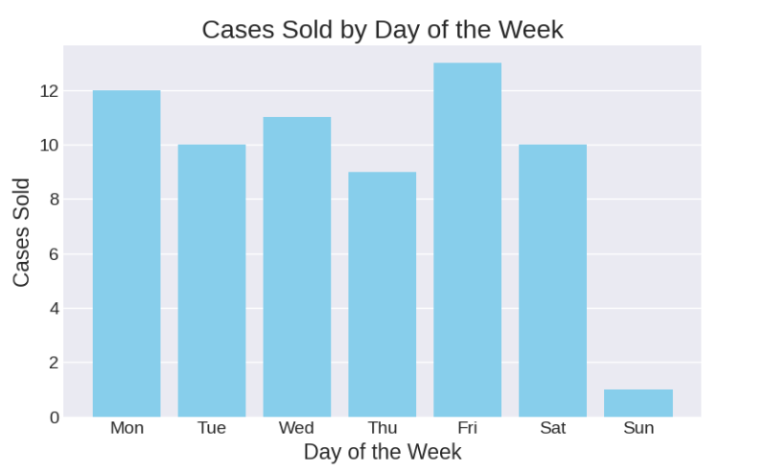

-Distribution of total revenue for different roles (SALES and MERCHANDISER)

Comparing Revenue Distributions: The plot allows us to compare the distribution of total revenue generated by each role. This helps identify if there are any significant differences in the typical revenue generated by SALES versus MERCHANDISER roles, as well as the spread and range of revenue values within each role.

Identifying Outliers: The density plot can help identify any outliers or unusual revenue values within each role. This could indicate exceptional performance, data entry errors, or other factors that might require further investigation.

Understanding Role Contributions: Businesses can use this information to understand the relative contributions of each role to the overall revenue generation. This can inform decisions related to resource allocation, performance incentives, and role-specific training programs.

Setting Realistic Goals: The visualization of the revenue distribution helps set realistic and achievable goals for each role. By understanding the typical range and spread of revenue values, businesses can set targets that are challenging yet attainable, promoting motivation and performance improvement.

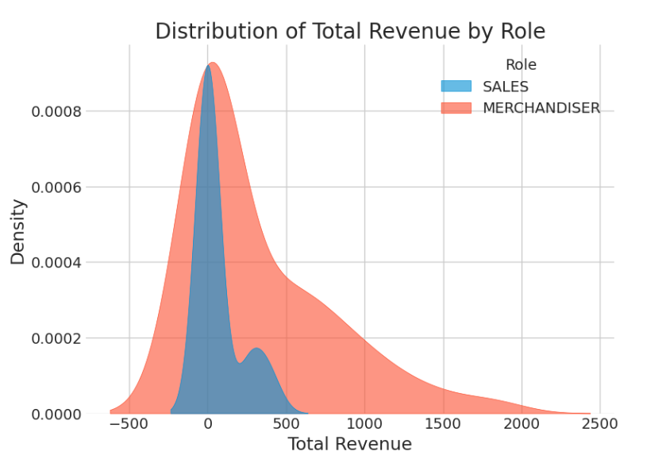

Also the report can:

-Visualizing Revenue Trends over Time for Each Role

-Exploring the Relationship Between Visits and Orders

-Comparing Performance Metrics for Different Roles

-Identifying Potential High-Value Clients