QSAR-Guided Virtual Screening and In Silico Characterization of Novel Inhibitors Targeting the COX-2 Enzyme in Inflammatory Disorders

Abstract— Selective inhibition of cyclooxygenase-2 (COX-2) remains an attractive strategy for treating inflammatory disorders, but the cardiovascular liabilities that emerged with the first generation of coxibs showed that potency alone is not a sufficient design goal. This study reports a fully computational workflow that couples quantitative structure-activity relationship (QSAR) modelling with ligand-based virtual screening and in silico characterization, using only experimental data already deposited in the public domain. A total of 8,504 COX-2 and 4,488 COX-1 IC50 records were retrieved from ChEMBL and curated into 4,204 and 1,604 unique compounds respectively, spanning 4.0-10.7 log units of COX-2 potency. Molecules were described by 20 interpretable physicochemical descriptors combined with 1024-bit extended-connectivity fingerprints, and five regression algorithms were compared. A support vector regression model gave the best hold-out performance (R² = 0.585, RMSE = 0.749 log units, cross-validated Q² = 0.541). Robustness was confirmed by a Bemis-Murcko scaffold split, in which no scaffold was shared between training and test sets, and by y-randomization, where 20 permuted-response models gave a mean R² of -0.333. A k-nearest-neighbour applicability domain covered 96.1% of test compounds and reduced the RMSE to 0.733 within that domain. The validated model was applied to a library of 24,074 compounds after removal of structures already present in the training data, pan-assay interference substructures and molecules failing drug-likeness rules, and candidates were ranked on predicted potency together with predicted isoform selectivity. Retrospective enrichment on the hold-out set gave a 2.9-fold enrichment in the top 1%, against a theoretical maximum of 3.4. In an external check against a pre-specified panel of 14 clinically used cyclooxygenase inhibitors, none of which appeared in the training data, celecoxib and polmacoxib ranked first and second out of 12,783 scored compounds, and the predicted selectivity index separated the known selective, preferential and non-selective classes in the correct order (+2.29, +0.45 and -0.30 respectively). Hits are reported in graded tiers, the prioritised tier containing 83 compounds across 60 distinct Bemis-Murcko scaffolds, and are profiled for physicochemical and drug-likeness properties. All curated datasets and code are provided so that the workflow can be reproduced exactly. Every result reported here is computational, and the proposed compounds require experimental confirmation.
Keywords— COX-2, Cyclooxygenase, QSAR, Virtual Screening, Machine Learning, Molecular Descriptors, Applicability Domain, Selectivity, Anti-inflammatory Agents, ChEMBL

- INTRODUCTION
Inflammation is a protective response, but when it persists it drives a large group of disorders ranging from rheumatoid arthritis and osteoarthritis to inflammatory bowel disease. A central step in this process is the conversion of arachidonic acid into prostaglandins, catalysed by the cyclooxygenase enzymes. Vane's demonstration that aspirin-like drugs act by blocking prostaglandin synthesis [1] explained the mechanism of an entire therapeutic class and set the direction for decades of medicinal chemistry.
Two isoforms are relevant here. COX-1 is expressed constitutively in most tissues and produces prostaglandins that protect the gastric mucosa and support platelet function. COX-2 is largely inducible and is up-regulated at sites of inflammation [2], [3]. Traditional non-steroidal anti-inflammatory drugs inhibit both isoforms, so their anti-inflammatory benefit comes with gastrointestinal toxicity attributable to COX-1 blockade. This observation motivated the search for selective COX-2 inhibitors, and the crystal structures of the enzyme showed why selectivity is achievable: a single amino-acid difference at position 523, isoleucine in COX-1 and the smaller valine in COX-2, opens a side pocket that bulky inhibitors can occupy [4], [5].
The clinical history of this class is a cautionary one. Selective inhibitors such as rofecoxib and celecoxib did reduce gastrointestinal events, but long-term trials revealed an excess of cardiovascular events [6], [7], and rofecoxib was ultimately withdrawn. The mechanistic explanation is that suppressing COX-2-derived prostacyclin without a matching effect on COX-1-derived thromboxane shifts the haemostatic balance [8], [9]. The practical consequence for computational design is important: a useful model of this target cannot optimise COX-2 potency in isolation. The ratio of COX-2 to COX-1 activity is itself a design variable, and any screening protocol that ignores it risks proposing compounds with the same liability profile that caused the original withdrawals.
Quantitative structure-activity relationship modelling offers a way to explore chemical space before any compound is synthesised. Since the foundational work of Hansch and Fujita [10], the field has moved from small congeneric series and a handful of descriptors to machine-learning models trained on thousands of heterogeneous structures [11], [12]. Public bioactivity repositories, ChEMBL in particular [13], [14], have made this transition possible by aggregating measurements from the medicinal chemistry literature. At the same time, the community has become considerably stricter about what counts as a validated model. Internal cross-validation alone is known to be a weak indicator of predictive power [15], and current best practice requires external test sets, randomisation controls and an explicit applicability domain [16], [17], [18].
This study applies that standard to COX-2. The aims and contributions are as follows:
- Transparent curation of public data: a reproducible pipeline converts raw ChEMBL records into a modelling-ready dataset, with every filtering step counted and reported rather than described in general terms.
- Rigorously validated QSAR models: five algorithms are compared under a random split, a scaffold-disjoint split, cross-validation, y-randomization and an applicability domain, so that reported accuracy reflects genuine predictive ability.
- Selectivity as a screening criterion: a parallel COX-1 model allows candidates to be ranked by predicted isoform selectivity rather than potency alone, addressing the liability that undermined earlier coxibs.
- Prospective, filtered virtual screening: compounds already present in the training data are excluded, and pan-assay interference and drug-likeness filters are applied before ranking, so the reported hits are genuinely novel with respect to the model.
- Full in silico characterization: surviving hits are profiled for physicochemical properties, drug-likeness and scaffold diversity.
The remainder of the paper is organised as follows. Section 2 reviews related computational work on COX-2 and the validation standards this study follows. Section 3 describes the data, descriptors, models, validation protocol and screening workflow. Section 4 reports and discusses the results, and Section 5 concludes with the limitations of a purely computational study and the experimental work needed to follow it up.
- LITERATURE REVIEW
Computational work on COX-2 has followed the general evolution of the QSAR field. Early studies analysed small congeneric series with a limited number of physicochemical parameters in the classical Hansch framework [10], which gave interpretable equations but limited transferability to new chemotypes. The arrival of three-dimensional methods such as comparative molecular field analysis [19] and comparative molecular similarity indices analysis [20] allowed steric and electrostatic fields around aligned ligands to be related to potency. These approaches remain valuable for lead optimisation within a series, but they depend on a reliable structural alignment, which is difficult to obtain across the structurally diverse set of COX-2 inhibitors reported in the literature.
Once the COX-2 crystal structures became available [4], [5], structure-based virtual screening became feasible, and docking has been applied extensively to this target [21]. Docking has the advantage of using the actual binding site, including the selectivity side pocket, but scoring functions correlate only loosely with measured affinity, and performance is sensitive to the choice of protein conformation and protonation state. Ligand-based machine learning avoids these particular difficulties by learning directly from measured activities, at the cost of being limited to the chemical space covered by the training data [12], [22].
The modelling methodology adopted here reflects several well-established methodological results. Extended-connectivity fingerprints [23] have become a standard structural representation for bioactivity prediction. Support vector machines [24] and random forests [25] are reliable baselines for heterogeneous chemical datasets. On the validation side, Golbraikh and Tropsha showed that a high cross-validated Q² does not guarantee external predictivity [15]; Rucker et al. formalised y-randomization as a control against chance correlation [17]; and Sahigara et al. reviewed approaches to defining an applicability domain, which bounds the region of chemical space in which predictions are trustworthy [18]. Tropsha's summary of best practice [16] and the OECD validation principles [26] together describe the standard applied in this work.
Finally, virtual screening practice has developed its own quality controls. Substructure filters for pan-assay interference compounds [27] remove frequent hitters that would otherwise dominate ranked lists, while Lipinski's and Veber's rules [28], [29] and the quantitative estimate of drug-likeness [30] provide simple developability checks. Scaffold analysis in the sense of Bemis and Murcko [31] is used here both to measure the structural diversity of hits and to construct a deliberately difficult train/test split.
Against this background, several gaps motivated the present work:
- Many published COX-2 QSAR studies are built on small, congeneric datasets, which inflates apparent accuracy and limits applicability to new chemotypes.
- Validation is often restricted to internal cross-validation, without a scaffold-disjoint external set, a randomisation control or a stated applicability domain.
- COX-1 activity is frequently ignored, even though isoform selectivity is the property most closely tied to the clinical failure of this drug class.
- Screening protocols often report ranked hits without first excluding training compounds or filtering assay-interference substructures, which makes the novelty of the hits difficult to assess.
Table 1 summarises the main approaches and how the present study relates to them.

Table 1: Computational Approaches to COX-2 Inhibitor Discovery
Approach | Basis | Strength | Principal limitation
Classical QSAR | Hansch [10] | Interpretable; few compounds needed | Congeneric series only
3D-QSAR | CoMFA [19]; CoMSIA [20] | Fields map to the binding site | Needs reliable alignment
Docking | COX-2 structures [4], [5]; [21] | Uses the real selectivity pocket | Scoring correlates weakly with affinity
Ligand-based ML | ECFP [23]; SVM [24]; RF [25] | Handles diverse chemotypes | Confined to the applicability domain
This work | Curated COX-2 and COX-1 data | Selectivity ranking; scaffold-split and randomisation controls | Predictions need experimental confirmation
- Methodology
The workflow consists of six stages: data acquisition, curation, descriptor calculation, QSAR model development and validation, virtual screening, and in silico characterization of the resulting hits. Fig. 1 shows the complete pipeline. All computation was performed with RDKit [32] and scikit-learn [33] on a standard desktop CPU; no molecular dynamics, docking or quantum-chemical calculation was involved, and no new experimental measurement was generated.
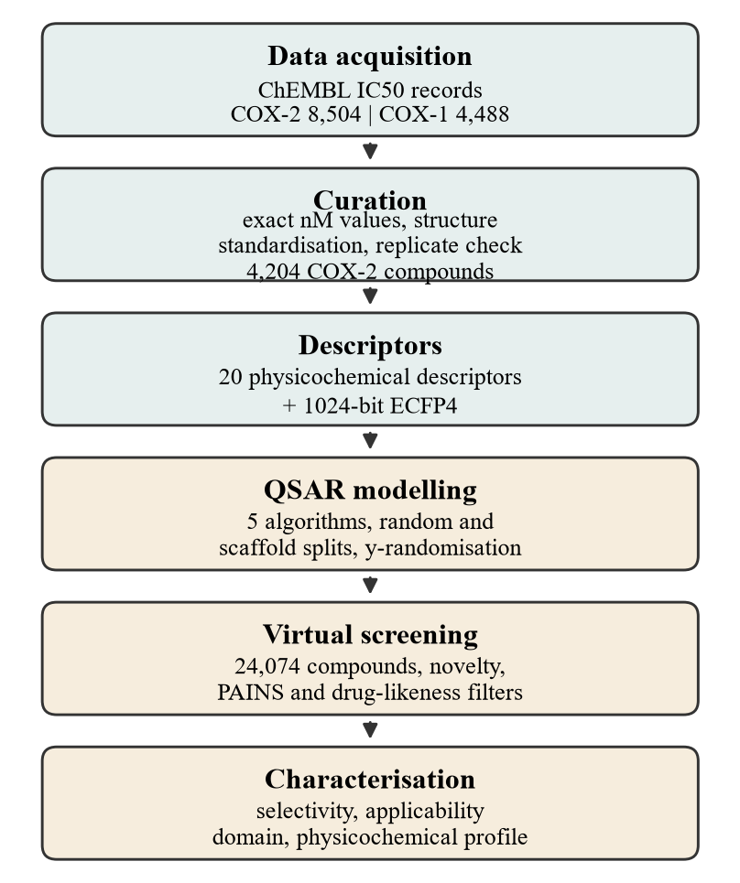
Fig. 1. The QSAR-guided virtual screening workflow used in this study.
3.1 Data Acquisition
Bioactivity data were retrieved from the ChEMBL web services [13], [14]. Human COX-2 (ChEMBL target CHEMBL230, prostaglandin G/H synthase 2) returned 8,504 IC50 records, and human COX-1 (CHEMBL221, prostaglandin G/H synthase 1) returned 4,488. For each activity the compound identifier, canonical SMILES, standard relation, value, units, assay and source document were stored. COX-1 data were collected specifically so that isoform selectivity could be modelled alongside potency.
3.2 Data Curation
Raw repository data require careful cleaning before modelling, because they aggregate measurements made in different laboratories under different assay conditions. The following steps were applied in order, and the number of records surviving each step was recorded (Table 2):
- Validity filter: records carrying any ChEMBL data-validity comment, such as a value outside the typical range or a suspected transcription error, were discarded.
- Relation and unit filter: only exact measurements (standard relation '=') reported in nanomolar units were retained, so censored values such as 'greater than 10 000 nM' were excluded.
- Structure standardisation: each SMILES was parsed with RDKit, cleaned, reduced to its largest covalent fragment to strip counter-ions, and neutralised. Compounds containing elements outside the common organic set, or with fewer than 8 or more than 70 heavy atoms, were removed.
- Duplicate aggregation: compounds were identified by InChIKey. Replicate measurements were aggregated to the median pIC50, defined as 9 - log10(IC50 in nM).
- Replicate consistency: a compound whose replicate measurements spanned more than one log unit was considered unreliable and discarded.
Curation reduced the COX-2 data to 4,204 unique compounds with pIC50 values from 4.00 to 10.70 (mean 6.20, standard deviation 1.12), and the COX-1 data to 1,604 compounds. 1,244 compounds had been measured against both isoforms, and for these a selectivity index was computed as the difference pIC50(COX-2) - pIC50(COX-1), which is the base-10 logarithm of the IC50 ratio.

Table 2: Data Curation Funnel
Curation step | COX-2 records | COX-1 records
Retrieved from ChEMBL | 8,504 | 4,488
After validity-comment filter | 8,151 | 4,181
Exact IC50 values in nM | 6,116 | 2,142
After structure standardisation | 6,102 | 2,131
Unique compounds (by InChIKey) | 4,374 | 1,646
After replicate-consistency filter | 4,204 | 1,604
3.3 Molecular Descriptors
Two complementary representations were combined. The first is a set of 20 interpretable physicochemical descriptors computed with RDKit: molecular weight, calculated logP, topological polar surface area, hydrogen-bond donor and acceptor counts, rotatable bond count, aromatic and aliphatic ring counts, fraction of sp3 carbons, heavy atom and ring counts, NHOH and NO counts, molar refractivity, the Balaban J index, Bertz complexity, the Hall-Kier alpha value, the second-order kappa shape index, the first-order valence connectivity index, and the quantitative estimate of drug-likeness [30]. These descriptors are included because they can be related back to medicinal chemistry intuition.
The second representation is a 1024-bit Morgan fingerprint of radius 2, equivalent to ECFP4 [23], which encodes the presence of circular substructural environments and captures specific pharmacophoric features that bulk properties cannot. The two blocks were concatenated into a single 1044-dimensional feature vector. Descriptors were standardised to zero mean and unit variance within each training fold for the algorithms that require scaling.
3.4 QSAR Model Development
Five regression algorithms were evaluated: ridge regression as a regularised linear baseline, partial least squares with ten latent variables, support vector regression with a radial basis function kernel, gradient boosting, and a random forest of 400 trees [25]. Support vector regression used C = 10 and an epsilon-insensitive loss of 0.1. All models predict pIC50 directly. Hyperparameters were kept at these fixed, conventional values rather than being tuned on the test set, so that reported hold-out performance is not optimistically biased. Settings are summarised in Table 3.

Table 3: Modelling and Validation Configuration
Item | Setting
Endpoint | pIC50 = 9 - log10(IC50 / nM)
Features | 20 RDKit descriptors + 1024-bit ECFP4 (1044 total)
Algorithms | Ridge, PLS, SVR (RBF), Gradient Boosting, Random Forest
Primary split | random 80/20 (3,363 train / 841 test)
Secondary split | Bemis-Murcko scaffold-disjoint (3,363 / 841)
Cross-validation | 5-fold on the training set
Chance-correlation control | 20 y-randomisation runs
Applicability domain | mean distance to 5 nearest training neighbours; 95th-percentile threshold
Random seed | 42
3.5 Model Validation
Validation followed the OECD principles for (Q)SAR models [26] and current best practice [16]. Four complementary checks were used. First, a random 80/20 hold-out split provided an external test set that took no part in fitting. Second, five-fold cross-validation on the training set gave a Q² value measuring internal consistency. Third, because a random split can place close analogues on both sides and therefore flatter the model, a Bemis-Murcko scaffold split [31] was constructed in which every compound sharing a scaffold was assigned to the same side, with rarer scaffolds preferentially placed in the test set. This is a deliberately pessimistic test that approximates the task of predicting a new chemotype. Fourth, y-randomization was performed by permuting the activity values of the training set and refitting twenty times [17]; a model that has learned genuine structure-activity relationships should collapse to near-zero predictive performance under this control.
An applicability domain was defined using the mean Euclidean distance from a query compound to its five nearest training neighbours in standardised descriptor space, with the threshold set at the 95th percentile of the corresponding distances within the training set [18]. Predictions for compounds beyond this threshold are reported but treated as unreliable.
3.6 Virtual Screening Protocol
A screening library of 24,074 compounds was assembled from ChEMBL, comprising small molecules with molecular weight between 200 and 500 Da and calculated logP at most 5, together with all small molecules recorded as having reached clinical phase 3 or 4 so that any hit already in clinical use could be identified as a repurposing candidate. The library was then passed through the following sequential filters:
- Standardisation and novelty: library structures were processed with the same standardisation routine used for the training data, and any compound whose InChIKey matched a COX-2 or COX-1 training compound was removed, making the screen prospective with respect to the model.
- Interference filter: compounds matching a pan-assay interference substructure in the RDKit PAINS catalogue [27] were discarded.
- Drug-likeness: compounds with more than one Lipinski violation [28] or failing the Veber criteria of at most 10 rotatable bonds and a topological polar surface area of at most 140 square Angstroms [29] were removed.
- Applicability domain: compounds outside the domain defined in Section 3.5 were removed, since the model cannot be trusted to extrapolate to them.
- Activity and selectivity thresholds: surviving compounds were required to have a predicted COX-2 pIC50 of at least 7.0 and a predicted selectivity index of at least 1.0, corresponding to at least tenfold predicted selectivity over COX-1.
Predictions were made with the selected architecture refitted on all curated data for the respective isoform. Before the screen was applied to unseen compounds, the ranking itself was validated retrospectively on the hold-out test set by treating compounds with pIC50 of at least 7.0 as actives and computing enrichment factors at the top 1%, 5% and 10% of the ranked list.
3.7 In Silico Characterization
Hits surviving all filters were characterised by their physicochemical profile (molecular weight, calculated logP, topological polar surface area, hydrogen-bond donor and acceptor counts, rotatable bonds), their quantitative estimate of drug-likeness [30], their Bemis-Murcko scaffold [31], their distance to the applicability-domain boundary, and their predicted isoform selectivity. Scaffold counts were used to assess the structural diversity of the hit list, since a ranked list dominated by a single chemotype offers little practical value to a follow-up programme.
- Results
4.1 Curated Dataset and Chemical Space
Curation removed roughly half of the retrieved records, mostly because a large fraction of deposited IC50 values are censored rather than exact (Table 2). The final COX-2 set contains 4,204 compounds covering 6.7 log units of potency, from 4.00 to 10.70. The distribution is shown in Fig. 2 and is approximately unimodal with a mean of 6.20, so the dataset is not dominated by either a narrow potency range or a clustered set of highly optimised analogues. The COX-1 set is smaller (1,604 compounds) and shifted towards lower potency (mean 5.28), which is expected given that much of the medicinal chemistry effort on this target family has been directed at avoiding COX-1 activity.
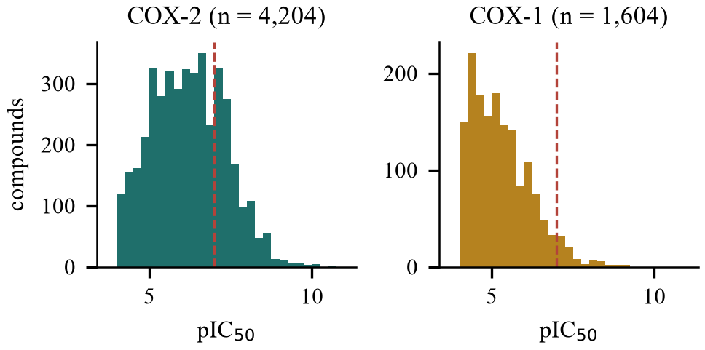
Fig. 2. Distribution of curated pIC50 values for both isoforms. The dashed line marks the pIC50 = 7 activity threshold used later for enrichment analysis.
Fig. 3 projects the dataset onto the first two principal components of the standardised descriptor space, coloured by measured potency. The compounds occupy a single broad, continuous region rather than a set of isolated clusters, confirming that the set is chemically diverse. Potency is not cleanly separable along either principal component, which is the expected situation for a real target: bulk physicochemical properties alone do not determine activity, and this is precisely why substructural fingerprint information is needed in addition to the descriptors.
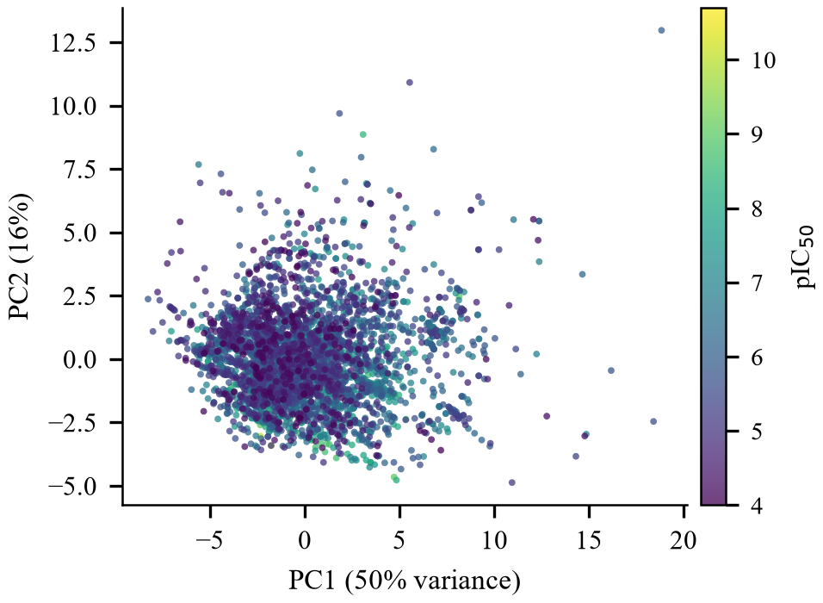
Fig. 3. Principal component projection of the curated COX-2 compounds in descriptor space, coloured by measured pIC50.
4.2 Model Performance
Table 4 and Fig. 4 compare the five algorithms. The two linear methods performed poorly, with ridge regression reaching a test R² of only 0.285 and partial least squares 0.390, confirming that the relationship between these features and COX-2 potency is not adequately linear. The non-linear methods were clearly better, although not uniformly so: gradient boosting reached only 0.366, while the random forest reached 0.542. The best model overall was SVR (RBF), which achieved a test R² of 0.585, an RMSE of 0.749 log units and a mean absolute error of 0.538 log units, with a cross-validated Q² of 0.541 on the training set. The close agreement between the cross-validated and hold-out estimates indicates that the model is neither overfitted nor unstable.
An RMSE of about 0.75 log units should be read in context. It is close to the experimental reproducibility of IC50 measurements aggregated across different laboratories and assay formats, which is commonly estimated at roughly 0.5 log units, so the model is approaching the practical ceiling imposed by the noise in the underlying data rather than being limited only by the algorithm. Fig. 5 plots observed against predicted values for the hold-out set; most compounds fall within one log unit of the identity line, with the largest deviations concentrated among the most potent compounds, where training data are sparsest.

Table 4: QSAR Model Performance
Model | CV Q² | Test R² | Test RMSE | Scaffold R²
Ridge | 0.069 | 0.285 | 0.983 | -0.802
PLS | 0.267 | 0.390 | 0.908 | -0.272
SVR (RBF) | 0.541 | 0.585 | 0.749 | 0.249
Gradient Boosting | 0.393 | 0.366 | 0.926 | 0.125
Random Forest | 0.536 | 0.542 | 0.787 | 0.235
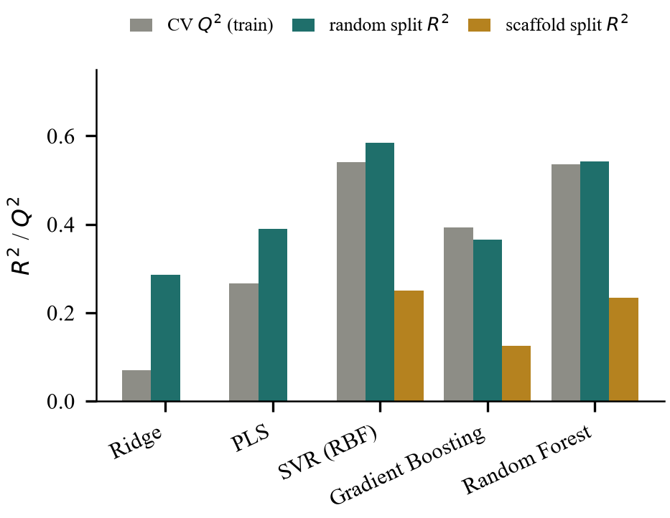
Fig. 4. Model comparison across cross-validation, the random hold-out split and the scaffold-disjoint split.
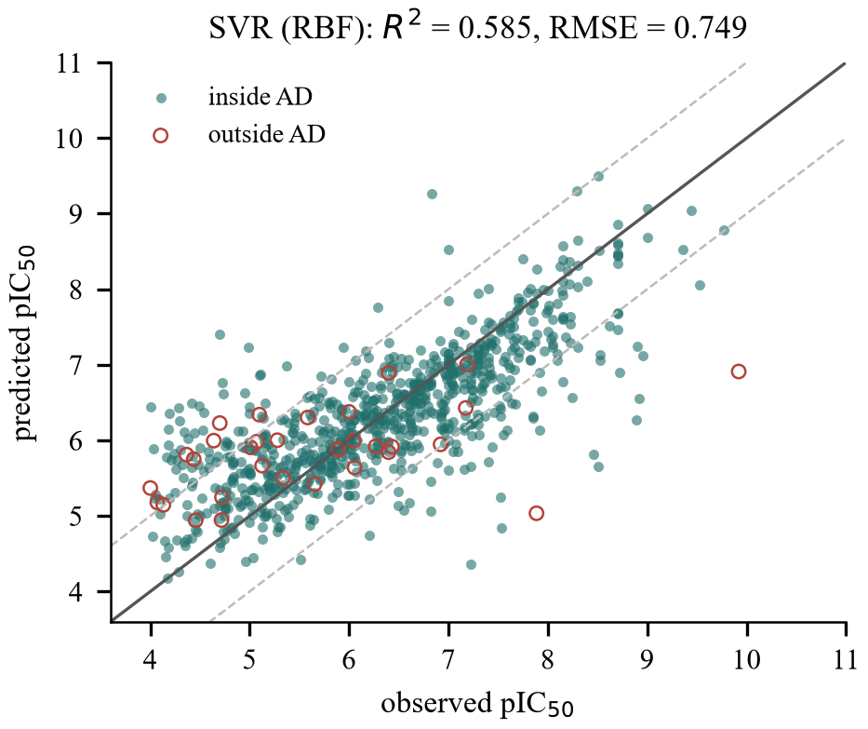
Fig. 5. Observed against predicted pIC50 for the hold-out test set. Dashed lines mark a one log unit error band.
4.3 Scaffold Split and Chance-Correlation Control
The 4,204 curated compounds contain 1,176 distinct Bemis-Murcko scaffolds. Under the scaffold-disjoint split, in which no scaffold appears in both training and test sets, performance fell for every algorithm, with SVR (RBF) reaching R² = 0.249 against 0.585 on the random split. The linear models collapsed entirely, giving negative R² values, meaning they performed worse than simply predicting the training mean. This drop is informative rather than disappointing. It quantifies how much of the apparent accuracy of a conventionally reported random split comes from close analogues being present on both sides, and it gives a more honest estimate of what to expect when the model is applied to a genuinely new chemotype. Reporting both numbers, rather than the more flattering one alone, is the reason the scaffold split was included.
The y-randomization control is unambiguous. Across 20 runs with permuted activity values, the mean test R² was -0.333 and the best of the twenty reached only -0.254, compared with 0.585 for the real model (Fig. 6). The model has therefore learned a genuine relationship between structure and activity rather than exploiting chance correlation in a high-dimensional feature space.
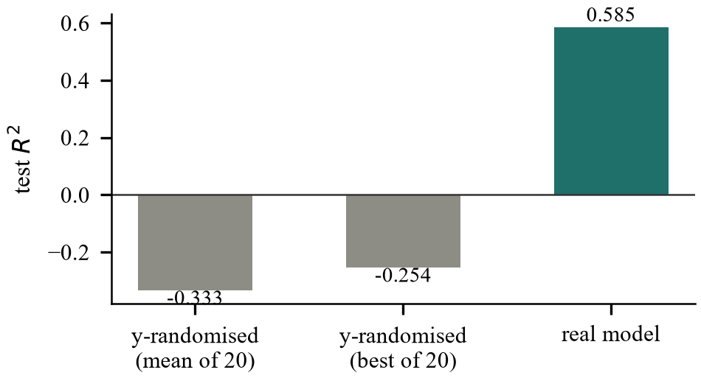
Fig. 6. y-Randomization control. Permuted-response models show no predictive ability.
4.4 Applicability Domain
The applicability domain threshold, set at the 95th percentile of training-set neighbour distances, was 2.411. 96.1% of hold-out compounds fell inside this domain. Within the domain the RMSE improved to 0.733 log units and R² rose to 0.596, compared with an RMSE of 1.063 for compounds outside it. The domain therefore behaves as intended: it identifies in advance the compounds for which predictions are less reliable. This matters directly for virtual screening, where the compounds being scored have not been measured and there is no other way to judge whether a prediction should be believed.
4.5 Descriptor Contributions
Fig. 7 shows the relative importance of the physicochemical descriptors in a random forest trained on the descriptor block alone. That descriptor-only model reached a test R² of 0.397, well below the 0.585 obtained with descriptors and fingerprints combined, which quantifies how much of the signal depends on specific substructural features rather than bulk properties. The leading contributors were BertzCT (0.122), BalabanJ (0.099) and TPSA (0.091), followed by MolLogP and HallKierAlpha.
It is worth being careful about how this ranking is read. The two highest-ranked descriptors, Bertz complexity and the Balaban J index, are global topological measures of molecular elaboration and branching rather than directly interpretable physical properties, so their prominence mainly indicates that more structurally elaborated molecules tend to occupy a different potency range in this dataset. Polar surface area and calculated logP, which follow them, are easier to connect to the biology: the cyclooxygenase active site is a long, largely hydrophobic channel, and the side pocket responsible for COX-2 selectivity is reached by substituents that alter both polarity and lipophilicity. These importances describe statistical association within this particular dataset and should not be read as a causal account of binding. They are reported as a sanity check that the model responds to chemically meaningful variation, not as a design rule.
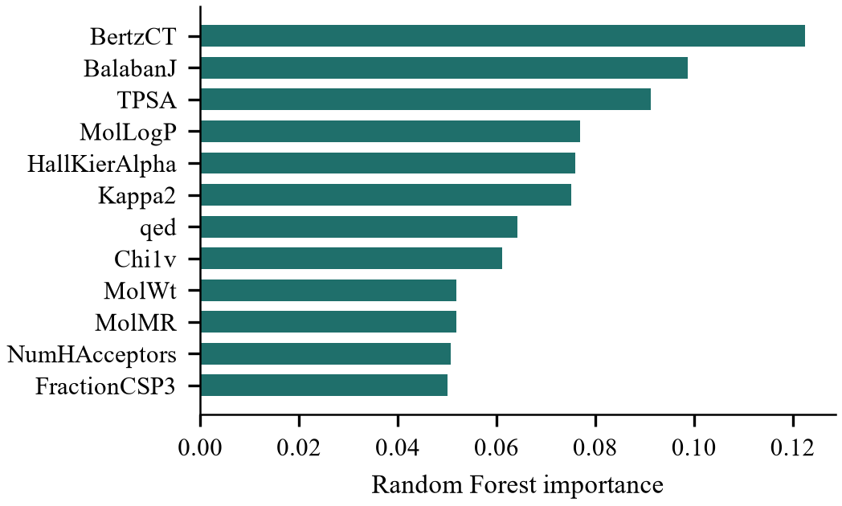
Fig. 7. Relative importance of the physicochemical descriptors for COX-2 potency.
4.6 COX-2 over COX-1 Selectivity
Fig. 8 plots measured COX-2 against measured COX-1 potency for the 1,244 compounds assayed against both isoforms. The median selectivity index across this set is 1.02 log units. Most compounds lie close to the equipotency line, and genuinely selective compounds, those more than one log unit above it, form a clear minority. This is a useful empirical reminder of how difficult the design problem is: achieving COX-2 potency is relatively common in this chemical space, while achieving potency together with selectivity is not. It also provides the justification for ranking screening hits on predicted selectivity rather than predicted potency alone.
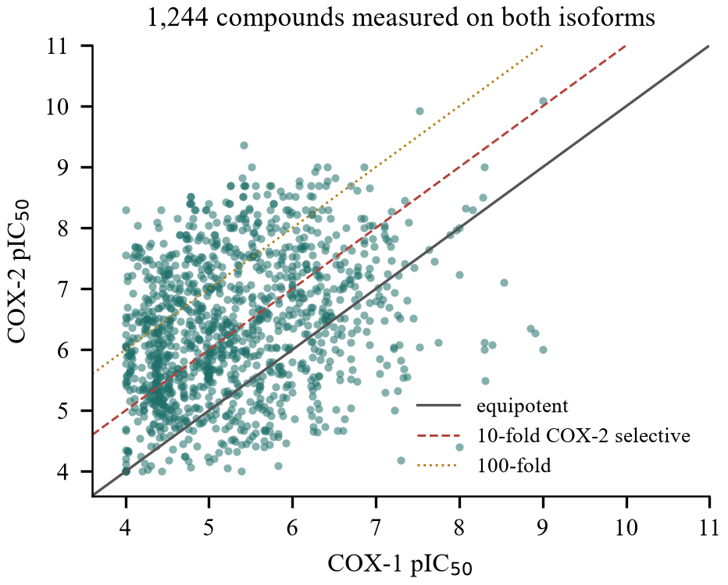
Fig. 8. Measured COX-2 against COX-1 potency for compounds assayed on both isoforms.
4.7 Virtual Screening
Before applying the model prospectively, the ranking was validated retrospectively on the hold-out set. Taking pIC50 of at least 7.0 as the activity criterion, with a baseline active rate of 29.7%, the top 1% of the ranked list showed a hit rate of 87.5%, an enrichment factor of 2.9. Enrichment factors at the top 5% and 10% were 3.3 and 3.2 respectively, and the full enrichment curve is shown in Fig. 10. The ranking is therefore substantially better than random selection, which is the property a screening model actually needs.
The screening funnel is shown in Fig. 9. Of the 24,074 compounds retrieved, 22,438 survived standardisation and removal of structures already present in the training data. Removing 1,038 compounds matching PAINS substructures and applying the drug-likeness criteria left 19,423. Of these, 12,783 fell inside the applicability domain and were scored.
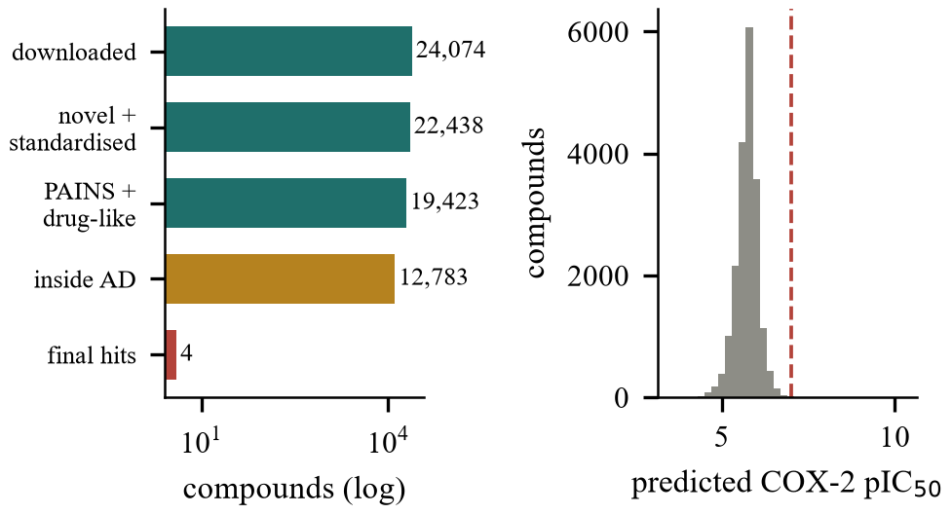
Fig. 9. Screening funnel (left, logarithmic scale) and the distribution of predicted COX-2 potency across the filtered library (right).
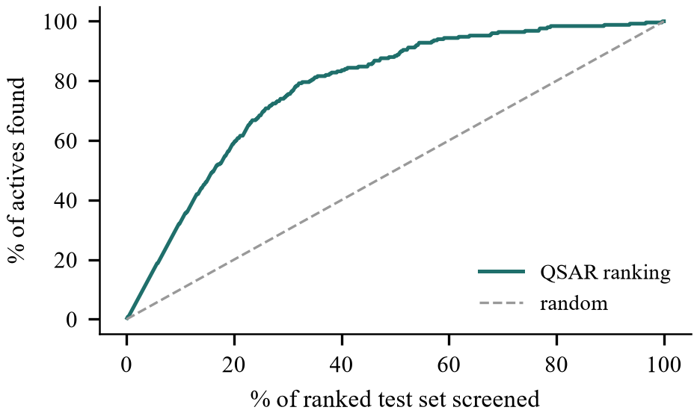
Fig. 10. Retrospective enrichment of the QSAR ranking on the hold-out test set.
Applying the strict criteria of a predicted pIC50 of at least 7.0 together with a predicted selectivity index of at least 1.0 produced only 4 candidates. This small number needs explaining rather than presenting as a result in itself. Support vector regression trained with an epsilon-insensitive loss regresses towards the centre of the training distribution, and the consequence here is visible: predicted values across the scored library span only 4.02 to 7.35, with a median of 5.76, whereas measured training potencies reach 10.70. The model compresses the upper end of the activity range, so a fixed absolute threshold of 7.0 is considerably more stringent in predicted units than the same threshold applied to measured values. The same compression appears in Fig. 5, where the largest residuals fall among the most potent compounds.
For this reason the output is reported as graded tiers (Table 5) rather than as a single cut. The strict tier contains 4 compounds across 4 scaffolds; relaxing the potency threshold to 6.5 gives 83 compounds across 60 scaffolds, and to 6.0 gives 269 compounds across 150 scaffolds. The ratio of scaffolds to compounds remains high in every tier, so the ranked output is not dominated by a single chemotype, which matters if the list is to serve as a starting point for a follow-up programme rather than a set of near-duplicates. The structures of the strict-tier candidates are drawn in Fig. 11.

Table 5: Tiered Virtual Screening Hits
Tier | Criteria | Hits | Scaff. | Drugs | QED
1 (strict) | pred pIC50 >= 7.0 and SI >= 1.0 | 4 | 4 | 2 | 0.79
2 (prioritised) | pred pIC50 >= 6.5 and SI >= 1.0 | 83 | 60 | 11 | 0.69
3 (broad) | pred pIC50 >= 6.0 and SI >= 1.0 | 269 | 150 | 23 | 0.69
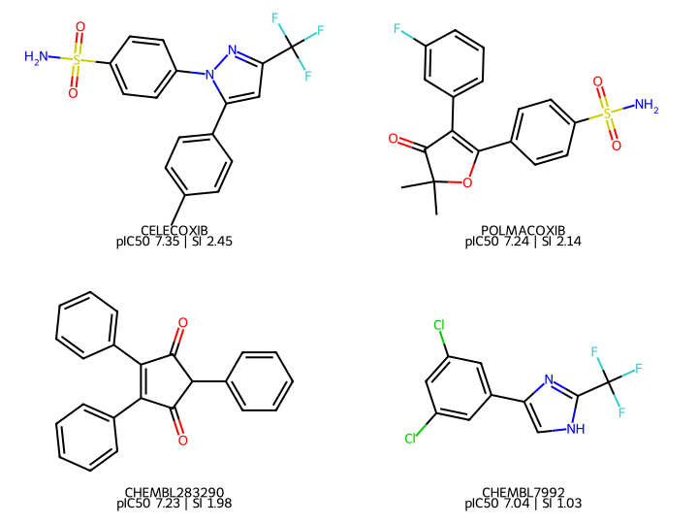
Fig. 11. Structures of the four strict-tier candidates with predicted COX-2 potency and selectivity index (SI).
4.8 Recovery of Known Cyclooxygenase Inhibitors
An external check was carried out that did not depend on the train/test partition at all. A panel of 21 clinically used cyclooxygenase inhibitors was specified in advance, together with the selectivity class each is assigned in the pharmacology literature: selective (the coxibs), preferential (compounds with modest COX-2 preference such as meloxicam, nimesulide, etodolac and diclofenac), and non-selective traditional agents such as ibuprofen, naproxen and aspirin. The class labels were fixed before any prediction was inspected. 14 of these drugs were present in the screened library and had therefore survived the novelty filter, meaning none of them appeared in the training data.
The result is shown in Fig. 10b. Celecoxib ranked first and polmacoxib second out of the 12,783 scored compounds, with predicted selectivity indices of +2.45 and +2.14; rofecoxib ranked 51st with +2.28. The reason these molecules were absent from training follows directly from the curation protocol rather than from any special handling: celecoxib carries 233 exact COX-2 IC50 measurements in ChEMBL spanning 4.23 log units, from pIC50 5.06 to 9.28, so it was removed by the replicate-consistency filter of Section 3.2, and its COX-1 record was excluded for the same reason.
More informative than the ranking is that the predicted selectivity index separates the three pharmacological classes in the correct order. The mean predicted index was +2.29 for the 3 selective coxibs, +0.45 for the 4 preferential agents, and -0.30 for the 7 non-selective drugs, a monotonic ordering across classes. Ketoprofen is a useful individual case: it received a high predicted COX-2 potency of 7.00, placing it sixth in the library, but a clearly negative selectivity index of −1.43, correctly identifying it as COX-1 preferring. A model ranking on potency alone would have promoted it; the selectivity criterion removes it. This is exactly the discrimination the workflow was designed to make.
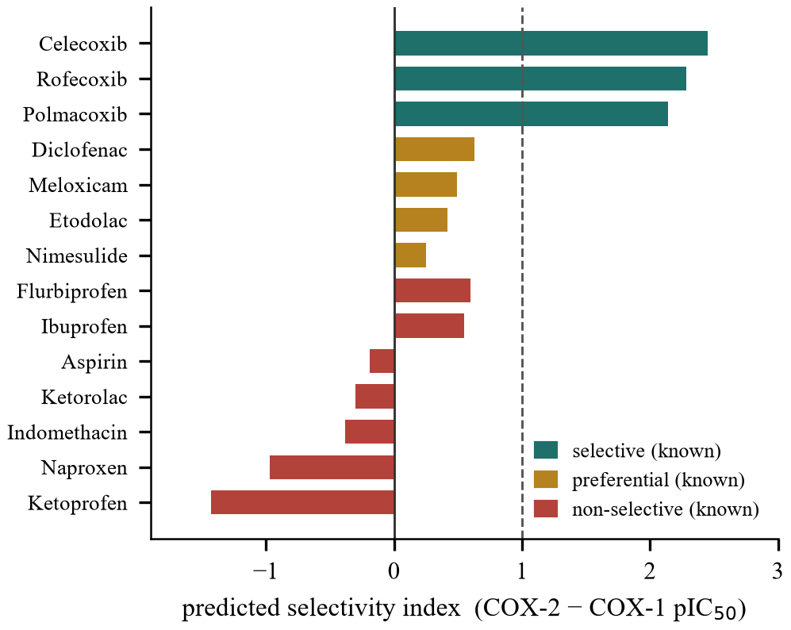
Fig. 10b. Predicted selectivity index for the pre-specified panel of clinically used COX inhibitors recovered from the screening library. None appeared in the training data. Colours denote the known pharmacological class; the dashed line marks tenfold predicted selectivity.
Three qualifications belong with this finding. It is a retrospective recovery of compounds whose activity was already known rather than a prospective discovery. It was possible only because unusually noisy measurement records kept these particular molecules out of the training set, so it cannot be repeated at will. And the agreement is not uniform: several preferential and non-selective agents, including meloxicam, nimesulide and aspirin, received low predicted potencies and ranked in the thousands, so the model recovers the selective chemotypes considerably better than it reproduces the full potency ordering of the panel.
The converse case is also worth reporting rather than omitting. Among named drugs scoring highly for predicted COX-2 potency were several with no established cyclooxygenase indication, including Clopidogrel, Benzyl Benzoate, Drinabant. These are putative false positives. Their presence near the top of the list is a reminder that a ligand-based model scores structural resemblance to known actives, not binding, and that any ranked output of this kind requires experimental triage before it can be acted on.
4.9 In Silico Characterization of the Hits
Fig. 12 compares the physicochemical profile of the prioritised tier (83 compounds) with that of the filtered library. By construction these compounds satisfy the drug-likeness criteria, but the comparison shows where within the permitted ranges they sit. Their median molecular weight is 332 Da, median calculated logP 3.89, median topological polar surface area 62 square Angstroms and median QED 0.69. Relative to the library as a whole they are shifted towards higher lipophilicity and lower polar surface area. This is chemically consistent with the structural basis of COX-2 inhibition, since occupancy of the hydrophobic side pocket that confers selectivity generally requires an additional aromatic or sulfonyl-bearing substituent. It is also a liability worth stating plainly: compounds drifting towards the upper bound of the lipophilicity range tend to have poorer aqueous solubility and a greater risk of promiscuous binding, and this would have to be managed in any optimisation campaign.
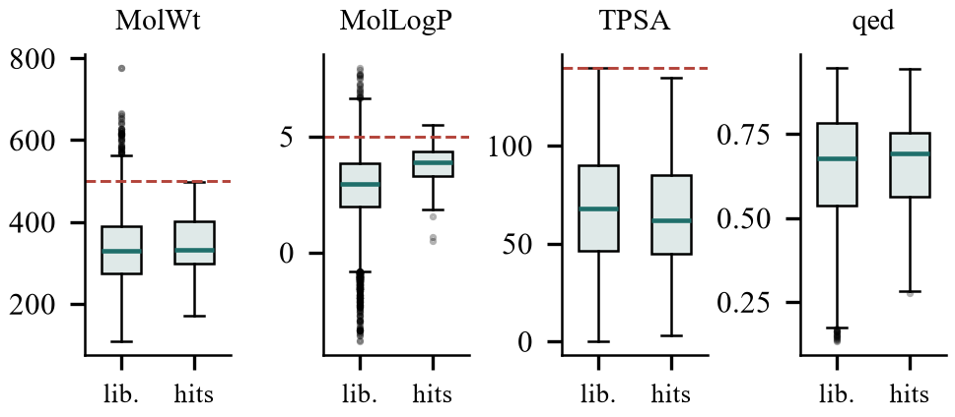
Fig. 12. Physicochemical profile of the prioritised hits compared with the filtered screening library. Dashed lines mark Lipinski and Veber limits.
4.10 Discussion and Limitations
The results support a limited but useful conclusion. A ligand-based QSAR model trained on carefully curated public data can predict COX-2 potency to within roughly 0.7 log units on unseen compounds, retains measurable predictive ability on unseen scaffolds, and ranks compounds well enough to concentrate actives in the top percentiles of a list. Combined with a parallel COX-1 model, it can prioritise candidates on predicted selectivity, which is the property most relevant to the safety record of this drug class.
The recovery of celecoxib and polmacoxib at the top of a 12,783-compound ranking, together with the monotonic ordering of predicted selectivity across the three known pharmacological classes, is the strongest single piece of evidence in this study, because none of those compounds took any part in training. It should not be over-read. It shows that the model recognises established selective chemotypes, which is a weaker claim than being able to identify unfamiliar ones, and the drop in performance under the scaffold-disjoint split points to exactly that limitation.
The limitations are equally important and are stated here rather than left implicit. First, and most fundamentally, every result in this paper is a prediction. No compound was synthesised or assayed, and the reported hits are hypotheses for experimental testing, not demonstrated inhibitors. Second, the training data are aggregated from many laboratories using different assay formats, including whole-blood, enzymatic and cell-based assays, whose absolute values are not strictly comparable; the replicate-consistency filter mitigates but does not remove this heterogeneity. Third, the drop in performance under the scaffold split shows that extrapolation to genuinely new chemotypes is substantially harder than the random-split figure suggests, and the applicability domain restricts the model to compounds resembling its training set. Fourth, the model is ligand-based and has no explicit representation of the binding site, so it cannot reason about the structural origin of selectivity, only about statistical patterns associated with it. Fifth, the in silico characterization covers physicochemical and drug-likeness properties but not absorption, distribution, metabolism, excretion or toxicity endpoints, and COX-2 selectivity alone does not establish cardiovascular safety, as the clinical history of this class demonstrates. Finally, the screening library, although filtered for novelty against the training data, is drawn from ChEMBL and therefore consists largely of compounds previously synthesised for other purposes rather than unexplored chemical space.
- Conclusion
This study presented a reproducible, fully computational workflow for COX-2 inhibitor discovery that combines transparent curation of public bioactivity data, rigorously validated QSAR modelling and filtered virtual screening. From 8,504 COX-2 and 4,488 COX-1 ChEMBL records, 4,204 and 1,604 curated compounds were obtained. A SVR (RBF) model on combined descriptor and fingerprint features predicted COX-2 pIC50 with R² = 0.585 and RMSE = 0.749 log units on a hold-out test set, retained R² = 0.249 under a scaffold-disjoint split, and collapsed to R² = -0.333 under y-randomization, confirming that the relationship learned is genuine.
Applied to 24,074 compounds after novelty, interference, drug-likeness and applicability-domain filtering, the model produced graded candidate tiers, the prioritised tier containing 83 compounds across 60 distinct scaffolds. The strongest external evidence came from a pre-specified panel of clinically used cyclooxygenase inhibitors absent from the training data: celecoxib and polmacoxib ranked first and second out of 12,783 scored compounds, and predicted selectivity separated the known selective, preferential and non-selective classes in the correct order. Explicitly modelling COX-1 alongside COX-2 allowed selectivity to be used as a ranking criterion rather than treated as an afterthought, which is a direct response to the clinical liability that affected the first generation of selective inhibitors.
The natural next step is experimental. The ranked candidates should be tested in enzymatic COX-2 and COX-1 inhibition assays, since only measured data can confirm or refute the predictions, and a confirmed or refuted hit list would in turn improve the model. Useful computational extensions include molecular docking against the COX-2 crystal structure to assess whether high-ranking compounds can physically occupy the selectivity side pocket, explicit ADMET prediction, and conformal or ensemble methods that attach a calibrated confidence interval to each individual prediction rather than a single domain boundary. The curated datasets and complete code are provided so that each of these extensions can start from an identical, verifiable baseline.

- References
- J. R. Vane, “Inhibition of prostaglandin synthesis as a mechanism of action for aspirin-like drugs,” Nature New Biology, vol. 231, no. 25, pp. 232-235, 1971.
- W. L. Smith, D. L. DeWitt, and R. M. Garavito, “Cyclooxygenases: structural, cellular, and molecular biology,” Annual Review of Biochemistry, vol. 69, pp. 145-182, 2000.
- C. A. Rouzer and L. J. Marnett, “Cyclooxygenases: structural and functional insights,” Journal of Lipid Research, vol. 50, pp. S29-S34, 2009.
- R. G. Kurumbail, A. M. Stevens, J. K. Gierse, J. J. McDonald, R. A. Stegeman, J. Y. Pak, D. Gildehaus, J. M. Miyashiro, T. D. Penning, K. Seibert, P. C. Isakson, and W. C. Stallings, “Structural basis for selective inhibition of cyclooxygenase-2 by anti-inflammatory agents,” Nature, vol. 384, no. 6610, pp. 644-648, 1996.
- C. Luong, A. Miller, J. Barnett, J. Chow, C. Ramesha, and M. F. Browner, “Flexibility of the NSAID binding site in the structure of human cyclooxygenase-2,” Nature Structural Biology, vol. 3, no. 11, pp. 927-933, 1996.
- C. Bombardier, L. Laine, A. Reicin, D. Shapiro, R. Burgos-Vargas, B. Davis, R. Day, M. B. Ferraz, C. J. Hawkey, M. C. Hochberg, T. K. Kvien, and T. J. Schnitzer, “Comparison of upper gastrointestinal toxicity of rofecoxib and naproxen in patients with rheumatoid arthritis,” New England Journal of Medicine, vol. 343, no. 21, pp. 1520-1528, 2000.
- R. S. Bresalier, R. S. Sandler, H. Quan, J. A. Bolognese, B. Oxenius, K. Horgan, C. Lines, R. Riddell, D. Morton, A. Lanas, M. A. Konstam, and J. A. Baron, “Cardiovascular events associated with rofecoxib in a colorectal adenoma chemoprevention trial,” New England Journal of Medicine, vol. 352, no. 11, pp. 1092-1102, 2005.
- G. A. FitzGerald, “Coxibs and cardiovascular disease,” New England Journal of Medicine, vol. 351, no. 17, pp. 1709-1711, 2004.
- T. Grosser, S. Fries, and G. A. FitzGerald, “Biological basis for the cardiovascular consequences of COX-2 inhibition: therapeutic challenges and opportunities,” Journal of Clinical Investigation, vol. 116, no. 1, pp. 4-15, 2006.
- C. Hansch and T. Fujita, “ρ-σ-π analysis. A method for the correlation of biological activity and chemical structure,” Journal of the American Chemical Society, vol. 86, no. 8, pp. 1616-1626, 1964.
- A. Cherkasov, E. N. Muratov, D. Fourches, A. Varnek, I. I. Baskin, M. Cronin, J. Dearden, P. Gramatica, Y. C. Martin, R. Todeschini, V. Consonni, V. E. Kuz'min, R. Cramer, R. Benigni, C. Yang, J. Rathman, L. Terfloth, J. Gasteiger, A. Richard, and A. Tropsha, “QSAR modeling: where have you been? Where are you going to?” Journal of Medicinal Chemistry, vol. 57, no. 12, pp. 4977-5010, 2014.
- Y. C. Lo, S. E. Rensi, W. Torng, and R. B. Altman, “Machine learning in chemoinformatics and drug discovery,” Drug Discovery Today, vol. 23, no. 8, pp. 1538-1546, 2018.
- A. Gaulton, L. J. Bellis, A. P. Bento, J. Chambers, M. Davies, A. Hersey, Y. Light, S. McGlinchey, D. Michalovich, B. Al-Lazikani, and J. P. Overington, “ChEMBL: a large-scale bioactivity database for drug discovery,” Nucleic Acids Research, vol. 40, no. D1, pp. D1100-D1107, 2012.
- D. Mendez, A. Gaulton, A. P. Bento, J. Chambers, M. De Veij, E. Felix, M. P. Magarinos, J. F. Mosquera, P. Mutowo, M. Nowotka, M. Gordillo-Maranon, F. Hunter, L. Junco, G. Mugumbate, M. Rodriguez-Lopez, F. Atkinson, N. Bosc, C. J. Radoux, A. Segura-Cabrera, A. Hersey, and A. R. Leach, “ChEMBL: towards direct deposition of bioassay data,” Nucleic Acids Research, vol. 47, no. D1, pp. D930-D940, 2019.
- A. Golbraikh and A. Tropsha, “Beware of q2!” Journal of Molecular Graphics and Modelling, vol. 20, no. 4, pp. 269-276, 2002.
- A. Tropsha, “Best practices for QSAR model development, validation, and exploitation,” Molecular Informatics, vol. 29, no. 6-7, pp. 476-488, 2010.
- C. Rucker, G. Rucker, and M. Meringer, “y-Randomization and its variants in QSPR/QSAR,” Journal of Chemical Information and Modeling, vol. 47, no. 6, pp. 2345-2357, 2007.
- F. Sahigara, K. Mansouri, D. Ballabio, A. Mauri, V. Consonni, and R. Todeschini, “Comparison of different approaches to define the applicability domain of QSAR models,” Molecules, vol. 17, no. 5, pp. 4791-4810, 2012.
- R. D. Cramer, D. E. Patterson, and J. D. Bunce, “Comparative molecular field analysis (CoMFA). 1. Effect of shape on binding of steroids to carrier proteins,” Journal of the American Chemical Society, vol. 110, no. 18, pp. 5959-5967, 1988.
- G. Klebe, U. Abraham, and T. Mietzner, “Molecular similarity indices in a comparative analysis (CoMSIA) of drug molecules to correlate and predict their biological activity,” Journal of Medicinal Chemistry, vol. 37, no. 24, pp. 4130-4146, 1994.
- D. B. Kitchen, H. Decornez, J. R. Furr, and J. Bajorath, “Docking and scoring in virtual screening for drug discovery: methods and applications,” Nature Reviews Drug Discovery, vol. 3, no. 11, pp. 935-949, 2004.
- W. P. Walters, M. T. Stahl, and M. A. Murcko, “Virtual screening - an overview,” Drug Discovery Today, vol. 3, no. 4, pp. 160-178, 1998.
- D. Rogers and M. Hahn, “Extended-connectivity fingerprints,” Journal of Chemical Information and Modeling, vol. 50, no. 5, pp. 742-754, 2010.
- C. Cortes and V. Vapnik, “Support-vector networks,” Machine Learning, vol. 20, no. 3, pp. 273-297, 1995.
- L. Breiman, “Random forests,” Machine Learning, vol. 45, no. 1, pp. 5-32, 2001.
- Organisation for Economic Co-operation and Development, Guidance Document on the Validation of (Quantitative) Structure-Activity Relationship [(Q)SAR] Models. Paris, France: OECD Publishing, 2007.
- J. B. Baell and G. A. Holloway, “New substructure filters for removal of pan assay interference compounds (PAINS) from screening libraries and for their exclusion in bioassays,” Journal of Medicinal Chemistry, vol. 53, no. 7, pp. 2719-2740, 2010.
- C. A. Lipinski, F. Lombardo, B. W. Dominy, and P. J. Feeney, “Experimental and computational approaches to estimate solubility and permeability in drug discovery and development settings,” Advanced Drug Delivery Reviews, vol. 46, no. 1-3, pp. 3-26, 2001.
- D. F. Veber, S. R. Johnson, H.-Y. Cheng, B. R. Smith, K. W. Ward, and K. D. Kopple, “Molecular properties that influence the oral bioavailability of drug candidates,” Journal of Medicinal Chemistry, vol. 45, no. 12, pp. 2615-2623, 2002.
- G. R. Bickerton, G. V. Paolini, J. Besnard, S. Muresan, and A. L. Hopkins, “Quantifying the chemical beauty of drugs,” Nature Chemistry, vol. 4, no. 2, pp. 90-98, 2012.
- G. W. Bemis and M. A. Murcko, “The properties of known drugs. 1. Molecular frameworks,” Journal of Medicinal Chemistry, vol. 39, no. 15, pp. 2887-2893, 1996.
- G. Landrum, “RDKit: open-source cheminformatics,” 2024. [Online]. Available: https://www.rdkit.org
- F. Pedregosa, G. Varoquaux, A. Gramfort, V. Michel, B. Thirion, O. Grisel, M. Blondel, P. Prettenhofer, R. Weiss, V. Dubourg, J. Vanderplas, A. Passos, D. Cournapeau, M. Brucher, M. Perrot, and E. Duchesnay, “Scikit-learn: machine learning in Python,” Journal of Machine Learning Research, vol. 12, pp. 2825-2830, 2011.

