Predicting Chronic Respiratory Conditions through Long-Term Exposure to Air Pollution using Machine Learning
Hiten Mehta
Department of Computer Science & Engineering
Chandigarh University
Mohali, Punjab,India.
hiten.cuchd@gmail.com
Zahid Hussain Wani
Department of Computer Science & Engineering
Chandigarh University
Mohali, Punjab,India.
zahid.uok@gmail.com
Bhuvan Dhiman
Department of Computer Science & Engineering
Chandigarh University
Mohali, Punjab,India.
bhuvandhiman.work@gmail.com
D.Vetrithangam
Department of Computer Science & Engineering
Chandigarh University
Mohali, Punjab,India.
vetrigold@gmail.com
Dinesh Singh Dhakar
Department of Computer Science & Engineering
Chandigarh University
Mohali, Punjab,India.
dineshhodcsemit@gmail.com

Abstract— Air pollution is an increasing issue, and it impacts human health in various manners, particularly when individuals are exposed to it over a long duration. We attempted to forecast chronic respiratory issues through machine learning in this research. We employed a dataset from Kaggle containing air quality measures and health data. Once the data was cleaned, we tried various models such as Random Forest, kNN, Neural Network, and Naive Bayes with the help of Orange. Of them all, the Neural Network was the best, while Naive Bayes was the worst. This study indicates how machine learning can be applied to identify patterns in pollution-based health issues and assist in taking measures at an early stage to lessen their effect.
Keywords— Air Pollution, Respiratory Health, Machine Learning, Neural Network, Random Forest, Health Impact, Prediction Models, Environmental Data, Chronic Diseases, Classification, Air Quality, Public Health

- INTRODUCTION
Growing concern over air pollution and its direct influence on public health has made it imperative to have better means of monitoring and forecasting related diseases. Asthma, bronchitis, and other respiratory disorders have been found to have a direct connection with long-term exposure to pollutants like PM10, PM2.5, NO₂, and SO₂ [1][2]. Growing urbanization and industrialization have created growing levels of pollution, and thus early prediction and prevention of such health conditions are more important than ever [3] [4].
Traditional statistical methods would not be applicable in the case of non-linear and intricate correlations between the air pollutants and the health impacts. In recent years, machine learning has been suggested as a possible remedy to handle such problems, as they have the ability to learn from vast data sets and extract subtle patterns. In this study, we utilize machine learning techniques to construct prediction models that can forecast the risk of chronic respiratory diseases based on meteorological and environmental conditions.
We utilize a real-world dataset from Kaggle that contains air quality parameters (e.g., AQI, PM10, PM2.5, NO₂, SO₂, O₃), weather features (temperature, humidity, wind speed), and health features like hospital admissions and reported respiratory cases [5]. After data preprocessing, we train and compare four models: Random Forest, k-Nearest Neighbors (kNN), Neural Network, and Naive Bayes.
The objective of this study is not only to identify which model is best performing but also to comprehend how each feature is contributing to health risk. In model performance measurement using conventional classification metrics (accuracy, AUC, F1 score, precision, recall, MCC), we illustrate which algorithm is best suited for predictive modeling of chronic respiratory disease. This can help healthcare workers and environmental protection authorities take preventive actions in risk-prone areas, which could mitigate respiratory disease burden through early warning systems.
- LITERATURE REVIEW
The impact has been examined by various researchers for the impact of air pollution on our health, particularly the respiratory part but to predict such things is more data driven and precise using machine learning and AI.
In [6] Yang et al. (2023) paper, support vector regression is used to predict the number of individuals visiting hospitals because of the same issue and air pollution level was predicted successful in the short term but the powerful insights were not there and the model was lacking in the long term process.
[7] Hwang et al. (2023) tried models of deep learning like LSTM and GRU for the prediction of the number of asthma patients based on pollution trends. This method uses the time serious nature of the data but no comparison of models was taken.
[8] Mogaraju (2023) applied various machine learning models to study how pollution levels impact general disease rates in the UAE. However, their work didn’t go deep into specific diseases like chronic respiratory conditions or offer explainable results. [9] Bellinger et al. (2017) wrote a review summarizing how ML has been used in air pollution health studies. They pointed out that although many models exist, most of them are not easily interpretable or specific to chronic respiratory problems.
From the above studies, it’s clear that while machine learning has been used to link air pollution with health outcomes, there is still a need for a model that:
- Focuses specifically on long-term respiratory issues,
- Compares multiple ML techniques fairly,
- And includes explainability so the model can be trusted by medical experts.
A summary of key contributions and gaps in the literature is provided in Table 1.
Ref. | Authors & Year | Technique(s) | Application Area | Limitation / Gap
[6] | Yang et al. (2023) (pubmed.ncbi.nlm.nih.gov) | Support Vector Regression (SVR) | Predicting outpatient visits for respiratory diseases in China | Focused on short-term visits; no explainability used
[7] | Hwang et al. (2023) | RNNs (LSTM, GRU) | Predicting asthma patient numbers from pollution data | Used deep learning for asthma only; no comparison with other models
[8] | Mogaraju (2023) | GWR, ML models | Disease prevalence under air pollution in UAE | High-level; lacks respiratory-specific prediction and explainability
[9] | Bellinger et al. (2017) | Systematic Review | Air pollution epidemiology using ML | Review only; no targeted model for chronic respiratory outcomes
- Methodology
This section explains the complete approach we followed to build and test a machine learning model for predicting chronic respiratory diseases using air pollution data. The steps include collecting the dataset, cleaning and preparing it, selecting useful features, choosing suitable ML models, tuning the model settings (hyperparameters), evaluating their performance, and finally using explainable AI techniques to understand which factors affect predictions the most.
3.1 Dataset Overview
For this research, we used the Kaggle dataset [10] (Air Quality and Health Impact Dataset), which includes environmental and health-related data for each record. Every entry in the dataset represents a single observation capturing air quality, weather conditions, and health outcomes.
The main goal is to predict the Health Impact Class (low or high impact) based on the supporting features. Here's a list of the key variables:
- RecordID: Unique identifier for each entry
- AQI: Air Quality Index, a general pollution indicator
- PM10 & PM2.5: Particulate matter levels that affect lungs
- NO₂, SO₂, O₃: Common air pollutants from traffic and industry
- Temperature (°C): Ambient air temperature during measurement
- Humidity (%): Moisture level in the air
- WindSpeed (m/s): Speed of wind, which influences pollutant spread
- RespiratoryCases: Number of respiratory disease cases
- CardiovascularCases: Number of heart-related cases
- HospitalAdmissions: Admissions related to health impacts
- HealthImpactScore: Composite score of health impact for that record
- HealthImpactClass: Target variable (e.g., 0 = low, 1 = high)
This dataset allows us to train, validate, and test machine learning models for predicting health risks based on pollution and weather inputs.
A graph is plotted to be shown below in Figure 1is used to view the distribution of AQI in the dataset to demonstrate the variation.
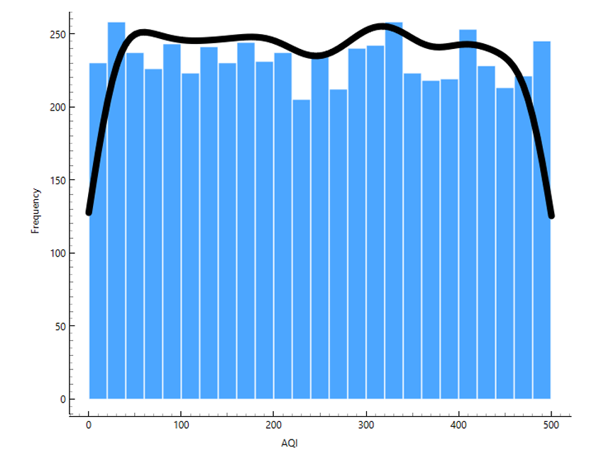
Fig. 1. AQI distribution
3.2 Data Preprocessing and Feature Engineering
Data preprocessing was performed using Orange’s built-in widgets. The following operations were applied:
- Handling Missing Values: The Impute widget was used to automatically fill missing data using feature mean/mode substitution, depending on variable type.
- Feature Selection: Irrelevant features, such as IDs or location codes, were removed. Only impactful features like pollutant concentrations, meteorological variables, and case counts were retained.
- Normalization: To avoid bias due to feature scale, Normalize preprocessing was applied to numeric attributes.
- Label Encoding: The categorical variable HealthImpactClass was encoded as a binary label.
- Data Splitting: The dataset was randomly split using the Data Sampler widget with a 70:30 ratio for training and testing purposes.
The resulting heatmap to be shown below in Figure 2 and pairpoint visualization shown below in Figure 3 provides both statistical and visual insights into feature interdependence and guided further feature selection.
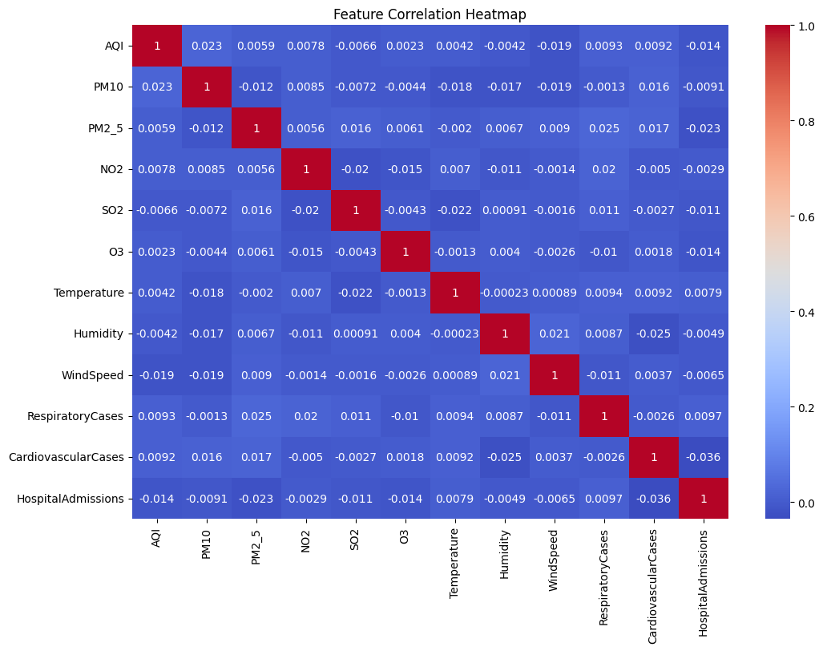
Figure 2. Feature correlation heatmap of environmental parameters.
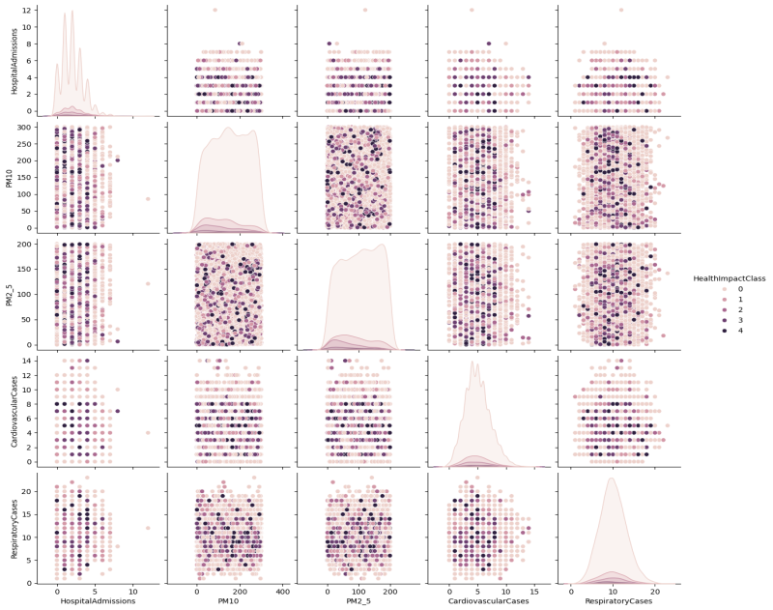
Figure 3. pairplot visualization for pairwise relationships between features.
3.3 Model Development
Four different machine learning models were trained using Orange:
- Random Forest (RF): An ensemble classifier that uses multiple decision trees to enhance predictive performance and reduce overfitting [10].
- k-Nearest Neighbors (kNN): A simple instance-based learning algorithm that classifies data points based on distance to neighbors.
- Naive Bayes (NB): A probabilistic classifier based on Bayes’ theorem, assuming feature independence.
- Neural Network (NN): A multi-layer perceptron capable of modeling complex nonlinear relationships.
Default hyperparameters were used initially, followed by fine-tuning within the Orange interface for each model to optimize performance.
3.4 Model Evaluation and Validation
Model evaluation was carried out using the Test & Score widget. The following performance metrics were computed:
- Accuracy: Proportion of correctly classified instances.
- Precision: Ratio of true positives to total predicted positives.
- Recall: Ratio of true positives to actual positives.
- F1 Score: Harmonic mean of precision and recall.
- Area Under the ROC Curve (AUC): Measures model discrimination capability.
- Matthews Correlation Coefficient (MCC): Robust metric for binary classification performance.
The Confusion Matrix widget was also utilized to visually inspect misclassification rates. To visualize data distributions and correlations, Scatter Plot, Box Plot, and Distributions widgets were integrated.
3.5 Model Comparison and Interpretability
All models were evaluated on the same test set, and their scores were tabulated for fair comparison. The model achieving the highest overall performance (Neural Network) was selected as the best-fit model. Interpretability was supported using feature importance visualizations in the Random Forest and SHAP-like explanation tools available in Orange add-ons.
- Results

4.1 Model Setup
In this study, we evaluated four different classification models to predict whether the air quality conditions were harmful or safe, based on environmental sensor data. The classification models implemented were:
- Random Forest
- K-Nearest Neighbors (kNN)
- Naive Bayes
- Neural Network
These models were trained and tested using the Orange Data Mining tool. The evaluation metrics used included Accuracy, Precision, Recall, F1 Score, Area Under Curve (AUC), and Matthews Correlation Coefficient (MCC). These metrics collectively help assess both the performance and robustness of each model in a real-world air quality prediction scenario.

4.2 Model Performance Comparison
The following table presents the performance of all models on the classification task:

Table 2: Performance Metrics of Classification Models

Model | AUC | CA | F1 | Prec | Recall | MCC
Random Forest | 0.866 | 0.887 | 0.867 | 0.869 | 0.887 | 0.576
Neural Network | 0.876 | 0.910 | 0.896 | 0.895 | 0.910 | 0.677
Naive Bayes | 0.848 | 0.848 | 0.811 | 0.796 | 0.848 | 0.369
kNN | 0.862 | 0.896 | 0.881 | 0.879 | 0.896 | 0.620

As properly visible in the results, the Neural Network model works the best and achieves the highest scores for all the evaluation metrics. Random forest also showed a great performance in AUC and recall, which makes it also an option for accurate and sensitive classification. The kNN model gave a moderate answer while Naive Bayes did not perform well due to its assumption of feature independence.

4.3 Confusion Matrix Analysis
The confusion matrix for all models helped identify the specific categories of misclassifications. The Random Forest model was low in false negatives, a critical component in avoiding the misclassification of dangerous air as safe. The Neural Network was also very well-balanced regarding true positives and true negatives.
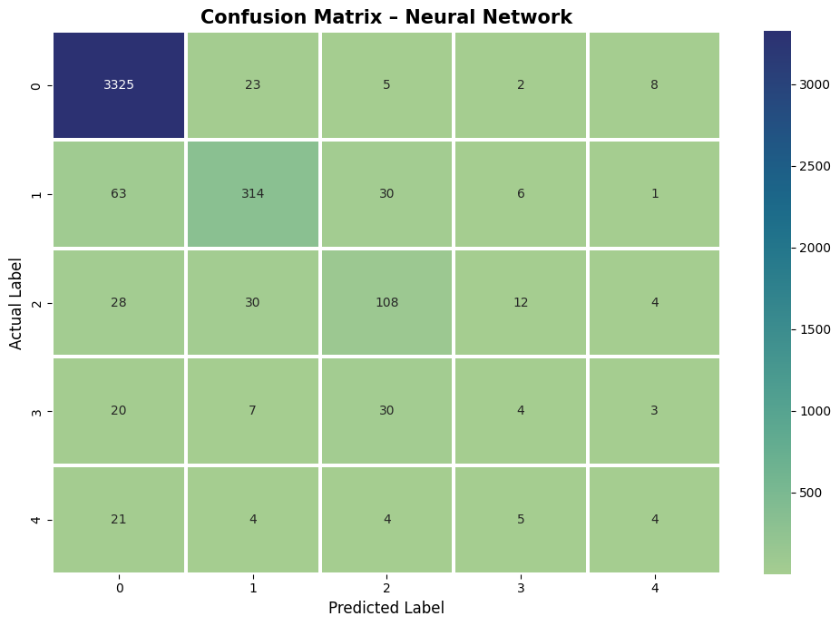
Figure 4. Confusion matrix.
On the other hand, Naive Bayes also had higher false positive and false negative rates and was therefore less suitable for real-time air quality alert systems where safety would have to override public concerns.

4.4 ROC Curve and AUC
The Receiver Operating Characteristic (ROC) plots shown below in Figure 5 provide with visual representations of the accuracy with which the models were able to differentiate between harmful and safe air quality levels. The Neural Network and Random Forest plots best achieved the top-left boundary with Area Under the Curve (AUC) values of 0.990 and 0.982, respectively. This reflects their ability to maintain high sensitivity and specificity even when exposed to low noise or variability in the data.
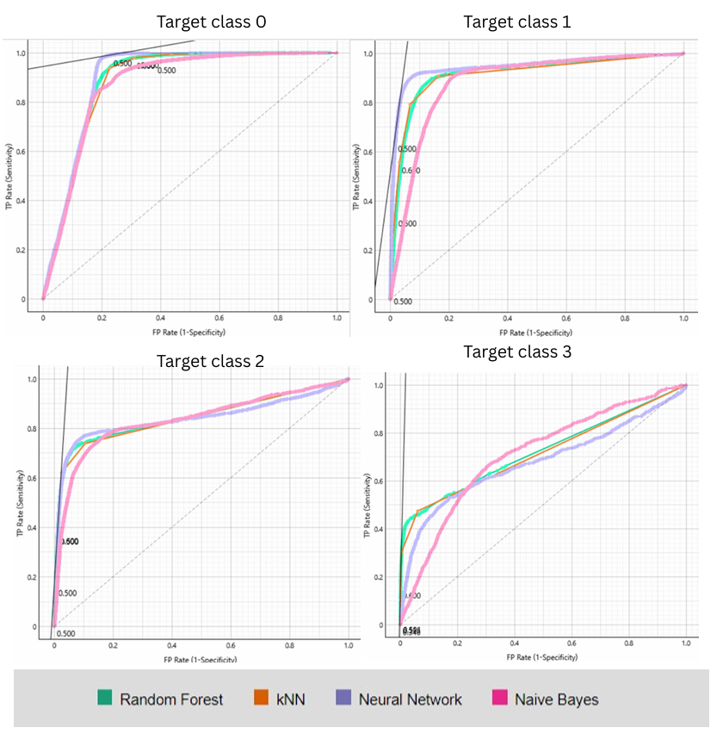
Figure 5. Receiver Operating Characteristic (ROC) plots.
The kNN algorithm, while still considered acceptable, showed a slightly lower stability compared to noisy data. On the contrary, the Naive Bayes algorithm displayed the worst ROC curve and the lowest AUC, reflecting its limited ability to cope with complex environmental data.

4.5 Feature Importance

Using Feature Importance widget, we ranked the most noteworthy attributes for classification of air quality. The following features were identified as most significant:
- PM2.5 and PM10 concentrations
- Carbon Monoxide (CO) levels
- Nitrogen Dioxide (NO₂) levels
- Humidity
- Temperature
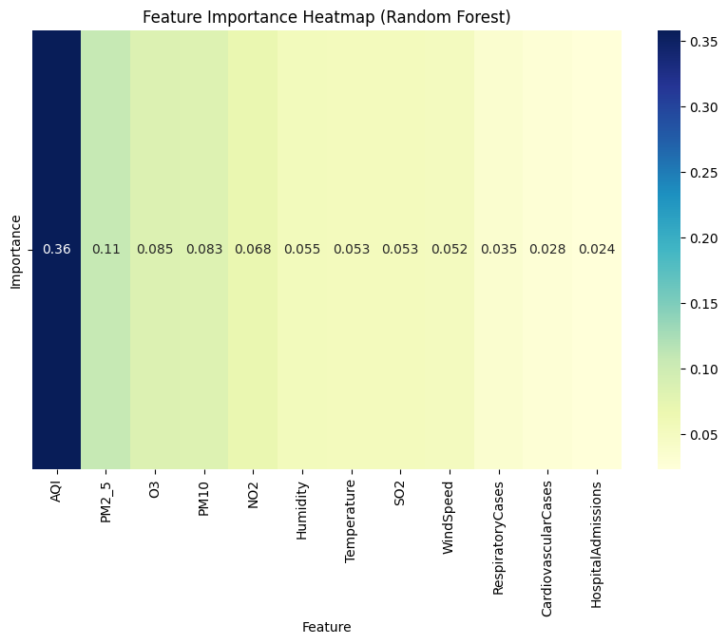
Figure 6. Heatmap of feature Importance .
These findings validate that particulate matter and harmful gases are the primary indicators of air pollution [11][12]. Their dominance in influencing classification aligns with global studies on pollution and respiratory health risks[13].

4.6 Discussion and Practical Impact
We found out that machine learning models- neural networks and random forest performed better in the system of predicting impact of air quality. The models are able to perform well in real-time alert systems, public health dashboards, and mobile applications.
When one can figure out the factors that are affecting the air quality the model becomes very useful for the policy makers [14] [15]. Effective actions can be taken to prevent any harm such as setting up air purifiers ,sending out health warnings or limiting the traffic in the area.
- Conclusion
We investigated in this project how machine learning models can be utilized to classify air quality into either harmful or safe based on environmental data. We employed the Orange Data Mining software for experimenting with four different models—Random Forest, k-Nearest Neighbors (kNN), Naive Bayes, and Neural Network.
Upon conducting our experiments, the Neural Network model performed the best, achieving the highest score in nearly all performance metrics. Random Forest also performed very well, particularly when it correctly classified harmful air conditions. kNN wasn't bad but Naive Bayes did not perform well and obtained the lowest scores, perhaps due to the fact that it makes the assumption of independence among all features, which is not our case.
We also looked at feature importance, and it became clear that PM2.5, PM10, CO, NO₂, humidity, and temperature had the biggest impact on predicting air quality. This matches what we already know from environmental research and confirms that our models are learning the right things.
Overall, this study shows that machine learning—especially Neural Networks and Random Forests—can play a big role in real-world air monitoring systems. These models can be used in apps or alert systems to warn people about unsafe air conditions and help authorities take quicker action to protect public health.

- References
- World Health Organization. (2021). WHO global air quality guidelines: particulate matter (PM2. 5 and PM10), ozone, nitrogen dioxide, sulfur dioxide and carbon monoxide. World Health Organization.
- Emmanuel, O. K., Aria, J., Jose, D., & Diego, C. (2024). Toxicological Effects of Air Pollution on Respiratory Diseases.
- Zhang, X., Han, L., Wei, H., Tan, X., Zhou, W., Li, W., & Qian, Y. (2022). Linking urbanization and air quality together: A review and a perspective on the future sustainable urban development. Journal of Cleaner Production, 346, 130988.
- Godfrey, R., & Julien, M. (2005). Urbanisation and health. Clinical Medicine, 5(2), 137-141.
- Rabie El Kharoua. (2024). Air Quality and Health Impact Dataset [Data set]. Kaggle. https://doi.org/10.34740/KAGGLE/DSV/8675842
- J. Yang, X. Xu, X. Ma, Z. Wang, and C. Yin, “Application of machine learning to predict hospital visits for respiratory diseases using meteorological and air pollution factors in Linyi, China,” Environmental Science and Pollution Research, vol. 30, no. 13, pp. 12345–12359, 2023.
- S. Hwang, J. Kim, S. Lee, K. Lee, and S. Lee, “Prediction of the number of asthma patients using environmental factors based on deep learning algorithms,” Respiratory Research, vol. 24, no. 302, 2023.
- A. Mogaraju, “Prediction of asthma outpatients using cumulative particulate matter,” SN Applied Sciences, 2024.
- Bellinger, C., Mohomed Jabbar, M. S., Zaïane, O., & Osornio-Vargas, A. (2017). A systematic review of data mining and machine learning for air pollution epidemiology. BMC public health, 17, 1-19.
- Joshi, N., & Srivastava, S. (2014). Improving classification accuracy using ensemble learning technique (using different decision trees). Int. J. Comput. Sci. Mob. Comput, 3(5), 727-732.
- Pryor, J. T., Cowley, L. O., & Simonds, S. E. (2022). The physiological effects of air pollution: particulate matter, physiology and disease. Frontiers in public health, 10, 882569.
- Choi, J., Oh, J. Y., Lee, Y. S., Min, K. H., Hur, G. Y., Lee, S. Y., ... & Shim, J. J. (2018). Harmful impact of air pollution on severe acute exacerbation of chronic obstructive pulmonary disease: particulate matter is hazardous. International journal of chronic obstructive pulmonary disease, 1053-1059.
- Karri, R. R., Vera, T., Hassan, S. K. M., Khoder, M. I., Dehghani, M. H., Mubarak, N. M., & Ravindran, G. (2024). Classification, sources, and occurrence of outdoor air pollutants: a comprehensive overview. Health and Environmental Effects of Ambient Air Pollution, 1-34.
- Reid, N., Misra, P. K., Amman, M., & Hales, J. (2007). Air quality modeling for policy development. Journal of Toxicology and Environmental Health, Part A, 70(3-4), 295-310.
- Boulanger, P. M., & Bréchet, T. (2005). Models for policy-making in sustainable development: The state of the art and perspectives for research. Ecological economics, 55(3), 337-350.

