Task Block 2 - Multi-Agent System Report
Kopilkin Multi-Agent Financial Assistant
Mubarakov Islam

1. Project overview
Kopilkin is a mobile-first personal finance web application. Users can register, log in, add income and expense transactions, create savings goals, and ask an AI assistant questions about their spending. For Task Block 2, the project was extended with a multi-agent AI system that helps users understand where their money goes and gives practical saving advice based on real transaction data.

2. Agent specification
The assistant is an integrated multi-agent system, not a set of disconnected bots. It uses routing and chaining between specialized agents.
Agent | Responsibility
Orchestrator Agent | Coordinates memory search, routing, agent execution, response creation, and memory saving.
Router Agent | Chooses analyst or advisor path.
Analyst Agent | Retrieves real transaction summary and explains spending patterns using actual numbers.
Advisor Agent | Uses analyst output and gives practical data-grounded saving advice.

3. LLM engine and model comparison
Ollama was selected as the local LLM engine because it is simple to install, supports local open-source models, and provides an HTTP API for FastAPI integration. The instructor did not require a specific model; the requirement was to compare lightweight local models.
Criteria | llama3.2:3b | qwen2.5:3b | gemma3:4b
Context understanding | General topic understood | Wrong: assumed user owns a cafe | Correct: personal expenses
Russian quality | Mixed languages, unstable phrasing | Good Russian, wrong context | Good Russian
Usefulness | Low | Low | High
Hallucinations | Present | Present | Minimal in this test
Final decision | Not selected | Not selected | Selected
Final choice: gemma3:4b. It gave the best balance between context understanding, Russian language quality, useful financial advice, and low hallucination tendency.
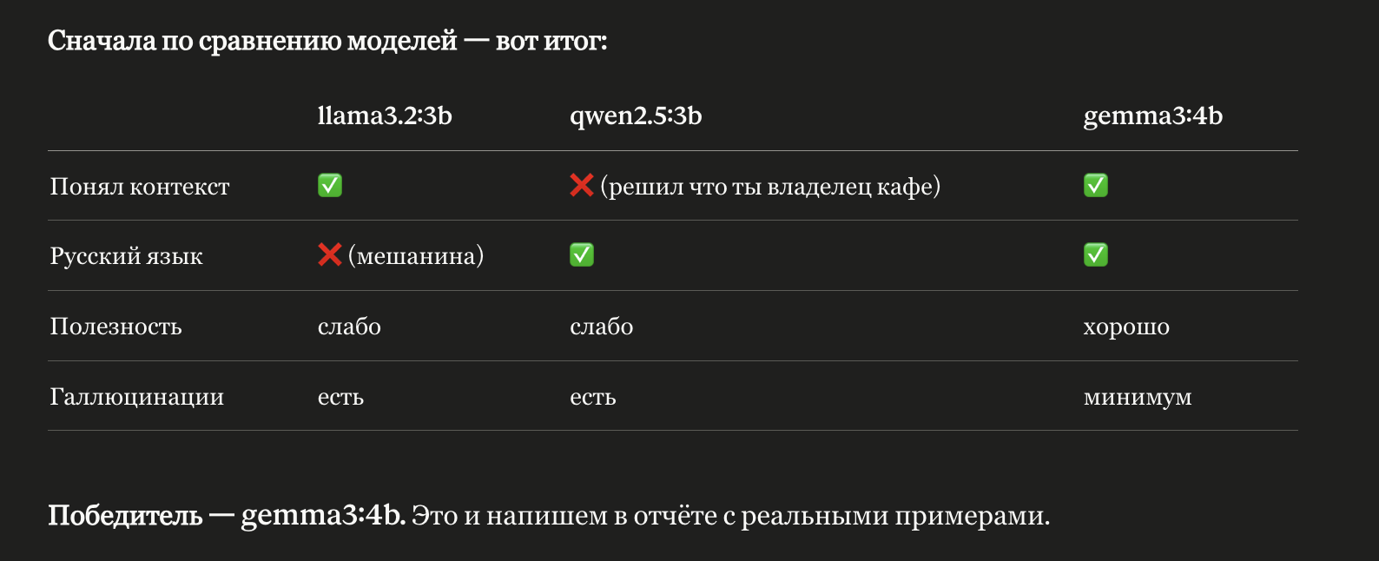

4. Multi-agent architecture and diagrams
Main flow: User -> Frontend AI Chat -> Agent Service /chat -> Orchestrator -> Memory Search -> Router Agent -> Analyst Agent -> Advisor Agent if advice is needed -> Memory Save -> Response.
C4 L1 - Kopilkin with Multi-Agent AI Assistant
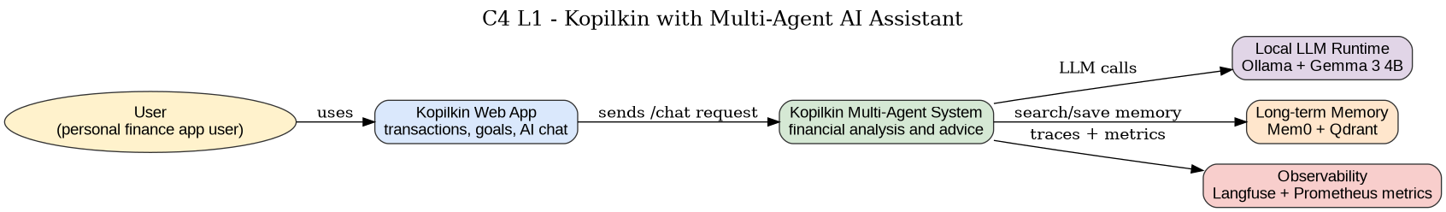
C4 L2 - Multi-Agent System Containers
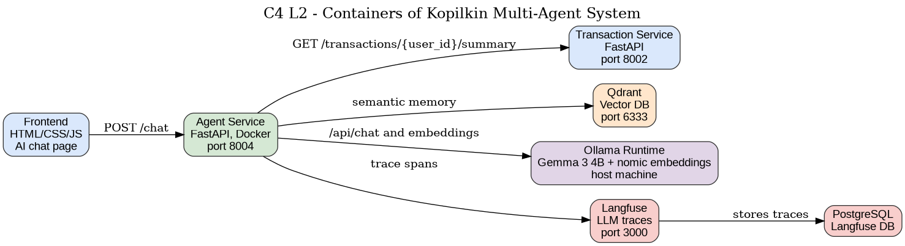
C4 L3 - Agent Service Components
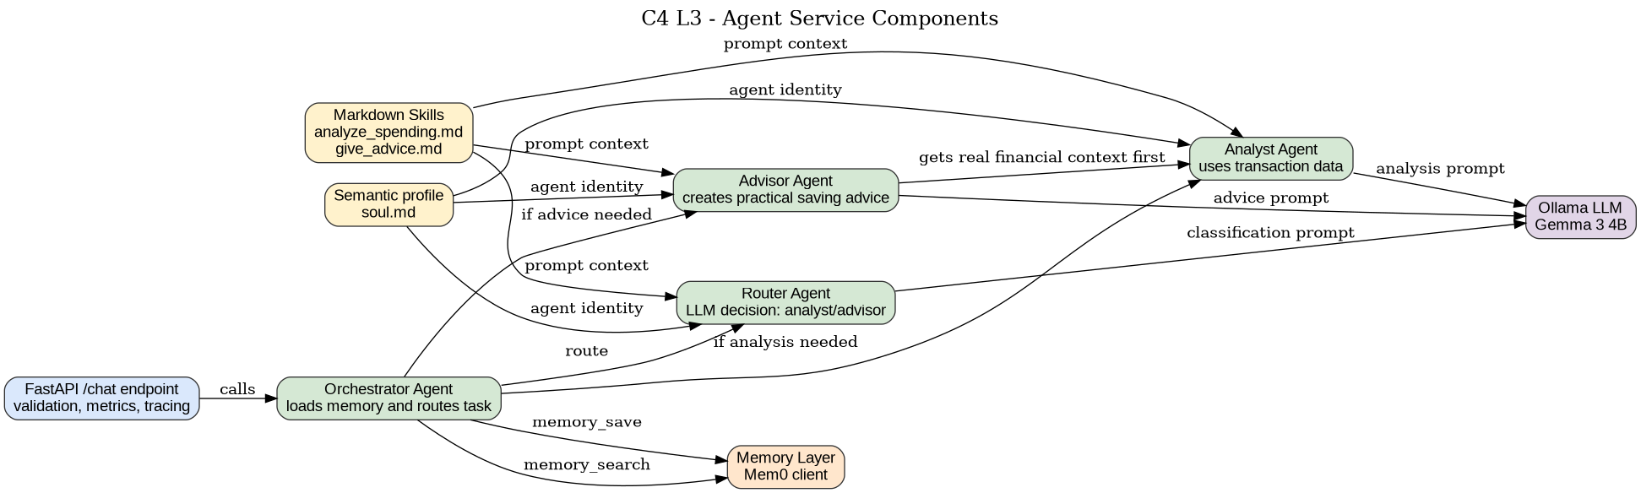
AI Chat Flow / Sequence Diagram

5. Isolation strategy
The agent-service, Qdrant, Langfuse, and Langfuse PostgreSQL database are containerized with Docker Compose. Ollama remains on the host machine and is accessed through host.docker.internal:11434. This hybrid setup is practical for student hardware because model execution depends on local model files and host resources.
Option | Decision
No isolation | Rejected: not reproducible and unsafe for dependencies.
Python venv | Not enough: does not isolate databases/services.
Docker containers | Selected: lightweight and reproducible.
Full VM | Too heavy for local student hardware.
Kubernetes | Future option, not necessary for local MVP.

6. Prompts, skills, and semantic Markdown
System prompts are implemented in agent-service/app/prompts/system_prompts.py. Skills are defined in agent-service/app/skills/analyze_spending.md and give_advice.md. The semantic identity file soul.md defines the role, character, limitations, and language behavior. A skill_loader.py file was added so these Markdown files can be loaded into prompt context.

7. Memory management
The system uses Mem0 + Qdrant + Ollama embeddings. Mem0 manages memory search/save operations, Qdrant stores vectors in the kopilkin_memory collection, and Ollama nomic-embed-text is used for embeddings. Memory is filtered by user_id.
Option | Advantages | Drawbacks | Decision
Classic RAG | Simple document retrieval | Not ideal for evolving personal memory | Not selected
Mem0 | Easy user/session memory | Less explainable than graph memory | Selected
Zep | Good conversation memory | More backend setup | Considered
Letta / MemGPT | Advanced stateful agents | Too complex for MVP | Considered
Graphiti | Temporal knowledge graph | Heavier implementation | Future improvement
LlamaIndex | Strong retrieval framework | More document-oriented | Considered
Classic RAG is not optimal here because Kopilkin needs evolving user-specific memory across conversations, not only retrieval from static documents.

8. Evaluations
The project includes evals/test_cases.json, evals/run_evals.py, and evals/README.md. The runner sends predefined prompts to /chat and saves a JSON report.
Metric | Meaning
Routing accuracy | Whether the orchestrator selects Analyst/Advisor correctly.
Groundedness | Whether the answer references real transaction data.
Hallucination rate | Whether the model invents non-existing facts or numbers.
Language consistency | Whether response language follows user language.
Tool success rate | Whether Transaction Service calls succeed.
Memory relevance | Whether retrieved memories are useful.
Latency | How long /chat takes.
Error rate | Percentage of failed chat requests.

9. Observability
Langfuse traces the chat endpoint, orchestrator, memory search, router agent, analyst agent, transaction service call, advisor agent, and memory save. The Agent Service also exposes a Prometheus-compatible /metrics endpoint and structured logs.
Implemented item | Status
Langfuse traces | Implemented and working.
/metrics endpoint | Implemented in agent-service.
Structured logs | Implemented in agent-service.
Full alerting | Planned improvement.
Evidence screenshot: Langfuse trace detail.
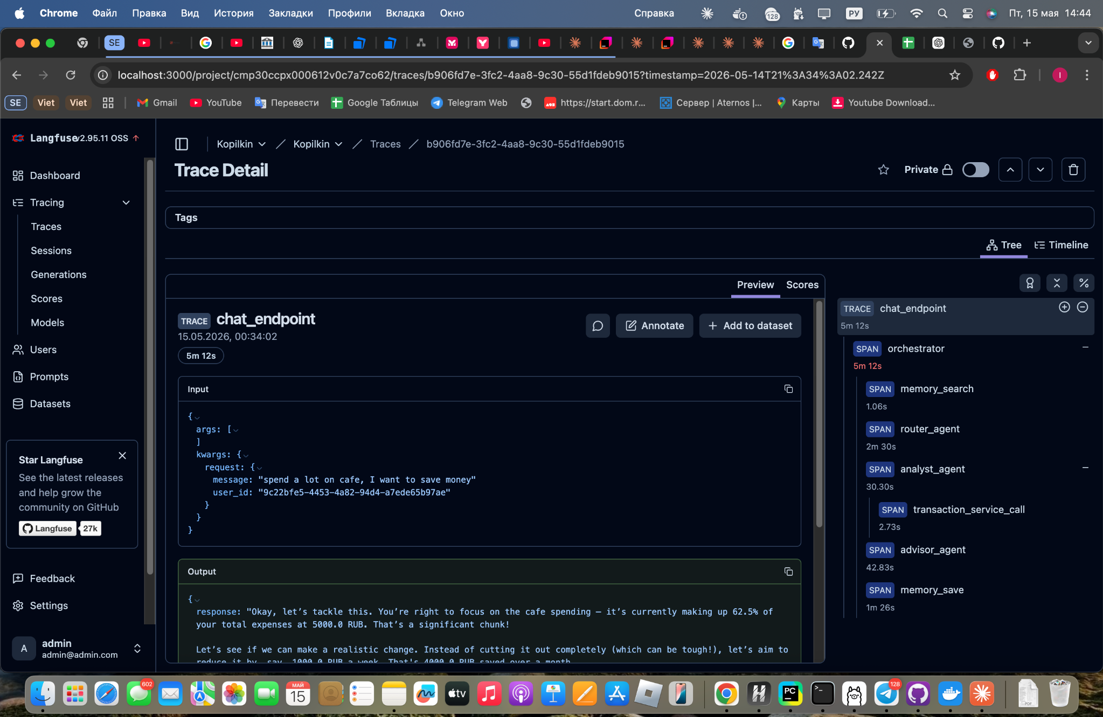

11. Conclusion
The Kopilkin project now includes a working multi-agent AI system with local LLM execution, Docker-based isolation, long-term memory, semantic skills, system prompts, LLM comparison, evaluation files, and observability through Langfuse and metrics. The selected model is gemma3:4b because it performed best in local tests. The current implementation is suitable for MVP demonstration and oral defense, while production improvements would include stronger alerting, persistent databases, stronger secret management, and more advanced memory evaluation.

