

Microservices, AI Assistant, gRPC, Kafka, Worker, Tests and Documentation

Student Name
Mubarakov Islam
Group
11-314a
Assignment
3rd task series (2nd semester)
GitHub Repository
https://github.com/iz-mv/Kopilkin

Kopilkin Full Project Report
Microservices, AI Assistant, gRPC, Kafka, Worker, Tests and Documentation

Student Name | Mubarakov Islam
Group | 11-314a
Assignment | 3rd task series (2nd semester)
Project | Kopilkin Personal Finance Application
GitHub Repository | https://github.com/iz-mv/Kopilkin

Full Project Report

English Part

1. Project Overview
Kopilkin is a mobile-first personal finance web application implemented as a microservice-oriented system. Users can register and log in, track income and expenses, create savings goals, upload profile and goal images, ask an AI assistant for financial analysis, and receive smart recommendations. The final version of the project demonstrates not only separate FastAPI services, but also service-owned PostgreSQL databases, Redis caching and synchronization, Kafka-based event-driven processing, gRPC communication, MinIO object storage, AI observability and integration tests.
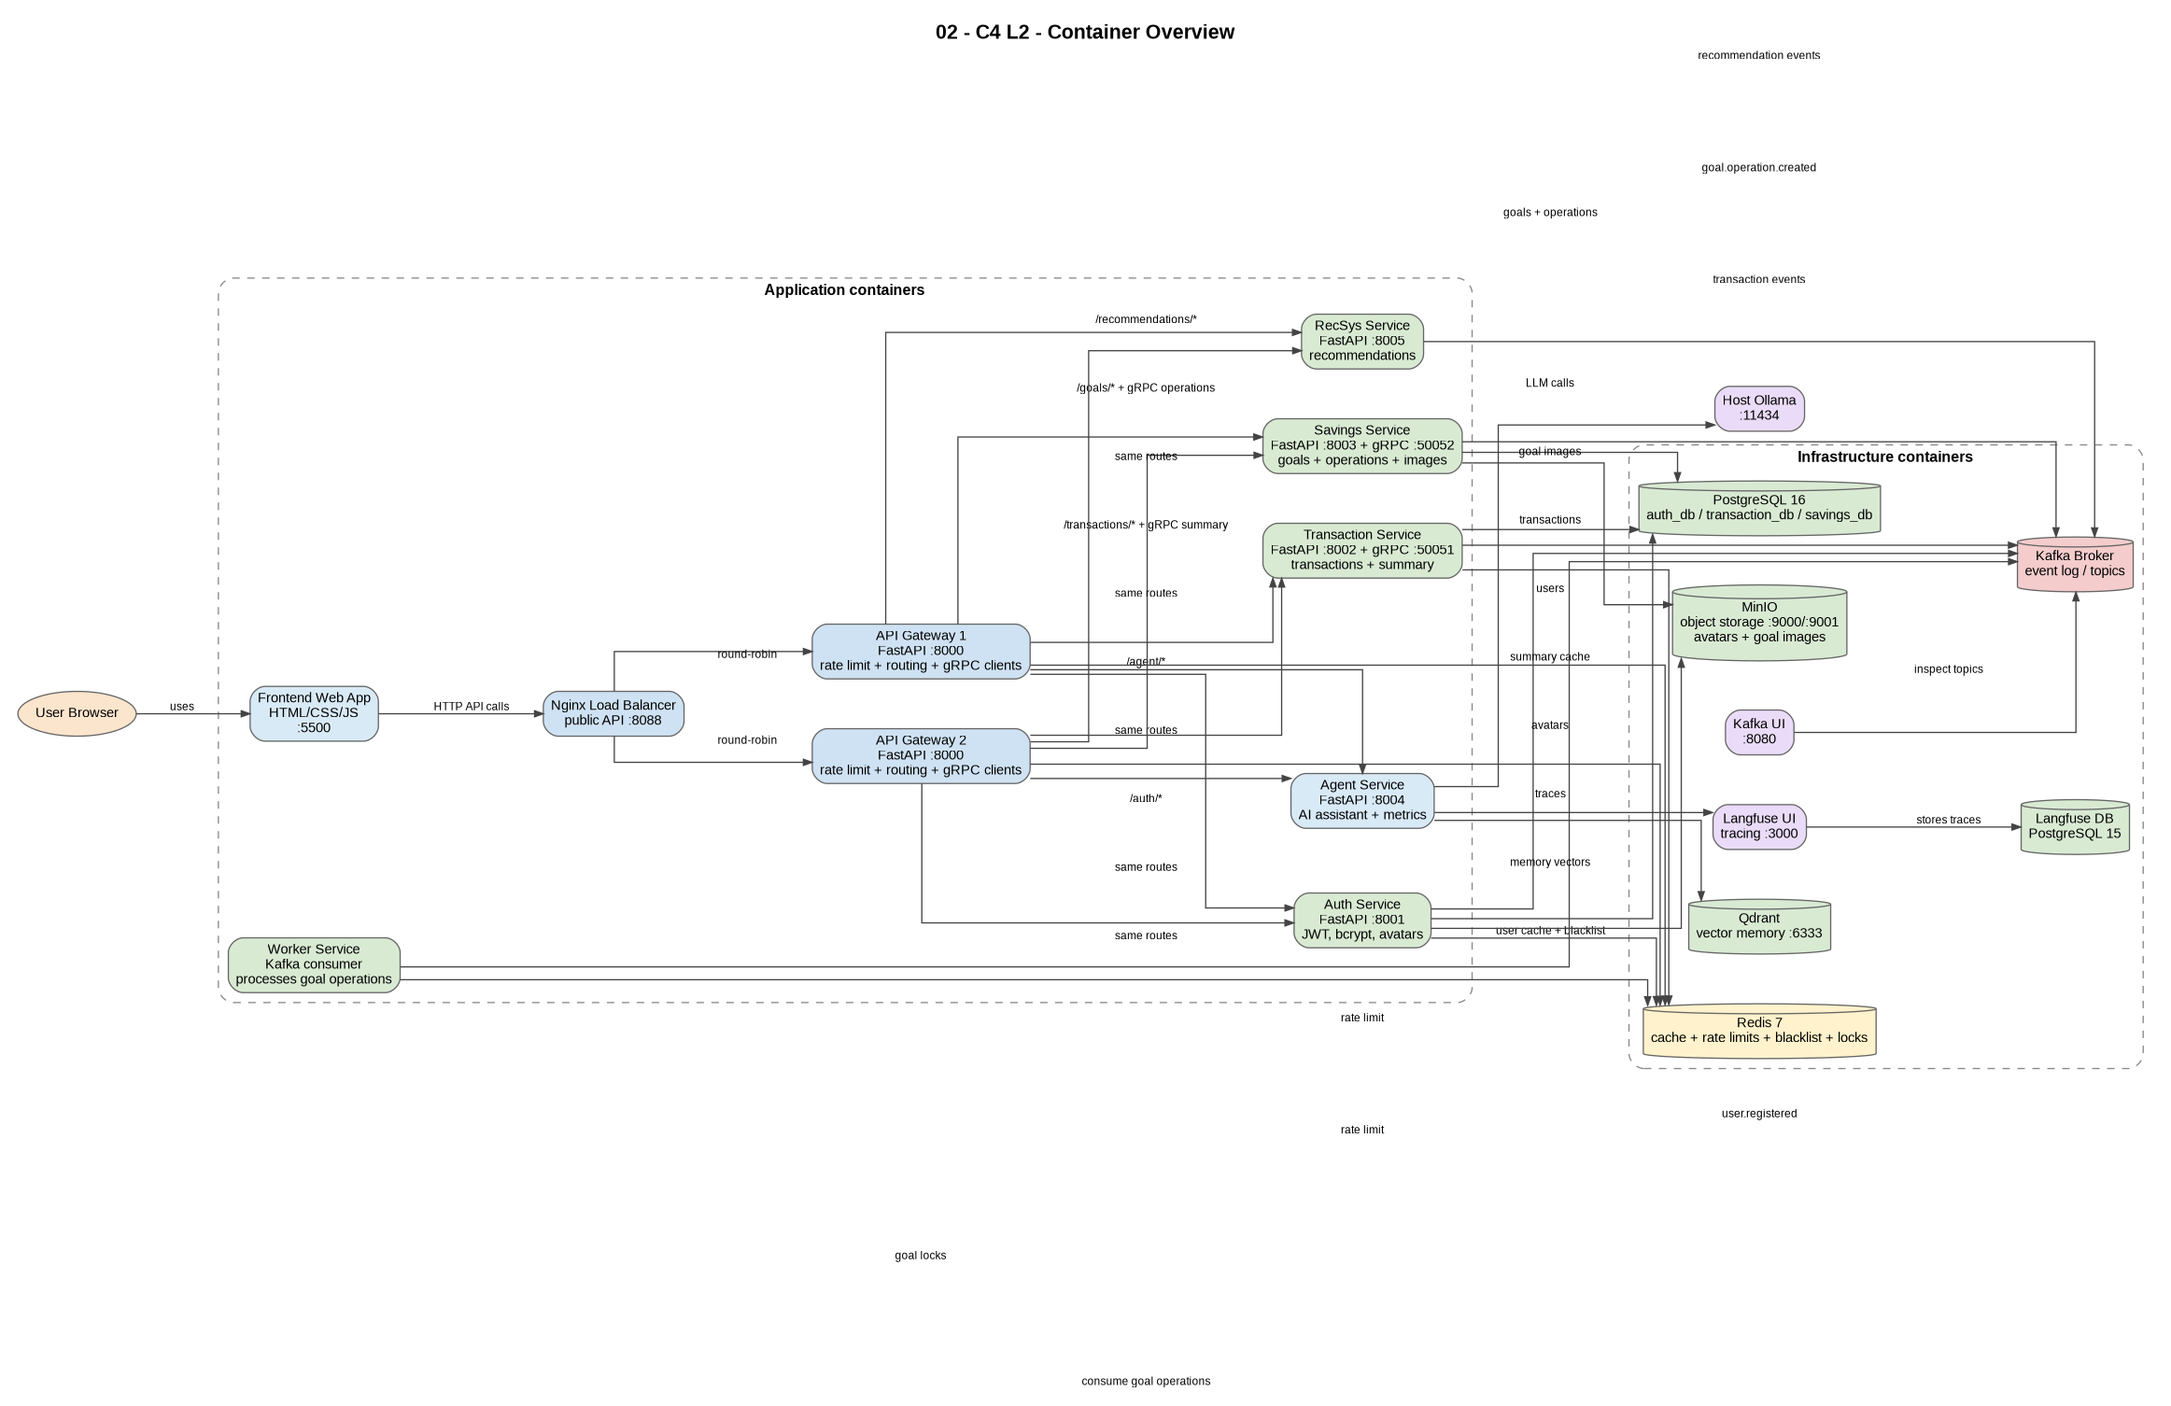
Figure 1. Final container-level architecture overview.

2. Final Scope and Requirements Mapping
Requirement / Area | Final implementation | Evidence in project
Kafka / EDA | Kafka broker, Kafka UI, domain events and a real worker consumer for goal operations. | docker-compose.yml; events.py files; worker-service/app/main.py
RDBMS + NoSQL / storage | PostgreSQL databases for business data, MinIO for files, Qdrant for AI memory, Redis for short-lived data, Kafka as event log. | infra/postgres/init.sql; service models.py; MinIO/Qdrant/Redis/Kafka containers
Redis caching / coordination | User profile cache, transaction summary cache, API Gateway rate limits, JWT blacklist, goal operation locks. | auth-service/app/cache.py; transaction-service/app/cache.py; api-gateway/app/main.py; worker-service/app/main.py
Routing layer | Frontend calls Nginx on port 8088; Nginx balances traffic to two API Gateway instances; gateways route to internal services. | infra/nginx/nginx.conf; api-gateway/app/main.py; docker-compose.yml
gRPC communication | API Gateway uses gRPC for transaction summary and goal operation creation. | proto/transaction.proto; proto/savings.proto; grpc_server.py; api-gateway/app/grpc_client.py
Worker service | Asynchronous processing of goal operations from Kafka with Redis locking and transaction mirroring. | worker-service/app/main.py; topic goal.operation.created
Object storage | User avatars and goal images are uploaded to MinIO; PostgreSQL stores only URLs. | auth-service/app/storage.py; savings-service/app/storage.py
AI assistant | Agent service uses local Ollama, Qdrant memory and Langfuse traces; it reads transaction data for financial analysis. | agent-service/app/main.py; analyst_agent.py; system_prompts.py
Recommender system | Separate RecSys microservice reads transactions and produces financial recommendations. | recsys-service/app/main.py
Testing | 12 integration tests verify real Docker Compose service flows. | tests/ directory; pytest output: 12 passed

3. Microservice Architecture
The system uses a set of independently deployable FastAPI services. The frontend communicates with a single public endpoint, while the internal services communicate through REST, gRPC, Kafka and shared infrastructure components. The API Gateway hides internal service ports from the frontend and applies Redis-based rate limiting. Two gateway instances are placed behind Nginx to demonstrate load balancing.
Service | Role | Port / interface
frontend | Browser user interface | 5500
nginx-balancer | Public entry point and load balancer | 8088
api-gateway-1 / api-gateway-2 | Routing, rate limiting, gRPC clients | internal 8000
auth-service | Users, JWT, bcrypt, Redis blacklist, avatars | 8001
transaction-service | Transactions, summaries, cache, Transaction gRPC server | 8002 / 50051
savings-service | Goals, images, GoalOperation, Savings gRPC server | 8003 / 50052
worker-service | Kafka consumer and async operation processor | internal
agent-service | AI assistant, memory, traces, metrics | 8004
recsys-service | Financial recommendations | 8005
PostgreSQL / Redis / Kafka / MinIO / Qdrant / Langfuse | Infrastructure layer | various ports

4. Data Architecture
Kopilkin follows the database-per-service idea at the logical database level. Auth, transaction and savings data are separated into different PostgreSQL databases. Object files are not stored inside relational tables; MinIO stores avatars and goal images, while PostgreSQL keeps only the resulting public URLs. Redis is used where low-latency temporary data is needed, and Qdrant stores AI vector memory.
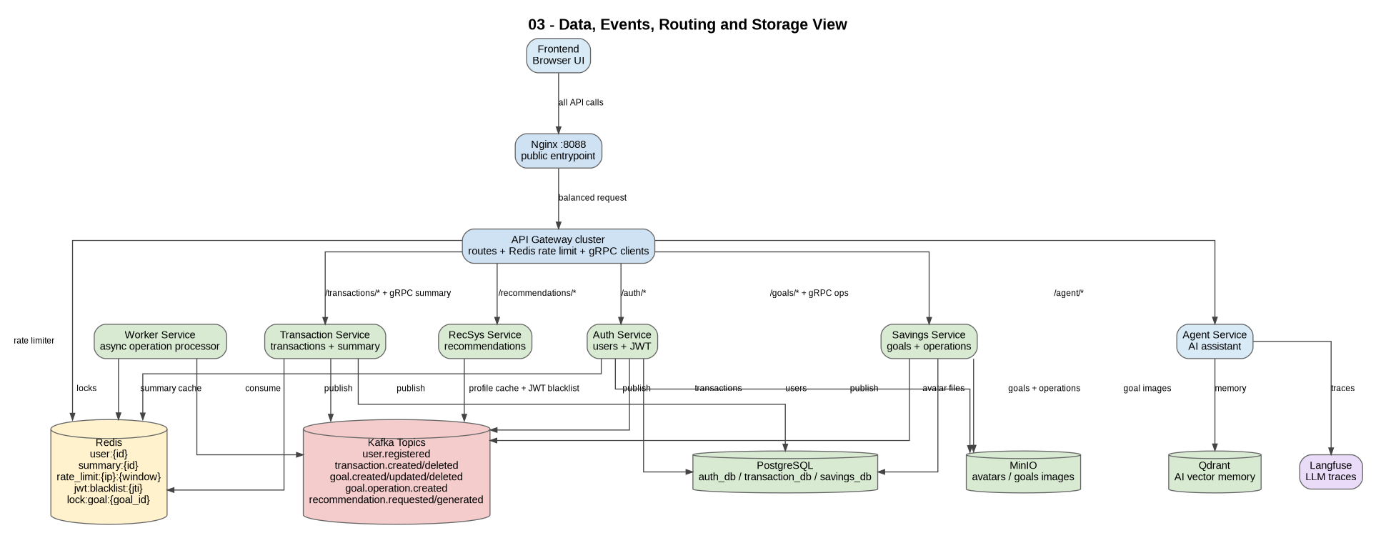
Figure 2. Data, events, routing, cache and object storage view.
Data | Storage | Owner / Reason
Users | PostgreSQL auth_db.users | Owned by auth-service; structured user data and uniqueness.
Transactions | PostgreSQL transaction_db.transactions | Owned by transaction-service; reliable financial records.
Savings goals | PostgreSQL savings_db.savings_goals | Owned by savings-service; goal state changes over time.
Goal operations | PostgreSQL savings_db.goal_operations | Created by savings-service and processed by worker-service.
Avatar files | MinIO kopilkin-files/avatars | Object storage is better for images than relational columns.
Goal images | MinIO kopilkin-files/goals | Stored as objects; service keeps only image_url.
AI memory | Qdrant collection kopilkin_memory | Vector search for semantic memory.
Temporary data | Redis | Caches, rate limits, JWT blacklist and locks.
Domain events | Kafka topics | Durable event stream for EDA and inspection.

5. Kafka and Event-Driven Processing
Kafka is used as the central event broker. Services publish domain events after successful business operations. The strongest event-driven use case is savings goal operations: the savings service creates a GoalOperation and publishes goal.operation.created; the worker-service consumes this event and updates the system asynchronously.
Topic | Producer | Consumer / Meaning
user.registered | auth-service | User account created.
transaction.created / transaction.deleted | transaction-service | Financial transaction changes; useful for analytics and recommendations.
goal.created / goal.updated / goal.deleted | savings-service | Savings goal lifecycle events.
goal.image.updated | savings-service | Goal image changed.
goal.operation.created | savings-service or Savings gRPC server | Consumed by worker-service to process deposit/withdraw.
recommendation.requested / recommendation.generated | recsys-service | Recommendation lifecycle events.

6. gRPC Communication
The final version uses gRPC in two places. First, the API Gateway calls Transaction Service through gRPC to return financial summaries. Second, the API Gateway calls Savings Service through gRPC to create deposit and withdraw operations. This makes gRPC part of a real business flow rather than a separate demonstration.
gRPC method | Caller | Server | Business purpose
GetUserSummary | API Gateway | Transaction Service :50051 | Returns income, expense and balance for a user.
CreateGoalOperation | API Gateway | Savings Service :50052 | Creates a pending deposit/withdraw operation and publishes Kafka event.

7. Main Business Flow: Goal Operation
The most important runtime scenario is the savings goal operation flow. A user deposits or withdraws money from a savings goal. The frontend sends an HTTP request to the gateway. The gateway calls Savings Service using gRPC. The savings service creates a GoalOperation with PENDING status and publishes a Kafka event. The worker-service consumes the event, acquires a Redis lock for the goal, changes the operation status, updates current_amount, and creates a linked transaction in the Transaction Service.
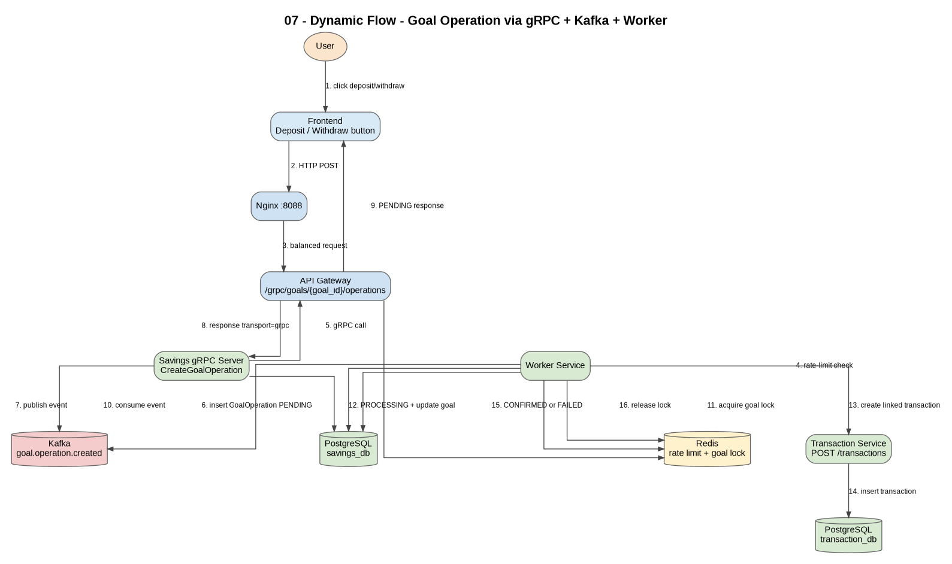
Figure 3. Dynamic goal operation flow through gRPC, Kafka and worker-service.
Status | Meaning
PENDING | Operation has been created and waits for worker processing.
PROCESSING | Worker has started processing the operation.
CONFIRMED | Operation was applied successfully and linked transaction was created.
FAILED | Operation failed, for example because withdraw amount was larger than current goal amount.
CANCELLED | Reserved for future cancellation logic.

8. Redis Usage
Redis is used in several practical places. It is not only a cache, but also part of authentication, routing and asynchronous coordination.
Use case | Key pattern | TTL / behavior
User profile cache | user:{user_id} | Short TTL; invalidated after profile update.
Transaction summary cache | summary:{user_id} | TTL 60 seconds; invalidated after transaction create/delete.
Rate limiting | rate_limit:{client_ip}:{minute_window} | Gateway increments counters and returns HTTP 429 when limit is exceeded.
JWT blacklist | jwt:blacklist:{jti} | Token jti is stored after logout until token expiration.
Goal operation lock | lock:goal:{goal_id} | Worker uses SET NX EX to avoid simultaneous updates.

9. MinIO Object Storage
MinIO is used for binary image files. The auth-service uploads user avatars to the avatars folder. The savings-service uploads goal images to goal-specific folders. Old images are deleted or cleaned up after replacement. This avoids storing image bytes in PostgreSQL and keeps database rows lightweight.

10. AI Assistant and Observability
The AI assistant is implemented in agent-service. It uses the local Ollama runtime for LLM and embeddings, Qdrant for semantic memory, and Langfuse for traces. The analyst agent reads real transaction data and builds context about total income, expenses, categories and previous-month transactions. The prompts include a language rule: if the user writes in Russian, the assistant answers in Russian; if the user writes in English, it answers in English.

11. Recommender System
RecSys is a separate FastAPI service. It reads transactions from transaction-service, generates personalized financial recommendations, and publishes recommendation events to Kafka. The current implementation combines heuristic recommendations, biggest expense category detection, educational collaborative filtering with synthetic profiles, and cold-start advice.

12. Integration Testing
The project includes integration tests that run against real Docker Compose services. They verify the system as a whole rather than isolated functions. The current expected result is 12 passed tests.
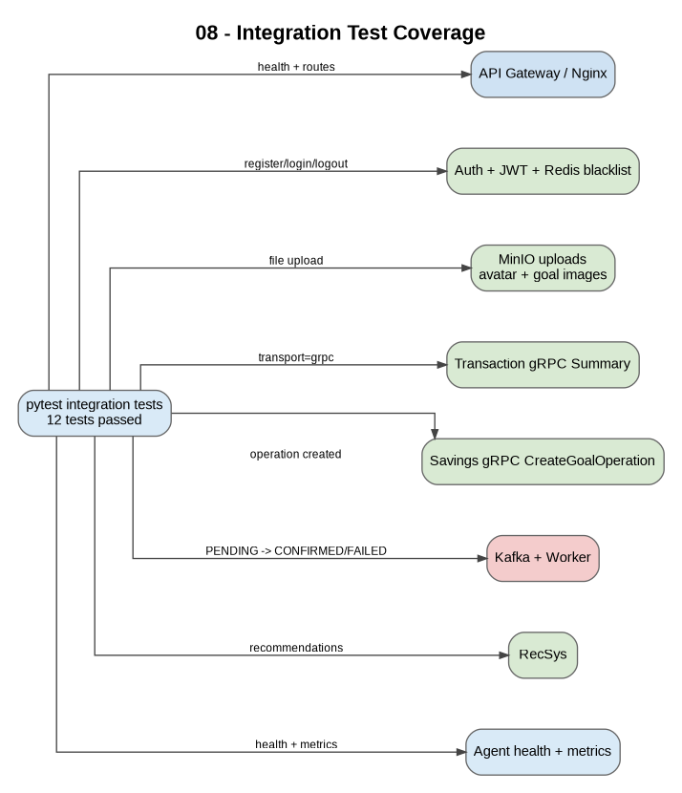
Figure 4. Integration test coverage.
Test file | What it verifies
test_01_health.py | Gateway, core service health, frontend, Kafka UI, agent health and metrics.
test_02_auth_jwt_and_minio.py | Register/login/me/logout, Redis JWT blacklist, avatar upload to MinIO.
test_03_transactions_grpc_summary.py | Transaction creation, gRPC financial summary, transaction idempotency.
test_04_savings_goal_grpc_worker.py | Goal image upload, gRPC CreateGoalOperation, Kafka worker, status transitions, failed withdraw.
test_05_recommendations.py | Recommendations generated from real transactions.

13. Conclusion
The final version of Kopilkin is a complete educational microservice project. It includes real business functionality, REST routing, gRPC communication, event-driven Kafka processing, Redis-based caching and coordination, persistent PostgreSQL storage, MinIO object storage, AI assistant integration, observability and integration tests. The project is suitable for demonstrating the main competencies required in the third task series.

Русская часть

1. Обзор проекта
Kopilkin - это mobile-first веб-приложение для управления личными финансами, реализованное как микросервисная система. Пользователь может регистрироваться и входить в аккаунт, добавлять доходы и расходы, создавать цели накоплений, загружать аватар и изображения целей, спрашивать AI-ассистента о финансах и получать рекомендации. Финальная версия показывает не только отдельные FastAPI-сервисы, но и service-owned PostgreSQL databases, Redis caching and synchronization, Kafka-based event-driven processing, gRPC communication, MinIO object storage, AI observability и integration tests.

Рисунок 1. Финальная container-level архитектура.

2. Объём проекта и связь с требованиями
Требование / область | Финальная реализация | Где видно в проекте
Kafka / EDA | Kafka broker, Kafka UI, доменные события и настоящий worker consumer для операций по целям. | docker-compose.yml; events.py; worker-service/app/main.py
RDBMS + NoSQL / storage | PostgreSQL для бизнес-данных, MinIO для файлов, Qdrant для AI memory, Redis для временных данных, Kafka как event log. | infra/postgres/init.sql; models.py; контейнеры MinIO/Qdrant/Redis/Kafka
Redis caching / coordination | Кэш профиля, кэш summary, rate limits, JWT blacklist, locks для целей. | cache.py; api-gateway/app/main.py; worker-service/app/main.py
Routing layer | Frontend обращается к Nginx на порту 8088; Nginx балансирует два API Gateway; gateway маршрутизирует во внутренние сервисы. | infra/nginx/nginx.conf; api-gateway/app/main.py
gRPC communication | API Gateway использует gRPC для summary транзакций и создания операций по целям. | proto files; grpc_server.py; api-gateway/app/grpc_client.py
Worker service | Асинхронная обработка операций целей из Kafka с Redis lock и созданием связанной transaction. | worker-service/app/main.py; topic goal.operation.created
Object storage | Аватары и картинки целей загружаются в MinIO; в PostgreSQL хранится только URL. | storage.py в auth и savings service
AI assistant | Agent service использует Ollama, Qdrant memory и Langfuse traces; читает financial data. | agent-service; analyst_agent.py; system_prompts.py
Recommender system | Отдельный RecSys microservice читает транзакции и генерирует рекомендации. | recsys-service/app/main.py
Testing | 12 integration tests проверяют реальные Docker Compose flows. | tests/; pytest output: 12 passed

3. Микросервисная архитектура
Система состоит из набора FastAPI-сервисов. Frontend работает только с публичным входом через Nginx и API Gateway. Внутри сервисы взаимодействуют через REST, gRPC, Kafka и общие инфраструктурные компоненты. API Gateway скрывает внутренние порты сервисов и применяет Redis-based rate limiting. Две копии gateway стоят за Nginx, чтобы показать load balancing.
Сервис | Роль | Порт / интерфейс
frontend | Пользовательский интерфейс | 5500
nginx-balancer | Публичный вход и балансировщик | 8088
api-gateway-1 / api-gateway-2 | Routing, rate limiting, gRPC clients | internal 8000
auth-service | Users, JWT, bcrypt, Redis blacklist, avatars | 8001
transaction-service | Transactions, summaries, cache, Transaction gRPC server | 8002 / 50051
savings-service | Goals, images, GoalOperation, Savings gRPC server | 8003 / 50052
worker-service | Kafka consumer and async processor | internal
agent-service | AI assistant, memory, traces, metrics | 8004
recsys-service | Financial recommendations | 8005
PostgreSQL / Redis / Kafka / MinIO / Qdrant / Langfuse | Infrastructure layer | разные порты

4. Архитектура данных
Kopilkin использует database-per-service подход на уровне логических баз данных. Данные пользователей, транзакций и целей разделены по PostgreSQL databases. Файлы не хранятся в таблицах: MinIO хранит аватары и картинки целей, а PostgreSQL хранит только URL. Redis используется для временных данных, Qdrant - для AI vector memory.

Рисунок 2. Data, events, routing, cache и object storage view.

5. Kafka и event-driven processing
Kafka используется как центральный брокер событий. Сервисы публикуют domain events после успешных бизнес-операций. Самый сильный event-driven сценарий - операции по целям накоплений: savings-service создаёт GoalOperation и публикует goal.operation.created, а worker-service читает событие и асинхронно обновляет систему.
Topic | Producer | Смысл / consumer
user.registered | auth-service | Создан новый пользователь.
transaction.created / transaction.deleted | transaction-service | Изменения финансовых транзакций; полезны для analytics и recommendations.
goal.created / goal.updated / goal.deleted | savings-service | Жизненный цикл savings goal.
goal.image.updated | savings-service | Изображение цели изменено.
goal.operation.created | savings-service или Savings gRPC server | Читается worker-service для обработки deposit/withdraw.
recommendation.requested / recommendation.generated | recsys-service | Жизненный цикл recommendations.

6. gRPC communication
Финальная версия использует gRPC в двух местах. Во-первых, API Gateway вызывает Transaction Service через gRPC для financial summary. Во-вторых, API Gateway вызывает Savings Service через gRPC для создания deposit/withdraw operations. Это делает gRPC частью реального business flow, а не отдельной демонстрацией.
gRPC method | Caller | Server | Назначение
GetUserSummary | API Gateway | Transaction Service :50051 | Возвращает income, expense и balance пользователя.
CreateGoalOperation | API Gateway | Savings Service :50052 | Создаёт pending deposit/withdraw operation и публикует Kafka event.

7. Главный бизнес-flow: операция по цели
Самый важный runtime-сценарий - операция по цели накопления. Пользователь пополняет цель или снимает деньги с цели. Frontend отправляет HTTP-запрос в gateway. Gateway вызывает Savings Service через gRPC. Savings Service создаёт GoalOperation со статусом PENDING и публикует Kafka event. Worker-service читает event, берёт Redis lock на goal, меняет статус operation, обновляет current_amount и создаёт связанную transaction в Transaction Service.

Рисунок 3. Dynamic goal operation flow через gRPC, Kafka и worker-service.
Status | Смысл
PENDING | Операция создана и ждёт обработки worker-ом.
PROCESSING | Worker начал обработку операции.
CONFIRMED | Операция успешно применена, связанная transaction создана.
FAILED | Операция не удалась, например withdraw больше текущей суммы цели.
CANCELLED | Зарезервировано для будущей логики отмены.

8. Redis usage
Redis используется в нескольких практических местах. Это не только cache, но и часть authentication, routing и asynchronous coordination.
Use case | Key pattern | TTL / поведение
User profile cache | user:{user_id} | Короткий TTL; invalidation после обновления профиля.
Transaction summary cache | summary:{user_id} | TTL 60 секунд; invalidation после create/delete transaction.
Rate limiting | rate_limit:{client_ip}:{minute_window} | Gateway увеличивает counters и возвращает HTTP 429 при превышении лимита.
JWT blacklist | jwt:blacklist:{jti} | Token jti хранится после logout до окончания срока действия token.
Goal operation lock | lock:goal:{goal_id} | Worker использует SET NX EX, чтобы избежать одновременных обновлений.

9. MinIO object storage
MinIO используется для binary image files. Auth-service загружает user avatars в папку avatars. Savings-service загружает картинки целей в goal-specific folders. Старые изображения удаляются или очищаются после замены. Это не перегружает PostgreSQL файлами.

10. AI assistant и observability
AI assistant реализован в agent-service. Он использует local Ollama runtime для LLM и embeddings, Qdrant для semantic memory и Langfuse для traces. Analyst agent читает реальные transaction data и строит контекст по доходам, расходам, категориям и активности за прошлый месяц. В prompt добавлено правило языка: если пользователь пишет на русском, ассистент отвечает на русском; если на английском - на английском.

11. Recommender System
RecSys - отдельный FastAPI service. Он читает transactions из transaction-service, генерирует personalized financial recommendations и публикует recommendation events в Kafka. Сейчас используются heuristic rules, biggest expense category detection, учебный collaborative filtering с synthetic profiles и cold-start advice.

12. Integration testing
В проект добавлены integration tests, которые запускаются против реальных Docker Compose services. Они проверяют систему целиком, а не только отдельные функции. Ожидаемый результат: 12 passed tests.

Рисунок 4. Покрытие integration tests.
Test file | Что проверяет
test_01_health.py | Gateway, health сервисов, frontend, Kafka UI, agent health and metrics.
test_02_auth_jwt_and_minio.py | Register/login/me/logout, Redis JWT blacklist, avatar upload to MinIO.
test_03_transactions_grpc_summary.py | Transaction creation, gRPC financial summary, transaction idempotency.
test_04_savings_goal_grpc_worker.py | Goal image upload, gRPC CreateGoalOperation, Kafka worker, status transitions, failed withdraw.
test_05_recommendations.py | Recommendations from real transactions.

13. Заключение
Финальная версия Kopilkin - полноценный учебный микросервисный проект. В нём есть реальные business features, REST routing, gRPC communication, event-driven Kafka processing, Redis-based caching and coordination, persistent PostgreSQL storage, MinIO object storage, AI assistant, observability и integration tests. Проект подходит для демонстрации основных компетенций третьего блока заданий.

