AI-Assisted Triage System
Week 9 — HCI/HRI Design & Prototyping
Interim Submission

1. Problem Space Co-Design Canvas — HCI (ED Triage Desk)
Setting: main Emergency Department triage desk. Screen-based interface used by triage nurses during live patient intake.
Users | Primary: ED triage nurse (often solo on night shift). Secondary: charge nurse, attending physician who reviews flagged cases, IT/clinical governance for audit.
Problem | Nurses under time pressure and cognitive load (esp. 3 a.m., low staffing) must assign an accurate acuity score quickly and consistently. Manual triage is prone to fatigue-driven inconsistency; nurses need a second opinion that is fast to read and doesn't slow the workflow.
Data in | Manual entry of presenting complaint and observations at the desk; EHR pull of patient history/allergies/prior visits; live device stream from vitals monitors (HR, BP, SpO2, RR, temp) where bedside monitoring exists.
Model output | A colour-coded acuity score (Red/Amber/Yellow/Green) with a numeric confidence score and a short rationale (which inputs drove the score), displayed on the desk screen and reflected in the patient queue.
Human next step | Nurse reads score + rationale, accepts or overrides within seconds, and proceeds with standard triage protocol (bed allocation, physician flag). Overrides require a one-line reason, logged for audit.
Existing workaround | Currently nurses use a paper/whiteboard-based Canadian Triage and Acuity Scale (CTAS) judgement call with no decision support; the tool should sit alongside, not replace, this judgement.

2. Problem Space Co-Design Canvas — HRI (Observation Unit Robotic Kiosk)
Setting: new Observation Unit, where a kiosk model may eventually sit next to a robot-assisted vitals station.
Users | Primary: patients in observation (often ambulatory, unsupervised for periods). Secondary: observation-unit nurse who monitors the robot's output remotely or on rounds; Head of Observation Medicine as clinical owner.
Problem | Patients in the Observation Unit need vitals captured repeatedly over hours without pulling a nurse away each time. A robot-assisted station must safely, physically interact with a patient (proximity, touch-adjacent sensors) and communicate risk changes clearly — to both the patient and remote staff.
Data in | Device stream from onboard/attached sensors (SpO2, BP cuff, temperature, camera/lidar for proximity), voice or touchscreen input from the patient, and an EHR pull for baseline/history.
Model output | A robot behaviour (e.g. approach, prompt for cuff placement, retreat), an on-kiosk colour/audio cue for the patient, and — for any deteriorating trend — an escalation alert routed to the nursing station, not just the patient.
Human next step | Nurse receives the escalation alert and decides whether to attend in person; patient follows on-screen/voice prompts from the robot for routine checks and is never left to interpret an ambiguous risk signal alone.
Existing workaround | Currently a nurse manually rounds hourly. The robot is meant to increase check frequency and catch earlier deterioration, not replace nurse judgement on escalation.

3. HCI vs HRI Safety Considerations

HCI-specific (ED Triage Desk)
- Alarm fatigue — too many Red/Amber flags erode trust and get dismissed; thresholds must be tuned to keep true alerts rare and credible.
- Display legibility under stress — must be readable at 3 a.m., in low light, by a nurse who has not slept, glancing for under 2 seconds.
- Accessibility — colour-blind-safe palette (colour + text label, not colour alone), large tap targets for gloved hands, keyboard/touch fallback if a mouse fails.

HRI-specific (Observation Unit Robot Kiosk)
- Proximity/physical safety — the robot must not startle, block, or physically contact a patient unsafely; needs predictable, slow approach behaviour and an easy stop/override.
- Voice input under noisy ED/observation conditions — speech recognition must degrade gracefully (fallback to touchscreen) rather than silently misfiring a triage-relevant command.
- Graceful degradation on sensor failure — if a vitals sensor drops out, the robot must say so explicitly and escalate to a human rather than presenting a stale reading as current.

4. Co-Design Canvas — Chosen Implementation (HCI, ED Triage Desk)
This is the design canvas for the setting we are carrying forward to mock-up and final submission: the screen-based, nurse-facing ED triage desk. Problem, Ethics, and Environment are completed below for the interim; Guidelines, MVP, and Form will be completed for the final submission.
Problem | Nurses must convert noisy, time-pressured patient presentations into a consistent acuity score, fast, without adding steps to an already overloaded workflow. The system's job is to make the right score faster to reach, not to replace the nurse's judgement.
Ethics | Accountability must stay with the nurse: the system recommends, the human decides. Every override is logged with a reason for audit and later model review, so the tool never becomes a silent black box in a safety-critical decision. Model confidence must be shown, not hidden, so nurses know when to trust it less. Patient data shown on screen must be limited to what's needed for the triage decision, and the desk display should not be visible to other patients in the waiting area (privacy).
Environment | Physically: a shared, often noisy triage desk, sometimes with more than one nurse using the terminal across a shift, under fluorescent or dimmed night lighting, with the nurse frequently interrupted mid-task. Digitally: must integrate with the existing EHR feed and any bedside monitors already in place, and must not require a separate login flow that adds friction during a live intake.

5. System Requirements — Notes

Inputs
- Manual entry: presenting complaint, observations, free-text notes (typed by the triage nurse at intake).
- EHR pull: patient identifiers, allergies, prior visit history, existing conditions (via secure read-only integration).
- Device stream: live vitals where a bedside/portable monitor is connected (HR, BP, SpO2, RR, temperature).

Outputs
- Colour-coded acuity score (Red/Amber/Yellow/Green) shown against the patient in the queue view.
- Numeric model confidence and a short, plain-language rationale (top contributing factors).
- System status indicators: last EHR sync time, sensor connectivity/dropout warnings.
- Audit log entry generated automatically whenever a nurse accepts or overrides a score.

What the human does with the output
The nurse reads the colour + confidence + rationale, makes the accept/override call within the normal triage workflow, and proceeds to bed allocation or physician escalation as usual. An override requires a one-line reason before the nurse can continue, which both preserves accountability and feeds a future model-review process.

Integration requirements
- Read-only EHR integration; the triage tool must not write back to the EHR without a separate, explicit clinical action.
- Runs on existing triage-desk hardware (no new terminal required) to avoid workflow disruption.
- Works in a degraded state (EHR or sensor feed down) by falling back to manual-entry-only mode with a clear on-screen notice, rather than failing silently.

Interface decision
Web/desktop interface for the ED triage desk (browser-based dashboard, no native app install), consistent with existing hospital IT infrastructure. This is the HCI path; the Observation Unit HRI concept (robot kiosk) is documented above as a comparison case and may be pursued as a physical prototype (TinkerCAD) for the final submission if time allows.

6. Initial Mock-Up Sketch
Low-fidelity wireframe of the ED triage desk dashboard (HCI implementation): patient queue on the left, selected-patient detail with score, confidence and rationale in the centre, and system alerts/status on the right. Colour + text labels are used together throughout for accessibility, and the layout is designed for large tap targets and quick scanning under low light.
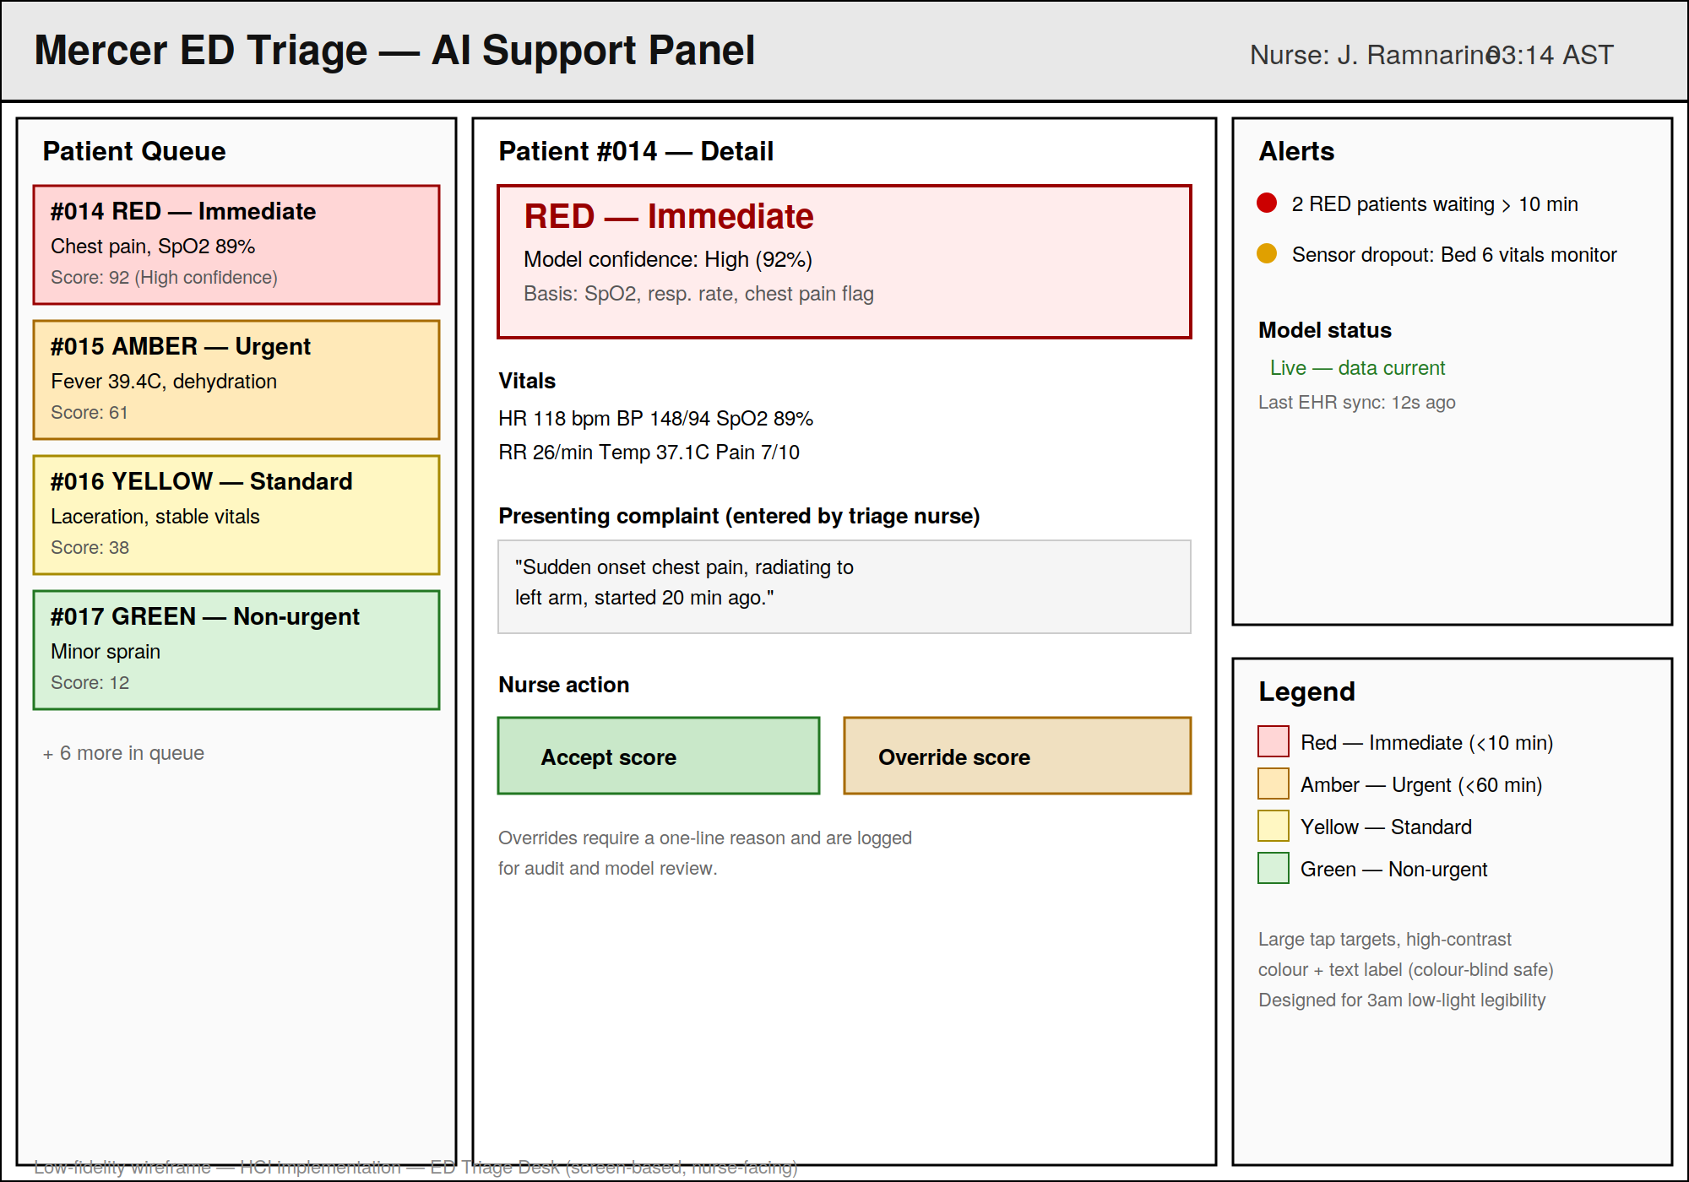
This sketch will be developed into a higher-fidelity Figma/Canva mock-up for the final submission.

