LAB 09 OUTPUTS

Question 01:

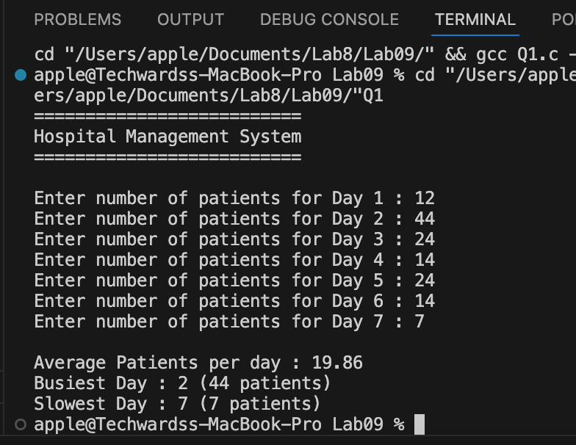

Question 02:

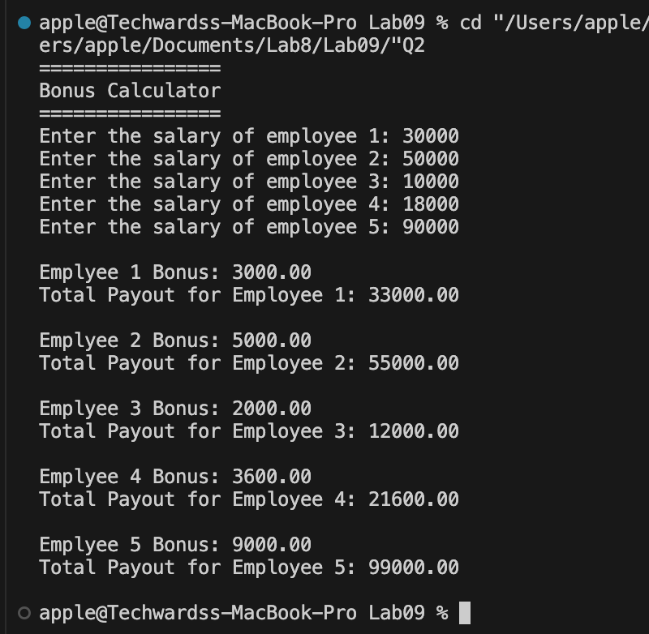

Question 03:

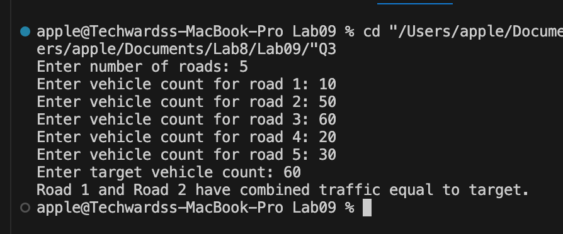

Question 04:

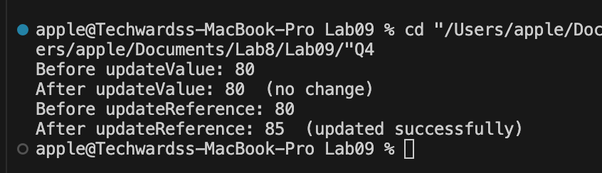

Question 05:

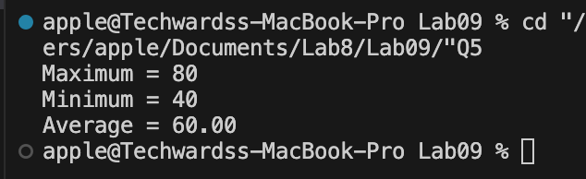

Question 06:

