1.
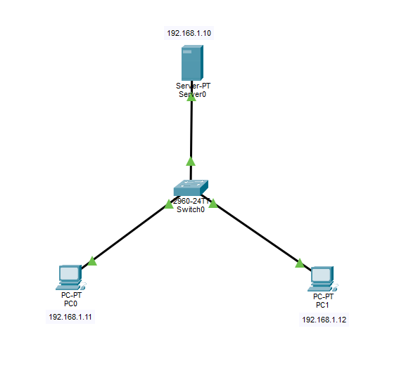
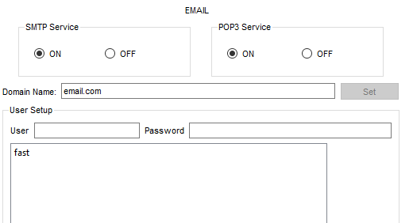
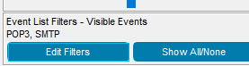
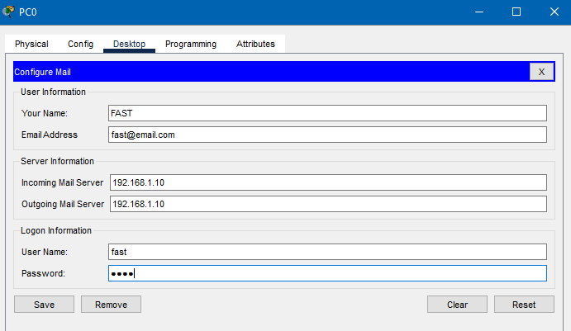
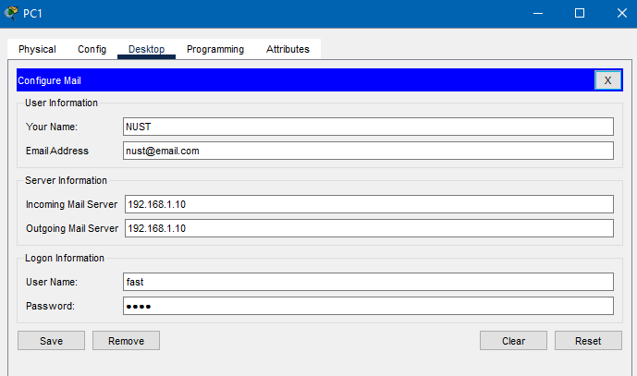
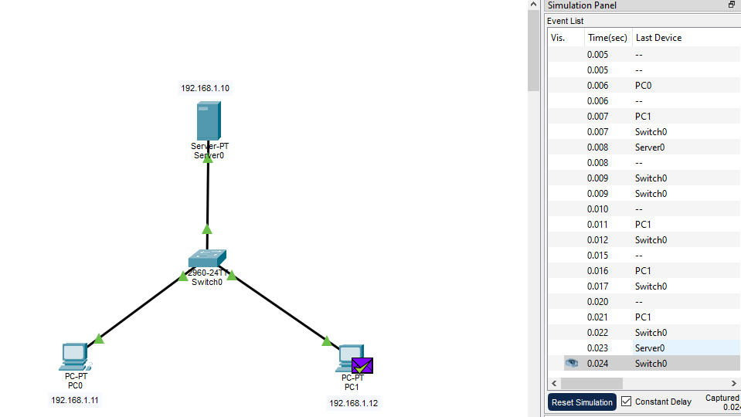
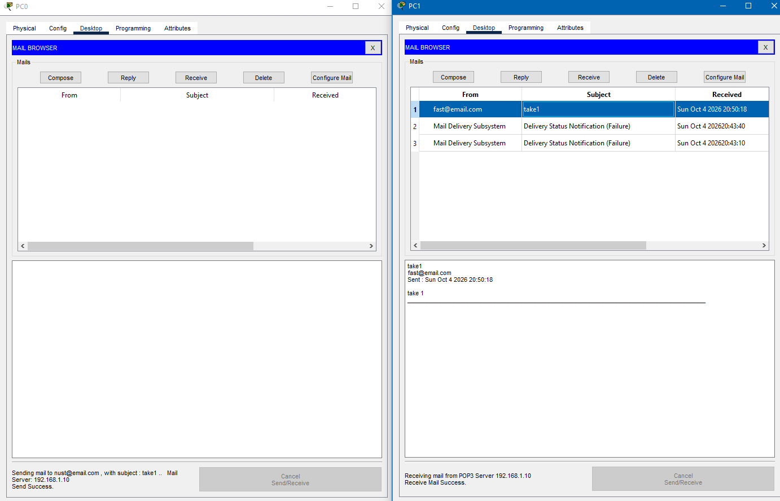
Sent: SMTP
Receiving Checks mailbox: POP3
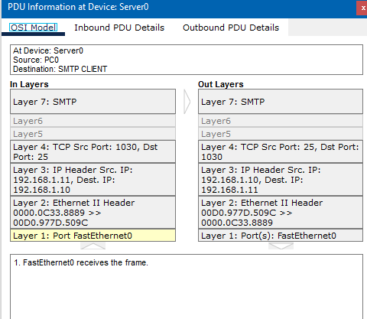
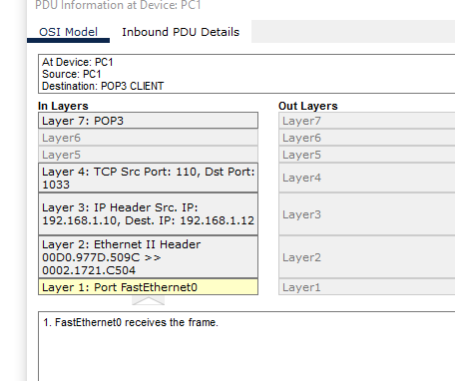
2.
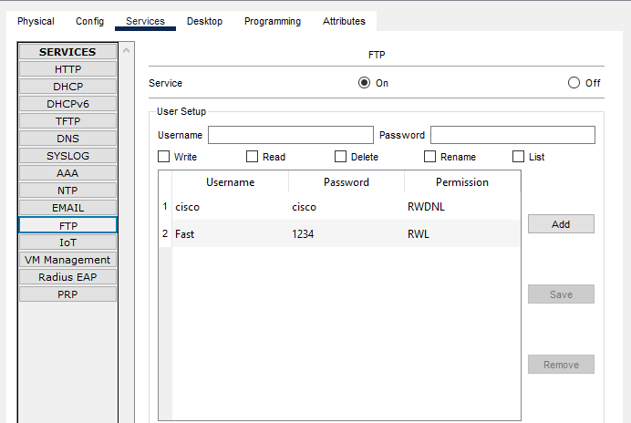
Pc0:
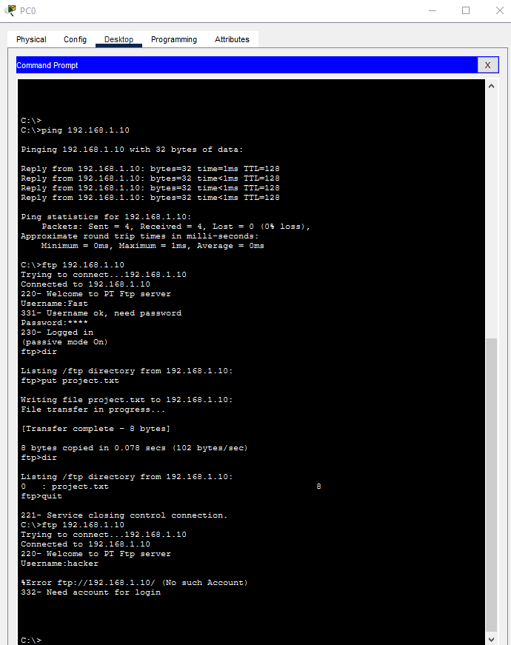
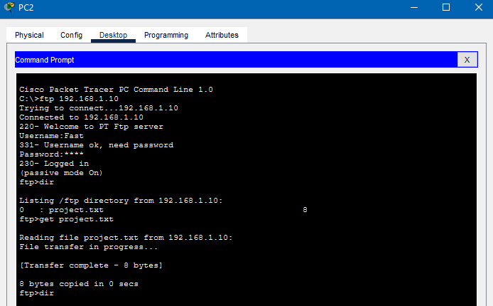
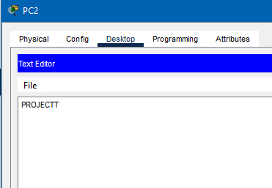
3.
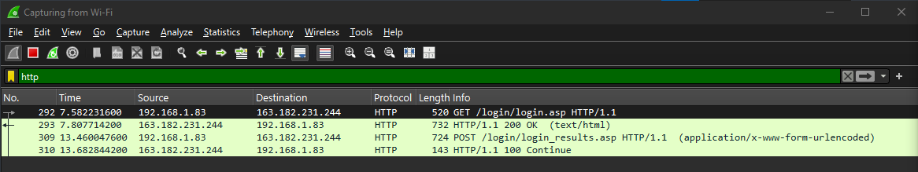
Reqs:
GET /login/login.asp HTTP/1.1
POST /login/login_results.asp HTTP/1.1
Res:
HTTP/1.1 200 OK
HTTP/1.1 100 Continue

Status codes:
- 200 : Successful
- 100 : Informational

Explanation for your submission
HTTP 200 OK: This is a successful response. It indicates that the server successfully processed the HTTP request and returned the requested resource.
HTTP 100 Continue: This is an informational response. It indicates that the server has received the initial part of the request and the client can continue sending the request.

Packet 292:
Source: 192.168.1.83
Destination: 163.182.231.244
Protocol: HTTP
Request: GET /login/login.asp
Packet 293:
Source: 163.182.231.244
Destination: 192.168.1.83
Protocol: HTTP
Response: HTTP/1.1 200 OK

