# 3-Cisco:

Topology:

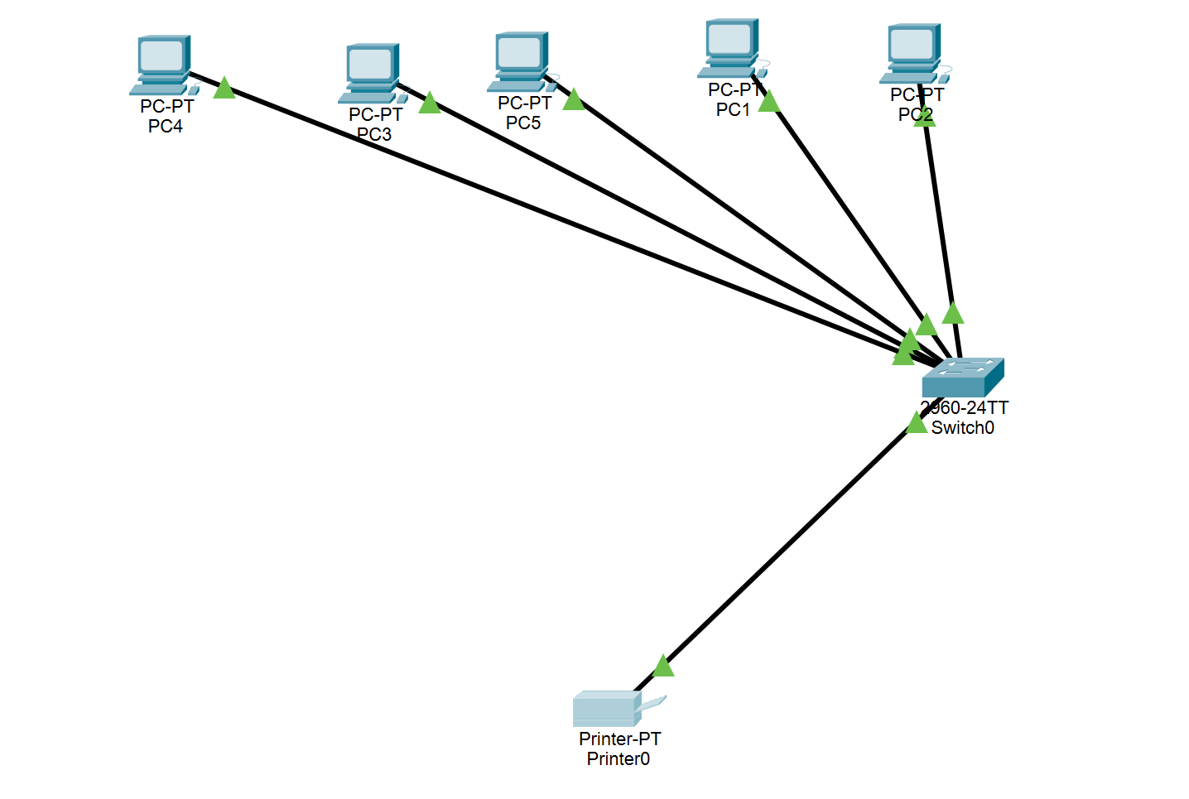

PC 1 connecting with others:

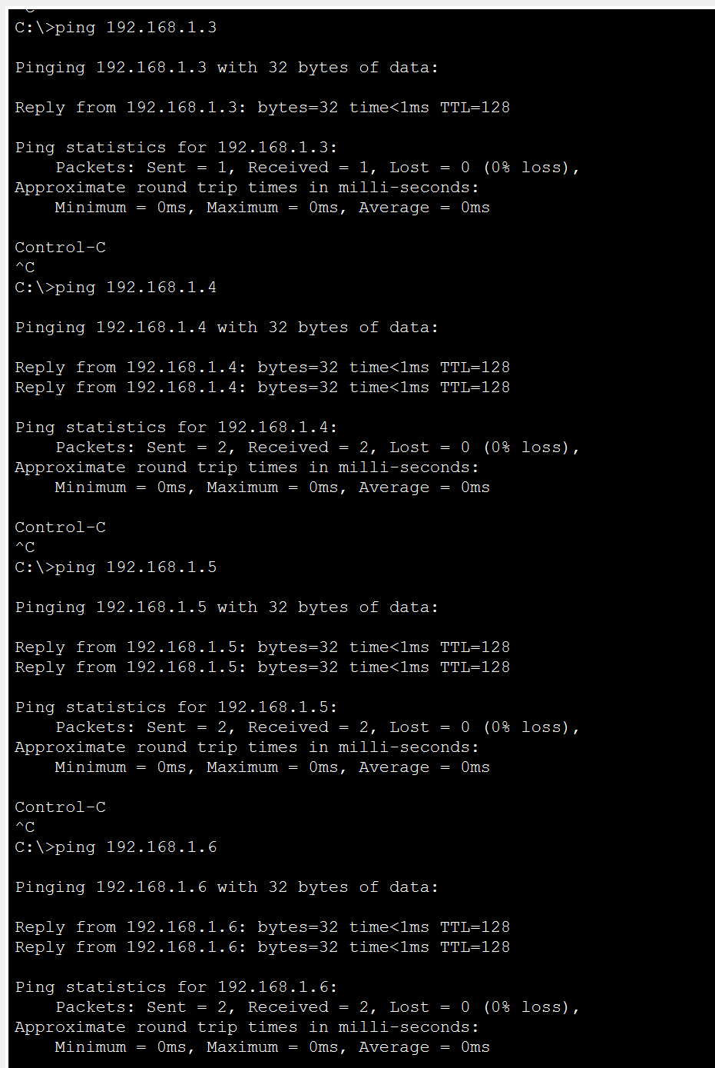

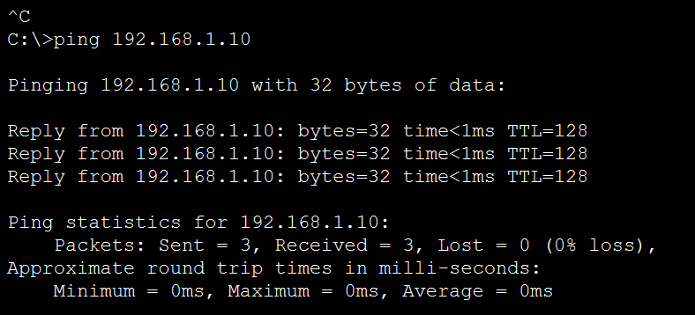

PC 2 connecting with others:

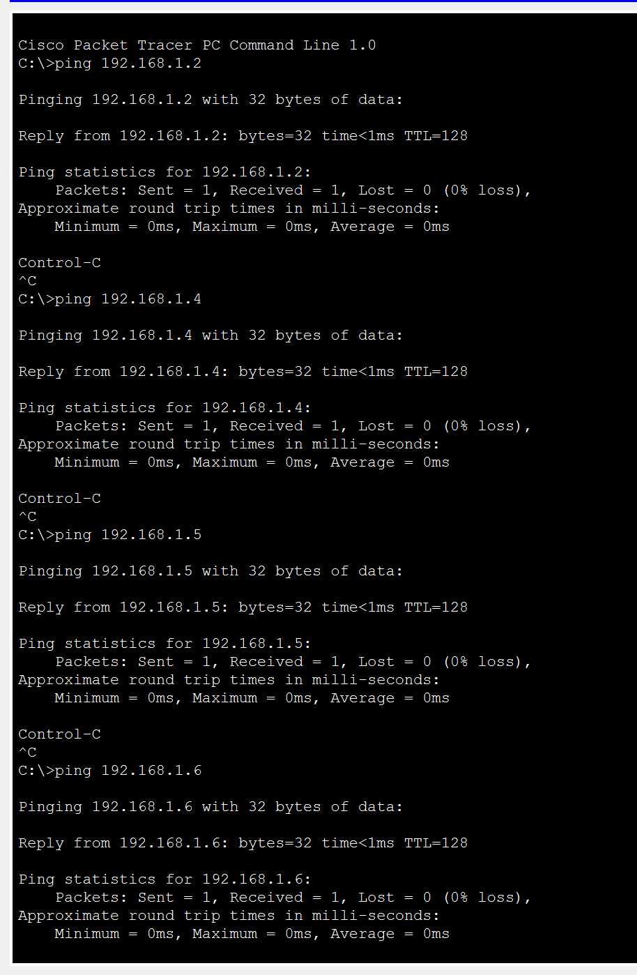

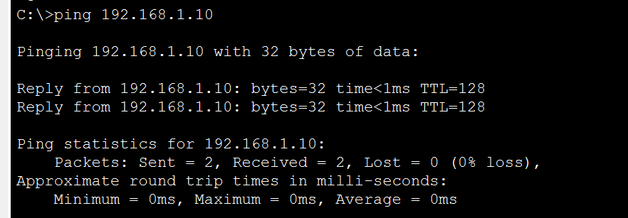

PC 3 connecting with others:

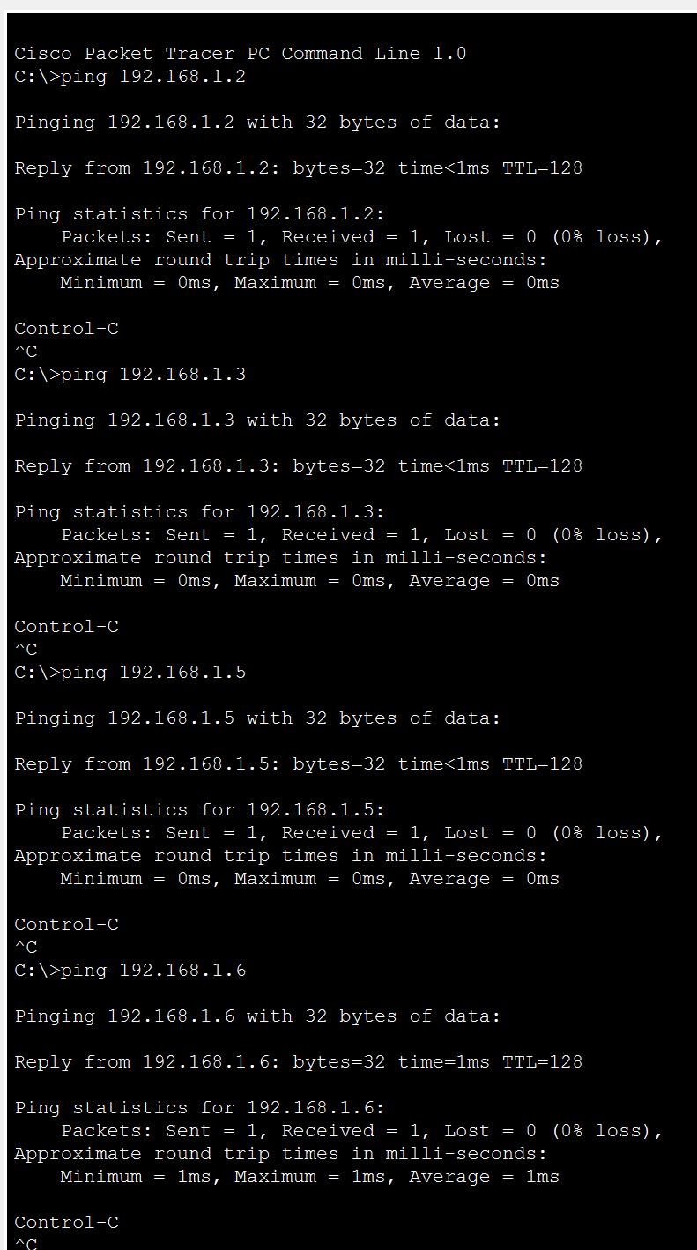

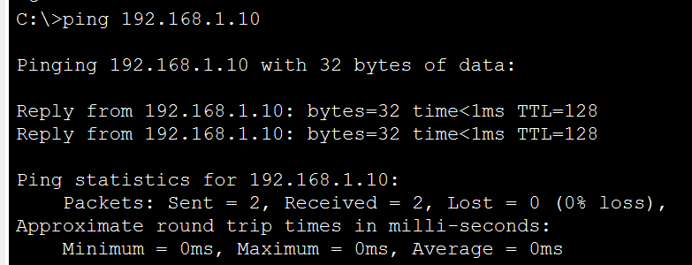

PC 4 connecting with others:

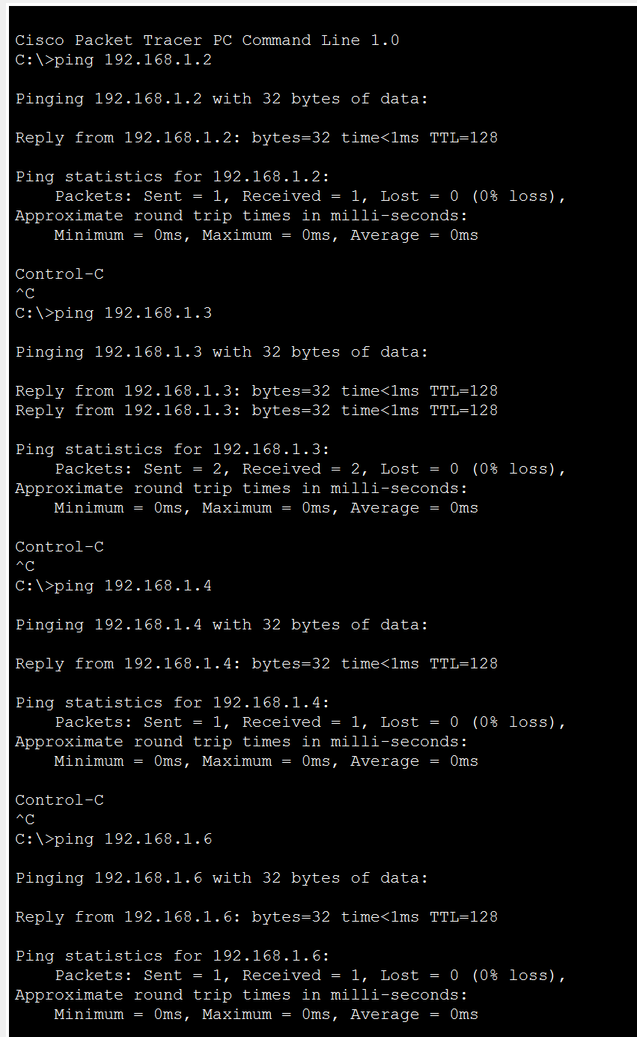

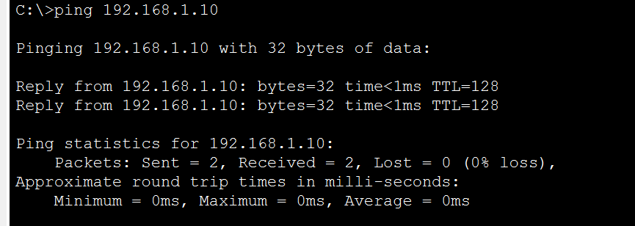

PC 5 connecting with others:

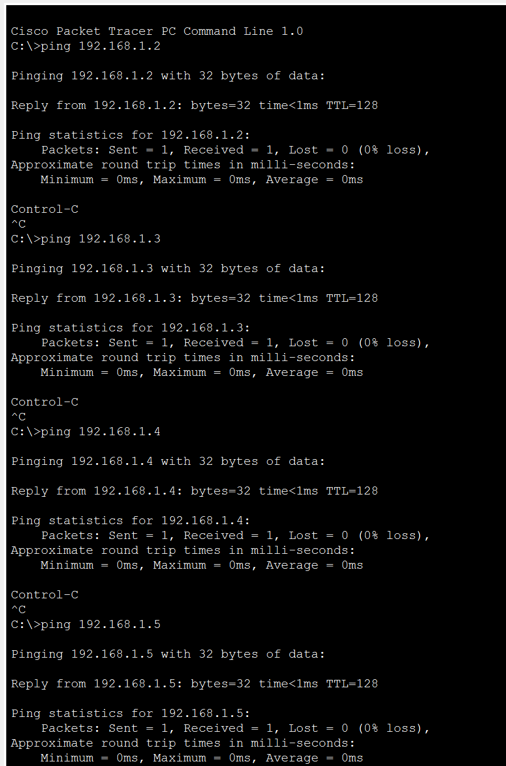

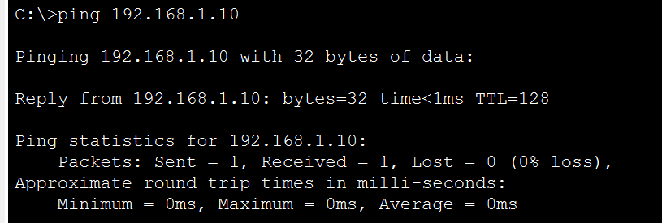

Description:

PCs and the network printer are located in the end-devices group, while the switch is in the switches group. To establish connections, all PCs and the printer should be connected to the switch using straight-through copper cables. IP addresses can be assigned to each PC through the IP Configuration option in the desktop tab, while the printer’s IPv4 address can be configured in the FastEthernet settings. Once the setup is complete, you can use the command prompt on each PC to ping other PCs and the printer to verify proper connectivity.