Q1:

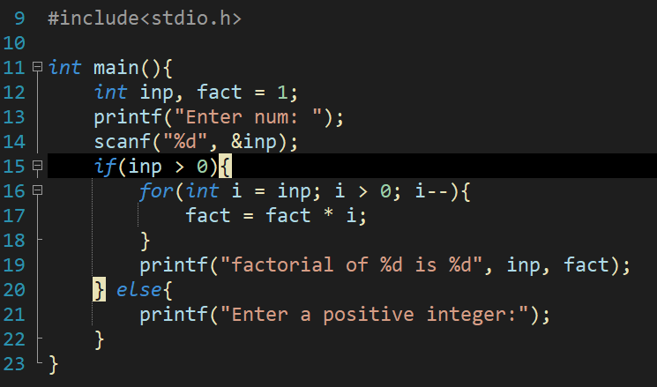

#include<stdio.h>

int main(){

int inp, fact = 1;

printf("Enter num: ");

scanf("%d", &inp);

if(inp > 0){

for(int i = inp; i > 0; i--){

fact = fact * i;

}

printf("factorial of %d is %d", inp, fact);

} else{

printf("Enter a positive integer:");

}

}

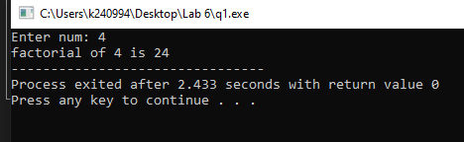

Q2:

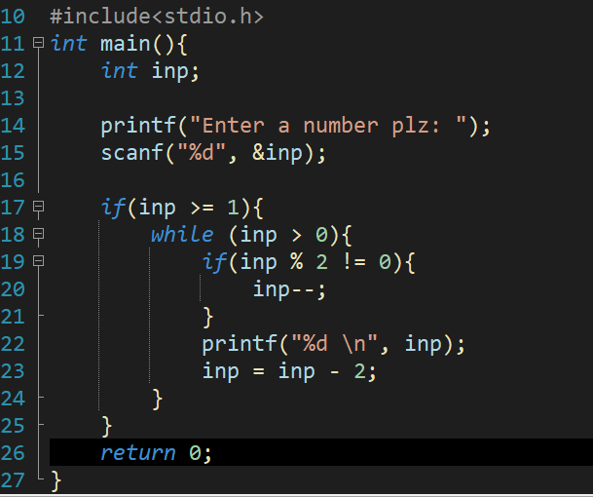

#include<stdio.h>

int main(){

int inp;

printf("Enter a number plz: ");

scanf("%d", &inp);

if(inp >= 1){

while (inp > 0){

if(inp % 2 != 0){

inp--;

}

printf("%d \n", inp);

inp = inp - 2;

}

}

return 0;

}

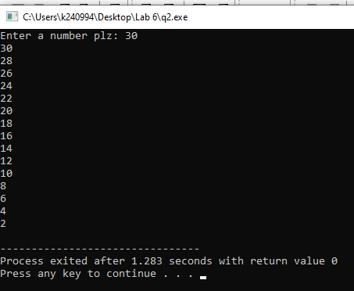

Q3:

#include<stdio.h>

int main(){

int num;

printf("Enter num: ");

scanf("%d", &num);

while (num < 0){

printf("no \n");

printf("Enter num: ");

scanf("%d", &num);

}

printf("Hell yeah ~<_%d_>~", num);

return 0;

}

