Q1:

#include<stdio.h>

int main(){

int i,num, flag = 0;

int array[9] = {2,4,3,7,9,5,2,9,6};

printf("Enter a number to search: ");

scanf("%d", &num);

for(i = 0; i < 9; i++){

if(num == array[i]){

printf("\nNumber found at index %d", i);

flag = 1;

}

}

if (flag == 0){

printf("Number not Found");

}

return 0;

}

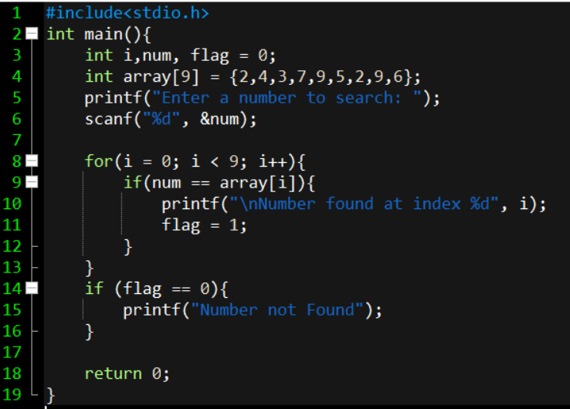

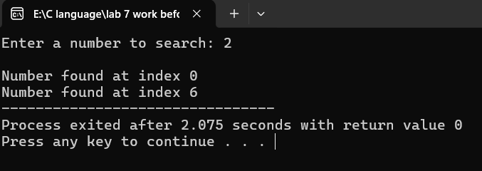

Q2:

#include<stdio.h>

int main(){

int i,j,k, size, temp;

printf("Enter the size of the Array: ");

scanf("%d", &size);

int array[size];

for (i = 0; i < size; i++){

printf("Enter Element Number %d: ", i+1);

scanf("%d", &temp);

array[i] = temp;

}

int first = array[0];

for (j = 0; j < size - 1; j++){

array[j] = array[j + 1];

}

array[size - 1] = first;

for (k = 0; k < size; k++){

printf("%d\t", array[k]);

}

return 0;

}

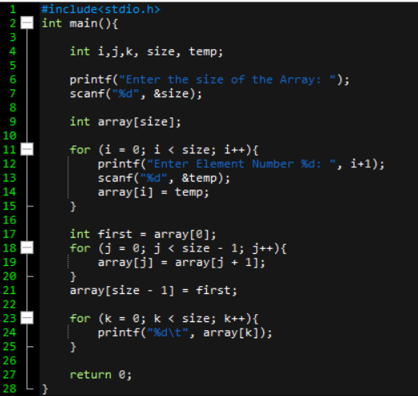

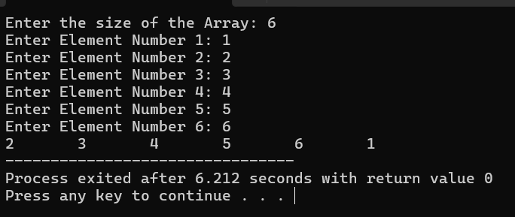

Q3:

#include<stdio.h>

int main(){

int size = 12, summer = 0, i, j, k, temp;

int array[size], sumArray[size/2];

for (i = 0; i < size; i++){

printf("Enter Element Number %d: ", i+1);

scanf("%d", &temp);

array[i] = temp;

}

for (j = 0; j < (size/2); j++){

sumArray[j] = array[summer] + array[summer + 1];

summer += 2;

}

for (k = 0; k < (size/2); k++){

printf("%d\t", sumArray[k]);

}

return 0;

}

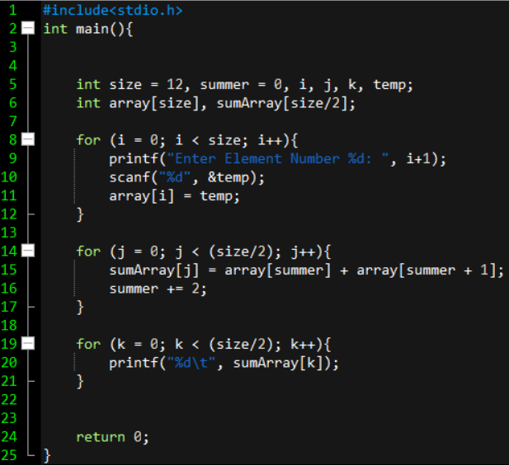

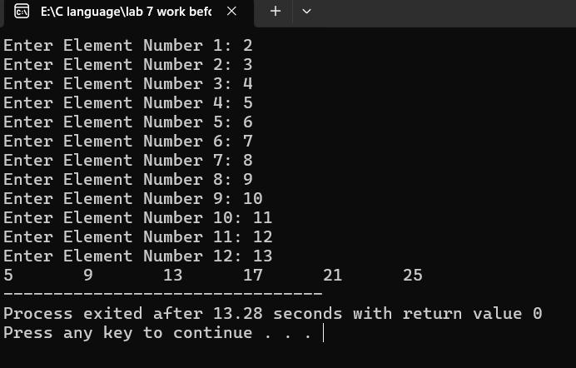

Q4:

#include<stdio.h>

void main(){

int k,n,len=15,temp,sum=0;

int arr[len];

for (n = 0; n < len ;n++){

printf("Enter Element %d: ", n+1);

scanf("%d", &temp);

arr[n] = temp;

}

for (k = 0; k < len; k++){

sum += arr[k];

}

printf("%d", sum);

}

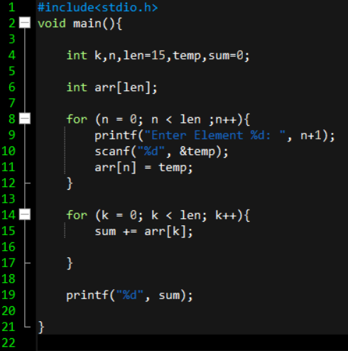

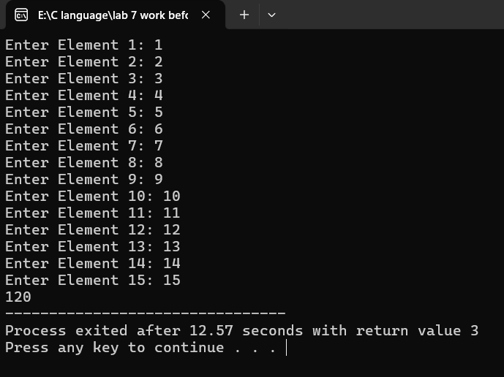

Q5:

#include<stdio.h>

void main(){

int k,n,r,len = 20,temp;

int arr[len];

for (n = 0; n<len;n++){

printf("Enter Element %d: ", n+1);

scanf("%d", &temp);

arr[n] = temp;

}

for (r = len - 1; r >= 0; r--){

printf(" %d ", arr[r]);

}

}

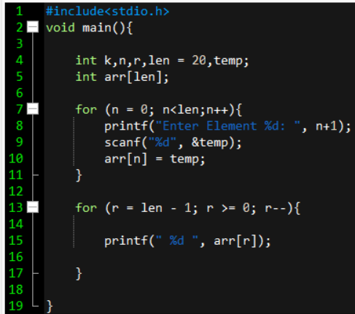

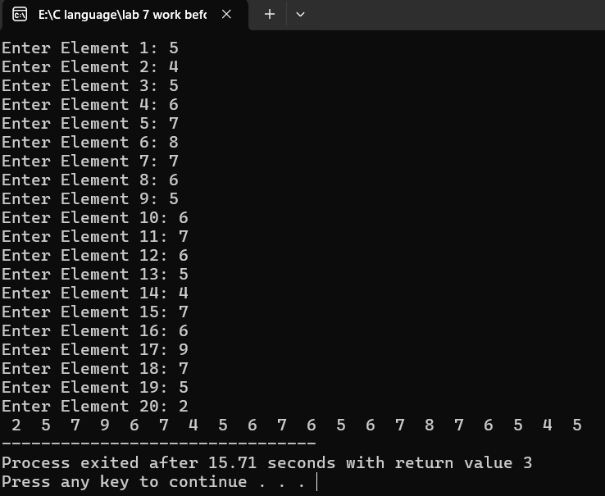

Q6:

#include<stdio.h>

void main(){

int k,n,len = 30,temp, min=9999, max= -9999;

int arr[len];

for (n = 0; n<len;n++){

printf("Enter Element %d: ", n+1);

scanf("%d", &temp);

arr[n] = temp;

}

for (k = 0; k < len; k ++){

if(min > arr[k]){

min = arr[k];

}

if(max < arr[k]){

max = arr[k];

}

}

printf("\nMinimum Number = %d \n", min);

printf("Maximum Number = %d \n", max);

}

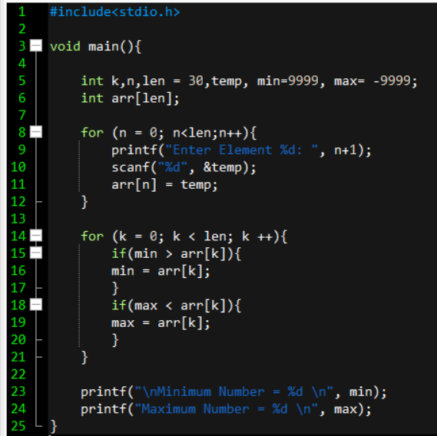

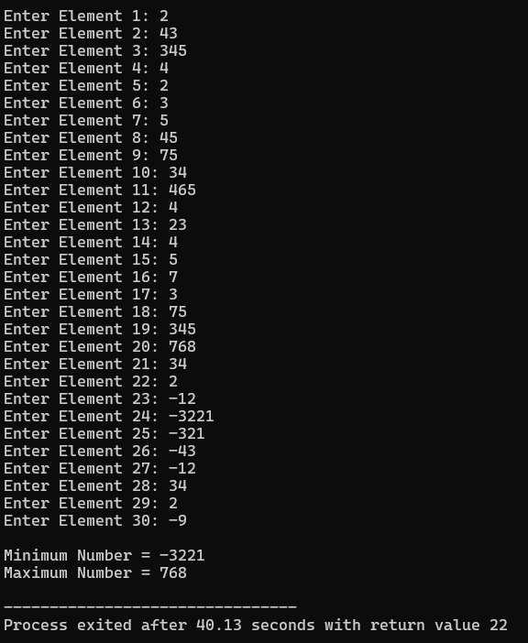

GITHUB LINK:

[CLICK HERE!](https://github.com/izaankhan0/pfLab7)

https://github.com/izaankhan0/pfLab7