PRPJECT NAME: SMART PLANT MONOTOR

In this project I’ll introduce a new type of analog sensor that detects moisture levels. You’ll set up a call and sound alarm system to tell you when your plant needs watering.

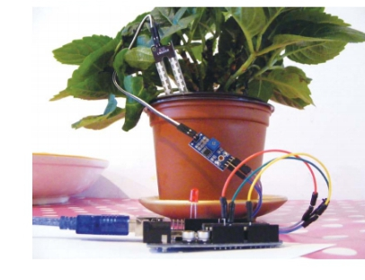

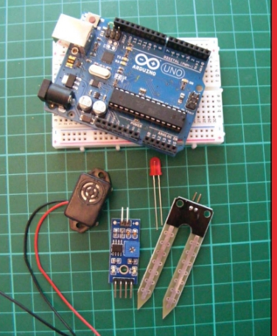

COMPONENTS REQUIRED:

• Arduino board

• Jumper wires

• LED

• HL-69 hygrometer soil moisture sensor

• Piezo buzzer

• telephone mobile

**How It Works**

You’ll use an HL-69 moisture sensor, readily available online for a few

dollars or from some of the retailers listed in Appendix A. The prongs

of the sensor detect the moisture level in the surrounding soil by passing current through the soil and measuring the resistance. Damp soil

conducts electricity easily, so it provides lower resistance, while dry soil conducts poorly and has a higher resistance. The sensor consists of two parts, as shown in Figure 5-1: the actual prong sensor(a)and the controller (b). The two pins on the sensor need to connect to the two separate pins on the controller (connecting wires are usually supplied). The other side of the controller has four pins, three of which connect to the Arduino.

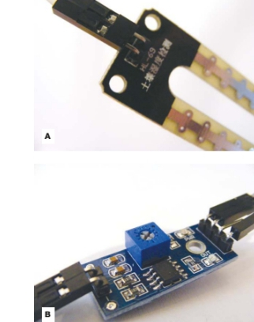

The four pins are, from left to right, AO (analog out), DO (digital out), GND, and VCC (see Figure 5-2). You can read the values from the controller through the IDE when it’s connected to your computer .This project doesn’t use a breadboard, so the connections are al lmade directly to the Arduino.

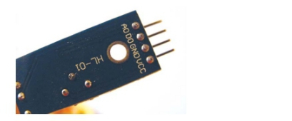

Lower readings indicate that more moisture is being detected, and higher readings indicate dryness. If your reading is above 900, your plant is seriously thirsty. If your plant gets too thirsty, the LED will light and the piezo buzzer will sound. Piezo are inexpensive buzzers

**The Build**

1. Connect the sensor’s two pins to the + and – pins on the controller using the provided connecting wires, as shown in Figure 5-3.

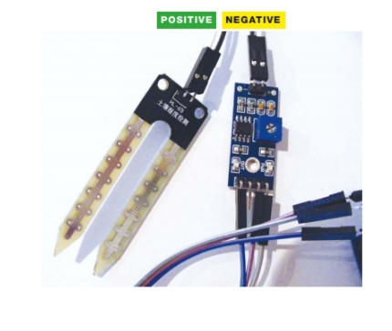

1.The pins are labeled on the underside of the module Connecting the sensor to the controller

2. Connect the three prongs from the controller to +5V, GND, and

Arduino A0 directly on the Arduino, as shown in the following

table. The DO pin is not used.

Sensor Controller arduino

VCC +5V

GND GND

A0 A0

DO Not used

3. Connect an LED directly to the Arduino with the shorter, negative leg in GND and the longer, positive leg in Arduino pin 13, as

shown in Figure 5-4.

LED arduino

Positive leg Pin 13

Negative leg GND

4. Connect the piezo buzzer’s black wire to GND and its red wire to

Arduino pin 11.

Piezo arduino

Red wire Pin 11

Black wire GND

5. Check that your setup matches that of Figure 5-5, and then

upload the code in “The Sketch” on page 51.

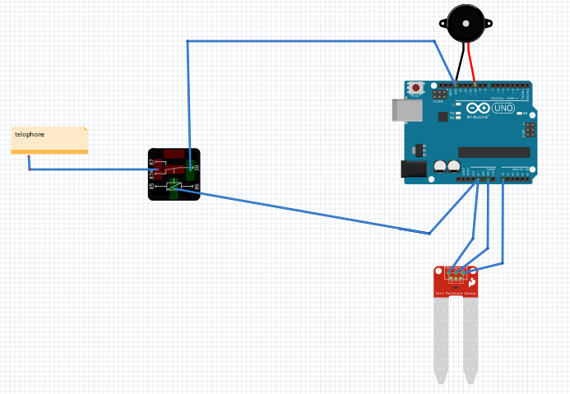

WHEN THE VALUE FROM THE SENSORRISES ABOVE YOUR CALIBRATED VALUE, THE phone will call AND THE BUZZERWILL SOUND.PLACE THE SENSOR IN THE SOIL OFTHE PLANT YOU WANT TO MONITOR.AS THE SOIL DRIES OUT, THE ARDUINO READS THE VALUE FROM THE SENSOR AND SENDS IT TO THE IDE.

6. Connect the Arduino to your computer using the USB cable. Open the Serial Monitor in your IDE to see the values from the sensor—this will also help you to calibrate your plant monitor. The IDE will display the value of the sensor’s reading. My value was 1000 with the sensor dry and not inserted in the soil, so I know this is the highest, and driest, value. To calibrate this value, turn the potentiometer on the controller clockwise to increase the resistance and counterclockwise to decrease it (see Figure 5-5) . When the sensor is inserted into moist soil, the value will drop to about 400. As the soil dries out, the sensor value rises when it reaches 900, the LED will light and the buzzer will sound.

Figure 5-5:

Circuit diagram for

the plant monitor

5 1 • project 5

POTENTIOMETER

The Sketch

The sketch first defines Arduino pin A0 so that it reads the moisture

sensor value. It then defines Arduino pin 11 as output for the buzzer,

and pin 13 as output for the LED. Use the Serial.Println() function to send the reading from the sensor to the IDE, in order to see

the value on the screen.

Change the value in the line

if(analogRead(0) > 900){

depending on the reading from the sensor when it is dry (here it’s900). When the soil is moist, this value will be below 900, so the LED and buzzer will remain off. When the value rises above 900, it means the soil is drying out, and the buzzer and LED will alert you to wateryour plant.

const int moistureAO = 0;

int AO = 0; // Pin connected to A0 on the controller

int tmp = 0; // Value of the analog pin

int buzzPin = 11; // Pin connected to the piezo buzzer

int LED = 13; // Pin connected to the LED

void setup () {

Serial.begin(9600); // Send Arduino reading to IDE

Serial.println("Soil moisture sensor");

pinMode(moistureAO, INPUT);

pinMode(buzzPin, OUTPUT); // Set pin as output

pinMode(LED, OUTPUT); // Set pin as output

}

void loop () {

tmp = analogRead( moistureAO );

if ( tmp != AO ) {

AO = tmp;

Serial.print("A = "); // Show the resistance value of the sensor

// in the IDE

Serial.println(AO);

}

delay (1000);

if (analogRead(0) > 900) { // If the reading is higher than 900,

digitalWrite(buzzPin, HIGH); // the buzzer will sound

digitalWrite(LED, HIGH); // and the LED will light

delay(1000); // Wait for 1 second

digitalWrite(buzzPin, LOW);

digitalWrite(LED, HIGH);

}

else {

digitalWrite(buzzPin, LOW); // If the reading is below 900,

// the buzzer and LED stay off

digitalWrite(LED, LOW);

}

}