Project ‘Memory cards’

Team project of team’ Nimbus Terrafaux’ for course JS-UI 2014 Telerik Academy

# Team members

We are:

Izabel Gandileva (gitHub user *izabelk*)  
Kiril Tsarnakliyski (gitHub user *Elinos*)  
Nikola Petkanski (gitHub user *nikolap04*)  
Tanya Dimitrova (gitHub user *TanyaDimitrova*)  
Valentin Lozev (gitHub user *valentin-lozev*)  
Yana Yankova (gitHub user *yyankova*)

# Project purpose

Our project is a game named ‘Memory Cards’: 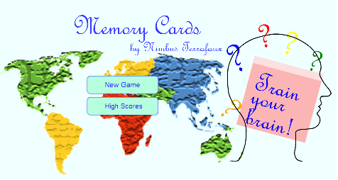

All of the cards represent country flags and are randomly coupled. The purpose is to discover all of them in the shortest time:

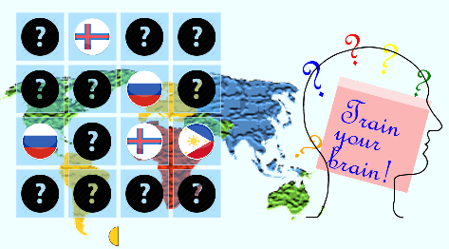

There’s an animated timer showing the time left: if a couple is discovered, time bonus is granted:

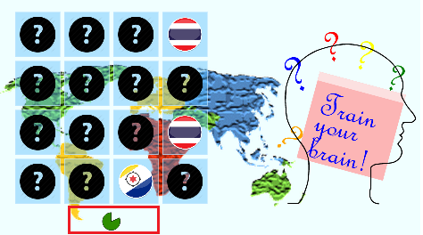

High-scores are also recorded:

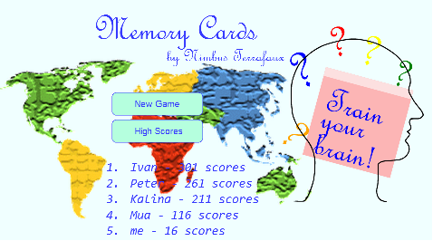

# GitHub URL

<https://github.com/izabelk/NimbusTerrafaux>

# Other information

We have used:

Vanilla JS  
SVG  
KineticJS  
Raphael  
CSS