

|  |
| --- |
| Business Template  Political Campaign |
| **Logo / Image** |

Contents

1 Business Description 3

1.1 Business background 3

1.2 Problems. Current Situation 3

1.3 The benefits of implementing a database. Project Vision 3

2 Model description 3

2.1 Definitions & Acronyms 3

2.2 Logical Scheme 3

2.3 Objects 3

# 

# Business Description

## Business background

The following business model describes a database for managing political campaign data.

The key functionalities include managing voter demographics, tracking contributions from donors, organizing campaign events, assigning volunteers to tasks, and storing candidate information. By linking entities such as campaign activities, various forms of contributions with related parties, the campaign team will be able to monitor the process.

## Problems. Current Situation

Potential issues/limitations that may arise in the future as the database grows are related to the scalability of the data. As the campaign grows, the volume of data will increase in entities like Voters, Contributions, Finances, and Events which can affect the performance of the database.

## the Benefits of implementing a database. Project Vision

The vision of the political campaign database is to evolve throughout multiple election years and to adapt to growing campaign needs such as the need for historical data or the need for additional functionalities and activities.

# Model description

## Definitions & Acronyms

This database is designed to manage and organize the key operations of a political campaign, providing a repository for tracking voters, donations, events, volunteers, candidates, and financial transactions.  
  
*Note: Detailed entity descriptions are included in the Objects section of the documentation.*

## Logical Scheme

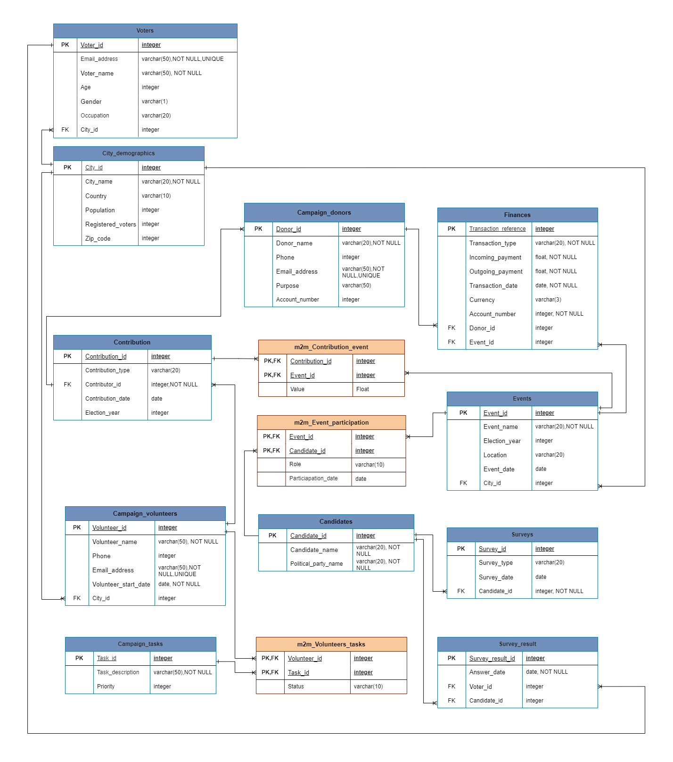

## Objects

1. **Voters table** – stores information about voters, including their contact details and associated city.

***One-to-Many relationship***: One voter can participate in multiple surveys via Voter_id however each Survey_result refers to only one voter.

|  |  |  |  |
| --- | --- | --- | --- |
| Table Name | Field name | Field Description | Data Type |
| Voters | Voter_id | **PK**, unique identifier for each voter, natural primary key | Integer |
| Email_address | voter's email address, unique, NOT NULL,UNIQUE, CHECK: '%_@__%.__%' | text |
| Voter_Name | name of the voter, NOT NULL | text |
| Age | voter’s age | Integer |
| Gender | voter’s gender, (CHECK: ‘F’,’M’,’O’) | text |
| Occupation | voter's occupation | text |
| City_id | **FK** connecting to the City_Demographics table | Integer |

|  |  |  |  |  |  |  |
| --- | --- | --- | --- | --- | --- | --- |
| Voter_id | Email_address | Voter_Name | Age | Gender | Occupation | City_id |
| 0510992823100 | James_Smith@gmail.com | James Smith | 40 | M | Professor | 3 |

1. **Campaign_volunteers table** - tracks details of volunteers and their assigned tasks.

***Many-to-Many relationship:*** the m2m_Volunteers_Tasks table connects multiple volunteers to multiple tasks meaning that a volunteer can work on multiple tasks, and one task can have multiple volunteers.  
***One-to-Many relationship:*** one volunteer can have many contributions, but each contribution is linked to one volunteer via the Contributor_id.

|  |  |  |  |
| --- | --- | --- | --- |
| Table Name | Field name | Field Description | Data Type |
| Campaign_volunteers | Volunteer_id | PK,unique identifier for each volunteer, natural primary key | Integer |
| Volunteer_name | name of the volunteer, NOT NULL | Text |
| Phone | volunteer’s phone number | Integer |
| Email_address | volunteer’s email address. NOT NULL, UNIQUE, CHECK: '%_@__%.__%' | Text |
| Volunteer_start_date | date when the volunteer joined the political campaign, NOT NULL | Date |
| City_id | FK referring to the City_Demographics table | Integer |

|  |  |  |  |  |  |  |
| --- | --- | --- | --- | --- | --- | --- |
| Volunteer_id | Volunteer_name | Phone | Email_address | Volunteer_start_date | City_id | Task_id |
| 0210996826300 | John Williams | 812546 | JW@gmail.com | 2024-01-01 | 4 | 1 |

1. **Campaign_donors table** - stores donor information and their designated contribution purpose.

***One-to-Many relationship:*** A donor via Donor_id can be linked to many financial transactions, but each transaction is linked to one donor.  
***One-to-Many relationship:*** One donor can have many contributions, but each contribution is linked to one donor through the Contributor_id.

|  |  |  |  |
| --- | --- | --- | --- |
| Table Name | Field name | Field Description | Data Type |
| Campaign_donors | Donor_id | PK,unique identifier for each donor, natural primary key | Integer |
| Donor_name | name of the donor, NOT NULL | Text |
| Phone | donor’s phone number | Integer |
| Email_address | donor’s email address, NOT NULL, UNIQUE, CHECK: '%_@__%.__%' | Text |
| Purpose | purpose of the donation | Text |
| Account_number | donor’s account number | Integer |

|  |  |  |  |  |  |
| --- | --- | --- | --- | --- | --- |
| Donor_id | Donor_name | Phone | Email_address | Purpose | Account_number |
| 0811999825200 | Sophie Evans | 812613 | Evansllc@gmail.com | Spomsorship | 5112345678 |

1. **Campaign_tasks** - stores information about tasks that volunteers need to complete.

|  |  |  |  |
| --- | --- | --- | --- |
| Table Name | Field name | Field Description | Data Type |
| Campaign_tasks | Task_id | PK,unique identifier for each task, surrogate primary key | Integer, SERIAL |
| Task_description | description of the task, NOT NULL | Text |
| Priority | priority of the task on a 1-5 scale where 1 has the highest priority and 5 has the lowest priority (CHECK: 1,2,3,4,5) | integer |

|  |  |  |
| --- | --- | --- |
| Task_id | Task_description | Priority |
| 1 | Data collection | 2 |

1. **Finances table** - tracks all financial transactions (incoming and outgoing payments) related to the campaign.

|  |  |  |  |
| --- | --- | --- | --- |
| Table Name | Field name | Field Description | Data Type |
| Finances | Transaction_reference | PK,unique identifier for each financial transaction, primary key | Integer |
| Transaction_type | type of the transaction (wire transfer, check, cash), NOT NULL | Text |
| Incoming_payment | amount of incoming payment, NOT NULL | Float |
| Outgoing_payment | amount of outgoing payment, NOT NULL | Float |
| Transaction_date | date of the transaction, NOT NULL | Date |
| Currency | currency used for the transaction, DEFAULT ‘USD’ | Text |
| Account_number | payer's account number, NOT NULL | Integer |
| Donor_id | FK referring to the Campaign_donors table | Integer |
| Event_ID | FK referring to the Events table | Integer |

|  |  |  |  |  |  |  |  |  |
| --- | --- | --- | --- | --- | --- | --- | --- | --- |
| Transaction_reference | Transaction_type | Incoming_payment | Outgoing_payment | Transaction_date | Currency | Account_number | Donor_id | Event_ID |
| 123 | Wire transfer | 1000 | 0 | 2024-01-01 | USD | 5112345678 | 0811999825200 | 1 |

1. **Events table** - stores information about campaign events, such as rallies or fundraising dinners.

***Many-to-Many relationship:*** Through the table m2m_Contribution_event, multiple contributions can be linked to multiple events, and vice versa.  
***Many-to-Many relationship:*** The m2m_Event_participation table allows multiple events to be linked with multiple candidates meaning that a candidate can participate in multiple events, and one event can have multiple candidates participating.  
***One-to-Many relationship:*** multiple financial transactions can be associated with a single event, but a financial transaction can only belong to one event.

|  |  |  |  |
| --- | --- | --- | --- |
| Table Name | Field name | Field Description | Data Type |
| Events | Event_ID | PK, unique identifier for each event, surrogate primary key | Integer, SERIAL |
| Event_name | name of the event, NOT NULL | Text |
| Election_year | year in which the political campaign took place | Integer |
| Location | location of the event | Text |
| Event_date | date of the event, NOT NULL | Date |
| City_id | FK referring to the City_Demographics table | Integer |

|  |  |  |  |  |  |
| --- | --- | --- | --- | --- | --- |
| Event_ID | Event_name | Election_year | Location | Event_date | City_id |
| 1 | Town Hall Meeting | 2024 | Town Hall | 2024-01-01 | 3 |

1. **Contribution table** - Tracks contributions made by any contributor (donors, volunteers) whether they were in the form of financial contributions or goods and services.

|  |  |  |  |
| --- | --- | --- | --- |
| Table Name | Field name | Field Description | Data Type |
| Contribution | Contribution_id | PK,unique identifier for each contribution, surrogate primary key | Integer, SERIAL |
| Contribution_type | type of the contribution (financial, goods, services) | Text |
| Contributor_id | FK referring to the Campaign_donors and Campaign_volunteers table, NOT NULL | Integer |
| Contribution_date | date of the contribution | Date |
| Election_year | year in which the contribution was made | Integer |

|  |  |  |  |  |
| --- | --- | --- | --- | --- |
| Contribution_id | Contribution_type | Contributor_id | Contribution_date | Election_year |
| 1 | Goods | 0210996826300 | 2024-01-01 | 2024 |

1. **Surveys table** - stores information about surveys conducted for candidates.

|  |  |  |  |
| --- | --- | --- | --- |
| Table Name | Field name | Field Description | Data Type |
| Surveys | Survey_id | PK, unique identifier for each survey, surrogate primary key | Integer, SERIAL |
| Survey_type | type of the survey (CHECK: online, face to face, via phone, paper survey) | Text |
| Survey_date | date when the survey was conducted | Date |
| Candidate_id | FK referring to the Candidates table, NOT NULL | Integer |

|  |  |  |  |
| --- | --- | --- | --- |
| Survey_id | Survey_type | Survey_date | Candidate_id |
| 1 | online | 2024-01-01 | 1 |

1. **Survey_result table** - stores responses from voters related to campaign surveys.

|  |  |  |  |
| --- | --- | --- | --- |
| Table Name | Field name | Field Description | Data Type |
| Survey_result | Survey_result_id | PK,unique identifier for each survey result, surrogate primary key | Integer, SERIAL |
| Answer_date | date when the survey answer was given, NOT NULL | Date |
| Voter_id | FK referring to the Voters table | Integer |
| Candidate_id | FK referring to the Candidates table | Integer |

|  |  |  |  |
| --- | --- | --- | --- |
| Survey_result_id | Answer_date | Voter_id | Candidate_id |
| 1 | 2024-01-01 | 0510992823100 | 1 |

1. **Candidates table** - stores information about political candidates participating in a campaign.

***One-to-Many relationship:*** A candidate can have many surveys related to them, but each survey is linked to one candidate.   
***One-to-Many relationship:*** One survey result belongs to only one candidate however multiple survey results can be linked to one candidate.

|  |  |  |  |
| --- | --- | --- | --- |
| Table Name | Field name | Field Description | Data Type |
| Candidates | Candidate_id | PK, unique identifier for each candidate, surrogate primary key | Integer, SERIAL |
| Candidate_name | name of the candidate, NOT NULL | Text |
| Political_party_name | name of the candidate’s political party, NOT NULL | Text |

|  |  |  |
| --- | --- | --- |
| Candidate_id | Candidate_name | Political_party_name |
| 1 | Emily Brown | Independent Party |

1. **City_Demographics table** - stores information about cities where voters reside and the associated demographic data.  
     
   ***One-to-Many relationship:*** Each voter belongs to one city via City_id and each city may have multiple voters.  
   ***One-to-Many relationship:*** Similarly, each volunteer can be assigned to only one city via City_id but each city may have multiple volunteers.  
   ***One-to-Many relationship:*** An event can only take place in one city, but a city can host multiple events.

|  |  |  |  |
| --- | --- | --- | --- |
| Table Name | Field name | Field Description | Data Type |
| City_Demographics | City_id | PK, unique identifier for each city, surrogate primary key | Integer |
| City_name | name of the city, NOT NULL | Text |
| Country | the country where the city is located | Text |
| Population | total population of the city | Integer |
| Registered_voters | number of registered voters in the city | Integer |
| Zip_code | Postal code of the city | Integer |

|  |  |  |  |  |  |
| --- | --- | --- | --- | --- | --- |
| City_id | City_name | Country | Population | Registered_voters | Zip_code |
| 3 | Madison | USA | 273372 | 176000 | 53701 |

1. **m2m_Event_participation table** - tracks contributions made during specific events.

|  |  |  |  |
| --- | --- | --- | --- |
| Table Name | Field name | Field Description | Data Type |
| m2m_Event_participation | Event_id | PK, FK referring to the Events table, composite key | Integer |
| Candidate_id | PK, FK referring to the Candidates table, composite key | Integer |
| Role | The role of the candidate at the event | Text |
| Particiapation_date | Date of the candidate's participation | Date |

|  |  |  |  |
| --- | --- | --- | --- |
| Event_id | Candidate_id | Role | Particiapation_date |
| 1 | 1 | Speaker | 2024-01-01 |

1. **m2m_Contribution_event table** - records which candidates participated in which campaign events and captures the role they played and when the participation occurred.

|  |  |  |  |
| --- | --- | --- | --- |
| Table Name | Field name | Field Description | Data Type |
| m2m_Contribution_event | Contribution_id | PK, FK referring to the Contribution table, surrogate key | Integer |
| Event_id | PK, FK referring to the Events table, surrogate key | Integer |
| Value | Approximate value of the contribution for the event in USD (CHECK: ‘USD’) | Float |

|  |  |  |
| --- | --- | --- |
| Contribution_id | Event_id | Value |
| 1 | 1 | 200 |

1. **m2m_Volunteers_tasks table** - tracks which volunteers are assigned to which tasks and their status in completing those tasks.

|  |  |  |  |
| --- | --- | --- | --- |
| Table Name | Field name | Field Description | Data Type |
| m2m_Volunteers_tasks | Volunteer_id | PK, FK referring to the Campaign_volunteers table, natural key | Integer |
| Task_id | PK, FK referring to the Campaign_tasks table, surrogate key | Integer, SERIAL |
| Status | Status of the volunteer’s task (CHECK:Not yet started, in progress, Finished) | Text |

|  |  |  |
| --- | --- | --- |
| Volunteer_id | Task_id | Status |
| 1 | 1 | In progress |