

|  |
| --- |
| Business Template  Political Campaign |
| **Logo / Image** |

Contents

1 Business Description 3

1.1 Business background 3

1.2 Problems. Current Situation 3

1.3 the Benefits of implementing a database. Project Vision 3

2 Model description 3

2.1 Definitions & Acronyms 3

2.2 Logical Scheme 3

2.3 Objects 4

2.4 Database Structure Changes 14

# 

# Business Description

## Business background

The following business model describes a database for managing political campaign data.

The key functionalities include managing voter demographics, tracking contributions from donors, organizing campaign events, assigning volunteers to tasks, and storing candidate information. By linking entities such as campaign activities, various forms of contributions with related parties, the campaign team will be able to monitor the process.

## Problems. Current Situation

Potential issues/limitations that may arise in the future as the database grows are related to the scalability of the data. As the campaign grows, the volume of data will increase in entities like Voters, Contributions, Finances, and Events which can affect the performance of the database.

## the Benefits of implementing a database. Project Vision

The vision of the political campaign database is to evolve throughout multiple election years and to adapt to growing campaign needs such as the need for historical data or the need for additional functionalities and activities.

# Model description

## Definitions & Acronyms

This database is designed to manage and organize the key operations of a political campaign, providing a repository for tracking voters, donations, events, volunteers, candidates, and financial transactions.  
  
*Note: Detailed entity descriptions are included in the Objects section of the documentation.*

## Logical Scheme

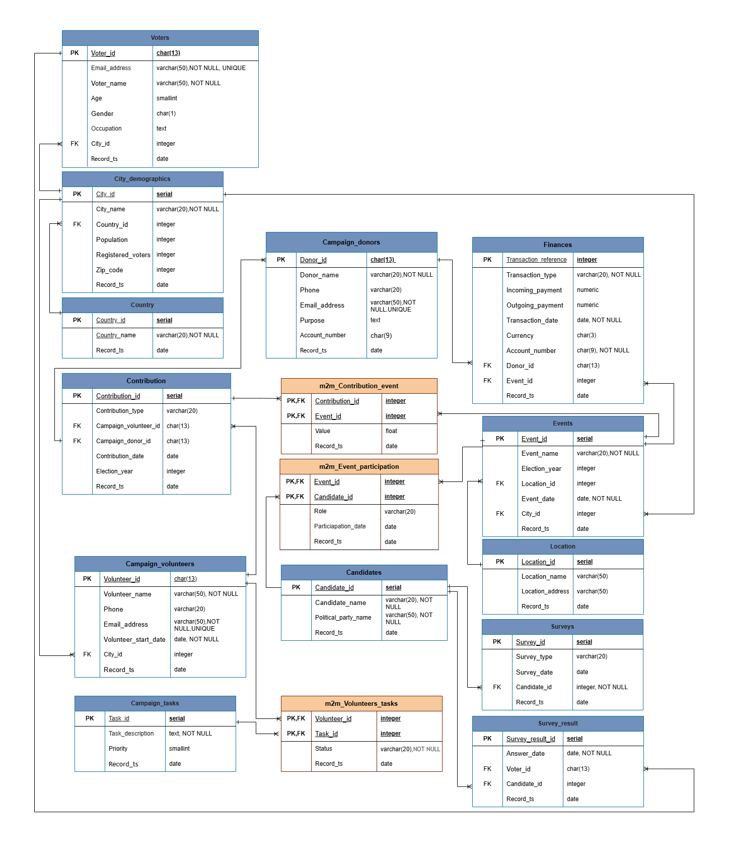

## Objects

1. **Voters table** – stores information about voters, including their contact details and associated city.

***One-to-Many relationship***: One voter can participate in multiple surveys via Voter_id however each Survey_result refers to only one voter.

|  |  |  |  |
| --- | --- | --- | --- |
| Table Name | Field name | Field Description | Data Type |
| Voters | Voter_id | **PK**, unique identifier for each voter, natural primary key | char(13) |
| Email_address | voter's email address, unique, NOT NULL,UNIQUE, CHECK: '%_@__%.__%' | varchar(50) |
| Voter_Name | name of the voter, NOT NULL | varchar(50) |
| Age | voter’s age | smallint |
| Gender | voter’s gender, (CHECK: ‘F’,’M’,’O’) | char(1) |
| Occupation | voter's occupation | text |
| City_id | **FK** connecting to the City_Demographics table | integer |
| Record_ts | Default current_date | date |

|  |  |  |  |  |  |  |
| --- | --- | --- | --- | --- | --- | --- |
| Voter_id | Email_address | Voter_Name | Age | Gender | Occupation | City_id |
| 0510992823100 | James_Smith@gmail.com | James Smith | 40 | M | Professor | 2 |

1. **Campaign_volunteers table** - tracks details of volunteers and their assigned tasks.

***Many-to-Many relationship:*** the m2m_Volunteers_Tasks table connects multiple volunteers to multiple tasks meaning that a volunteer can work on multiple tasks, and one task can have multiple volunteers.  
***One-to-Many relationship:*** one volunteer can have many contributions, but each contribution is linked to one volunteer via the Contributor_id.

|  |  |  |  |
| --- | --- | --- | --- |
| Table Name | Field name | Field Description | Data Type |
| Campaign_volunteers | Volunteer_id | PK,unique identifier for each volunteer, natural primary key | char(13) |
| Volunteer_name | name of the volunteer, NOT NULL | varchar(50) |
| Phone | volunteer’s phone number | VARCHAR(20) |
| Email_address | volunteer’s email address. NOT NULL, UNIQUE, CHECK: '%_@__%.__%' | varchar(50) |
| Volunteer_start_date | date when the volunteer joined the political campaign, NOT NULL, CHECK: date has to be greater than January 1, 2000 | date |
| City_id | FK referring to the City_Demographics table | integer |
| Record_ts | Default current_date | date |

|  |  |  |  |  |  |
| --- | --- | --- | --- | --- | --- |
| Volunteer_id | Volunteer_name | Phone | Email_address | Volunteer_start_date | City_id |
| 0210996826300 | John Williams | 812546 | JW@gmail.com | 2024-01-01 | 4 |

1. **Campaign_donors table** - stores donor information and their designated contribution purpose.

***One-to-Many relationship:*** A donor via Donor_id can be linked to many financial transactions, but each transaction is linked to one donor.  
***One-to-Many relationship:*** One donor can have many contributions, but each contribution is linked to one donor through the Contributor_id.

|  |  |  |  |
| --- | --- | --- | --- |
| Table Name | Field name | Field Description | Data Type |
| Campaign_donors | Donor_id | PK,unique identifier for each donor, natural primary key | char(13) |
| Donor_name | name of the donor, NOT NULL | varchar(20) |
| Phone | donor’s phone number | varchar(20) |
| Email_address | donor’s email address, NOT NULL, UNIQUE, CHECK: '%_@__%.__%' | varchar(50) |
| Purpose | purpose of the donation | text |
| Account_number | donor’s account number | char(9) |
| Record_ts | Default current_date | date |

|  |  |  |  |  |  |
| --- | --- | --- | --- | --- | --- |
| Donor_id | Donor_name | Phone | Email_address | Purpose | Account_number |
| 0811999825200 | Sophie Evans | 812613 | Evansllc@gmail.com | Sponsorship | 511234567 |

1. **Campaign_tasks** - stores information about tasks that volunteers need to complete.

|  |  |  |  |
| --- | --- | --- | --- |
| Table Name | Field name | Field Description | Data Type |
| Campaign_tasks | Task_id | PK,unique identifier for each task, surrogate primary key | SERIAL |
| Task_description | description of the task, NOT NULL | text |
| Priority | priority of the task on a 1-5 scale where 1 has the highest priority and 5 has the lowest priority (CHECK: 1,2,3,4,5) | smallint |
| Record_ts | Default current_date | date |

|  |  |  |
| --- | --- | --- |
| Task_id | Task_description | Priority |
| 1 | Data collection | 2 |

1. **Finances table** - tracks all financial transactions (incoming and outgoing payments) related to the campaign.

|  |  |  |  |
| --- | --- | --- | --- |
| Table Name | Field name | Field Description | Data Type |
| Finances | Transaction_reference | PK,unique identifier for each financial transaction, primary key | Varchar(10) |
| Transaction_type | type of the transaction (wire transfer, check, cash), NOT NULL | varchar(20) |
| Incoming_payment | amount of incoming payment, CHECK value that cannot be negative | numeric |
| Outgoing_payment | amount of outgoing payment, CHECK: value that cannot be negative | numeric |
| Transaction_date | date of the transaction, NOT NULL, CHECK: date must be greater than January 1, 2000 | date |
| Currency | currency used for the transaction, DEFAULT ‘USD’ | char(3) |
| Account_number | payer's account number, NOT NULL | CHAR(9) |
| Donor_id | FK referring to the Campaign_donors table | char(13) |
| Event_ID | FK referring to the Events table | integer |
| Record_ts | Default current_date | date |

|  |  |  |  |  |  |  |  |  |
| --- | --- | --- | --- | --- | --- | --- | --- | --- |
| Transaction_reference | Transaction_type | Incoming_payment | Outgoing_payment | Transaction_date | Currency | Account_number | Donor_id | Event_ID |
| 123 | Wire transfer | 1000 | 0 | 2024-01-01 | USD | 5112345678 | 0811999825200 | 1 |

1. **Events table** - stores information about campaign events, such as rallies or fundraising dinners.

***Many-to-Many relationship:*** Through the table m2m_Contribution_event, multiple contributions can be linked to multiple events, and vice versa.  
***Many-to-Many relationship:*** The m2m_Event_participation table allows multiple events to be linked with multiple candidates meaning that a candidate can participate in multiple events, and one event can have multiple candidates participating.  
***One-to-Many relationship:*** multiple financial transactions can be associated with a single event, but a financial transaction can only belong to one event.

|  |  |  |  |
| --- | --- | --- | --- |
| Table Name | Field name | Field Description | Data Type |
| Events | Event_ID | PK, unique identifier for each event, surrogate primary key | SERIAL |
| Event_name | name of the event, NOT NULL | varchar(20) |
| Election_year | year in which the political campaign took place and generated from the Event_date | integer |
| Location_id | FK referring to the location table | integer |
| Event_date | date of the event, NOT NULL, CHECK: date must be greater than January 1, 2000 | date |
| City_id | FK referring to the City_Demographics table | integer |
| Record_ts | Default current_date | date |

|  |  |  |  |  |  |
| --- | --- | --- | --- | --- | --- |
| Event_ID | Event_name | Election_year | Location_id | Event_date | City_id |
| 1 | Town Hall Meeting | 2024 | 1 | 2024-01-01 | 2 |

1. **Contribution table** - Tracks contributions made by any contributor (donors, volunteers) whether they were in the form of financial contributions or goods and services.

|  |  |  |  |
| --- | --- | --- | --- |
| Table Name | Field name | Field Description | Data Type |
| Contribution | Contribution_id | PK,unique identifier for each contribution, surrogate primary key | SERIAL |
| Contribution_type | type of the contribution (e.g.financial, goods, services) | varchar(20) |
| Campaign_volunteer_id | FK referring to the Campaign_volunteers table | char(13) |
| Campaign_donor_id | FK referring to the Campaign_donors table | char(13) |
| Contribution_date | date of the contribution which must be greater than January 1, 2000 | date |
| Election_year | year in which the contribution was made, generated from the Contribution_date | integer |
| Record_ts | Default current_date | date |

|  |  |  |  |  |  |
| --- | --- | --- | --- | --- | --- |
| Contribution_id | Contribution_type | Campaign_volunteer_id | Campaign_donor_id | Contribution_date | Election_year |
| 1 | Food | 0210996826300 | 0 | 2024-01-01 | 2024 |

1. **Surveys table** - stores information about surveys conducted for candidates.

|  |  |  |  |
| --- | --- | --- | --- |
| Table Name | Field name | Field Description | Data Type |
| Surveys | Survey_id | PK, unique identifier for each survey, surrogate primary key | SERIAL |
| Survey_type | type of the survey (CHECK: online, face to face, via phone, paper survey) | varchar(20) |
| Survey_date | date when the survey was conducted which must be greater than January 1, 2000 | date |
| Candidate_id | FK referring to the Candidates table, NOT NULL | integer |
| Record_ts | Default current_date | date |

|  |  |  |  |
| --- | --- | --- | --- |
| Survey_id | Survey_type | Survey_date | Candidate_id |
| 1 | online | 2024-01-01 | 1 |

1. **Survey_result table** - stores responses from voters related to campaign surveys.

|  |  |  |  |
| --- | --- | --- | --- |
| Table Name | Field name | Field Description | Data Type |
| Survey_result | Survey_result_id | PK,unique identifier for each survey result, surrogate primary key | SERIAL |
| Answer_date | date when the survey answer was given, NOT NULL which must be greater than January 1, 2000 | date |
| Voter_id | FK referring to the Voters table | char(13) |
| Candidate_id | FK referring to the Candidates table | integer |
| Record_ts | Default current_date | date |

|  |  |  |  |
| --- | --- | --- | --- |
| Survey_result_id | Answer_date | Voter_id | Candidate_id |
| 1 | 2024-01-01 | 0510992823100 | 1 |

1. **Candidates table** - stores information about political candidates participating in a campaign.

***One-to-Many relationship:*** A candidate can have many surveys related to them, but each survey is linked to one candidate.   
***One-to-Many relationship:*** One survey result belongs to only one candidate however multiple survey results can be linked to one candidate.

|  |  |  |  |
| --- | --- | --- | --- |
| Table Name | Field name | Field Description | Data Type |
| Candidates | Candidate_id | PK, unique identifier for each candidate, surrogate primary key | SERIAL |
| Candidate_name | name of the candidate, NOT NULL | varchar(20) |
| Political_party_name | name of the candidate’s political party, NOT NULL | varchar(50) |
| Record_ts | Default current_date | date |

|  |  |  |
| --- | --- | --- |
| Candidate_id | Candidate_name | Political_party_name |
| 1 | Emily Brown | Independent Party |

1. **City_Demographics table** - stores information about cities where voters reside and the associated demographic data.  
     
   ***One-to-Many relationship:*** Each voter belongs to one city via City_id and each city may have multiple voters.  
   ***One-to-Many relationship:*** Similarly, each volunteer can be assigned to only one city via City_id but each city may have multiple volunteers.  
   ***One-to-Many relationship:*** An event can only take place in one city, but a city can host multiple events.

|  |  |  |  |
| --- | --- | --- | --- |
| Table Name | Field name | Field Description | Data Type |
| City_Demographics | City_id | PK, unique identifier for each city, surrogate primary key | SERIAL |
| City_name | name of the city, NOT NULL | varchar(20) |
| Country_id | FK referring to the Country table | integer |
| Population | total population of the city | integer |
| Registered_voters | number of registered voters in the city | integer |
| Zip_code | Postal code of the city | integer |
| Record_ts | Default current_date | date |

|  |  |  |  |  |  |
| --- | --- | --- | --- | --- | --- |
| City_id | City_name | Country_id | Population | Registered_voters | Zip_code |
| 2 | Madison | 1 | 273372 | 176000 | 53701 |

1. **m2m_Event_participation table** - tracks contributions made during specific events.

|  |  |  |  |
| --- | --- | --- | --- |
| Table Name | Field name | Field Description | Data Type |
| m2m_Event_participation | Event_id | PK, FK referring to the Events table, composite key | integer |
| Candidate_id | PK, FK referring to the Candidates table, composite key | integer |
| Role | The role of the candidate at the event | varchar(20) |
| Particiapation_date | Date of the candidate's participation, which must be greater than January 1, 2000 | date |
| Record_ts | Default current_date | date |

|  |  |  |  |
| --- | --- | --- | --- |
| Event_id | Candidate_id | Role | Particiapation_date |
| 1 | 1 | Speaker | 2024-01-01 |

1. **m2m_Contribution_event table** - records which candidates participated in which campaign events and captures the role they played and when the participation occurred.

|  |  |  |  |
| --- | --- | --- | --- |
| Table Name | Field name | Field Description | Data Type |
| m2m_Contribution_event | Contribution_id | PK, FK referring to the Contribution table, surrogate key | integer |
| Event_id | PK, FK referring to the Events table, surrogate key | integer |
| Value | Approximate value of the contribution for the event. Value that cannot be negative | numeric |
| Record_ts | Default current_date | date |

|  |  |  |
| --- | --- | --- |
| Contribution_id | Event_id | Value |
| 1 | 1 | 200 |

1. **m2m_Volunteers_tasks table** - tracks which volunteers are assigned to which tasks and their status in completing those tasks.

|  |  |  |  |
| --- | --- | --- | --- |
| Table Name | Field name | Field Description | Data Type |
| m2m_Volunteers_tasks | Volunteer_id | PK, FK referring to the Campaign_volunteers table, natural key | char(13) |
| Task_id | PK, FK referring to the Campaign_tasks table, surrogate key | integer |
| Status | Status of the volunteer’s task (CHECK:Not yet started, in progress, Finished), NOT NULL | varchar(20) |
| Record_ts | Default current_date | date |

|  |  |  |
| --- | --- | --- |
| Volunteer_id | Task_id | Status |
| 1 | 1 | In progress |

1. **Country table** - stores information about the country's names

***One-to-Many relationship:*** Each city belongs to exactly one country however one country can have many cities

|  |  |  |  |
| --- | --- | --- | --- |
| Table Name | Field name | Field Description | Data Type |
| Country | Country_id | unique identifier for each country, surrogate primary key | SERIAL |
| Country_name | the name of the country | varchar(20) |
| Record_ts | Default current_date | date |

|  |  |
| --- | --- |
| Country_id | Country_name |
| 1 | USA |

1. **Location table** - stores distinct locations where events can be held

***One-to-Many relationship:*** One location can host many events however each event occurs at exactly one location

|  |  |  |  |
| --- | --- | --- | --- |
| Table Name | Field name | Field Description | Data Type |
| Location | Location_id | unique identifier for each loaction, surrogate primary key | SERIAL |
| Location_name | stores the location name | varchar(50) |
| Location_address | stores the location address | varchar(50) |
| Record_ts | Default current_date | date |

|  |  |  |
| --- | --- | --- |
| Location_id | Location_name | Location_address |
| 1 | Town Hall | 8 Campus Drive |

## Database Structure Changes – HW DDL

**Datatype modifications:**

The Voter_id, Donor_id and Volunteer_id fields, initially were defined as an integer and it was changed to CHAR(13). This allows for more flexibility with identification as IDs may contain leading zeros.

The Phone and Account Number fields were changed from integer to VARCHAR. This change allows the inclusion of symbols such as dashes or country codes and preserves leading zeros, which can be lost when numbers are stored as integers.

**New 'record_ts' column:**

Each table now includes a record_ts column, defined as NOT NULL with the default value set to the current date. This column was added using ALTER TABLE statements, and the default value was applied to existing rows.

**New check constraints:**

Date Constraint: A check constraint was added that require that any date inserted must be greater than January 1, 2000.

Non-negative values: A constraint was added to prevent negative values to be inserted into the database.

Election year generation: In the events and contribution tables, the value in the election_year column is calculated using the GENERATED ALWAYS AS syntax to calculate the election year based on existing date columns.  
In the events table, election_year is generated based on the event_date column.  
In the contribution table, election_year is generated based on the contribution_date column.