How to calculate refresh rate using live collection data

1. Add two headers: Difference and Clean to the headers. The first row of the documents should look like the following (Fields in red must be added, the ones in black should exist)

|  |  |  |  |  |  |  |  |
| --- | --- | --- | --- | --- | --- | --- | --- |
| **OBJECTID** | **Fleet_ID** | **Date_Time** | **Heading** | **Speed** | **Power** | **Difference** | **Clean** |

1. Sort the data, under the **Sort and Filter** tool, select **Custom Sort**
   1. Sort by *Fleet_ID*
   2. Add a level, then sort by *Date_Time*
   3. Add a level, then sort by *OBJECTID*
   4. All of the sorts should be ordered smallest to largest
   5. 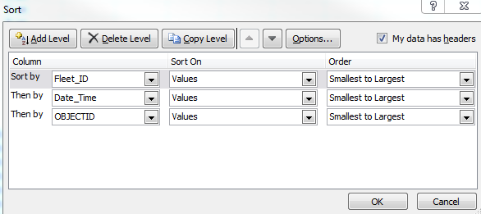
2. Set the first value in the difference field to the formula
   1. =IF(B2=B1,C2-C1,"OMIT")
3. Set the first value in the Clean field to the formula
   1. =IF(OR(G2="OMIT",G2>20, G2=0),"OMIT",G2)
   2. By omitting data, it allows accurate statistics. The formula is color coded to the reasons below
      1. By omitting rows with different fleet IDs (Done in the formula step 3a) we prevent the first point of a vehicle from looking at the last point of the previous vehicle. (This would be a large number, skewing our average)
      2. By omitting rows over 20 seconds, we remove any period of time where the vehicle had been turned off, parked, or otherwise wasn’t providing data. The purpose of this was to focus the data
      3. By omitting rows that have a 0 value for the difference we remove the duplicate entries caused by the collection program polling faster than the GPS updates. Leaving these in would skew the data to a lower number.
4. Select all cells in the Difference and Clean column, for all rows except the header row. Then fill downward. This will populate the formulas into all the cells.
5. When creating Pivot Tables, be sure to use the *Clean* field as a filter, and remove “OMIT” from the dataset.

How to calculate refresh rate using path collection data

1. Add a *Time Difference, Clean Difference, Fleet ID* fields to the data so the header row looks like

|  |  |  |  |  |  |  |
| --- | --- | --- | --- | --- | --- | --- |
| **OBJECTID** | **ID** | **Date_Time** | **Speed** | **Time Difference** | **Clean Difference** | **Fleet_ID** |
|  |  |  |  |  |  |  |

Fields to the right of the red line will need to be added, the ones to the left should exist

1. Sort the data by *ID*, then by *Date_Time*, then by *OBJECTID*
2. Set E2 to the formula
   1. =IF(B2=B1,INT((C2-C1)*86400),"OMIT")
   2. This will omit any data where the fleet IDs are not the same
3. Set F2 to the formula
   1. =IF(OR(E2="OMIT", E2 > 20), "OMIT", E2)
   2. This follows the same reasoning as the live log collection formula above. The upper bound of 20 limits any time the vehicle was turned off. There is not a need for a removal of 0 values, because this pulls logs from zonar.
4. *Fleet_ID* can be used to store the Fleet_ID from using a index-match formula on a lookup table to take the zonar ID and turn it into the fleet ID.
   1. Pseudo formula
      1. =INDEX(**lookuptable!fieldOfFleetID:fieldOfFleetID,** MATCH(**currentsheetname!B2**, **lookuptable!IDfield:IDfield**, 0))
      2. This may take some maneuvering and altering to work. The lookuptable is an export from the zonar system asset page, and can be stored as another tab in a workbook.