PROCESS ENGINEERING REPORT
Thermal Oxide Growth — Run-to-Run and Within-Wafer Variation Characterization
Process | Wet thermal oxidation, atmospheric, bubbler steam | Metrology | Filmetrics reflectometry, 5 pt/wafer
Substrate | Si (100), boat with dummy wafers at both ends | Runs analyzed | 2 (2026-02-03, 2026-02-10)
Report ID | OX-VAR-001 — characterization, not qualified | Prepared | Process Engineering
1. OBJECTIVE
Quantify and partition the sources of oxide thickness variation in the wet thermal oxidation process, establish where corrective effort should go first, and define the follow-on experiment required to resolve what the present data cannot.
2. EXPERIMENTAL MATRIX
Run | Setpoint | Time at setpoint | Ambient | Wafers loaded | Wafers analyzed | Points
R1 | 900 °C | 60 min (excl. ramp) | Wet, bubbler | 16 (A00–A15) | 12 | 60
R2 | 1100 °C | 60 min (excl. ramp) | Wet, bubbler | 16 (A00–A15) | 12 | 60
This is not a designed experiment. Time is held constant at 60 min and only temperature varied, so the two factors are not confounded with each other. But the runs were sequential and reactive — R2 was executed because R1 produced unexpectedly thin oxide — with one run per temperature, so temperature is fully aliased with run, day, furnace load and metrology session. No temperature coefficient, rate constant or activation energy can be estimated from these data.
3. DATA INTEGRITY AND EXCLUSIONS
Metrology recipe discontinuity. Twenty measurements per run were taken in a separate session on a different Filmetrics recipe, applied in error (R1: A08–A11; R2: A00–A03). In R2 the recipe boundary coincides with a 157 Å step in wafer mean at the A03/A04 slot boundary, so load position and metrology recipe are perfectly aliased there. All 40 are excluded; 12 wafers per run remain. Detail in Appendix A.1.
Export inconsistency. The summary block at the head of each file describes the 60-point original session, not the 80 surviving rows, and was not regenerated after the re-measured wafers were appended; it agrees with that session to within 0.5 % on mean and median. Its reported minimum and maximum still fall outside the surviving range, so a small number of extreme measurements were deleted before export. Reconstruction in Appendix A.1. Separately, A15 (both runs) and A05 (R1) are gross outliers with no assignable cause on record — retained in the primary analysis, removed in a sensitivity case, both reported.
4. RESULTS
4.1 Variance components
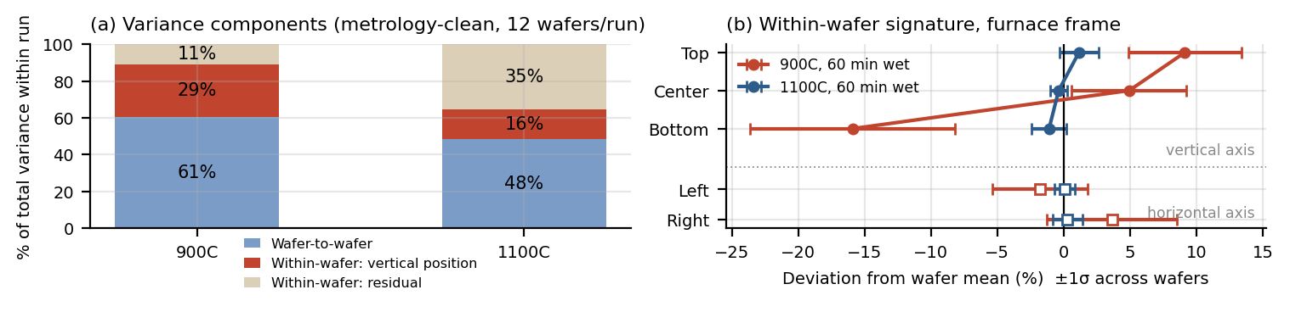
Figure 1. (a) Nested variance decomposition within each run. (b) Mean within-wafer deviation by furnace-frame position, ±1σ across wafers.
Component | R1 900 °C, % of total | R1 σ (Å) | R2 1100 °C, % of total | R2 σ (Å) | Sensitivity (flagged removed)
Wafer-to-wafer within run | 60.6 % | 126 | 48.4 % | 61 | R1 0.9 % | R2 66.2 %
Within-wafer: vertical position | 28.6 % | 87 | 16.3 % | 35 | R1 80.8 % | R2 23.3 %
Within-wafer: residual | 10.8 % | 53 | 35.2 % | 52 | R1 18.3 % | R2 10.5 %
Where to look first: at 900 °C the wafer-to-wafer term collapses from 60.6 % to 0.9 % when A05 and A15 are removed — essentially all apparent wafer-to-wafer variation in R1 is two wafers, not a distributed load effect — and 81 % of what remains is the vertical position signature. The first investigation is the vertical gradient and the cause behind A05/A15, not a general uniformity program. No run-to-run component is reported: with two runs it carries one degree of freedom and absorbs temperature, day, load and metrology session at once.
4.2 Within-wafer uniformity
Run | Range/2·mean | Range, wafers | 1σ/mean | Top−bottom | Range, T−B | Top>bot
R1 900 °C | 13.08 % | 5.37 – 21.86 % | 10.41 % | 25.0 % (222 Å) | 4.4 – 43.7 % | 12 / 12
R2 1100 °C | 1.17 % | 0.46 – 5.30 % | 0.96 % | 2.25 % (95 Å) | 0.1 – 10.6 % | 12 / 12
The five points lie on orthogonal axes with no recorded radius, so radial contour maps cannot be produced. In the furnace frame they are the top, bottom, left, right and center of a vertically standing wafer. The dominant signature is a vertical gradient — oxide thickest at the top, thinnest at the bottom — without exception in all 24 wafers. The horizontal difference is smaller and inconsistent in sign: the signature is gravity-aligned, not flow-aligned.
Thermal stratification and a bottom-specific mechanism (boat contact or carrier shadowing) both remain open: the runs imply inconsistent top-to-bottom ΔT, so stratification alone does not account for it. The ten-fold difference between runs follows from the shift out of reaction-rate-limited growth. See Appendix A.2.
4.3 Deal–Grove residuals
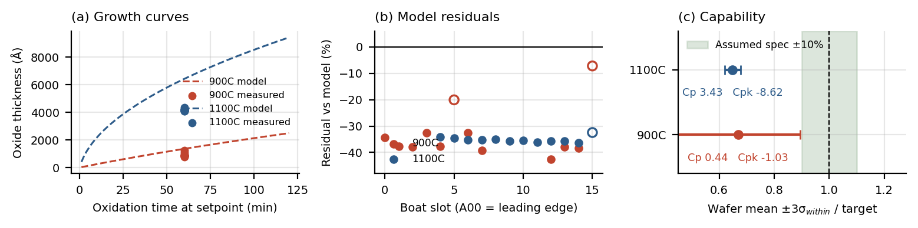
Figure 2. (a) Growth curves, wet O₂ on Si (100), measured wafer means at 60 min. (b) Per-wafer residual by boat slot; open symbols flagged. (c) Wafer mean ±3σ(within) vs. assumed ±10 % band.
Run | Model target (Å) | Measured (Å) | Ratio | Implied pH₂O factor | Implied ΔT (°C) | Implied eff. time (min)
R1 900 °C | 1353 | 904 | 0.67 | 0.64 | −26 | 38.7
R2 1100 °C | 6421 | 4165 | 0.65 | 0.47 | −90 | 28.3
Both recipes fall roughly 35 % short of the textbook prediction using standard wet O₂ (100) coefficients (B = 386 µm²/hr, 0.78 eV; B/A = 9.7×10⁷ µm/hr, 2.05 eV), τ = 0. The residual is a proportional deficit rather than a temperature-dependent divergence, and is flat across slot — a process-level offset, not a load effect.
Ramp accounting is ruled out: with 60 min dwell-only, real growth time exceeds 60 min, which would put measured thickness above the prediction, not below. Of three single-parameter explanations, sub-saturation bubbler pH₂O is the least inconsistent between runs (0.64 vs. 0.47); a temperature offset (−26 vs. −90 °C) and an effective-time error (38.7 vs. 28.3 min) are grossly inconsistent. With one time level the responsible parameter is not identifiable here.
4.4 Process capability
Specification basis: target is the hand-calculated Deal–Grove thickness for each recipe. No tolerance is on record, so spec limits of ±10 % of target are assumed and flagged as such, with capability reported at ±5 / 10 / 15 % so the assumption does not drive the conclusion. Within-sigma is the pooled within-wafer estimate (√MSW), matching the REML residual in 4.1; a moving-range estimator gives Cp 0.48 and 5.29.
Run | Target (Å) | Mean (Å) | σ within (Å) | σ overall (Å) | Cp ±5/10/15 % | Cpk ±5/10/15 % | Ppk ±10 %
R1 900 °C | 1353 | 904 | 102 | 159 | 0.22 / 0.44 / 0.66 | −1.25 / −1.03 / −0.81 | −0.66
R2 1100 °C | 6421 | 4165 | 62 | 85 | 1.72 / 3.43 / 5.15 | −10.3 / −8.62 / −6.91 | −6.29
Mean shift versus spread. The two runs fail for different reasons and need different actions. R2 has excellent spread — Cp 3.43 at ±10 % — but Cpk −8.62 because the mean sits 35 % below target, outside the band entirely: purely centering, corrected cheaply by recipe time. R1 has both problems, since Cp 0.44 means process width alone exceeds the tolerance band, so re-centering would not bring it into specification. Cpk here measures the gap between a first-principles model and the tool as built, not the stability of a qualified process. Nonconformance is 91.7 % below LSL in R1 and 100 % in R2; the stability index (overall σ ÷ within σ) is 1.68 and 2.11 against a 1.25 threshold, corroborating 4.1.
4.5 Statistical process control (SPC) and run-to-run control (APC)
I-MR charts of wafer mean are in Appendix A.3, in load order rather than time order — with two runs there is no basis for a time-ordered run-to-run chart, and all limits are trial limits. A15 falls beyond the upper control limit in both runs; the same slot violating in two independent runs makes a slot-specific assignable cause far more likely than chance.
APC response rule (proposed). Once ≥20 runs exist, hold run-to-run control on lot mean thickness with an EWMA controller, λ = 0.25, acting on dwell time. Fitted process gain is 14 Å/min at 900 °C and 41 Å/min at 1100 °C; a ±1σ deadband keeps the controller off common-cause noise. Out-of-control response by Western Electric rules: any lot mean beyond 3σ (Test 1), or nine consecutive on one side of centre (Test 2), suspends automatic adjustment and raises an engineering hold. Two consecutive Test 1 violations, or any moving range above its upper limit, escalates to tool-level investigation rather than a recipe trim.
5. CONCLUSIONS
1. The dominant within-wafer signature is a vertical, gravity-aligned gradient, oxide thickest at the top, in 24 of 24 wafers — 29 % of total variance at 900 °C and 16 % at 1100 °C, and 81 % at 900 °C with two outliers set aside.
2. Apparent wafer-to-wafer variation at 900 °C is almost entirely two wafers, A05 and A15, rather than a distributed load effect.
3. Both recipes grow roughly 35 % less oxide than the hand calculation predicts — proportional, flat across slot, not explained by ramp. Sub-saturation bubbler water partial pressure is the leading unconfirmed hypothesis.
4. Neither run is capable against a hand-calculated target. R2 fails on centering alone (Cp 3.43, Cpk −8.62), correctable by recipe time; R1 fails on both spread and centering (Cp 0.44) and needs uniformity work first.
5. The ten-fold uniformity difference between runs follows from setpoint and the shift out of reaction-limited growth — not a process improvement; any earlier reading of it as one is withdrawn.
6. RECOMMENDED PROCESS WINDOW
Pending resolution of the model offset, 1100 °C / 60 min wet is the recommended operating point where better than 2 % within-wafer uniformity is required: demonstrated mean 4165 Å, σ(within) 62 Å, non-uniformity 1.17 % half-range. 900 °C / 60 min wet is not recommended for thickness-critical layers, where within-wafer non-uniformity of 13 % would be yield-limiting.
Re-centering on the textbook targets would need roughly 93 min at 900 °C and 127 min at 1100 °C on the fitted rate; both extrapolate beyond the single verified time point and must be verified before use. The preferable action is to re-set the target from a demonstrated process center once the model offset is understood. No process window should be released to production on two runs — these are characterization data.
7. LIMITATIONS
One run per temperature, so temperature is fully aliased with run, day, load and metrology session. One time level, so no rate law or activation energy can be fitted. Boat slot is confounded with metrology recipe in R2 across A00–A03. Points lie on orthogonal axes with no recorded radius, so radial uniformity cannot be mapped. No gauge R&R exists, so the residual within-wafer term cannot be separated from metrology repeatability. A small number of extreme measurements were deleted before export.
8. NEXT EXPERIMENT
Action | Design
8.1 Gauge R&R — do first | Three wafers × five sites × three repeats, two operators, two days, one frozen recipe. Protocol in A.5.
8.2 2×2 factorial, replicated | 900 / 1100 °C x 30 / 60 min, two replicate runs per cell, eight runs, randomized across days. Detail in A.5.
8.3 Directed checks | Bubbler pH₂O calculation against the fitted 0.64 / 0.47, and a three-height thermocouple profile at both setpoints (A.5).

APPENDIX A — SUPPORTING DETAIL
A.1 Metrology recipe discontinuity
R1 wafers A08–A11 were measured 2026-02-17 on recipe "Si02_dwp" and report goodness-of-fit values of 1.35–2.01, against 0.91–0.997 for every other measurement in the dataset. A goodness-of-fit above unity is a different statistic on a different scale, indicating a different optical model rather than a differently named recipe. Those four wafers average 715 Å against 904 Å for their neighbours on both sides — a rectangular notch in the middle of the boat, which is not a physical furnace signature.
R2 wafers A00–A03 were measured 2026-02-24 on recipe "SiO2 on Si" and average 4322 Å against 4165 Å for A04–A15. The recipe boundary and the 157 Å step both fall at the A03/A04 slot boundary, so any leading-edge load gradient in R2 is perfectly aliased with the metrology change and cannot be claimed from these data.
The R2 file header additionally reports L1 n and L1 k values while the surviving data rows leave both blank, indicating the header statistics came from a floating-index fit and the rows from a fixed-index fit.
Header statistics reconstruction. The summary block in each file does not describe the 80 rows it sits above; it describes the 60-point original session. R1 header mean, median and σ are 900.0 / 887.2 / 161.1 Å against 904.1 / 890.7 / 158.8 Å for that session and 856.9 / 854.5 / 160.7 Å for all 80 rows. R2 header values are 4160.2 / 4146.5 / 81.1 Å against 4165.4 / 4148.8 / 85.4 Å for the session and 4204.7 / 4169.5 / 100.9 Å for all 80 rows. The block was therefore computed before the accidentally re-measured wafers were appended and was never regenerated — a bookkeeping artifact rather than a selection applied to the data.
A residual gap remains. The header minimum and maximum fall outside the surviving session range in both files (564.7 vs. 598.4 Å and 1410.2 vs. 1330.3 Å in R1; 4031.8 vs. 4044.3 Å and 4620.7 vs. 4583.9 Å in R2), so a small number of extreme measurements — of order two to ten, judging from the mean reconciliation — were deleted before export. Too few to shift the session statistics by more than about 0.5 %, but enough to account for the reported endpoints. The Meas # column cannot settle the question: it runs 1–80 without gaps in both files, but ascends while Date/Time jumps backwards between sessions four or five times, so it was reassigned when the sessions were merged and sorted by Sample ID and is a row counter rather than the instrument index.
A.2 Within-wafer gradient mechanism
At 1100 °C the vertical profile is close to linear (+1.15 % / −0.38 % / −1.10 % for top / center / bottom), consistent with thermal stratification in the tube. At 900 °C it is not linear: center sits at +4.9 % while bottom sits at −15.9 %, so the bottom is anomalous against a linear gradient and a bottom-specific mechanism — boat slot contact, or the carrier shadowing gas access at the wafer’s lowest point — is a competing explanation.
Attributing the entire gradient to temperature and inverting the growth model implies a top-to-bottom ΔT of 16–18 °C at 900 °C but only 5–6 °C at 1100 °C. A fixed tube stratification should produce a comparable ΔT at both setpoints, so thermal stratification alone does not account for the observation. Both mechanisms remain open and the thermocouple profile in Section 8.3 is the discriminating measurement.
The magnitude difference between runs is expected on first principles. At 900 °C wet oxidation retains substantial reaction-rate-limited character, where the linear rate coefficient carries a 2.05 eV activation energy; at 1100 °C growth is strongly parabolic at 0.78 eV. The same local temperature non-uniformity therefore produces a far larger fractional thickness spread at the lower setpoint.
A.3 Control charts and rational subgroup
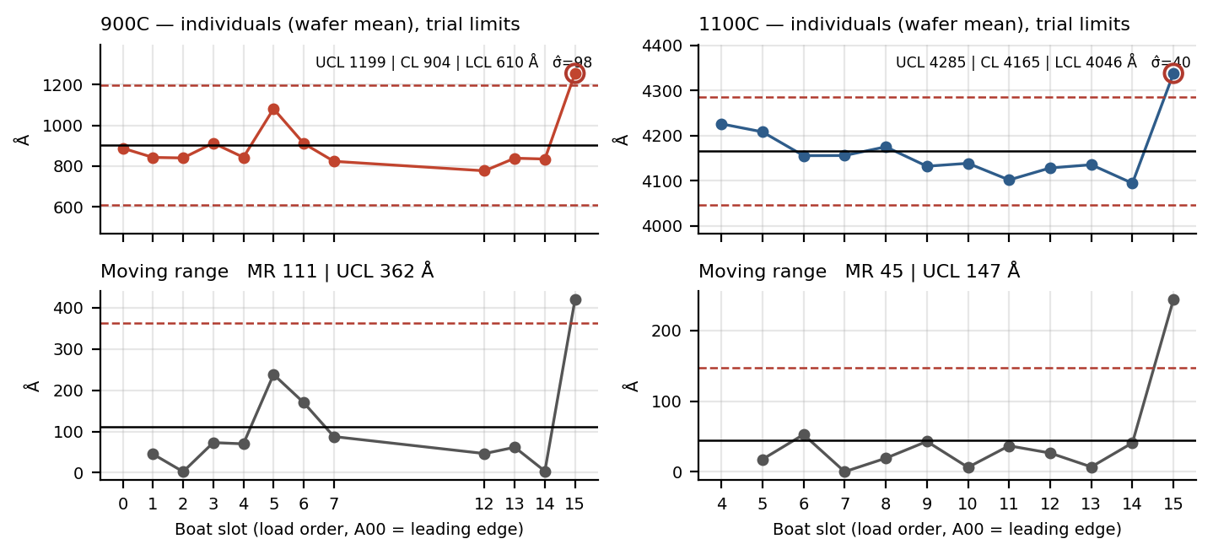
Figure 3. Individuals and moving-range charts of wafer mean thickness, plotted in boat load order. Trial limits from the moving range (σ̂ = M̄R/1.128). Circled points fall outside the control limits.
Charts are plotted in load order, not time order. With two runs there is no basis for a time-ordered run-to-run control chart; standard practice requires roughly 20–25 points before limits carry meaning, so all limits shown are trial limits. Plotted this way the chart estimates short-range wafer-to-wafer sigma robustly against any monotonic load-position trend and serves as a within-lot uniformity chart.
The wafer mean is the correct rational subgroup. The five within-wafer points are a spatial signature rather than random sampling error, so an X̄–R chart treating them as a subgroup would understate true within-wafer sigma; I–MR on the wafer mean avoids that.
R2 also shows a sustained monotonic decline from A04 to A14 that would trigger a trend rule. Whether that is a real leading-to-trailing depletion gradient cannot be established here, because the metrology recipe change in R2 falls inside the same span.
A.4 Per-wafer summary, metrology-clean set
Wafer | Run | Mean (Å) | Range/2·mean | 1σ/mean | Top−bottom (Å) | Top−bottom (%) | Residual vs model
A00 | 900C | 888 | 12.48 % | 9.32 % | 222 | 25.0 % | -34.4 %
A01 | 900C | 843 | 10.42 % | 8.32 % | 176 | 20.9 % | -37.7 %
A02 | 900C | 840 | 21.86 % | 16.97 % | 367 | 43.7 % | -37.9 %
A03 | 900C | 913 | 5.37 % | 4.41 % | 98 | 10.7 % | -32.5 %
A04 | 900C | 843 | 13.09 % | 10.94 % | 221 | 26.2 % | -37.7 %
A05 * | 900C | 1081 | 21.20 % | 17.51 % | 457 | 42.3 % | -20.1 %
A06 | 900C | 911 | 15.33 % | 12.10 % | 280 | 30.7 % | -32.6 %
A07 | 900C | 824 | 18.71 % | 14.39 % | 265 | 32.1 % | -39.1 %
A12 | 900C | 777 | 9.39 % | 6.75 % | 146 | 18.8 % | -42.5 %
A13 | 900C | 839 | 12.68 % | 10.52 % | 213 | 25.4 % | -38.0 %
A14 | 900C | 835 | 10.03 % | 8.20 % | 168 | 20.1 % | -38.3 %
A15 * | 900C | 1255 | 6.39 % | 5.52 % | 56 | 4.4 % | -7.2 %
A04 | 1100C | 4226 | 0.75 % | 0.61 % | 60 | 1.4 % | -34.2 %
A05 | 1100C | 4208 | 0.86 % | 0.70 % | 72 | 1.7 % | -34.5 %
A06 | 1100C | 4155 | 0.61 % | 0.47 % | 51 | 1.2 % | -35.3 %
A07 | 1100C | 4156 | 0.65 % | 0.50 % | 54 | 1.3 % | -35.3 %
A08 | 1100C | 4175 | 0.72 % | 0.58 % | 60 | 1.4 % | -35.0 %
A09 | 1100C | 4132 | 0.74 % | 0.58 % | 61 | 1.5 % | -35.6 %
A10 | 1100C | 4138 | 0.46 % | 0.37 % | 38 | 0.9 % | -35.5 %
A11 | 1100C | 4101 | 0.66 % | 0.54 % | 54 | 1.3 % | -36.1 %
A12 | 1100C | 4128 | 0.61 % | 0.59 % | 4 | 0.1 % | -35.7 %
A13 | 1100C | 4135 | 1.55 % | 1.12 % | 128 | 3.1 % | -35.6 %
A14 | 1100C | 4094 | 1.19 % | 0.91 % | 98 | 2.4 % | -36.2 %
A15 * | 1100C | 4338 | 5.30 % | 4.51 % | 460 | 10.6 % | -32.5 %
Asterisked wafers are flagged outliers with no assignable cause on record; they are retained in the primary analysis and removed in the sensitivity case.
A.5 Next-experiment protocols (detail for Section 8)
2×2 factorial execution. Load six monitor wafers per run at fixed slots including both boat ends, holding slot assignment constant across all eight runs so that load position enters the model as a blocking factor rather than as noise. Freeze a single Filmetrics recipe for the entire campaign and record the recipe name against every measurement, so that the failure mode documented in Section 3 cannot recur. Move from the five-point pattern to a nine-point pattern with recorded X–Y coordinates and a scribe-mark orientation reference, so that the vertical gradient resolves as a continuous profile rather than three points and so that radial and vertical components can be separated for the first time.
Gauge R&R. Three wafers spanning the thickness range of interest — nominally one near 900 Å, one near 4200 Å and one intermediate — measured at five sites each, three repeat measurements per site, by two operators on two separate days, on a single frozen Filmetrics recipe with the stack model and index treatment recorded. Report repeatability, reproducibility and total gauge variation as a percentage of the study variation and of the tolerance. The residual within-wafer variance component reported in Section 4.1 — 35 % of total variance at 1100 °C — cannot be attributed to the process until this study bounds the measurement contribution, and the recipe error documented in Section 3 makes it the highest-priority action in the campaign. Unload and reload the wafer between repeats so that stage placement enters the repeatability estimate rather than being held artificially constant.
Bubbler water partial pressure. Record bubbler water bath temperature, carrier gas species and flow rate, and any dilution flow, for both recipes as run. Compute expected water partial pressure from the saturation vapour pressure at the bath temperature and the carrier-to-total flow ratio, and compare against the factors of 0.64 (900 °C) and 0.47 (1100 °C) fitted in Section 4.3. Agreement within the run-to-run scatter would confirm sub-saturation steam as the cause of the proportional thickness deficit; disagreement, particularly if the computed factor is close to unity, would redirect the investigation toward tube temperature or toward the Deal–Grove coefficients assumed for this ambient.
Tube thermal profile. Profile the tube with a calibrated thermocouple at three heights — corresponding to the top, center and bottom of a loaded wafer — at both setpoints, at the same load configuration used in production runs. This is the discriminating measurement for Section A.2: a measured top-to-bottom ΔT of roughly 16–18 °C at 900 °C and 5–6 °C at 1100 °C would support thermal stratification as the sole mechanism, while a ΔT that is comparable at both setpoints, or substantially smaller than these figures, would implicate a bottom-specific mechanism such as boat slot contact or carrier shadowing. The same profile also checks setpoint against actual wafer temperature and so tests the temperature-offset explanation for the thickness deficit independently.

APPENDIX B - JMP PLATFORM OUTPUT
All results in Sections 4.1 to 4.5 were produced in JMP Student Edition and independently reproduced in Python. The two implementations agree to seven significant figures across REML variance components, method-of-moments ANOVA, and descriptive statistics. The single divergence, in the within-sigma estimator used for capability, is documented in B.4. Screenshots are unedited platform output.
B.1 Variance components - Fit Model, REML
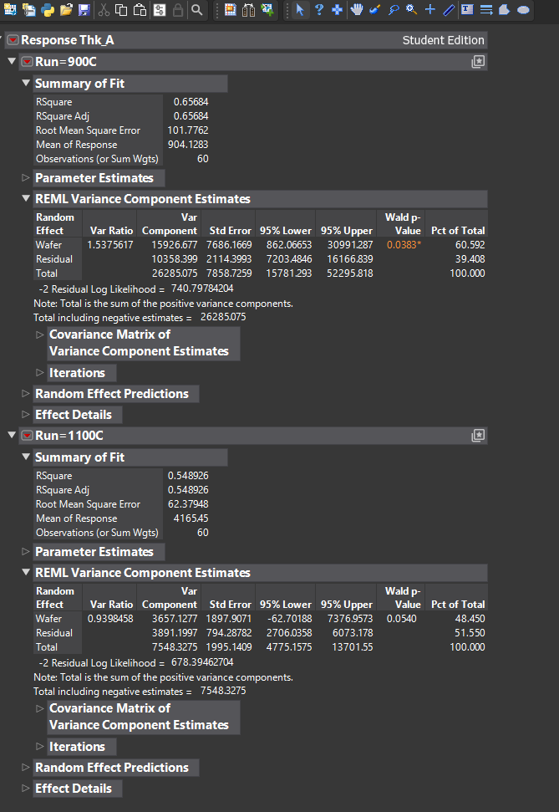
Figure B1. Fit Model with Wafer as a random effect, By Run, REML. Metrology-clean subset, 60 observations per run. Wafer variance 15926.677 and 3657.128; residual 10358.399 and 3891.200. Note the 1100 C wafer component has a 95 % interval of -62.7 to 7377.0, spanning zero.
B.2 Variance components - Variability chart, nested
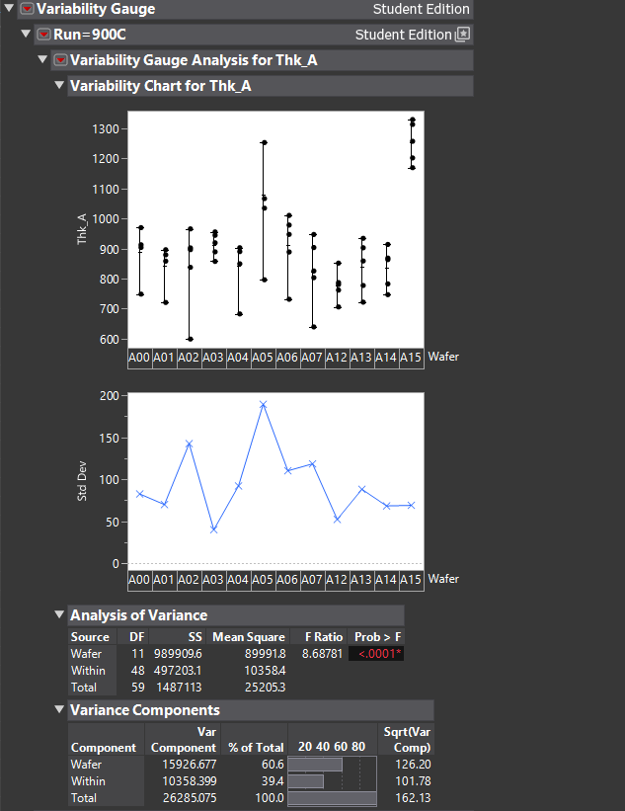 | 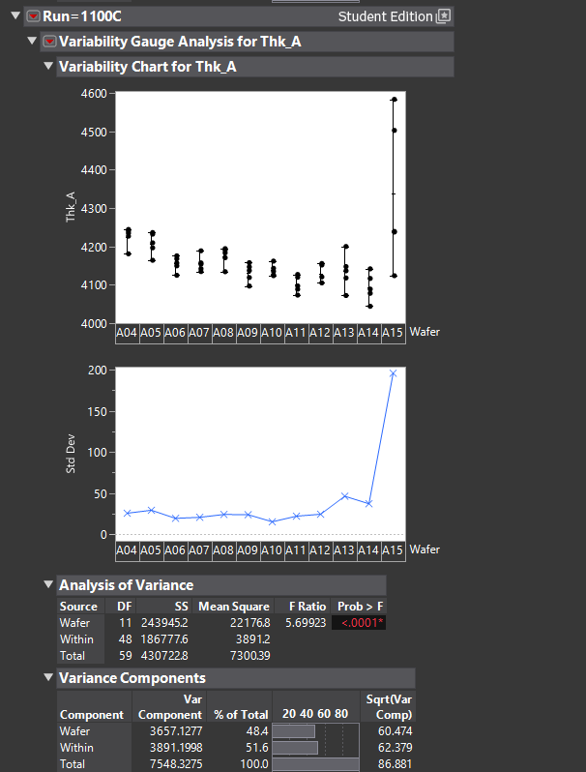
Figure B2. Nested ANOVA and variance components by run. Method-of-moments estimates reproduce the REML values exactly, as expected on a balanced 12 x 5 design. The Std Dev panels show the ten-fold uniformity difference between setpoints and the A15 excursion in both runs.
B.3 Within-wafer signature and uniformity
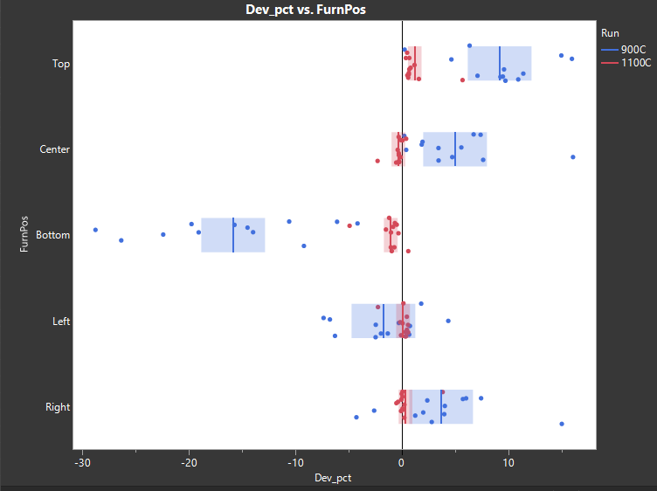
Figure B3. Deviation from wafer mean by furnace-frame position, overlaid by run. Vertical axis ordered Top / Center / Bottom, with the horizontal pair below. The 900 C series sweeps to -15.9 % at Bottom while 1100 C stays near zero.
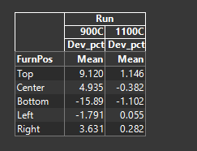
Figure B4. Mean deviation from wafer mean by furnace position, both runs (Tabulate). Values reproduce the Python calculation to three decimals at all ten cells.
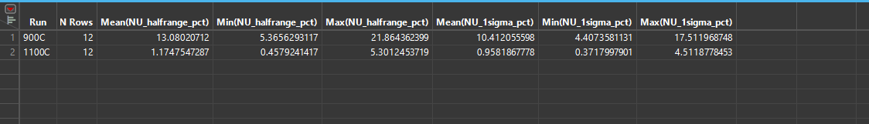
Figure B5. Within-wafer non-uniformity by run, 12 wafers each. The two ranges do not overlap: the best 900 C wafer at 5.37 % is worse than the worst 1100 C wafer at 5.30 %.
B.4 Process capability
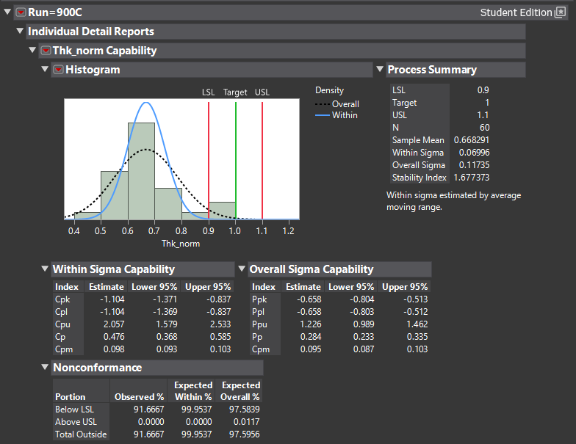 | 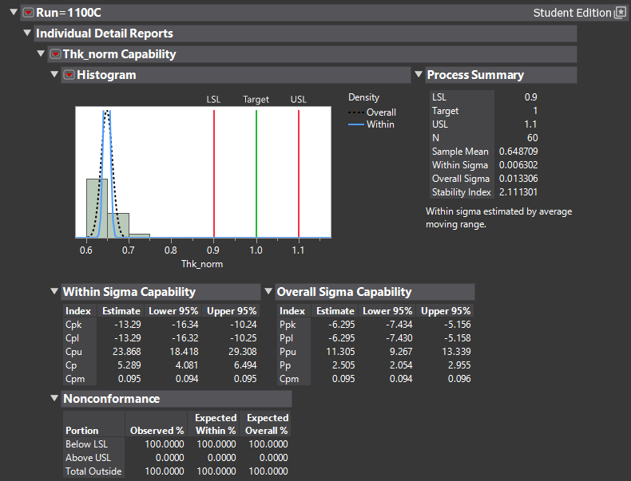
Figure B6. Capability against the assumed +/-10 % band on target-normalised thickness. Overall-sigma indices match the reported values exactly (Pp 0.284 and 2.505; Ppk -0.658 and -6.295). JMP Student Edition estimates within-sigma by average moving range rather than pooled standard deviation, giving Cp 0.476 and 5.289 in place of 0.44 and 3.43; the estimator is stated in the platform output. Nonconformance is 91.7 % below LSL at 900 C and 100 % at 1100 C, and the stability index is 1.677 and 2.111 against a 1.25 threshold.
B.5 Control charts
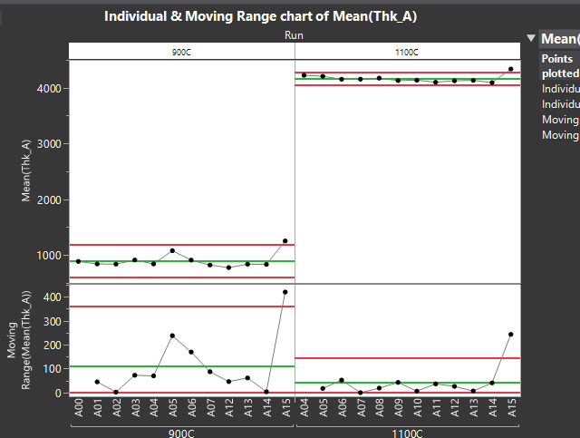
Figure B7. Individual and moving-range charts of wafer mean, by run, in boat load order. Moving-range limits 110.776 / 361.855 at 900 C and 44.982 / 146.935 at 1100 C. A15 exceeds the upper control limit on both the individuals and the moving-range chart in both runs, indicating the step between A14 and A15 is anomalous rather than only A15 level.
Prepared from Filmetrics reflectometry exports 900C_60min_Wet_A0-A15.xlsx and 1100C_60min_Wet_A0-A15.xlsx. Primary analysis in JMP (OX-VAR-001_analysis.jsl) against oxide_tidy_for_JMP.csv, independently cross-validated in Python (analysis.py); agreement documented in JMP_workflow_and_validation.md. Computed results retained as wafer_uniformity.csv and results.json.

