Read Me Document

Hours Taken: 4.5 approximate

Customer

In the screen below you can find customer by id and by name also you can edit and see the details of the customer. Currently customer data is hard coded in memory and intialize in Global.ascx file on application start.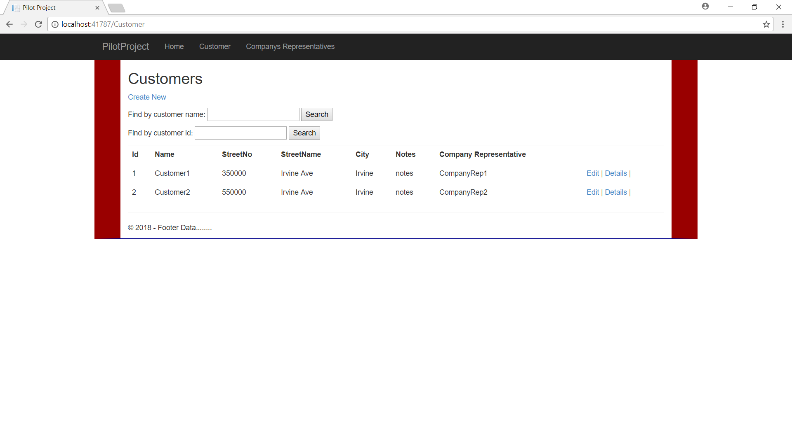

Company Representative

In the screen below you can find the company’s representatives by id and by name also can find the company representatives by company id too.

Also you can edit and see the detail of representative too.

Also, when you edit and modify the field and press tab or leave the field it change the color to yellow.

Currently company representative data is hard coded in memory and intialize in Global.ascx file on application start.

Note: currently edit and add is not in the scope of this project.

