Họ tên: Trần Vân Anh

MSV: B20DCCN075

# Apps

* 1. **catalog**
  2. **catalog/models.py**

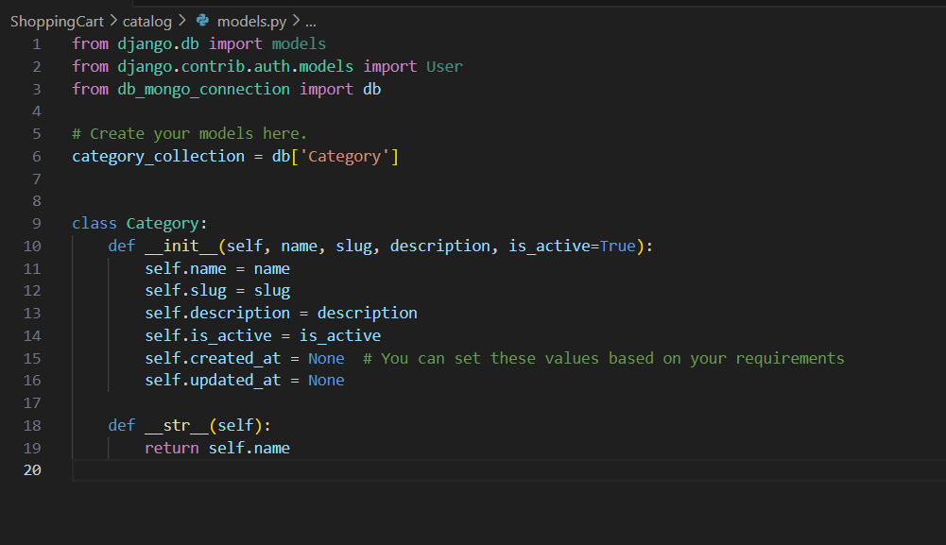

* 1. **catalog/views.py**

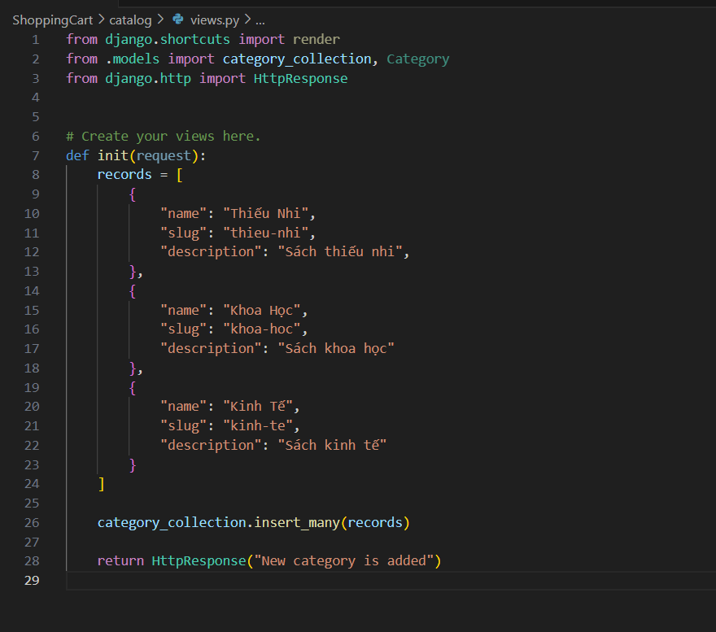

* 1. **catalog/urls.py**

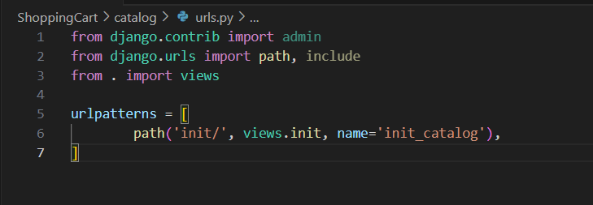

* 1. **product**

**2.1. product/models.py**

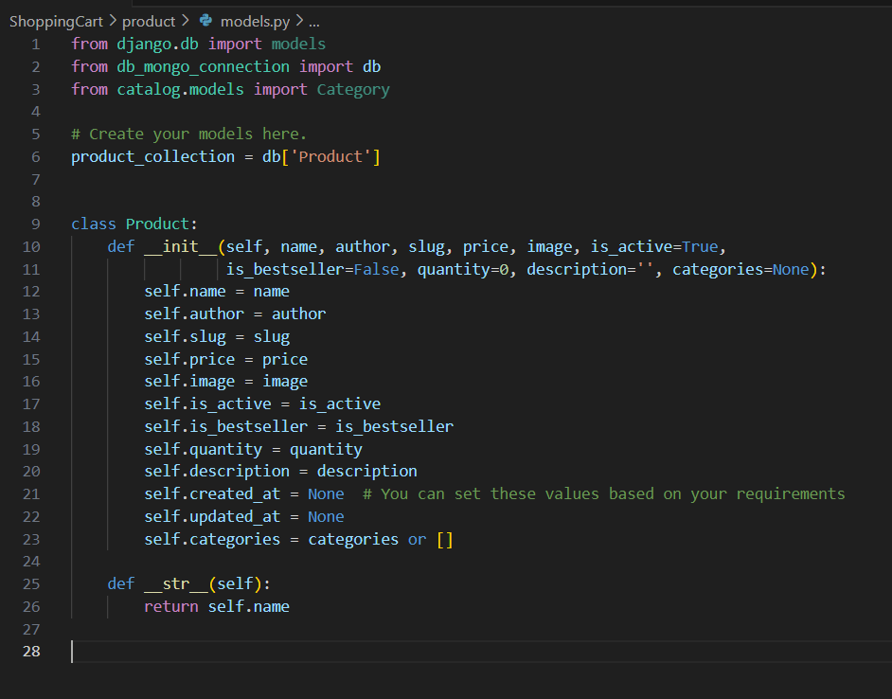

**2.2. product/views.py**

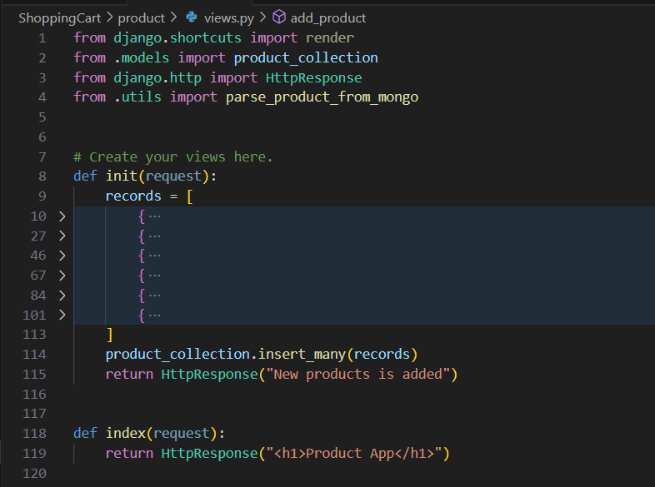

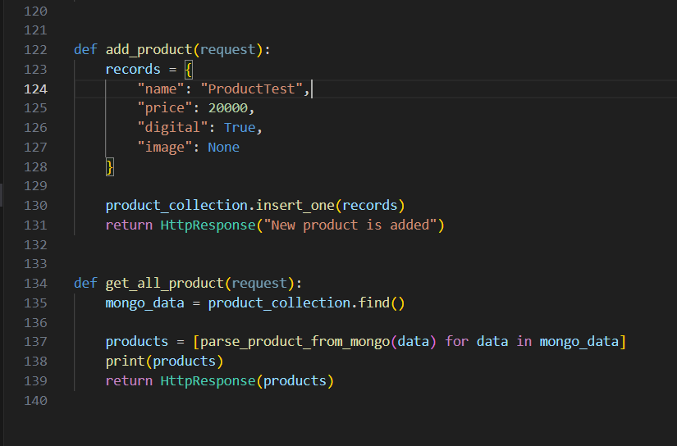

**2.3. product/urls.py**

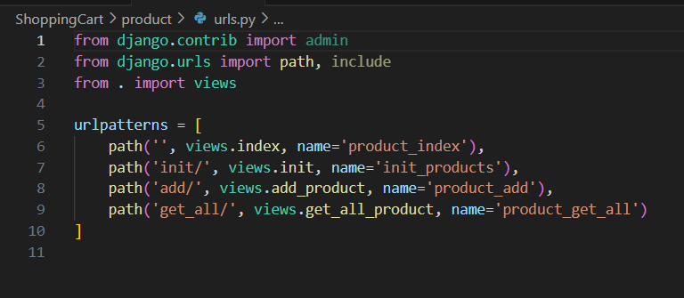

* 1. **cart**

**3.1. cart/models.py**

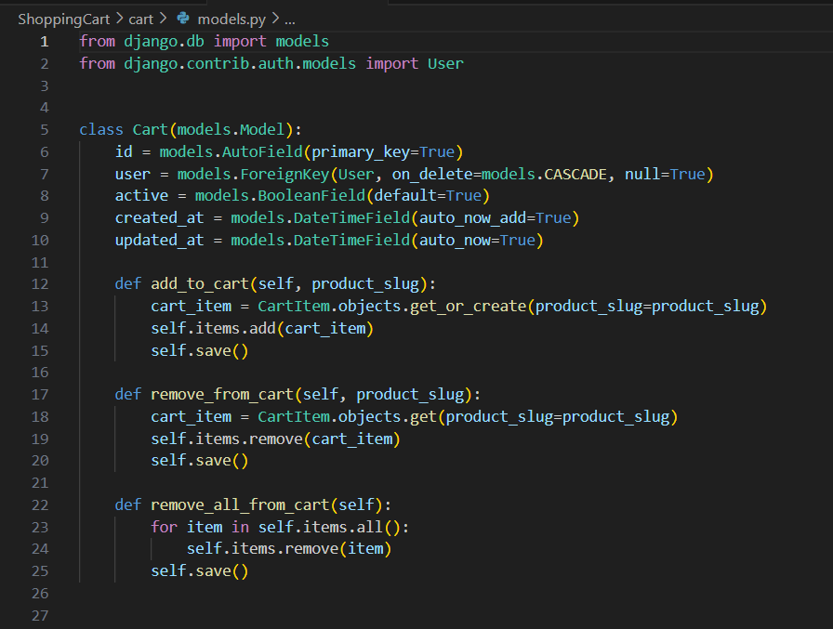

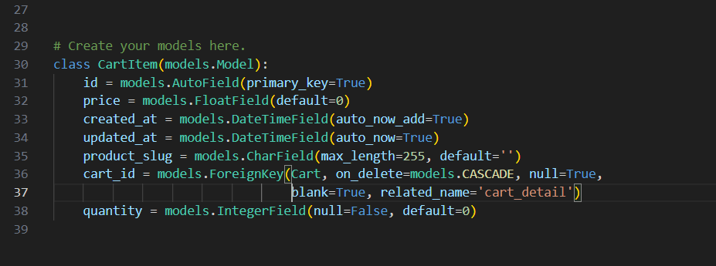

**3.2. cart/views.py**

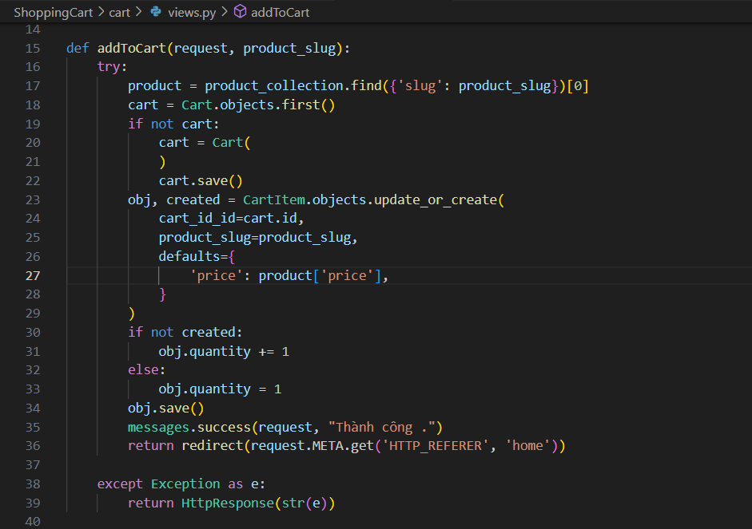

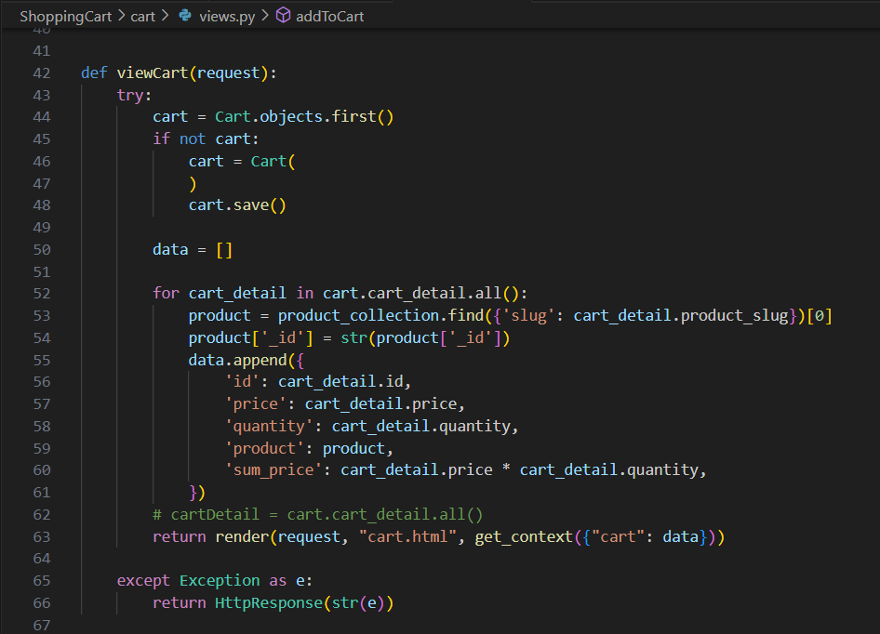

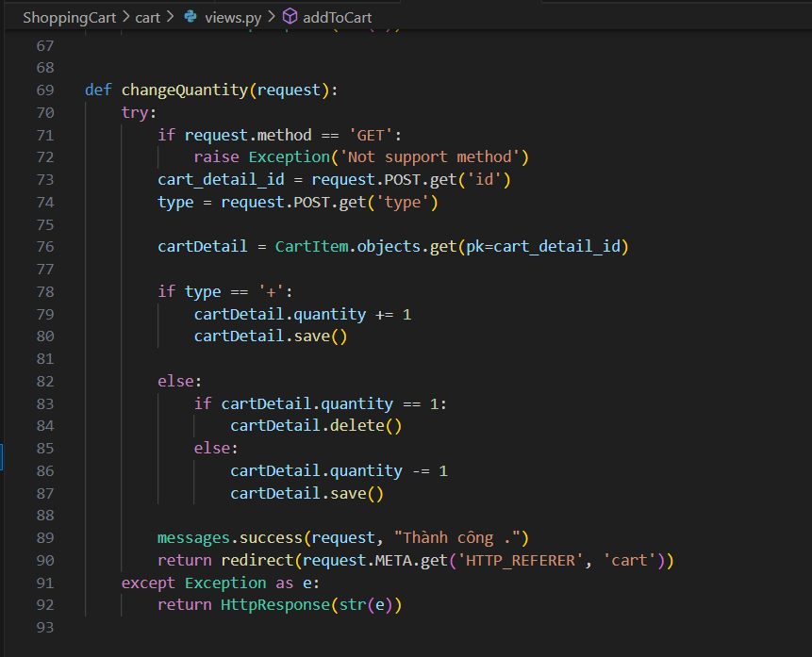

**3.3. cart/urls.py**

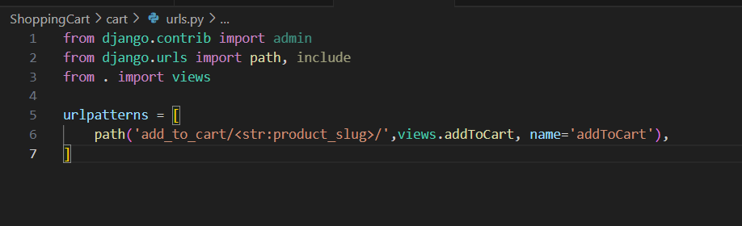

* 1. **app(checkout+search)**

**4.1. app/models.py**

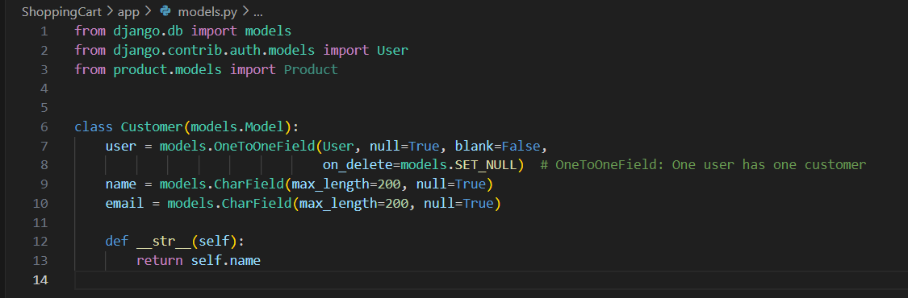

**4.2. app/views.py**

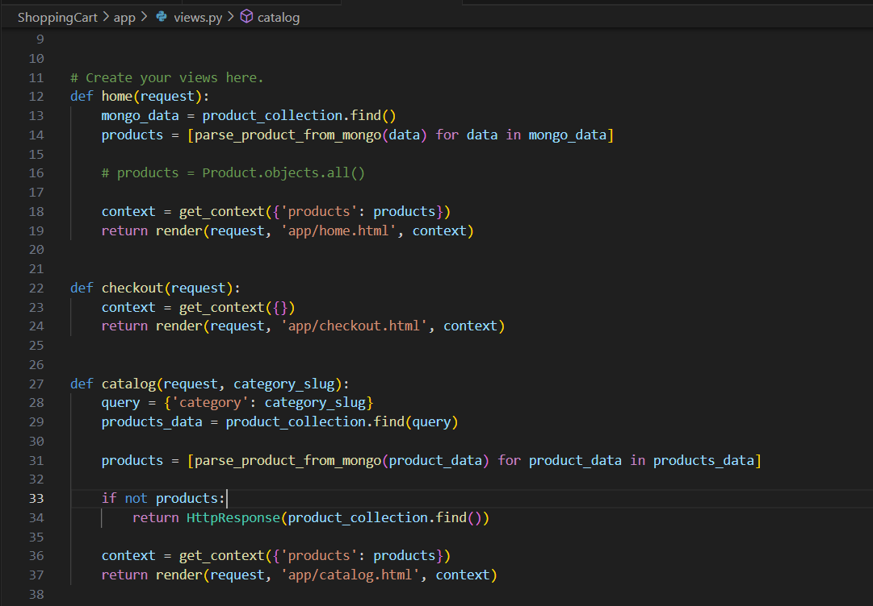

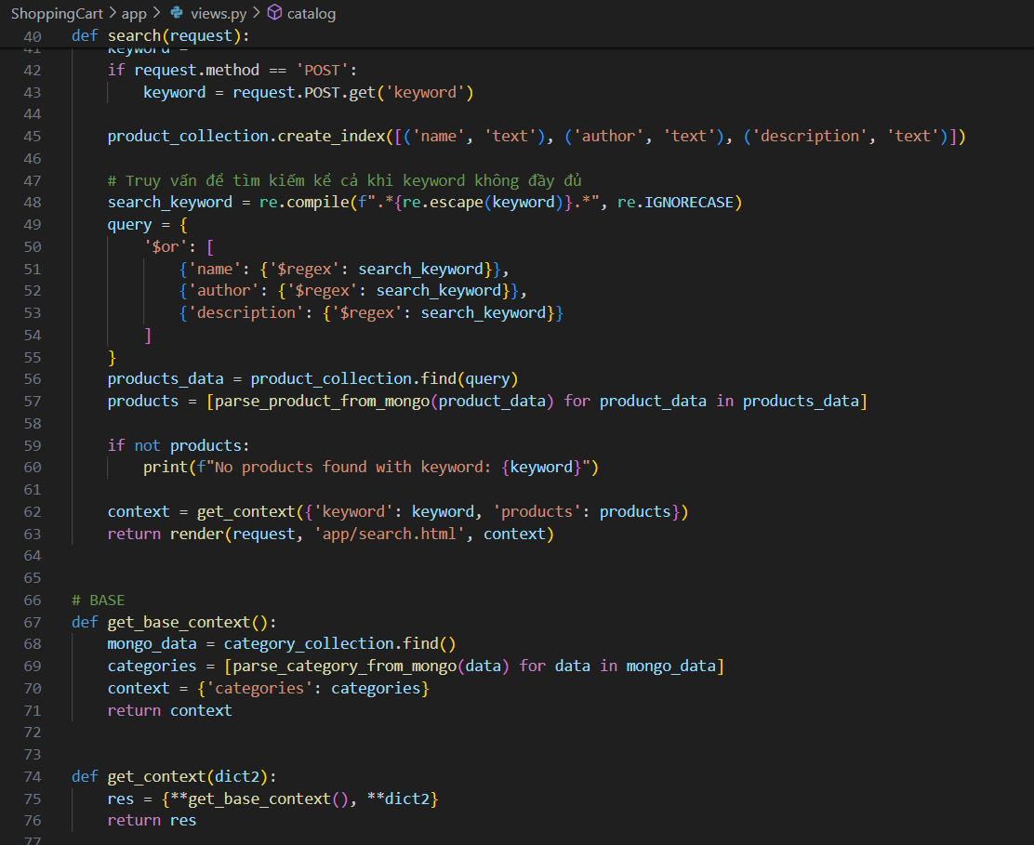

**4.3. app/urls.py**

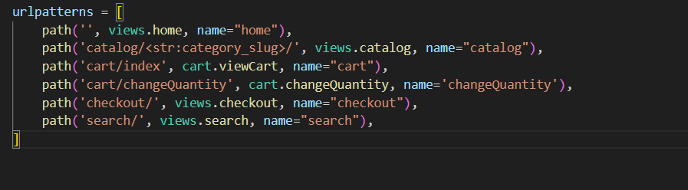

# ShoppingCart

* 1. **INSTALLED_APPS**

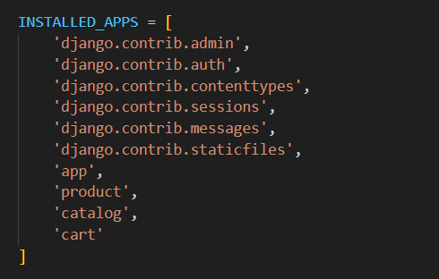

* 1. **Database**

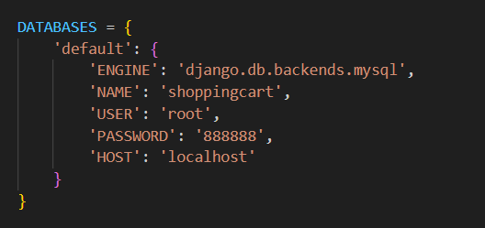

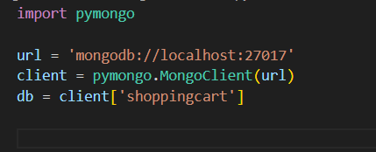

* 1. **urlpatterns**

