Gordon Peter Wills
  Tel: 07710416608 | Email: gordy.wills@gmail.com
Web: https://gordywills.com | : https://www.linkedin.com/in/gordywills/
I lead teams that get hard things done. I actively grow business cultures where trust, safety, and belonging are the bedrock of fostering individual growth and cohesive teamwork. Over a 25-year career in technology I have evolved from a Royal Signals officer to software engineer to an engineering leader. My experience is technology centric, but true satisfaction comes from creating high-performance teams to achieve the objectively hard. Living by the principles rooted in my military service of commitment, loyalty, integrity, and professionalism, I help others live and work to these ideals. As a lifelong learner I love exploring new ideas, particularly in technology; I strive to embed a learning mindset in my organisations, welcoming the lessons of both success and failure.
Career Timeline:
Skills:
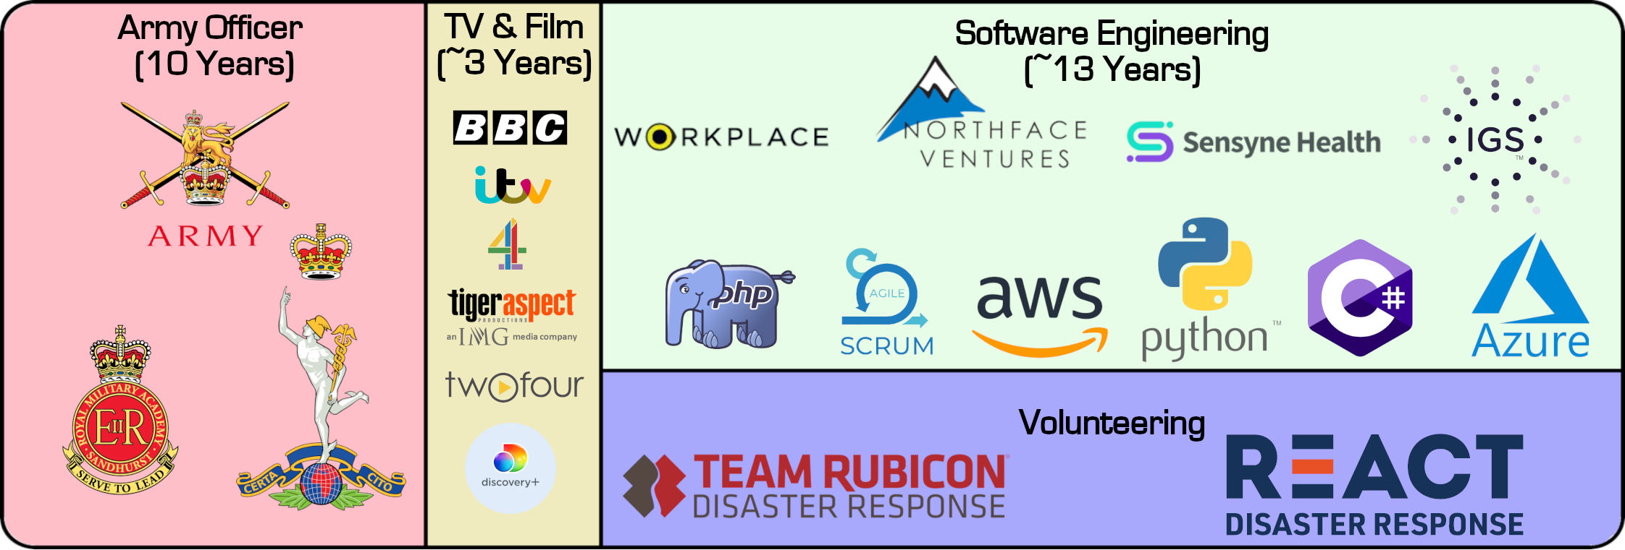For more details see LinkedIn: https://www.linkedin.com/in/gordywills/
Leadership: A servant leader, trusting frontline decision makers, setting OKR goals in line with business objectives, and facilitating the environment for success. | Agile Thinking and Coaching: Assume it can be done, take small fast steps and respond to feedback. Base decisions on evidence, make decisions at lowest level. Embrace failure to learn.
Strategy, Forecasting and Budgeting: Helping to shape long term business/investment plans, then setting and managing departmental budget and recruitment constraints. | Systems Architect: User focused and evidence based architectures make for the best products. Ensuring products work within their ecosystems; providing control, data and telemetry APIs.
Supplier and Partner Management: Developing relationships with partners and suppliers to ensure mutual commercial success. Identifying opportunities to reduce business costs by leveraging already built solutions. | DevOps Culture: Instilling a CI/CD mindset that belongs to the full engineering team. Providing platforms for rapid product change and experimentation. Empowering customer support to solve problems for users.
For more details (and more skills) see: https://gordywills.com
Interests:
Adventuring: I love being outdoors and hiking long distances, recently covering ~1400 miles of the PCT and ~600 miles of the TA. | Gaming: Board or computer games, you will find me playing anything that requires thought, tactics and strategy. | Astronomy: Focusing on naked eye observing I also have an 8” reflector for absorbing the majesty of the Moon and Jupiter.
Executive Summary:
I bring proven technology leadership from a wide experience base gained over 25 years. I am human centric, creating and nurturing cultures that help humans to be better and to perform. I understand business and, more importantly, investors and the part the engineering team plays in generating revenue. I can design systems and then recruit the teams to build and maintain them. I love to learn new things, am passionate and dedicated, but I am a real human too.

I am an intelligent, hard-working human seeking other intelligent hard-working humans to achieve meaningful things. I am seeking roles at Chief Technical Officer/Director of Technology level.

