Using agent-based modelling to infer economic processes in the past

##### 

##### Iza Romanowska

##### Barcelona Supercomputing Centre, Spain

##### iza.romanowska@bsc.es

## 

Abstract

###### Inferring past economic processes from archaeological data is a notoriously difficult process. The interpretation of archaeological data is often hampered by a number of unquantifiable uncertainties related to pre and post depositional factors as well as differing research methodologies. Here we explore the possibilities offered by simulation - a relatively little known and rarely applied computational tool in archaeology. It is argued that it holds great potential to aid the process of theory building and hypothesis testing, currently undertaken only conceptually by the majority of archaeologists. Formalisation of theories and the ability to test their feasibility and correspondence with archaeological data are highlighted as the key advantages of the method. To illustrate these advantages, a simple model of exchange is presented using a particular type of simulation technique: agent-based modelling. The results highlight the non-linear nature of interdependencies between the level of production and the trading capacities of commercial centres engaged in the exchange of goods, shaping the distribution of these goods over large distances. In addition, the reader is encouraged to familiarise themselves with the technique and the model using an openly available tutorial.

## 1. Introduction

The grand ambition of most of the research concerning the Roman trade system, or indeed any trade system, is to identify what economic processes are at play and whether they can be reconstructed from the collected data. Compared to their counterparts studying modern economics archaeologists and ancient historians face an additional double hurdle of the incompleteness of the data and the uncertainty regarding their suitability as proxies for the ancient economic processes. Here, we demonstrate how to overcome these limitations by using a formal computational method enabling researchers to match patterns detected in data to particular economic processes.

Trade is a complex dynamic system. It can be classified as a complex system because its elements interact with each other in a non-linear way resulting in creating global outcomes which cannot be easily deducted from the individual attributes of these elements. To illustrate this, consider financial markets. They are composed of agents whose main behavioural rule is “buy low, sell high”. Yet, despite the apparent simplicity of the system and the rules of interaction the emergent pattern of financial fluctuations over time is notoriously difficult to predict. Trade is also a dynamic system. It changes over time and is subject to ‘catastrophic’ events, such as wars, droughts or politically inspired regulations as well as to more subtle trends caused by changes in supply and demand. The primary research tool for studying complex dynamic systems in all branches of science is simulation (Hartmann 1996).

There can be little doubt that ancient trade should also be categorised as a complex dynamic system because of the interplay between different actors, economic processes and feedback loops/ However, this makes ancient trade a particularly difficult topic to study using traditional archaeological toolkit. As Brughmans and Poblome (2016) recently argued what is currently needed to move forward the study of trade in the past is the development of qualitative, formal frameworks that will allow researchers to infer past economic processes from the datasets they painstakingly collect. In simple words, what archaeology of trade interactions needs now is a tool that will enable researchers to link the data to concrete economic processes and in particular to establish what do we expect the data to look like if a given economic process took place in the past. To do so it is necessary to construct a formal model to generate ‘artificial data’ which can then be compared to the available archaeological data.

This shifts the research focus from collecting and analysing data in hope that “it will speak for itself”, towards using it for testing and validating formal economic models and identifying past economic processes. This research strategy can also guide future data collection and analysis as it is relatively easy to identify what type and how much of data is necessary to validate/test any given model. As a result, this approach can help overcome some of the commonly cited issues of archaeological data (e.g, Bowman and Wilson 2009), namely:

* The incompatibility of different datasets (What was collected? How was it done?), and
* The incompleteness of data (Is it representative of the process that occurred in the past?).

First, data can be collected in many different ways (single count of sherds, number of sites with a specific type of pottery, MNI - minimum number of individuals, etc.), which often obstructs attempts to compare one assemblage to another. However, computational modelling often uses patterns in the distribution of the data, that is, large-scale trends, such as increase or decrease over time, sudden drop, replacement of one type by another, a certain slope of the inception curve, etc. These trends can be detected in any dataset, regardless of its type or the collection method.

Second, the incompleteness of data and the inherent postdepositional biases introduced into it in the past and present are often cited as a primary factor hampering attempts to reconstruct the past with any degree of certainty. Here again, formal modelling methods can assist researchers. The post-depositional factors can be included in the model to account for the biases in the data set. Equally, models running on a wide range of inputs and algorithms (null models) can provide a ‘benchmark’ to which the data can be compared to see if the economic processes we suspect played part in the past have left a mark on the data at all.

In sum, computational modelling provides a new, relatively unexplored avenue of research which holds much potential for archaeological research and which have proven most valuable in many closely related disciplines. Here, we will use a simple example of an abstract model of exchange to illustrate how one particular formal computational technique - a type of simulation called agent-based modelling - can identify past processes and interactions and, therefore, aid researchers in understanding and interpreting their datasets better. In addition, the simulation has been deconstructed into a practical tutorial allowing the readers to explore the presented results for themselves and expand the model according to their interests. The tutorial can be found at: github.com/izaromanowska/ABM_tutorials.

## 2. Introducing Agent-based Modelling

Simulation is a family of methods used in a very wide variety of research contexts and case studies. Although most archaeologists associate simulation with engineering and computer science, in fact, it is a common tool in many disciplines closely related to ours, such as sociology, geography, health science or ecology (Chattoe-Brown 2013; O’Sullivan and Perry 2013). There are also different types of simulation: a variety of equation-based models, such as system dynamics common in ecology or fluid dynamics models often used by engineers, numerical simulations, game-theory models popular among economists, cellular automata or finally, the simulation technique most commonly used in archaeology: agent-based modelling (Davidsson and Verhagen 2013; Lake 2014).

What unites them all is having two elements: 1) a model at their core and 2) a time dimension. A model is an artificially constructed simplified abstraction of a real-world system. What is included in this abstraction depends on the research questions asked of the model (Sterman 2000). Thus, a model of world financial markets may include agents trading goods and their portfolios. It is unlikely though that such model will record the traders heights and widths - characteristics that would without doubt play an important part in a model of the pedestrian movement in and out of the London Stock Exchange. This is not to say that in the first case modellers do not think that traders have a height or width but as far as a model of financial markets is concerned these aspects are not relevant to the research questions posed. Thus, the aim of a model is not to represent the reality in all its detail but to identify and separate only these elements that are relevant to the questions asked of the model.

To move from a model to a simulation it is necessary to add time. A simulation models a process hence it needs to change and evolve over time. This is the main difference between simulation and other types of computational models. GIS models, 3D models, statistical models all offer static snapshots of the studied phenomena. Simulation focuses on the process and change over time.

In sum, a simulation can be defined as a dynamic abstraction of a real world process built in a formal, computational environment. As such it can be used in different capacities: from development of theories to providing predictions and supporting empirical experiments. Here we will focus on the heuristic functions of simulation, that is, the ‘theoretical’ end of the spectrum.

In particular, there are three potentially worthwhile applications of simulation techniques to archaeological case studies, and the study of Roman trade in particular: i) simulation as a tool to ”think with”, ii) simulation as a formal method of theory building and iii) simulation as a hypotheses testing framework (Lake 2014; Premo 2006). These three functions of simulation: a formalisation tool, a theory building aid and a hypothesis testing framework hold much potential for disciplines such as archaeology, where data is incomplete and often non-randomly sampled and where conducting empirical experiments is unfeasible (for example, because the society we are interested in is not accessible).

First, the most evident attribute of formal computational models is that they are formal. That is, the entities and the interactions between them are clearly defined usually using mathematical notation or, at least, computer code. As such there is no place for ambiguity, competing interpretations or underspecification of the model elements. This may feel restrictive to humanities scholars who are used to expressing themselves in natural language over pages of manuscripts. Nevertheless, it brings a number of advantages. Formalisation of one’s ideas often clarifies them and facilitates identification of logical or contextual errors in the model. Using a formal language (e.g, equations) to describe a model lays bare even small inconsistencies which would pass as inconsequential in the informal environment of natural language. Thus computational modelling (simulation included) is often termed a “tool to think with”. Once formally defined the model is accessible (understandable) to anyone. Even more importantly, it will be understood and interpreted in exactly the same manner regardless of the background or attitudes of the researcher who approaches it. This facilitates and encourages constructive critique, exchange, testing and extension of models - propelling the process of building the understanding of past phenomena in a cumulative fashion.

Second, in disciplines where theory is not well developed, i.e., the causal relationships between system elements are not fully understood, such as social sciences, simulation can aid theory building (Barton 2014; Hartmann 1996). By creating an artificial world and subjecting it to any type of experiments the researcher fancy (from increased intergroup aggression to an asteroid strike) modelling enables us to unravel the interdependencies in the system and, often surprising, consequences of the internal dynamics of the system as well as the impact of external factors. Although all researchers regularly perform such “thought experiments” (e.g., “if production of wine increases, I expect to see more wine drinking sets as well”), the amount of information humans can manipulate effectively in their heads restricts the explanations to only the simplest of causal relationships (“if x then y”). Given the complexity of the internal dynamics and the impact of external factors on the past and present social systems this limitation of conceptual research makes it inadequate for many problems archaeology aims to study (Neiman 1995).

Third, in archaeology and other disciplines we are often confronted with a number of potential explanations of the studied phenomena where all of them fulfil the condition of plausibility and internal logic. Choosing from equally plausible alternatives is then often guided by subjective ‘feeling’ or other not-strictly scientific methods, such as dependence on authorities. The phenomenon of confirmation bias which makes us put more faith into evidence that supports what we already believe in means that strong convictions can be carried on even from the early undergraduate years. Simulation (and other computational modelling tools) can help to break this impasse by comparing the data prediction of each of the potential theory with the ‘real-world’ data to determine which one is the most consistent with the evidence we have (e.g., Crema et al. 2014). Again formalisation of competing theories is key. Once we establish how the data is expected to look like according to each competing hypothesis we can then much more easily identify these, which despite looking plausible, are inconsistent with the available evidence. Models that corroborate with data patterns found in the archaeological record can also be ranked according to their degree of correspondence with the data.

There is one specific family of simulation studies that in particular fulfils these three functions (formalisation, theory building and hypothesis testing) - the so-called “models from first principles” or “null models” (Brantingham 2003). In physics, mathematics and philosophy models build from first principles are models which consist of only the minimum number of the most basic assumptions (principles). The most famous example of this is Whitehead and Russell’s proof from first principles in *Principia Mathematica* which took over 300 pages to demonstrate that 1 + 1 = 2. In social and natural sciences the process of constructing null models is less strict. However, the general premise is the same: the model is constructed from the most basic of ingredients (entities, rules of behaviour, external factors, etc) that most certainly played a role in the real system. Such benchmark models show how things would look like if the world was the simplest possible. If such model produces artificial data resembling the real-world data it is possible that additional processes we believed to have occurred in the past might have not done so or at least they have not left a mark on the data making their identification from the available dataset impossible (e.g, Brantingham 2003).

To further illustrate the points raised here in the next section we will present a simple, null model of exchange. Although not aiming to capture the full complexity of the trade in the Roman Empire it provides some data prediction. It also raises important issues regarding the mechanisms of regional and macro-scale exchange therefore aiding the theory building. The aim of the model is to unravel the pattern of uptake of new goods at trading markets differentiated by their distance from their production centre. Since it is a null model a number of simplifying assumptions have been made when constructing it in order to provide a ‘benchmark’ data prediction. As mentioned before it is freely accessible at github.com/izaromanowska/ABM_tutorials. Also, it is accompanied by a tutorial allowing any researcher interested in these issues to change any aspect of it and extend it with factors s/he deems important.

## 3. Model description

This model description follows a simplified version of the ODD (Overview, Design Concepts and Details) protocol (Grimm et al. 2010).

3.1 Purpose  
 The aim of the study is to elucidate the pattern of goods distribution at markets located at different distances from a production centre. In particular, what is of interest here is the uptake curve and the impact of a different trading capacities on the frequency of goods in assemblages at different markets. The overarching goal is to provide benchmark data prediction for the most fundamental economic processes involved in simple goods exchange over distance, such as an increase and decrease in production, an increase and decrease in trading capacity, or the proportion of goods reaching different markets. The simulated trend lines can then be directly compared with the changes in distributions of different types of archaeological material over time at archaeological sites.

3.2 Entities, state variables and scales  
 The simulation consists of a production centre surrounded by trading markets. The production centre has a production capacity determined by the user. Each trading post is located within a band representing its distance to the production centre (*distance-band*)(Figure 1). Note that each band has a higher number of markets (first band - 4 markets, second band - 8 markets, third band - 12 markets, etc.). Each trading post has a trading capacity defined as the maximum number of goods it can store at any one time (*storage*). The simulation is highly abstract meaning that the distance is represented by the number of ‘trade intermediaries’ and there is no explicit time dimension, other than a ‘trading cycle’.

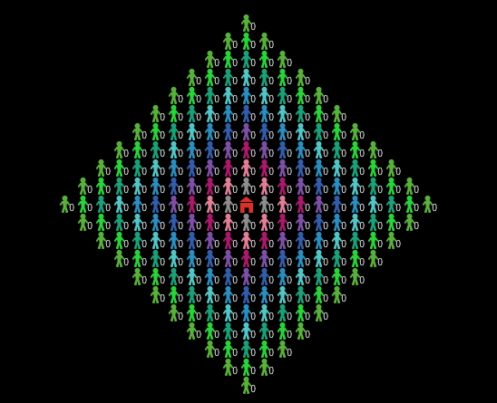

###### Figure 1. The view of the modelled world. The production centre is symbolised by a house icon and trading markets are shown as little human figures whose colour denotes their distance to the production centre.

3.3 Process overview and scheduling  
 At each time step the production centre generates a number of goods defined by user (*production size*). These goods are distributed to the four closest trading markets until there are no more goods left or the markets reached their storage capacity. The trading markets will then commence the trade procedure. They will sell exclusively to the neighbouring trading markets in a higher distance band, i.e., those further away from the production centre. Each market will keep on selling goods until the user defined *storage threshold* (e.g., defined as a percentage of the storage capacity - *storage*) is reached or until all neighbouring trading markets are at their full storage capacity. All trading markets will accept goods coming from one of the neighbouring markets in a lower distance band until they reach their maximum storage capacity. At the end of a time step each trading market ‘consumes’ one good to account for accidental loss/breakage, etc.

3.4 Initialisation and input data  
The simulation is initialised with six distance bands. That is, for goods to reach one of the most distant markets it has to first pass through five intermediaries. The simulation was run under a combination of low, medium and high *production level*, *storage* and *storage threshold* (27 scenarios in total) (Table 1). Each run was repeated 10 times to account for the stochasticity in the model. However, the variance in the results between runs is negligible.

|  |  |  |  |
| --- | --- | --- | --- |
|  | **low** | **medium** | **high** |
| Production level | 10 | 50 | 100 |
| Commercial capacity | 10 | 50 | 100 |
| Storage threshold | 10% | 30% | 50% |

*Table 1. Tested parameter values.*

## 4. Results

The results show clear correspondence between the distance from the production centre and the pattern of increase in the amount of goods at the sites. Figure 2 visualises this relationship on an example plot. First, the time of the first appearance of the goods increases with distance. Second, the steepness of the goods uptake curve slopes is directly proportional to the distance from the production centre. The further away the trading market the less steep the initial curve. This is a reflection of the rate of goods acquisition which varies proportionally to the distance.

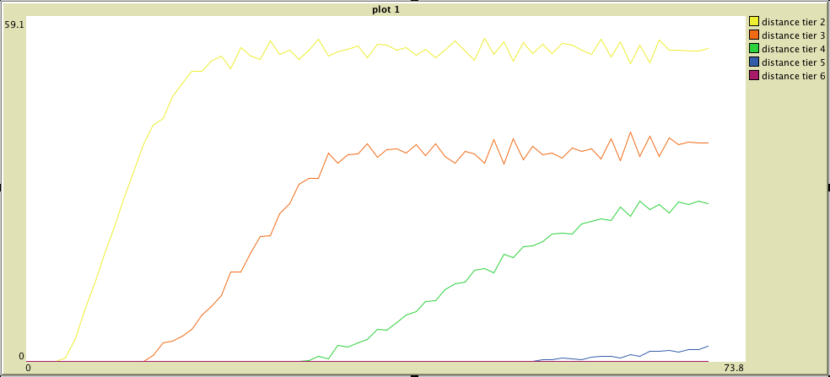

###### Figure 2. The uptake curves. Each line shows a change over time in the amount of goods present in all sites belonging to one distance tier. (Scenario plotted: production-50, storage-100 storage-threshold-0.5).

The level of production of a given good and the number of sites it reaches are only directly correlated for low values of production level (Figure 3). In the example given in figure 3, when the production is low the goods reach only two closest bands of sites, while in the scenario with *medium production* level, they reach four bands. However, increasing the production level even further (*high production*) does not change the number of distance bands reached by the goods. The goods still arrive to four bands. Clearly another factor, not related to the level of production, must be curtailing the distribution of the goods.

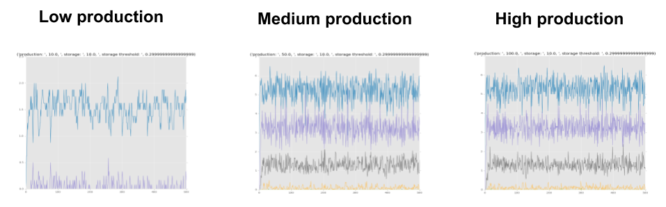

###### Figure 3. The level of production. Each line shows a change over time in the amount of goods present in all sites belonging to one distance band. (Scenarios plotted: production-10, 50, 100; storage-10; storage-threshold-0.3).

This factor is easily identifiable in the following set of scenarios. In scenarios where the commercial capacity is low the goods reach only limited number of markets regardless of the level of production. Low commercial capacity means that markets close to the production centre cannot accept any more goods and therefore they do not have enough goods to pass further on. Thus, only a combination of medium or high production level and an adequately high commercial capacity guarantees that the goods will reach even the furthermost markets.

###### 4storage.pngFigure 4. The commercial capacity (storage). Each line shows a change over time in the amount of goods present in all sites belonging to one distance band. (Scenarios plotted: production-50; storage-10, 50, 100; storage-threshold-0.5).

Finally, varying the storage threshold, that is, the amount of goods each market keeps for themselves, has only limited impact on the amount of goods in circulation (Figure 5). However, the amplitude of commercial fluctuation is heavily dependant on the threshold. When agents trade up to 90% of their stored goods (*low threshold*) the fluctuations are much higher than when they trade only 50% of their goods.

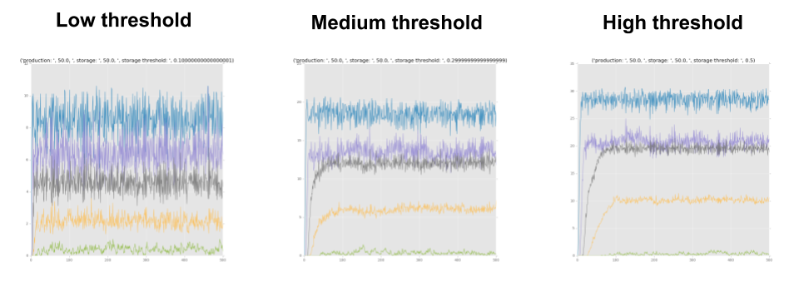

###### Figure 5. The storage threshold. Each line shows a change over time in the amount of goods present in all sites belonging to one distance tier. (Scenarios plotted: production-50, storage-50, storage-threshold-0.1, 0.3, 0.5).

## 5. Discussion and Conclusions

The aim of this study was to illustrate the potential of simulation techniques for relating economic processes to archaeological data. The simple model of exchange presented here demonstrates how the basic model built ‘from first principles’ can generate data predictions which can be then directly compared to large-scale distribution trends in the real data therefore overcoming some of the inherent limitations of the empirical record.

For example, the differences in the slope of the goods uptake curves (Figure 2) can be directly compared to changes in the frequency of a given pottery type at a series of archaeological sites. The exact method of quantifying the pottery (sherd count, weight, MNI) is irrelevant here as it is only the angle of the curve showing the change in the frequency of a given ware that is of interest. Thus data collected by different teams following different methodologies can be easily used in a comparative study. In a similar vein, distribution patterns generated by modelling other common economic processes (e.g., decline in production, competition on the market, a catastrophic event, down-the-line exchange, government intervention etc. See Scheidel 2012; Scheidel et al. 2007) could be used to explain patterns in the distribution of archaeological data commonly used as proxy evidence for these processes (see Wilson 2009).

In addition, the results of the study have highlighted the non-linear dependencies between the production, trade capacity and the frequency of new types of goods reaching markets at different distances from the production centre. First, the dynamics of the model indicate that an increase in the production level correlates with the goods reaching further away markets up to a point. Past this threshold an increase in production does not translate into the distance the goods will travel. Second, if the trading capacity increases, the distance at which the goods will be traded also increases. However, similarly to the production level variable, this only works up to a point. Once a certain threshold is reached, an increase in the trading capacity does not influence the global distribution of the goods. In sum, the production level and the trading capacity of markets are two factors, which determine the final distribution of goods. However, they are dependent on each other so that an increase in one is only significant if there is a proportional increase in the other.

In other words, for goods to reach further located markets it is not enough to increase the level of production (a similar conclusion was obtained through the agent-based network model by Brughmans and Poblome 2016). A rise in the amount of goods produced will only influence the archaeological record at sites further away from the production centre if it is coupled with an increase in the trading capacity of all the intermediate markets. Thus a distribution pattern of a certain good, for example, a type of pottery constrained to one region, may not necessarily indicate cultural preference or low production levels but can be the result of limited trading capacity of neighbouring markets confining the goods to the area close to their production centre. This conclusion highlights the important role played by the proximity to urban centres with a large population and a high demand for goods that act as redistribution centres (Abadie-Reynal 1989).

This raises the possibility of bottlenecks arising every time the goods need to pass through a market of limited capacity. In reality, much of the flow of goods passed through Rome - the major redistribution centre of the vast empire. This was the case with some of the key products which needed to reach the furthest outposts of the empire - e.g., olive oil distributed to troops stationed at the Limes (Remesal 2008). In theory, the most efficient strategy would be to let the goods travel following the most direct (and therefore the cheapest) route between the production centre and the destination. However, this study raises a distinct possibility that Roman administrators might have instead prefered a risk-reducing distribution strategy aimed at avoiding trading bottlenecks rather than optimising the shortest/fastest route to the destination. Future elaborations of the model should further explore this possible scenario.

Finally, these findings illustrate how formal models can reveal internal dynamics of economic systems and relate them to the available archaeological data. While challenging simple ‘one factor explains all’ explanations the computational nature of the model means that the range of potential scenarios that can be implemented, tested and compared to the data is theoretically unlimited. As a result, researchers are not constrained to the ‘most probable’ narratives mapping one cause to one effect but can try out more complex scenarios much more likely to reflect the true complexity of the economic processes in the past. These should be built in a cumulative fashion, introducing, experimenting with and testing one factor at a time. And we encourage the reader to do exactly that with the base model presented here.

**Literature cited**

Barton, C.M. (2014), Complexity, Social Complexity, and Modeling, *Journal of Archaeological Method and Theory* 21, 306–24.

Bowman, A. & Wilson, (2009), *Quantifying the Roman Economy. Models and Problems.* Oxford.

Brantingham, P.J. (2003), A Neutral Model of Stone Raw Material Procurement. *American Antiquity* 68, 487–509.

Brughmans, T. & Poblome, J. (2016), Roman bazaar or market economy? Explaining tableware distributions in the Roman East through computational modelling. *Antiquity* 90, 393–408.

Chattoe-Brown, E. (2013), Why Sociology Should Use Agent Based Modelling. *Sociological Research Online* 18, 3, 3. <http://www.socresonline.org.uk/18/3/3.html>.

Crema, E.R., K. Edinborough., T. Kerig. & Shennan, S.J. (2014), An Approximate Bayesian Computation approach for inferring patterns of cultural evolutionary change. *Journal of Archaeological Science* 50, 160–70.

Davidsson, P. & Verhagen, H. (2013), Types of Simulation. En Verhagen B. Edmonds & R. Meyer (Ed.) *Simulating Social Complexity. A Handbook*. Berlin, 23–38.

Grimm, V., U. Berger., D.L. DeAngelis., J.G. Polhill., J. Giske. & Railsback, S. F. (2010), The ODD protocol: A review and first update. *Ecological Modelling* 221, 23, 2760–68.

Hartmann, S. (1996), The World as a Process: Simulations in the Natural and Social Sciences. En R. Hegselmann, U. Mueller & K.G. Troitzsch (Ed.) *Modelling and Simulation in the Social Sciences from the Philosophy of Science Point of View*. Dodrecht, 77–100.

Lake, M.W. (2014), Trends in Archaeological Simulation *Journal of Archaeological Method and Theory* 21, 258–87.

Neiman, F.D. (1995), Stylistic Variation in Evolutionary Perspective: Inferences from Decorative Diversity and Interassemblage Distance in Illinois Woodland Ceramic Assemblages. *American Antiquity* 60, 1, 7–36.

O’Sullivan, D. & Perry, G. (2013), *Spatial Simulation: Exploring Pattern and Process*. Chichester.

Premo, L.S. (2006), Agent-based models as behavioral laboratories for evolutionary anthropological research *Arizona Anthropologist* 17, 91–113.

Remesal Rodríguez, J. (2008), Provincial interdependence in the Roman Empire: an explanatory model of Roman economy. En P.P.A. Funari, R.S. Garraffoni & B. Letalien (Ed.) *New Perspectives on the Ancient World: Modern Perceptions, Ancient Representations.* Oxford, 155–59.

Scheidel, W., (2012), T*he Cambridge Companion to the Roman Economy.* Cambridge.

Scheidel, W., Morris, I. & Saller, R.P. (2007), *The Cambridge Economic History of the Greco-Roman World*. Cambridge.

Sterman, J.D. (2000), *Business Dynamics. System Thinking and Modeling for a Complex World*. Boston.

Wilson, A. (2009), “Approaches to Quantifying Roman Trade.” En *Quantifying the Roman Economy. Methods and Problems*. En A. Bowman & A. Wilson (Ed.). Oxford, 213–49.