PE_PRN222_SU25_TrialTest
SUMMER 2025
Subject: PRN222
Duration: 85 minutes

INSTRUCTIONS
Please read the instructions carefully before doing the questions.
- You are NOT allowed to use any other materials. You are NOT allowed to use any device to share data with others.
- You must use Visual Studio 2019 or above, MSSQL Server 2008 or above for your development tools.
IMPORTANT – before you start doing your solution, MUST do the following steps:
- Create Solution in Visual Studio named PE_PRN222_SU25_TrialTest_StudentName. Inside your Solution, the Project ASP.NET Core Razor Page must be named: LionPetManagement_StudentName.
- To do your program, you must use ASP.NET Core Web App (Razor Pages), apply 3-Layer architecture (Presentation Layer, Business Logic Layer, Data Access Layer), there are at least 2 Projects for the Solution. The database connection string must get from the appsettings.json file.
In the case your code connects directly to the database from ASP.NET Core Web App (Razor Pages) or hard coded the connection string, you will get 0 point.
- Create your MS SQL database named SU25LionDB by running code in script SU25LionDB.sql.
- Set the default user interface for your project as a Login page.
- If there are syntax errors or compilation errors in your PE program, you will not pass the PE requirements, the mark will be 0.
- Your work will be considered invalid (0 point) if your code inserts stuff that is unrelated to the test.

Create an application using ASP.NET Core Razor Pages with .NET Core (.NET 8/.NET 9), C#, and Entity Framework Core. A MS SQL Server database will be created to persist the data and it will be used for reading and managing data.
A part of SPU5LionDB database.
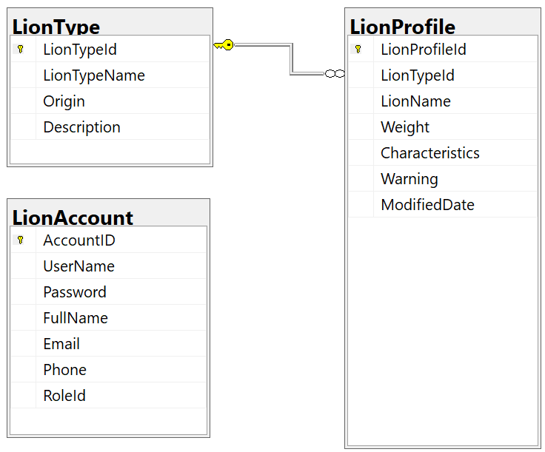
Store account role: Administrator = 1; Manager = 2; Staff = 3; Member = 4

Role  Function/URL | Administrator | Manager | Staff | Member
Create | ✓ | ✓
Update | ✓ | ✓
Delete | ✓ | ✓
View list of items | ✓ | ✓ | ✓
View detail of an item | ✓ | ✓ | ✓
Search | ✓ | ✓ | ✓
Login | ✓ | ✓ | ✓ | ✓
Table 1. Permissions to implement functions in the test

Function/URL
Create | http://localhost:XXXX/LionProfile/Create
Update | http://localhost:XXXX/LionProfile/Update
Delete | http://localhost:XXXX/LionProfile/Delete
View list of items | http://localhost:XXXX/LionProfile/Index
View detail of an item | http://localhost:XXXX/LionProfile/Detail
Search | http://localhost:XXXX/LionProfile/Search
Login | http://localhost:XXXX/Login
Table 2. Mapping between functions and URLs

- (1.0 point) The permissions are defined in Table 1, you must use email/password for the authentication/authorization process.
- The Create, Update, Delete functions for LionProfile are required Manager role or Administrator role.
- The Search and View list of items, View detail functions for LionProfile are required Manager role or Staff role
- Other roles (Member role) cannot do any functions in this case. Display “You have no permission to access this function!”.
- No Authentication “Invalid Email or Password!”.

Design the login Razor Page, if login is successful, the list of LionProfile Page will open, otherwise you should be shown a suitable message.

- (1.5 points) Please check the permissions listed in Table 1; In case you do the authentication/authorization wrong, you will not get any points for this section; List all of items in LionProfile table (each record includes information of LionProfile and LionTypeName). Paging is required for this function, 3 records/1 page.

- (2.5 points) Please check the permissions listed in Table 1; In case you do the authentication/authorization wrong, you will not get any points for this section; Add a new item with the requirements:
- The new item will display at the top of the list.
- All fields are required.
- Value for LionName is greater than 3 characters. Each word of the LionName must begin with the capital letter. The value of LionName is not allowed with special characters such as #, @, &, (, ).
- Value for Weight > 30
- The LionTypeId/LionTypeName will come from the LionType table (you can use ComboBox UI control in this case)

- (2.0 points) Please check the permissions listed in Table 1; In case you do the authentication/authorization wrong, you will not get any points for this section; Update the selected existing item with the same validation requirements with Add function.

- (1.5 points) Please check the permissions listed in Table 2; In case you do the authentication/authorization wrong, you will not get any points for this section; Search all items with 3 conditions: Weight, LionTypeName (OR option for this case and using relative search), the UI for this function must have 2 input fields.

- (1.5 points) Please check the permissions listed in Table 2; In case you do the authentication/authorization wrong, you will not get any points for this section; Using real time communication with SignalR for delete function. Delete the selected item(s) with the confirmation then update the list of items for all connected clients.

