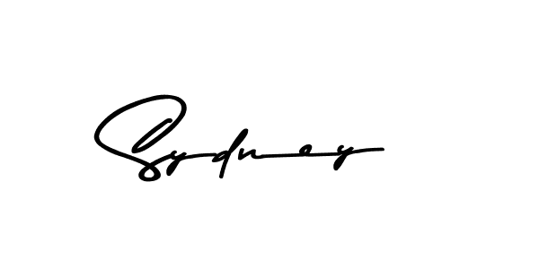

*……………………………… Director*

*Olympia College*

*……………………………..*

*Chairman Olympia Academic Board*



Bachelor of Science

# This is to certify that

*Ahmad bin Abdullah*

# has been awarded the

***Bachelor of Computer Science***

having fulfilled the requirements prescribed by the Academic Board, and with the assent of the Examination Board. Witness our hand and seal this

June 2023

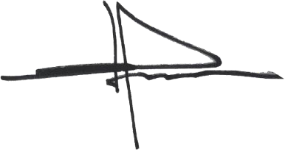

*……………………………… Registrar*

*Olympia Examination Board*

CERT-202510-5701

**​**

