md2docx 示例文档 / Sample Document
这是一段中文正文，用来测试中文字体是否正确显示。源文件里这一行在中间换了行，转换后不应该出现多余的空格。English text is mixed in with italic, bold italic, strikethrough and inline code.
Links work too: Python documentation, an autolink https://github.com, and a bare URL https://www.example.com/path.
This sentence has a pipe | in it, but it is not a table.

1. 列表 Lists
- 第一步：安装依赖
- 第二步：运行脚本
  - 子项目 A，包含 加粗 内容
  - 子项目 B
    - 更深一层的编号
    - 第二个
- 第三步：检查结果
This paragraph belongs to step 3 and is indented with it.
A paragraph between two lists.
- This numbered list starts again at 1
- instead of continuing from the list above
Another paragraph.
- A list can also start at 3
- like this
Task lists:
- ☑ Finished task
- ☐ Unfinished task

2. 表格 Table
指标 Metric | 说明 | 数值
Heart rate | 心率 HR | 92
Core temp | 核心体温 | 37.8
Escaped | a | b | —

3. 代码 Code
Run the converter:
pip install python-docx
python md2docx.py input.md --toc

def hello(name):
# 中文注释
if name:
print(f"Hello, {name}")
Steps with code inside a list:
- Create a virtual environment:
python -m venv .venv
- Activate it and install.

4. 引用 Quotes
这是一段引用。Quotes can span multiple lines and contain formatting.
A second paragraph in the same quote.

Note
GitHub-style alerts are supported.

5. Images & placeholders
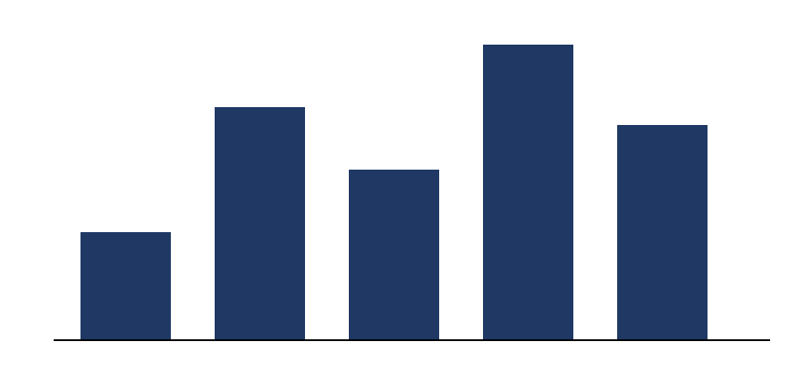
Figure 1: A sample chart
Figure 2: Conceptual framework (to be inserted)

6. Line breaks
First line with a hard break
second line on its own.

Setext Heading
The end. 完。

