**Introduction**

Welcome to the user manual for the Movie Equipment Rental Management System (MERMS). MERMS is a proprietary management system that leverages Java code and relational database technology to allow an organization to successfully manage rental orders and enterprise stock levels. This manual will inform you on how to successfully use the project through interaction with the GUI.

**Product elements**

The main elements of MERMS are the GUI and the relational database. The GUI was developed in Java using the Netbeans IDE and is used to interact and make changes to the database. The relational database was created using MS Access and is used to store enterprise data regarding rental orders and equipment stock levels.

**Tutorial**

1. **Logging in** - The default username and password is **admin**:**admin**, this can be modified through the database. Ensure that the database is within the project folder to prevent any issues. 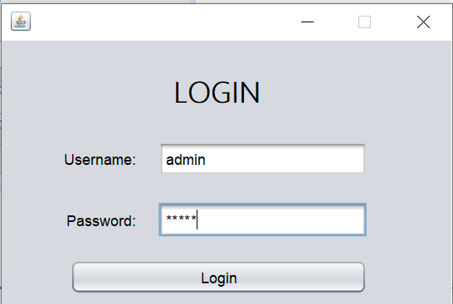
2. **Equipment**

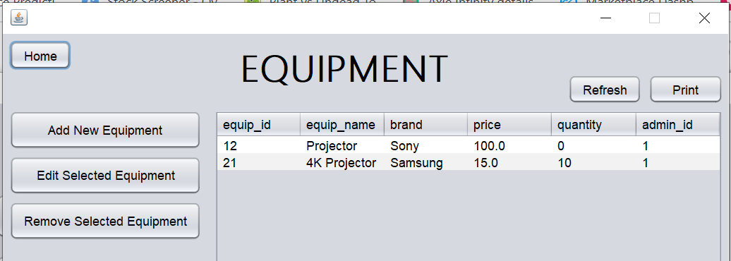

**2.1 Adding new equipment** - To add new equipment, from the Main Menu, click the “Equipment” button and the Equipment window will show up, you will be able to see the equipment database. Press “Add New Equipment”, and fill up the details and press the add button to add the new equipment to the database.

**2.2 Edit equipment parameters -** To update the stock levels, change stock price or edit equipment brand select “Edit Selected Equipment”. An edit window will appear and the user can then change an equipment record’s details. Equipment ID and Admin ID cannot be modified from the GUI.

**2.3 Removing existing equipment -** Removing existing equipment can be done by selecting a row from the table and pressing “Remove Selected Equipment”. **NOTE:** this cannot be undone.

1. **Customers**

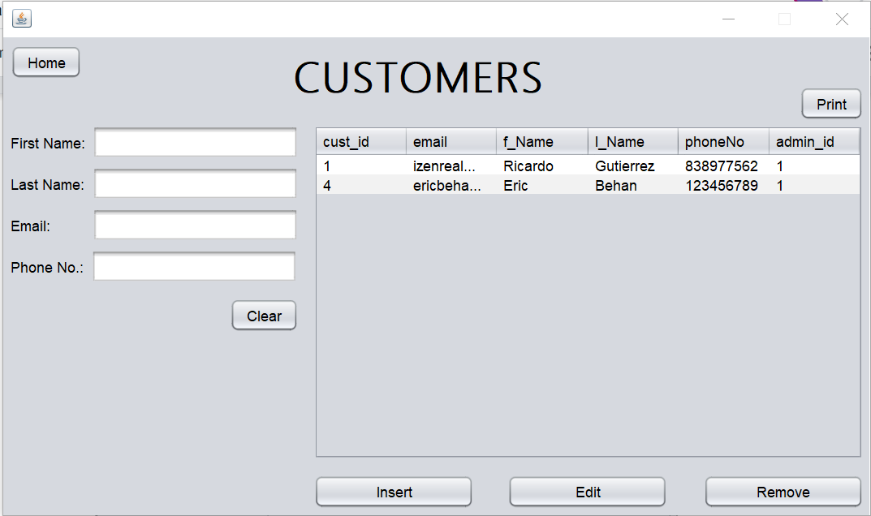

**3.1 Adding a new customer -** To add a new customer, fill up the text fields and press the “Insert” button. Keep in mind that email and phone number cannot be used by other customers.

**3.2 Editing a customer’s record -** To edit an existing customer record select a customer record from the table on the window, the customer record details will appear in the text fields on the window. Modify the parameters of the record through the text fields on the window and then select the “Edit” button. A message will then appear to inform the user if the edit was successful.

3.3 **Removing a customer -** to remove a customer record, select the customer record you wish to remove and then select the “Remove” button. **NOTE**: this cannot be undone

1. **Orders**

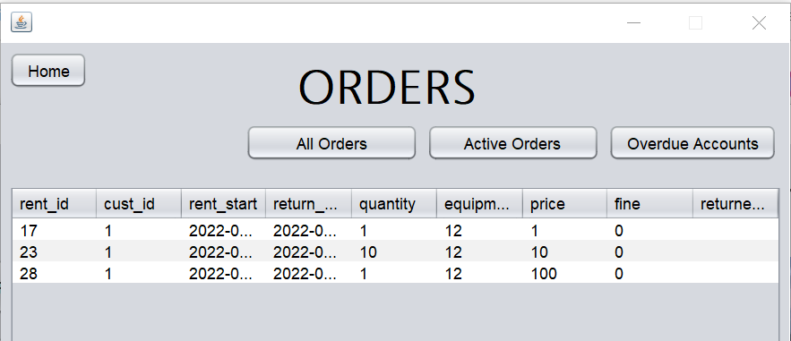

**4.1 Viewing All Orders -** From the Main Menu, select the “Orders” button and the Orders window will appear, the default table that will show all orders from the database.

**4.2 Viewing Active orders -** To view all active orders select the “Active Orders” button. All of the active orders will then be shown in the table on the GUI.

**4.3 Viewing Overdue Accounts -** This table shows customers’ records that have not returned the equipment and past due the returned date. To view this, just select “Overdue Accounts” from the buttons above the table.

1. **Rent**

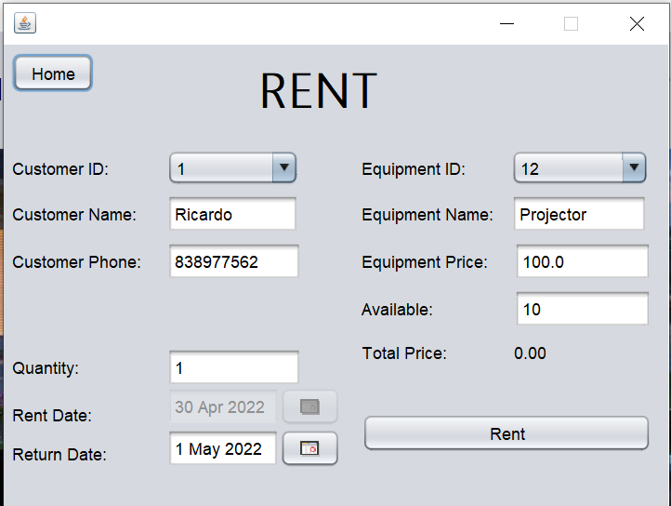

**5.1 Adding a rent order -** To create a rent order, first, the user must select which customer id is going to rent the equipment and select the number of quantities the customer would like to rent (it cannot exceed the available equipment in the inventory). Moreover, the combo box for the equipment id will only show the available equipment to prevent users renting an equipment that is not available.

1. **Returns**

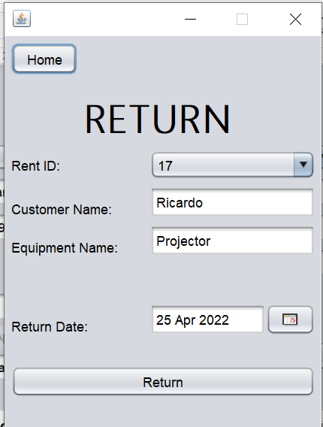

**6.1 Returning an order -** To return an order select the “Rent ID” from the combo box and then change the return date of the order to the current date. Then select the “Return” button, a message will display if the order was returned successfully and whether there is a fine for late return.