Exercise 1-
'/Users/izabellaferguson/Downloads/Moulin Rouge! Set Design.pdf'
Root
Directory chain
File name
Extension
Exercise 2- 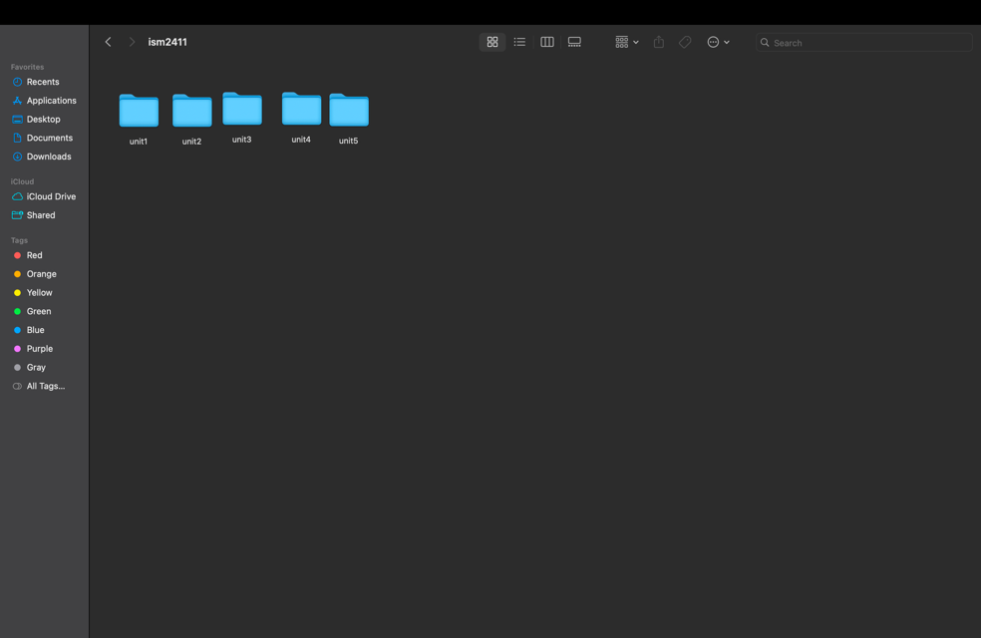
Exercise 3-
- CPU- The Central Processing unit, a chip in the computer that carries out instructions.
- RAM- Random Access memory, the shirt term memory of a computer, will be deleted when the computer is restarted or shut down. Things that are currently active on the computer are stored here.
- Storage- long term memory of a computer, files that are still available after restart/shut down.
- File- a named group of bytes that is saved in storage, can be different types such as .py or .pdf.
- Directory- the organizer of a chain of files, can contain files and/or other directories.
- Path- the full address of a file, contains all components such as file name and the root.
- Extension- the ending of a file after . that indicates the format of the file such as .py or .pdf
- Program- set of instructions that tells a computer how to complete a task.
- Interpreter- program that reads code and tells the CPU how to perform tasks

Exercise 4-
-making to-do lists (could not)
-Solving math problems (could)
-budgeting (could)

Exercise 5-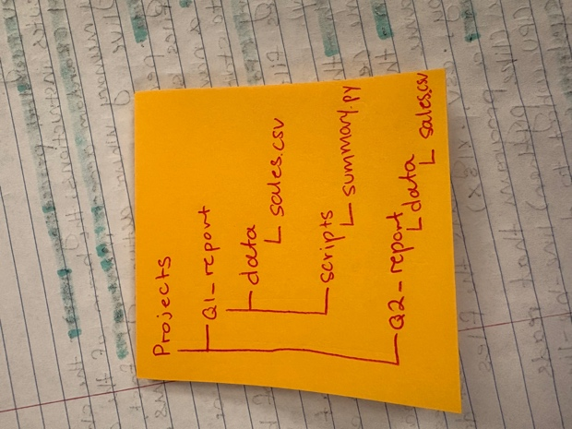
Exercise 6-
- Ram, because it was deleted after restart of computer. Ram is temporary.
- Storage, because there was something wrong with the file path or the file is missing.
- RAM might have too much running or not enough storage on computer.
Self assessment
- Before, you click on it and the computer opens it. Now, you click on the file and it is moved to ram and interpreted by the interpreter to open the file
- Program, just re-read the lecture.
- Coding, how to use excel, how to input code to excel, programming.

