

ENT 189 COMPUTER PROGRAMMING

LAB-2 LOGICAL AND REPETITIVE STRUCTURE

Lecturer : Dr. Lam Chee Kiang

Name : _____________________________________

Matric Number : _____________________________________

Program : Mechatronic Engineering

ENT 189 COMPUTER PROGRAMMING

LAB-2 LOGICAL AND REPETITIVE STRUCTURE

Lecturer : Dr. Muhammad Izham Bin Ismail

Name : _____________________________________

Matric Number : _____________________________________

Program : Mechanical Engineering

OBJECTIVE

At the end of this lab students should reach the below objectives:

- Able to develop simple problems using ‘if’ structure, ‘if-else’ structure.
- Able to represent nested loop structure and switch structure.
- Able to develop simple programs using repetitive structure.

TASK 1

Write a program to compute the roots of a quadratic equation (ax² + bx + c = 0). The roots of the equation can be calculated using the following formulae:

x₁ = (-b + sqrt(b² – 4ac))/2a
x₂ = (-b – sqrt(b² - 4ac ))/2a
Note: If b² – 4ac is negative, the roots are complex.

Write your program in the space provided. Using gedit, type and save your program. Test your program to solve the following equations:

- x² + 2x – 24 = 0
- 3x² + 4x + 8 = 0
- x² + 6x + 9 = 0
- 5x – 3 = 0

A flow chart to solve the problem is shown below.

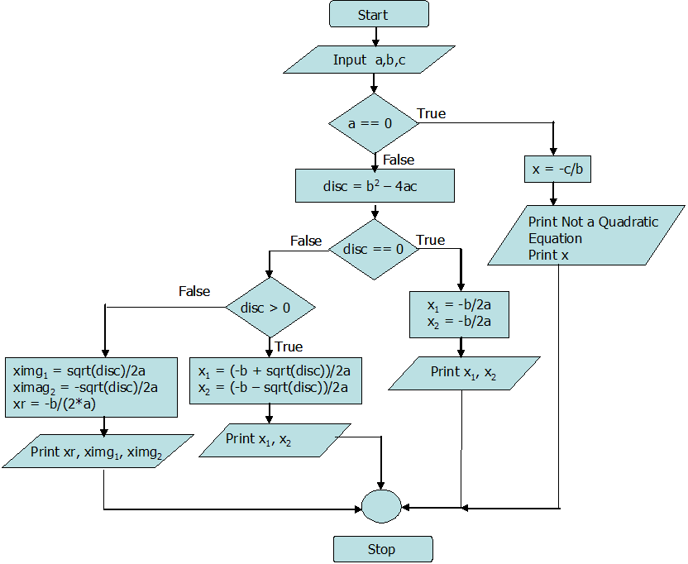

TASK 2

Some measures of interest in statistics are the arithmetic mean (a_{m}), geometric mean (g_{m}), harmonic mean (h_{m}) and variance (v) defined for a set of numbers x₁, x₂, x₃, …, x_{n} as follows:
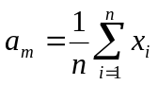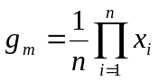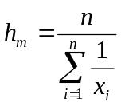
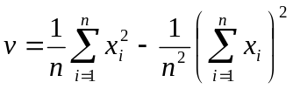

Write a program in C to read a set of data and compute the arithmetic mean, geometric mean, harmonic mean and variance. Test your program with the following data set:

14.8, 21.0, 11.9, 12.0, 13.8, 10.2, 12.9, 12.6, 12.5, 13.0

TASK 3

Consider a DC - RC transient circuit with the supply voltage V as 12 V, the resistance R is 3.0 kΩ and the capacitor value is 5.6 µF. The current (i), voltage across the resistor (V_{R}) and the inductor (V_{C}) in the RC series circuit are given by the following expressions:

V is the applied voltage in Volts.
R is the circuit resistance in Ohms.
C is the Capacitance in farad.
t is the time in seconds.

Write a program in C to read in the circuit parameters and compute the current, voltage across the resistor and the inductor when the time is varied from 0 to 10.0 milliseconds in steps of 1.0 millisecond using (a) while loop (b) for loop. Execute your program and tabulate the results. Which method is advantageous? State the reason for your answer.

