**Documentation**

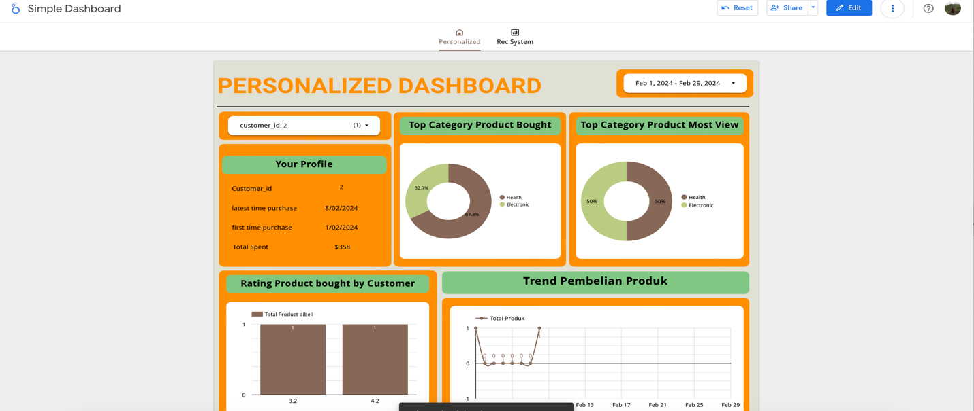

**Fig 1. First Tab**

The dashboard contains 2 tabs, personalized dashboard and recommendation system. Since dataset is small, in the first tab at personalized dashboard, we build simple analytics behavior for customer. We can adjust the filter for the range date and customer.

For the second tab, we have 2 metrics, rating product distribution and top 5 recommendation product. The usage of this page is simple, just choose desire customer, you will get top 5 recommendation product for the customer. For metric rating distribution, it only shows the distribution product in general. In the end, note that in dataset, 1 product might be has more than 1 category.

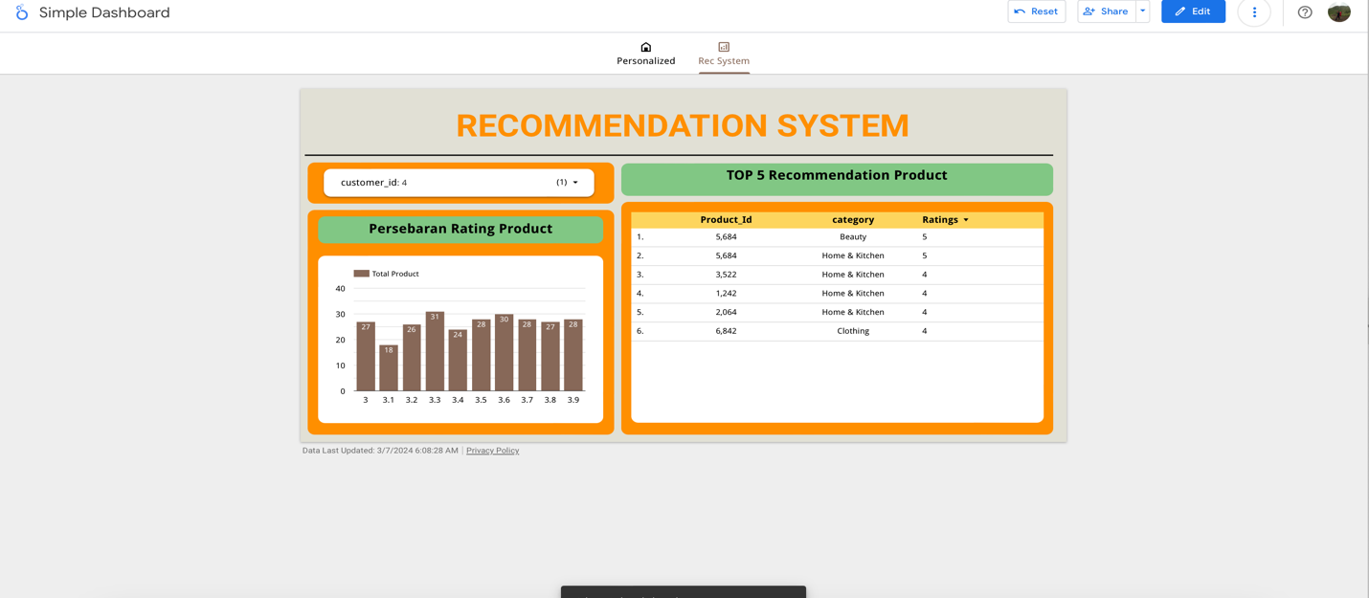

**Fig 2. Second Tab**