**Visual Sentiment Analysis:**

**Model- Block Diagram**

The viability of our model in foreseeing feelings utilizing a tweaked move learning model is displayed in Figure 10. This was finished by tweaking the current pre-prepared VGG-19, ResNet50V2, and DenseNet-121 models. The justification for picking the ResNet50V2 model is that it can lessen the evaporating angle issue that happens when slopes are backpropagated, and the presence of lingering or skip association further develops the learning. It utilizes a character association or skip association with increment framework execution by bringing down the blunder rate and uses a cluster standardization layer before weight layers to further develop grouping execution. The DenseNet-121 model is leaned toward by us since it can alleviate the evaporating inclination issue, requires less boundaries, and has include reuse abilities. The approval blunder for the DenseNet model is a lot of lower than that of the ResNet model, and the creators of guarantee that DenseNet performed better in light of broad hyperparameter changes. We favor the VGG-19 model since it is an updated variant of the VGG-16 model and is leaned toward by numerous specialists for picture arrangement errands. Our work included four phases — Stage I, Stage II, Stage III, and Stage IV.

In Stage I, the picture tests that were extricated from the dataset were stacked with their opinion marks. We extricated around 470,586 pictures from the dataset utilizing the URLs of the pictures alongside their opinion extremity marks. In Stage II, the pre-handling of pictures was finished by changing over the pictures into a RGB design, and the resizing of the pictures into various aspects was proceeded as expected by the pre-prepared models. The models required a picture aspect of 224 × 224 × 3, and the standardization of picture pixels was finished in the subsequent stage. In Stage III, the preparation and testing tests were made by separating the information picture tests into preparing and testing pictures. Almost 80% of the examples were used for preparing, with the excess 20% being utilized for testing. In Stage IV, the preparation cycle was begun by building the pre-prepared model designs with extra layers, and the expectation of obscure examples was finished straightaway. The tweaking of the models was finished by freezing a few layers and thawing the excess layers. The exhibition measurements of the models, like exactness, accuracy, review, and F1 measures, were produced, and the near examination of the different pre-prepared models was finished.

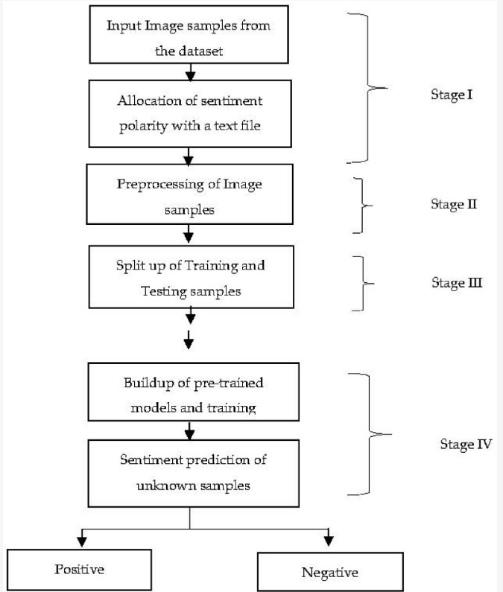

**Dataset:**

For dataset, the link is given below,

<http://www.t4sa.it/#experimental-results>

**File name**: b-t4sa_imgs (The file size is large so make sure you have enough space in your pc)

In this examination, we utilized the tweet pictures which were posted on twitter, a stage that gives space in which to share one's insight. It offers a chance to client to impart their encounters to the general population. In this examination, dataset was recovered from twitter. The dataset comprises of the 470,586 pictures. In which the quantity of positive, negative and impartial pictures are 156,862 pictures each.

After all these things:

Change **the import (directory)** mentioned in the code to your **latest directory location**.

Then start running the code one by one and get the results.

**File name:**

* DenseNet.py
* ResNet.py
* VGG-19.py