WEB ENGINEERING

# ASSIGNMENT 1 :

## NAME : IZHAR UL HAQ CLASS: BESE-4B REG NO : 06206

# DOCUMENT:

HOME PAGE :  
In home page i have done some animation like cirls moving around with changing colors. The code was taken from google but was totally understood and changed by me. There is a background music in home page.

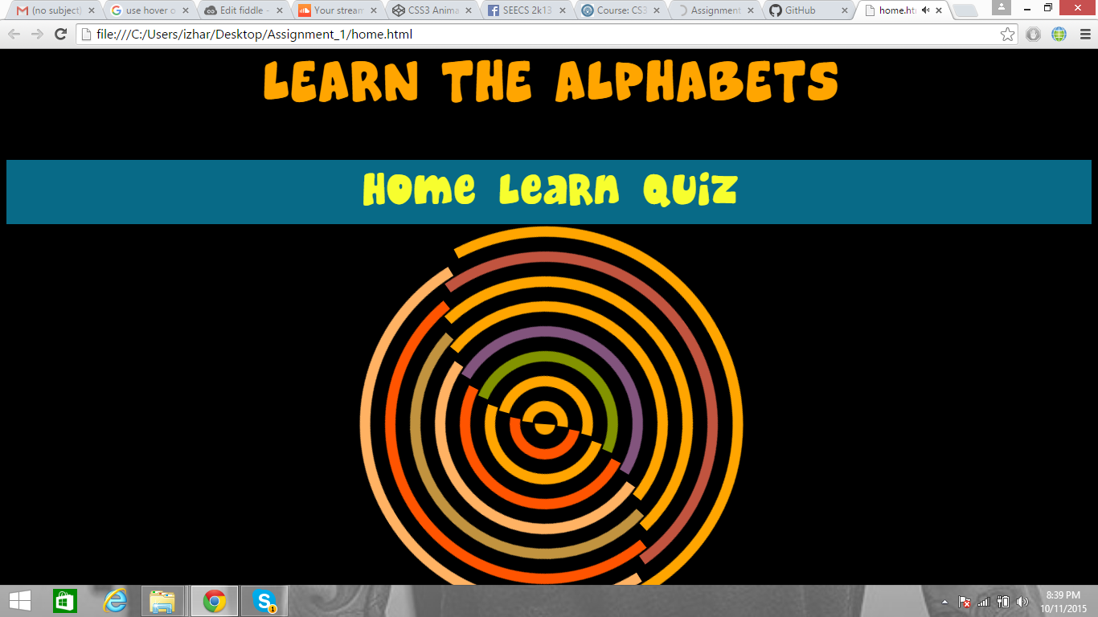

LEARN PAGE:  
In learn page i have imported different font styles. And images are placed under the alphabets in small size. When i click the image it zoom into the screen. It is done in CSS by using Focus and figure caption is inserted into it.

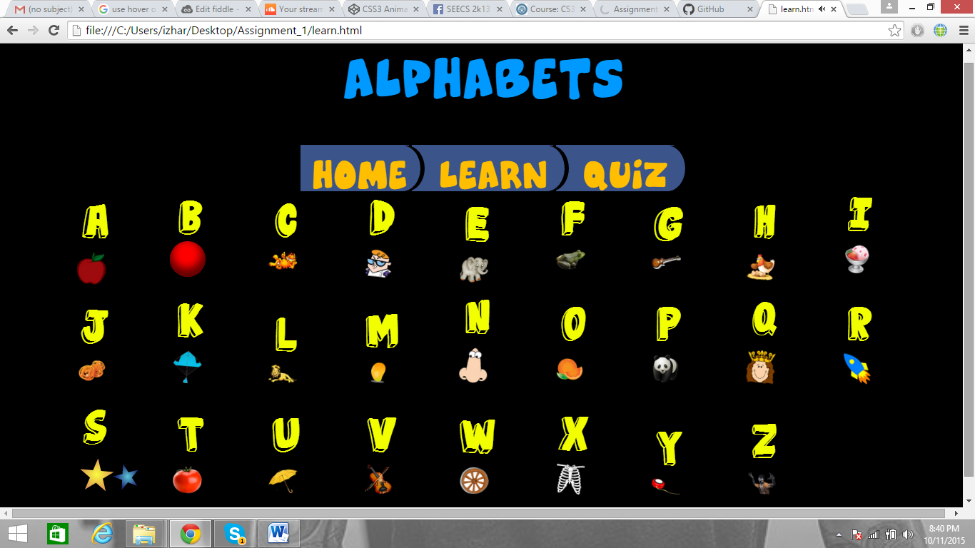

QUIZ PAGE:  
There is a simple quiz containing ten questions. The question slides into the screen by animation. Different font styles are imported in it . At the end of the quiz there is a Congrats page with clapping as a background music and a button which will take you to the home page again.

# 

# URDU LETTERS:

Learn Urdu page have urdu letters. The respective code of the corresponding urdu letters are inserted.

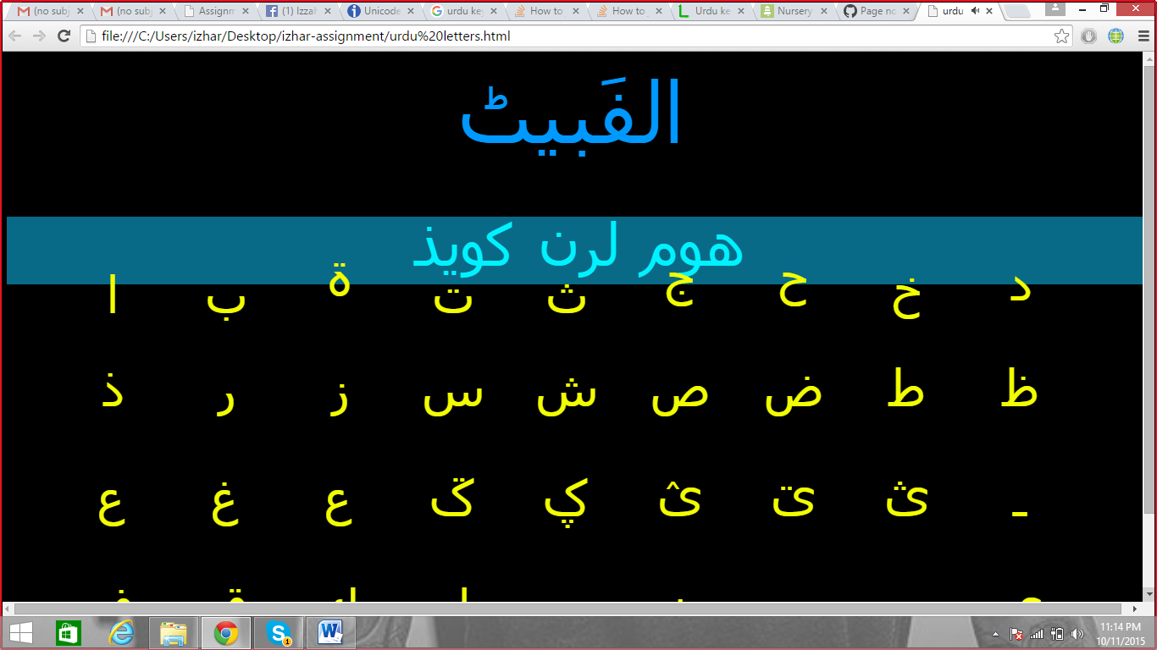

# Link of Github:

## https://github.com/izharkhan/Assignment_1.git