WEB ENGINEERING

# ASSIGNMENT 2 :

## NAME : IZHAR UL HAQ CLASS: BESE-4B REG NO : 06206

# DOCUMENT:

HOME PAGE :  
Home page contains the Login for the user. The login and registeration panel is the default feature of laravel which is created by the command  
php artisan make:auth.

You can login with ID=> 1 which will be the moderator who can see all the codes entered by any users.  
Users with ID else then 1 will be normal user who can only view their own code.  
This Feature completes the second task of the Assignment.

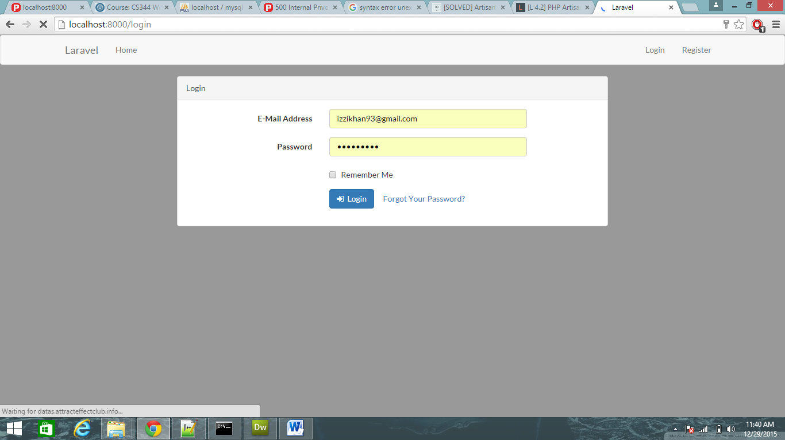

This is the Registeration page which is default of laravel. You can register any user you want.

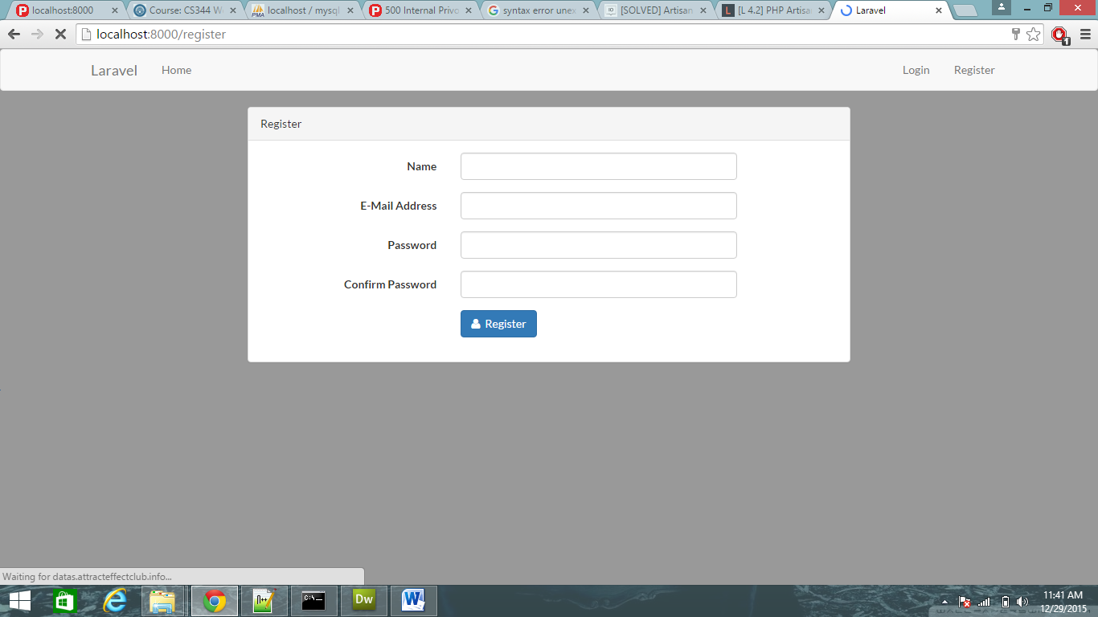

Here is the 1st task of the project making a PhP interpreter. You enter your code and the out put is displayed on the right box.

Here are two options at top left corner viewcodes and logout. View codes will display all the codes that you have typed.

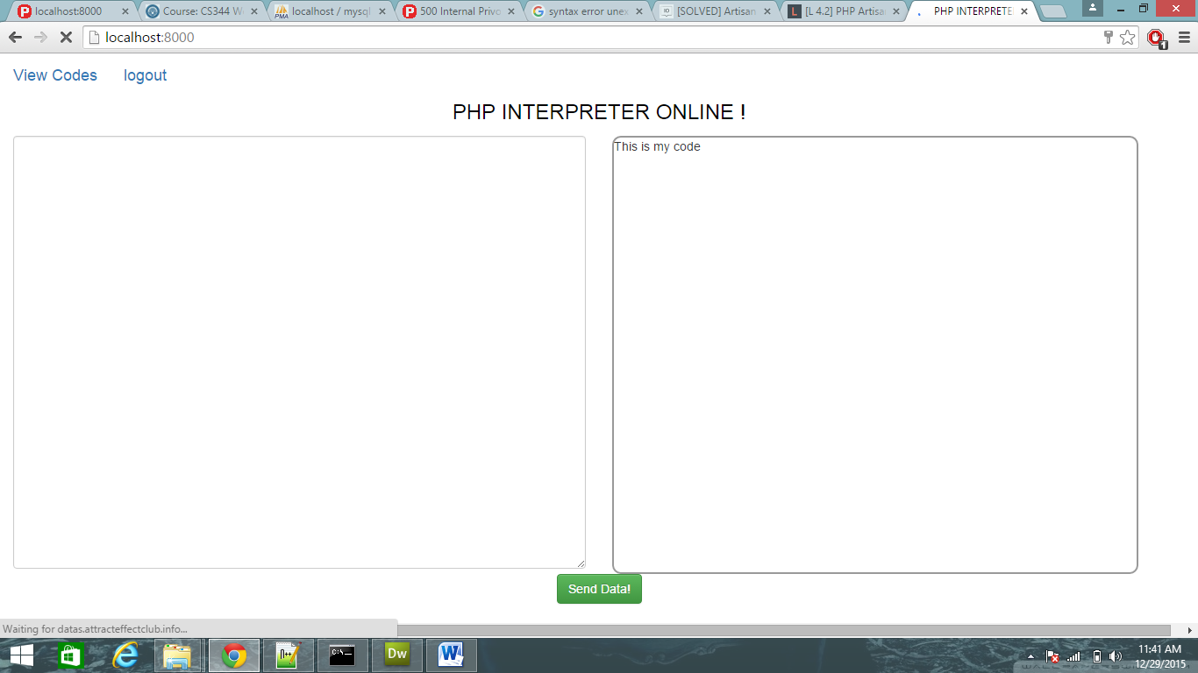

Here is the ViewCode page where all the codes are displayed.

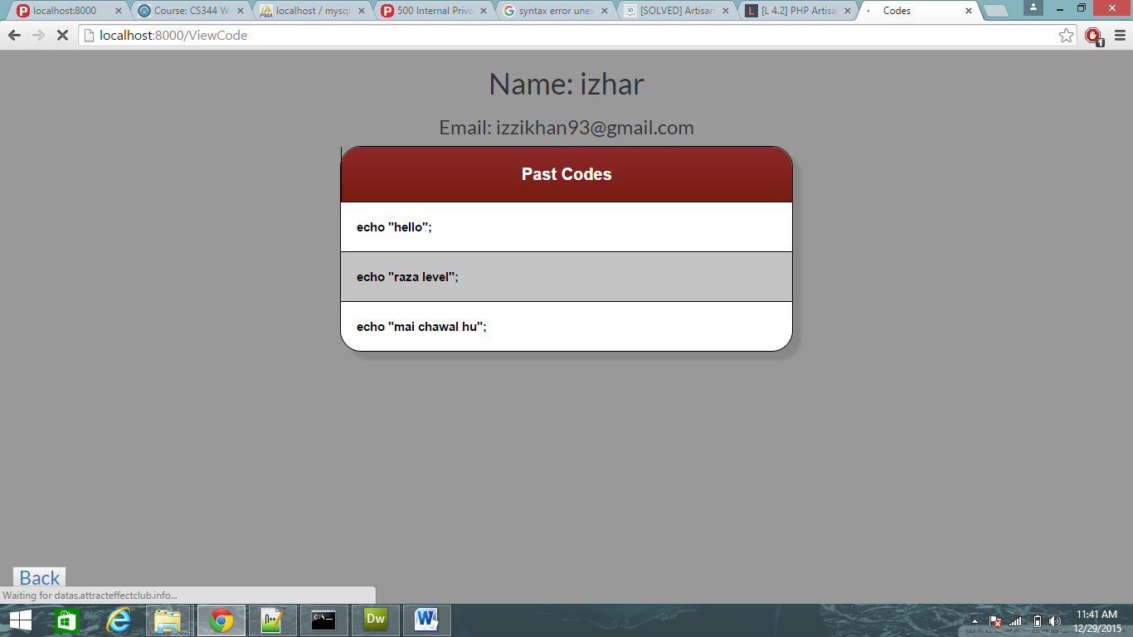

# Link of Github:

## https://github.com/izharkhan/Assignment_3.git