BacNet v.1.0
User manual

BacNet software tool builds a network from given:

- XML-file that contains abstracts downloaded from PubMed database
- File (files) that contain list of words to search for

Usage:

Step 1: Download abstracts from PubMed

Go to http://www.ncbi.nlm.nih.gov/pubmed and run your query to that database. The query migh look like this: "(vagina OR vaginal ) AND (lactobacillus)". Then push the "Search" button. Results should look similar to those in Fig. 1 below:

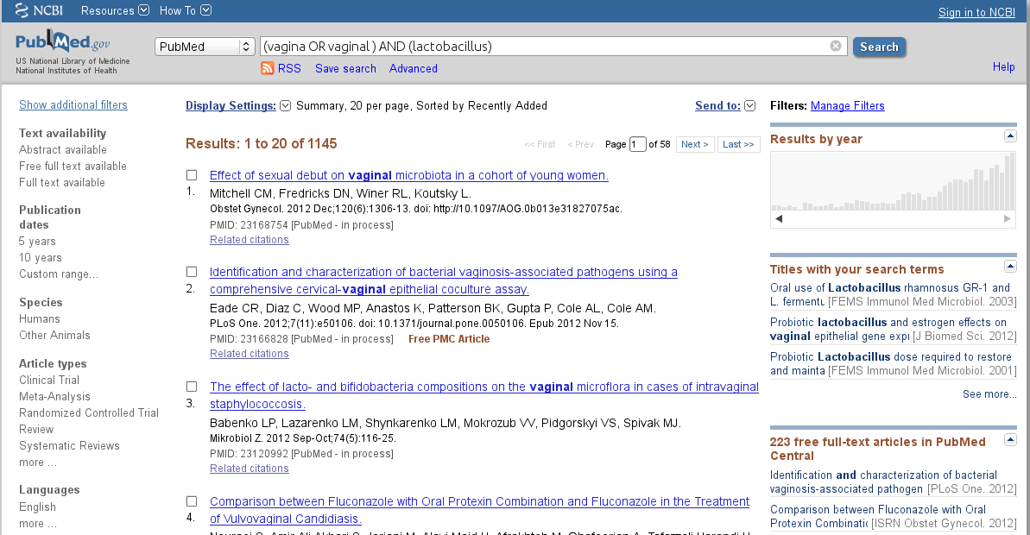
Fig. 1. Pubmed results from "(vagina OR vaginal ) AND (lactobacillus)" query.

Then download results. Save them into BacNet's root directory. The name of the file must be: "pubmed_result.xml":
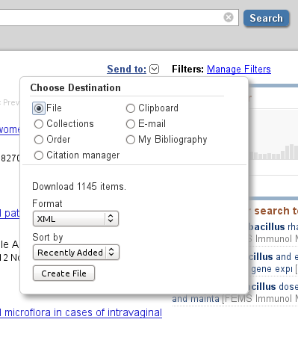

Fig. 2. Downloading results.

This pubmed_result.xml file contains all abstracts from the output.

Step 2: Prepare input files

Go to BacNet's root directory. Prepare a list of words to look for. Save it into separate file (in BacNet roor directory), name it wherever you want. The file must contain lines, each single line represents a word (or a phrase).

Example:
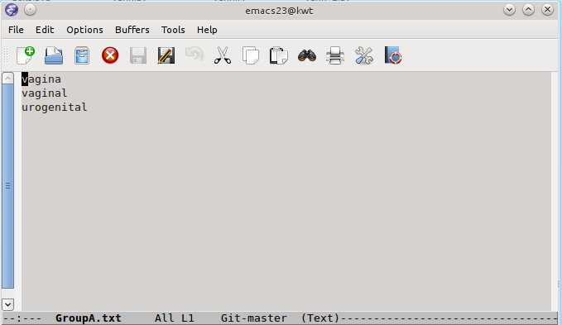
Fig. 3. Example of the set of words in the input file.

Step 4: Run the BacNet's search engine

BacNet software tool generates adjacency matrices and saves them into .csv format. Adjacency matrix is needed to build a network. Run BacNet by executing the following command:

python bacnet.py <required options>

<required options> :

-1 <filename> - Looks for co-occurrence of any of the words in a set_of_words.txt with other words in the same set excluding themselves. The output of this is the adjacency matrix named "adj_matrix_11.csv"

Example: python bacnet.py -1 GroupB.txt

-1 <filename> -2 <filename> - Co-occurrence of any of the words in set_of_words1.txt with any of the words in set_of_words2.txt. The output of this is the adjacency matrix named "adj_matrix_12.csv"

Example: python bacnet.py -1 GroupA.txt -2 GroupB.txt
In order to do this you have prepare two separate files. Look at the figures below:

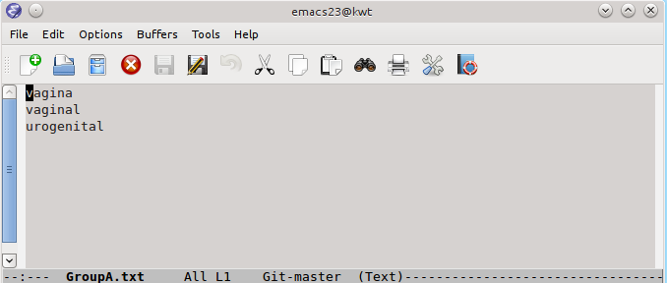
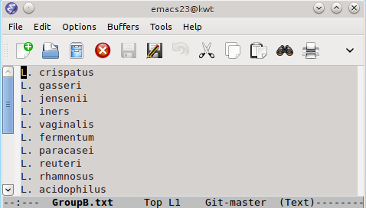

Figure 4. Example of input files.

--kw <filename> - Keyword approach. If this option is set, you have to provide a list of words, assuming that "pubmed_result.xml" is already presented. The output of that is adjacency matrix named "adj_matrix_strong.csv". For more detailed explanations of this method, please see the article.

Example: python bacnet.py --kw set_of_words.txt

--tm <filename> - Timing approach. Initial goal was to see how the network structure changes with time. Output of this commant is a large set of PDF files saved in the BacNet root directory. Each of those PDF files represent a network generated for single year.

Example: python bacnet.py --tm GroupA.txt

Step 5: Visualization

Open the R-script "network_visualizator.R" (saved in the BacNet's root directory) and edit it if necessary. Run this script to see the network structure.

Example:

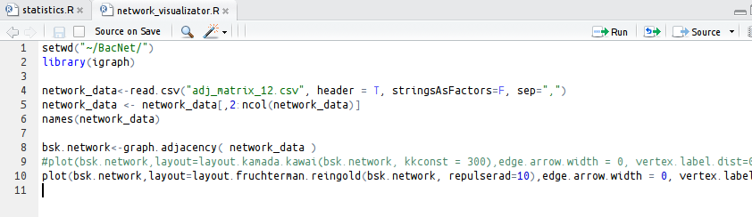
Fig. 5. R-script.
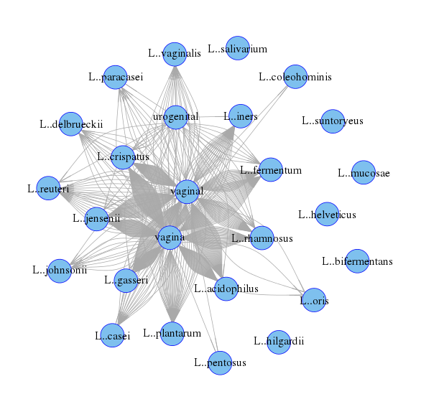

Fig. 6. Example of network.

Contacts

Ilya Zhbannikov, zhba3458@vandals.uidaho.edu. Any feed backs are greatly appreciated!

