Fault-Tolerant Swarm Quadrotor Control for Non-Convex Geodetic Mapping
Izma Alhazmi Herdian^{1,2,a),*}, Sulthan Naufal Affan^{1,b)}, and Estiyanti Ekawati^{1,2,c)}
¹Engineering Physics Department, Institut Teknologi Bandung, Bandung, Indonesia, 40132
²Center for Instrumentation Technology and Automation, Institut Teknologi Bandung, Bandung, Indonesia, 40132
^{a),*}corresponding author: izmaherdian@gmail.com
^{b)}sulthannaufal96@gmail.com
^{c)}esti@itb.ac.id
Abstract. Autonomous swarm quadrotor systems are promising for large-scale geodetic mapping in complex environments. This paper proposes a three-layer control architecture for resilient non-convex geodetic mapping using a quadrotor swarm. The high-level layer integrates Voronoi-based non-convex region partitioning, Boustrophedon path planning, and Fault-Tolerant Cooperative Coverage (FT-CC) for adaptive task redistribution. The mid-level layer utilizes Optimal Reciprocal Collision Avoidance (ORCA) for decentralized collision-free navigation. The low-level layer employs a cascaded PID control architecture comparing optimal LQR and robust $H_{∞}$ synthesis for tracking under disturbances. Validated via ROS2, Gazebo, and PX4 SITL, preliminary simulation results demonstrate a 90–95% coverage completion of non-convex regions with zero inter-robot collisions, validating the framework's potential.

INTRODUCTION
Swarm quadrotor systems are vital for autonomous geodetic mapping in disaster response, precision agriculture, environmental surveillance, and infrastructure inspection. Coordinated swarms enable rapid data acquisition by partitioning large territories among multiple agents. However, these applications demand efficient non-convex region partitioning, robust flight control under environmental uncertainties, and resilient operation despite individual vehicle failures.
Current literature faces several critical gaps. Most coverage algorithms assume convex operational regions¹, end-to-end pipelines spanning partitioning to low-level rotor control remain scarce², fault tolerance under swarm communication or actuator failures is still underexplored³, and validation is primarily conducted using simplified kinematic models rather than full quadrotor dynamics⁴. To address these limitations, this paper proposes a unified three-layer architecture that integrates non-convex Voronoi partitioning, Boustrophedon planning, FT-CC, ORCA, and cascaded PID-LQR / PID-$H_{∞}$ robust control. The proposed framework is validated through high-fidelity simulations using ROS2, Gazebo, and PX4.

METHODOLOGY
The proposed architecture comprises three hierarchical layers operating in a closed loop (Figure 1). The high-level layer receives non-convex boundaries and initial poses to perform obstacle-aware Voronoi tessellation, partitioning the sub-regions for individual quadrotors⁵. Boustrophedon sweeping then generates optimal, energy-efficient coverage paths⁶. Concurrently, the FT-CC module monitors agent health via peer-to-peer heartbeats, triggering automated re-tessellation among surviving operational agents upon actuator or communication failure to redistribute tasks³. Generated waypoints are passed to the mid-level layer. The mid-level layer implements decentralized ORCA for collision avoidance⁷. Each quadrotor broadcasts its states, computes velocity obstacles relative to neighbors, and selects a reciprocal collision-free velocity that preserves progress toward its assigned waypoint. The low-level layer executes the velocity commands through a cascaded PID control architecture⁴. Both PID-LQR and PID-$H_{∞}$ share the identical cascaded topology, consisting of an outer position control loop ($x, y, z$) generating reference attitude angles and an inner attitude control loop ($ϕ, θ,ψ$) regulating quadrotor torques. The distinction lies in gain synthesis: PID-LQR solves the standard continuous Algebraic Riccati Equation (ARE), whereas PID-$H_{∞}$ solves the $H_{∞}$ Riccati Equation (HARE) incorporating an explicit $H_{∞}$ disturbance attenuation bound $γ$. Control outputs are converted to motor PWM signals and applied to the quadrotor plant simulated in the Gazebo Harmonic physics engine running PX4 SITL firmware. State feedback (pose, velocity, IMU measurements) propagates upward through all layers, enabling ORCA to update collision avoidance decisions and FT-CC to detect faults and trigger coverage redistribution.
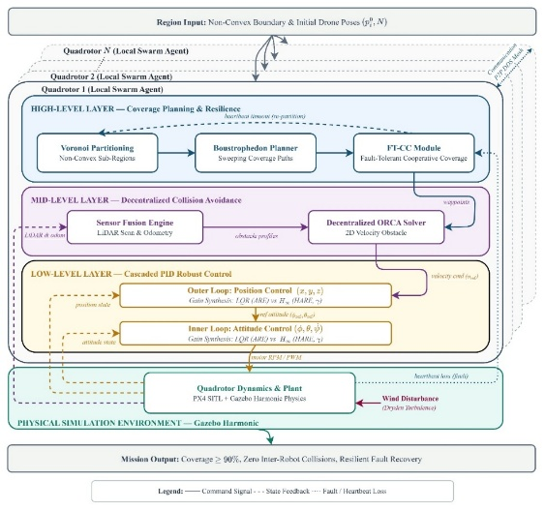
Figure 1. Proposed three-layer control architecture for resilient autonomous swarm quadrotor geodetic mapping. (https://github.com/izmaherdian/swarm-quadrotor-mapping/blob/main/docs/Diagram-Swarm-Quadrotor-Mapping.jpg)

PRELIMINARY RESULTS
Evaluated across non-convex obstacle environments, initial simulation results demonstrate that the framework successfully achieves 90–95% coverage completion with zero inter-robot collisions. Upon simulated agent failure, the FT-CC module maintains $≥$ 85% fleet coverage via dynamic re-partitioning. Under Dryden wind turbulence, the robust PID-$H_{∞}$ controller yields a 10–15% reduction in trajectory tracking root-mean-square error (RMSE) compared to PID-LQR. Quantitative tracking plots and recovery times will be detailed in the full paper.

CONCLUSION
This paper presents a three-layer control architecture for resilient, autonomous non-convex geodetic mapping by quadrotor swarms. It provides a comprehensive end-to-end pipeline integrating high-level non-convex planning (Voronoi/Boustrophedon/FT-CC), mid-level ORCA collision avoidance, and low-level PID-LQR/PID-$H_{∞}$ robust cascade control. Validated in high-fidelity ROS2-Gazebo-PX4 simulations, the framework effectively resolves critical integration and fault-tolerance gaps. Future work includes physical outdoor flight experiments and extension to heterogeneous multi-robot teams.

REFERENCES
¹ S. Papatheodorou, and A. Tzes, “Cooperative Visual Convex Area Coverage using a Tessellation-free Strategy,” in 2017 IEEE 56th Annual Conference on Decision and Control (CDC), (2017), pp. 4662–4667.
² S. Hu, T. Xu, and B. Wang, “Route-Planning Method for Plant Protection Rotor Drones in Convex Polygon Regions,” Sensors 21(6), 2221 (2021).
³ J. O’Keeffe, “Anticipating Degradation: A Predictive Approach to Fault Tolerance in Robot Swarms,” IEEE Robotics and Automation Letters 10(9), 8954–8961 (2025).
⁴ M. Belkheiri, A. Rabhi, A.E. Hajjaji, and C. Pegard, “Different linearization control techniques for a quadrotor system,” in CCCA12, (IEEE, Marseilles, France, 2012), pp. 1–6.
⁵ K. Lee, and K. Lee, “Adaptive Centroidal Voronoi Tessellation With Agent Dropout and Reinsertion for Multi-Agent Non-Convex Area Coverage,” IEEE Access 12, 5503–5516 (2024).
⁶ A. Breitenmoser, M. Schwager, J.-C. Metzger, R. Siegwart, and D. Rus, “Voronoi coverage of non-convex environments with a group of networked robots,” in 2010 IEEE International Conference on Robotics and Automation, (2010), pp. 4982–4989.
⁷ K. Cao, Y. Chen, S. Gao, H. Dang, and D. An, “Distributed Weighted Coverage for Multi-Robot Systems in Non-Convex Environment,” Applied Sciences 13(14), 8530 (2023).

