Nutrition & Wellness Website

About Us
Welcome to our Nutrition & Wellness platform. Our mission is to promote healthy living through balanced nutrition, regular physical activity, and positive lifestyle choices. We provide guidance on healthy foods, wellness practices, and simple habits that support a strong body and mind.

Healthy Living
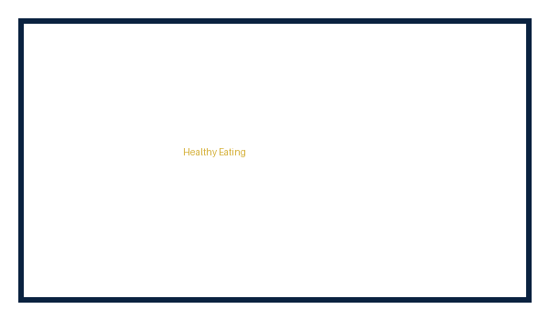


Contact Us
Phone: +256784132199

