

Urban planning for Radio Communications

SP 1
Generic architecture for the management of the radio resources and the management of the associated protocols
(Architecture Générique de gestion des ressources et des protocoles associés)

Deliverable merged from :
D1.4.2 and D1.5.1

Edition 1 1/06/2009

Editions

Edition | Date | Authors | Comments
Ed. 0 | 01/06/09 | V. Kumar - V. Capdevielle (Alcatel-Lucent) | Initial version:  Table of Content

Contents
1 Introduction to this deliverable 4
1.1 Context 4
1.2 Content of the deliverable 4
2 URC Spectrum management methods 4
2.1 DSA algorithms 4
2.2 JRRM 4
2.3 Other 4
3 Network architecture for DSA implementation 4
3.1 Existing architectures 4
3.2 New architectures 4
Vertical&Horizontal Radio Enabler / Common Pilot Channel / RRH / P1900.4 4
4 Usage and traffic models 4
4.1 Services/Applications in URC scenarios 4
4.2 Traffic models in selected scenarios 4
4.2.1 Large scale models 5
4.2.2 Small scale models 6
4.2.3 Voice source modeling 7
4.2.4 Video modeling 9
4.2.5 Web applications models 11
5 Analysis of cost/complexity increase resulting from DSA implementation 13
5.1 Studied scenario cases 13
5.2 Analysis of the impacts on the deployment of networks implementing DSA 13
6 Conclusion 13
7 References 13

Introduction to this deliverable
ALU

Context

Content of the deliverable

URC Spectrum management methods

DSA algorithms
FT ?

JRRM
PRISM

Other
PRISM ?

Network architecture for DSA implementation

Existing architectures
ALU

New architectures

Vertical&Horizontal Radio Enabler / Common Pilot Channel / RRH / P1900.4
THALES-PRISM (P1900)

Usage and traffic models

Services/Applications in URC scenarios
THALES

Traffic models in selected scenarios
PRISM
In this section, we present traffic models that should be used for the QoS and operator performances measurement in the one hand, and as input in the simulator in the other hand. Each traffic model should be related to the appropriate application, service defined according to the scenario defined in the section above. We decided to detail particularly the most common usages according to those defined scenarios.
For each scenario and each RAT, different services (telephony, video, streaming, data …) are proposed by operators. In each of the sections below, quantifications of those services should be given (in the session time scale), with the ratio of each service and, if possible the arrival and services rates variations according to space and time. This scale modeling should be used for the macro simulator and the micro simulator as well.
These parameters values should be known be the operator and could also be guessed from the measurements campaigns.
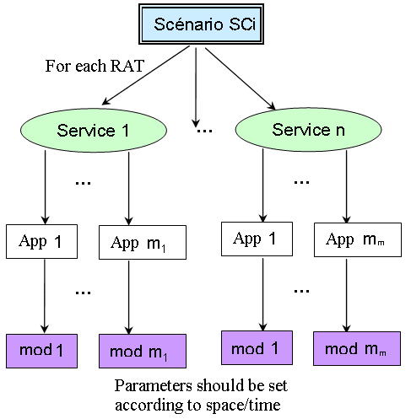
Figure 4.1 – Relations between scenarios and traffic profiles

After the session scale, the packet scale modeling will be made before being used in the micro simulator. This supposes that for each service/RAT a corresponding application is defined. Example: for telephony service, GSM => AMR application, WiFi => G711, G726, G729. Depending on those defined applications, the corresponding traffic models will be determined (geometric, rate based, Markovian, hyper-exponential …) and parameterized (data: mean rate, rate variance, mean reading time …; voice: mean on/off periods durations).
This mapping Services/RAT => applications should be given from operators but some parameters could be guessed from available (public domain) documents/articles. The measurements campaigns should not give interesting information for the packet scale modeling.
Each traffic model is generally associated with a time scale. The time scale indicates what the data units considered in the model are. In this section, two time scale are proposed for the study, the larger one which corresponds to one or more hours and the finest one which corresponds to finest time scale, i.e., the packet time scale.

Large scale models
In this section we describe large time scale model. Those models are based on the daily variations of the arrival rate, in a time scale larger than the session mean duration. Its value could be based on the DSA operation periodicity, i.e., around 1 hour.
Many works were conducted to identify traffic evolution in the large scale time period.
Generally, those models give the sessions arrival rate evolution for each day time. From this arrival rate, we can determine the probabilities corresponding to various number of active sessions.
For telephonic services, as the individual activity is very low (mean arrival rate less than 0.01) and as the population number is supposed very important, the well known poisson model could be used to describe the arrival rate of telephonic calls. Hence, combined to the daily variations, the model will describe the variations of the mean number of incoming sessions per time period.
Below, we propose a study on the case of telephonic calls. Usually the main voice activity follows the main business/working activities. It means an increase 2 peak hours the first one located in the middle of morning and the second located in the middle of afternoon. Note that the mean duration of calls is exponentially distributed and constant along the time periods, usually between 120 and 180 seconds.
From many measurements, we can demonstrate that the traffic generated could be described by a double gaussian function G(t) as illustrated below. At each day hour, the plot gives the mean traffic load for the whole period, assuming that this period of 1 hour is long enough comparing to the calls mean period.

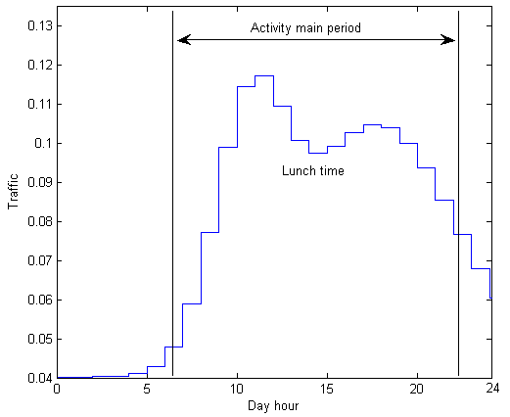
Figure 4.2 – Traffic evolution Vs day hour
The associated function can be expressed as a double Gaussian function. It could be the concatenation or the sum of two single functions corresponding to the traffic evolution in the respective half day period. The parameters correspond to the offset C, the amplitudes C₁, C₂, the mean peak hours M1, M2 (respectively for the morning and the afternoon) and variances V₁, V₂.
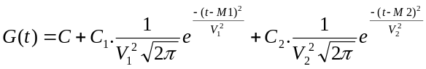

Small scale models
In this section we describe microscopic models which characterize source traffic Those models are needed to describe the traffic generated for individual sources as well as for aggregated sources.
Depending on the considered application, those microscopic models can focus from the burst scale to the packet scale (finest scale).
For example, the web traffic can be seen as a number of sessions initiated by users. Modeling at the session level consists in approximating the statistical behavior of the session’s interarrival time data volume. If we zoom in, a session appears as a set of flows separated by idle periods. Similarly, a flow is formed of packets that are generated in certain manner. At each level, the modeling process will try to build a statistical approximation of the data units behavior, especially their arrival process and their size.
The choice of time scales is closely related to the traffic type. If three time scales were necessary to fully describe web traffic, other traffics have different granularity levels. The radio technologies that will be covered in the project have their own traffic classes; GSM offers two classes, UMTS have four classes, and WiFi defines multiple priority classes.
We propose defining three generic traffic classes that will be used in the simulator independently of the Radio Access Technology (RAT) in use.
- Real time traffic (conversational)
- Non real time traffic with rate constraints
- Best effort traffic.

Voice source modeling
The voice traffic, which was initially transported by traditional telecommunication networks like GSM, is now experiencing an important growth in data networks due to the proliferation of Voice over IP (VoIP) services. With the convergence of data and telecommunication networks, and the diversity of offered applications (Telephony, Audio Phony, News, Audio Conferencing, etc.), the voice traffic will be predominantly packetized. In this section, we propose an overview of the proposed models of packetized voice.

ON/OFF Model
A voice source is characterized by two alternating periods, the active period (ON period) and the inactive period (OFF period) where the source remains silent. The coders used in digitizing the voice are usually equipped with a Voice Activity Detector (VAD), which controls the frames coming out of the coder. The «silence» frames are prevented from being emitted through the network. The main objective of a voice model is to statistically characterize the ON and OFF periods.
Below is an example of the packets generated by the AMR codec with activity detection. When active, the voice source generate 244 bits packets with an inter-arrival time τ of 20 ms. This period corresponds to the well known sampling frequency of 8KHz with 160 samples per packet (coded and compressed).
τ = 20ms
Silence Period
Activity Period
t
Figure 4.3 – Example of generated voice traffic by AMR codec
The common model is a two-state Markov process, known as the ON/OFF model. The duration of the OFF and ON periods are independent exponentials with respective parameters μ and λ. In the ON period, packets are generated at a constant rate D = 1/ τ. The parameters below are the most commonly used.

Model | E[1/ λ]  exponential | E[1/ μ]  exponential | τ = 1/D  deterministic | Packet size (bits)  deterministic
Model #1 | 650 ms | 350 ms | 20 ms | 244
Brady model | 1350 ms | 1000 ms | 20 ms | 244
Table 1: ON/OFF model parameters
The table above shows the most commonly used values of the ON/OFF parameters. These values were adopted by ETSI in the UMTS standards. It is worthy to note that the parameters of the model depend on the coder in use (G.711, G.26, G.28, etc.). In fact, the VAD has a great impact on the model; the more sensible the VAD, the longer the OFF periods.
When aggregating N homogeneous independent ON/OFF sources, we obtain a finite state birth and death process. The chain below describes this process with i, the number of sources in the active state simultaneously.
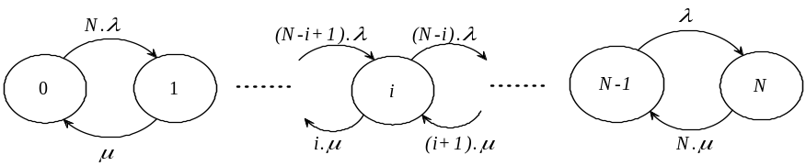

The duration in each state i is exponentially distributed with a mean duration Ti:
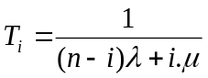
Moreover, for each state i, we can determine its corresponding probability π_{i}. Those probabilities are computed after solving the corresponding linear system through the infinitesimal generator.
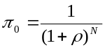
and 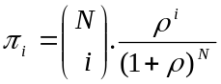 ; with 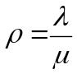
Another modeling approach is the Interrupted Poisson Process (IPP). IPP, like the ON/OFF model, has two exponential periods ON and OFF. The only difference is that the packets arrival in the ON period is a Poisson process of parameter D.
The IPP model has the advantage of simplicity that makes it suitable for performance analysis. Besides, aggregating N ON/OFF sources leads to a Markov Modulated Poisson Process (MMPP-N+1) which is analytically tractable. However, many studies showed the inaccuracy of the exponential assumptions, especially for the OFF period, and proposed alternative approached.
Among the several proposed models, we present in the next section the hyperexponential model, for it is a natural extension of the ON/OFF model.

Integrate voice models in the simulator: combining large scale and burst scale models
For markovian models, the distribution probabilities of each state in the packet time scale could be correlated with the traffic load in the session scale, considering that the time interval is long enough comparing to the burst interval.
We propose to combine the large scale models with the burst/packet scale voice model. First, for each time period (one hour), we take the mean traffic load from the large scale model, as given by the double Gaussian function in section 2.
Then, for each of those values, we compute the probability of each state represented by a number of active voice sources. We then obtain, for each day hour and for each number of active sources, the corresponding probability.
From those results, we obtain the mean and maximum number of active sources for each large scale time period and hence the mean and maximum throughput.
Below are given the obtained results for the typical Brady model with the following parameters:
- For the large scale function, G(t)
  - M1 = 9:12am, M2 = 5:20pm
  - C = 0.04; C₁ = 0.3 ; C₂ = 2.5
  - V₁ =1.9 ; V₂ = 4.3
- For the burst scale: Ton 1000 ms and Toff = 1350 ms.

The probability distribution for each day hour period and number of active sources
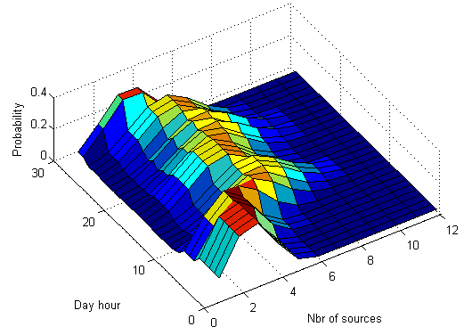
Figure 4.4 – probability distribution for each day hour and number of sources

An example of the traffic bit rate generated is given below using the results above. This traffic could be used in the simulator for the time period between 5:00am and 11:00am.
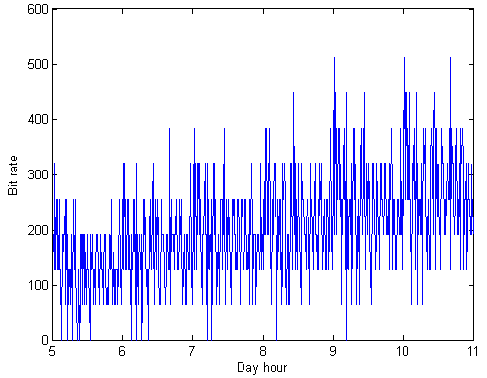
Figure 4.5 – traffic that could be generated in the simulator for 5:00am to 11:00am

Video modeling
With the novel compression techniques, the digital video offers multiple applications such as the digital television, video on demand, video telephony, etc. The video coders exploit the spatial and temporal dependencies that exist between consecutive images in order to compress the images. M-JPEG, MPEG-1, MPEG-2, MPEG-4, H261, and H263 are examples of standard video coders.

Voice modeling vs. Video modeling
In voice modeling, we were interested in the statistical distribution of the activity periods, which means how the packets are temporally generated. In video traffic, there are no ON/OFF periods because images are periodically generated. The modeling considers the images or Group Of Pictures (GOP) size and their correlation. Recall that in MPEG coding, the GOP is a set of pictures starting with an Intra coded (I) picture and containing Predicted coded (P) and Bidirectional predictive coded pictures.
GOP: I B B P B B P B B P BB

Rate-based video modeling
This type of modeling studies the statistical properties of the video rate D(t). A video flow can be characterized by the mean rate E[D], the variance of the rate Var[D], and the correlation function corr(τ) = e^{-aτ} . This behavior can be approximated by the MMPP-M+1 process as shown in the figure above.
0
1
2
M
Mλ
... ...
μ
(M-1)λ
(M-2)λ
λ
2μ
3μ
Mμ
D
2D
MD

Figure 4.6 – MMPP-M process

Each state corresponds to an averaged value of the rate. The MMPP calculations give:
E[D] = MDλ/( λ+ μ)
Var(D) = MD² λ μ /( λ+ μ)²
Corr(τ) = e⁻⁽ ^{λ+ μ)τ}

Example of generating video traffic
In this section we propose an example of what could be generated using the Maglaris model, well adapted for the conferencing model
Knowing the rate characteristics, we can deduce the MMPP parameters, λ, μ, and D. M is chosen such as M.D will be the maximum rate.
Below an example of with the values founded in the case of video conferencing:
λ | Μ | D | M
0.78 | 3.12 | 2540 (cellls/s) | 50

Table 2: MMPP parameters of a video source
Note that we considered the H323 video mean bit rate of 768 Kbps per source. Moreover, the M parameter could be given from a large time scale model, as explained for voice.
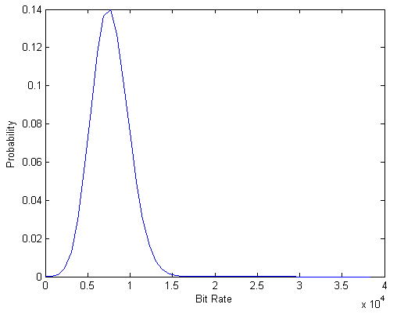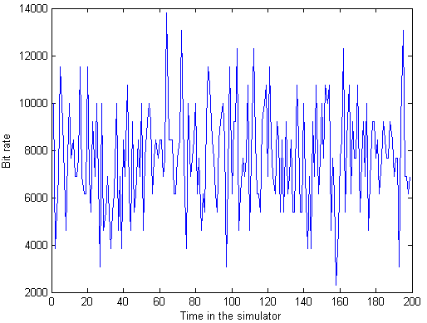
Figure 4.7 – video H323 modeling, (a) Probability states for the bit rate, (b) Throughput generated for the simulator

Web applications models

UMTS standards
In the UMTS recommendations, a web session is constituted by a succession packet calls separated by idle periods called reading time. Initiated by a user request, a packet call contains a sequence of packets. The reading time corresponds to the time spent by the user to read the downloaded information. Note that each packet has a different packet size.
Packet call
Packet call
Reading Time
… …
Session
Packet size
Figure 4.8 – A web session temporal trajectory
The statistical model parameters is given below.

 | Session Arrival | Packet call per session  E[N_{pc}] | Reading time  E[D_{pc}] | Packets number per packet call E[N_{d}] | Packets interarrival  E[D_{d}] | Packet size  (α, k, m)
WWW UDD (kpbs) | Poisson | Geometric | Geometric | Geometric | Geometric | Truncated Pareto
8 | λ | 5 packet call | 412 s | 5 packets | 0.5 | α = 1.1  k = 81.5 bytes (minimum size)  m = maximum size
16 |  |  |  |  | 0.125 | α = 1.1  k = 81.5 bytes (minimum size)  m = maximum size
64 |  |  |  |  | 0.0625 | α = 1.1  k = 81.5 bytes (minimum size)  m = maximum size
144 |  |  |  |  | 0.0277 | α = 1.1  k = 81.5 bytes (minimum size)  m = maximum size
384 |  |  |  |  | 0.0104 | α = 1.1  k = 81.5 bytes (minimum size)  m = maximum size
2048 |  |  |  |  | 0.00195 | α = 1.1  k = 81.5 bytes (minimum size)  m = maximum size
Figure 4.9 – Web session statistical

Measurement-based UMTS web traffic modeling,
A single user traffic model can be derived for UMTS networks based on real traffic measurement. The model has three different levels: the session level, the connection level, and the packet level. The main results are:
- The session interarrival time is lognormally distributed with mean m = 0.9681 and variance σ² = 4.3846.
- The session data volume has a lognormal distribution whose parameters depend on the bandwidth class
- The interarrival times and the data volume of connections are lognormally distributed.
- Packets interarrival times are also lognormally distributed.
- For packet sizes, the model considers four size sets: 40, 576, 1500, and other sizes. For each size, the model determines the proportion of packets that have this size.
The model parameters were estimated for different web applications such as HTTP, FTP, e-mail, etc.

Example of generating web/HTTP traffic
The results below illustrate the traffic generated for an example of 150 aggregated HTTP sources. The parameters are the same as defined above for the 16 Kbps nominal bit rate.
First we describe the obtained traffic for one of the individual sources, in the session scale and then in the packet call scale.
Hence, the first plot below describes the maximum packet size for each packet call according the time. After that, the second plot gives the sizes of each packet inside the same packet call (the 4th one).
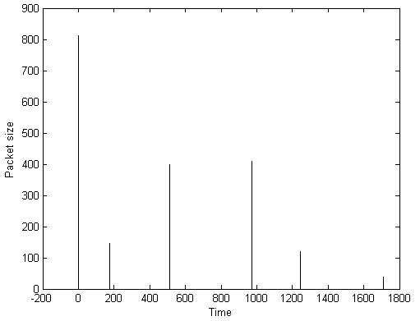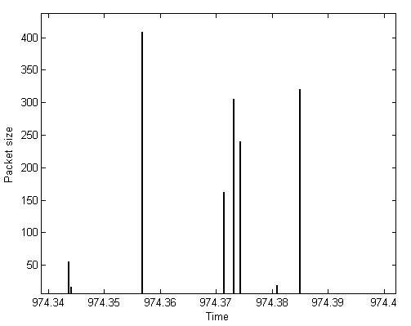
Figure 4.10 – A web session illustrating (a) packet calls arrivals and (b) the packets sizes
For each source, the individual bit rate is calculated thanks to packets sizes and corresponding inter-arrival time.
The figure below illustrates the throughput variation for one of the defined HTTP sources for a period of 100 seconds.
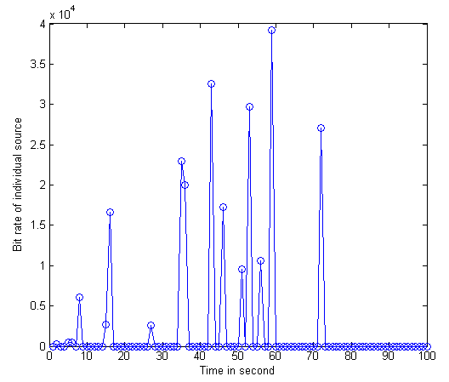
Figure 4.11 – Throughput for one individual web source

Analysis of cost/complexity increase resulting from DSA implementation
THALES – ALU
PRISM ?

Studied scenario cases
- Single/heterogeneous networks/technologies
- Single/multiple operator networks
- Networks in operated/unlicensed bands

Analysis of the impacts on the deployment of networks implementing DSA
- Depending on results in section IV

Conclusion
ALU

References

