

Urban planning for Radio Communications

SP 1
Generic architecture for the management of the radio resources and the management of the associated protocols
(Architecture Générique de gestion des ressources et des protocoles associés)

Task 1.4
Characterization of users traffic
(Caractérisation du trafic des utilisateurs)

Deliverable 1.4.1

Edition 1 14/10/2008

Editions

Edition | Date | Authors | Comments
Ed. 0 | 15/09/08 | M. Ibrahim (Prism)  S. Tohmé (Prism)  M. Abdennebi (Prism) | Initial version:  packet scale models
Ed. 1 | 14/10/08 | M. Ibrahim (Prism)  S. Tohmé (Prism)  M. Abdennebi (Prism) | Some additions and corrections
Ed. 2 | 30/10/08 | M. Abdennebi (Prism)  S. Tohmé (Prism)  M. Ibrahim (Prism) | Addition of hour scale models
Ed. 4 | 24/11/08 | M. Abdennebi (Prism)  S. Tohmé (Prism)  M. Ibrahim (Prism) | Addition of section 3
Ed. 5 | 29/11/08 | S. Tohmé (Prism)  M. Abdennebi (Prism)  M. Ibrahim (Prism) | Some additions and corrections

Contents
1 Introduction to this deliverable 4
1.1 Context 4
1.2 Content of the deliverable 4
2 Hour scale models 5
3 Burst/Packet scale models 6
3.1 Voice source modeling 6
3.1.1 ON/OFF Model 6
3.1.2 Hyperexponential Modeling 9
3.1.3 Integrate voice models in the simulator: combining large scale and burst scale models 10
3.2 Video modeling 11
3.2.1 Voice modeling vs. Video modeling 11
3.2.2 Rate-based video modeling 12
3.2.3 Correlation-based modeling 12
3.2.4 Example of generating video traffic 13
3.3 Web applications models 14
3.3.1 UMTS standards 14
3.3.2 Measurement-based UMTS web traffic modeling, 15
3.3.3 Example of generating web/HTTP traffic 15
4 Illustration with the examples of SC1 and SC2 16
5 Conclusion 18
6 References 18

Introduction to this deliverable

Context
This deliverable is related to the sub-project 1 of the project « Urbanisme des radiocommunications » within the system@tic pole of competences for the “Ile de France” Region. Its reference within the management plan is D1.4.1.
The project « urbanisme des radiocommunications » focuses on dynamic spectrum management for communication systems. The project is recognized in the TELECOM theme and sustained by the « System@tic» pole since July 2005.
Sub-Project 1 is dedicated to the general conception of the management system of the spectrum ressources, taking into account
- administrative and technical constraints,
- expected legacy evolutions and technological upgrades,
- the current uses of the spectrum,
- the possible evolutions of these uses.
Thus, Sub-project 1 defines the mains directions of work for other sub-projects (SP2 to SP4), that will investigated technical aspects relevant to sensing, to optimization and to access protocols. The further subprojects will confirm or modify the previous analysis performed in SP1
The goal of the task 1.4.3 is to characterize users traffics, this according to different usage scenarios, existing and/or future according to each services and applications defined in the deliverable 1.4.1 which defines the scenarios to be taken into account. Actually, this deliverable will give opportunity to expose how the traffic can be generated in the simulator and hence how to quantify the interest of DSA algorithms.

Content of the deliverable
A traffic model is generally associated with a time scale. The time scale indicates what the data units considered in the model are. In this document, 2 time scales are proposed for the study, the larger one which corresponds to 1 or more hours and the finest one which corresponds to finest time scale, i.e., the packet time scale.
This deliverable is organized as follow. The first section contains a description of large scale traffic models which could be used to describe the macroscopic evolution of traffic demand. Then, in the second section we describe microscopic traffic models corresponding to the most common applications. Those proposed statistical models are useful to describe the behaviour of voice, video and data sources, in both, burst scale and the packet scale. Moreover, for voice traffic, a combination of hour scale and packet scale models is given as an example of how to generate traffic in the SP2/SP3 simulators.
Finally, we apply the proposed traffic models to the proposed scenarios Sc1 and Sc2, described in the deliverable 1.4.1.

Hour scale models
In this section we describe large time scale model. Those models are based on the daily variations of the arrival rate, in a time scale larger than the session mean duration. The value of this scale could be based on the DSA operation periodicity, i.e., around 1 hour.
Many works were conducted to identify traffic evolution in the large scale time periods. Generally, those models give the sessions arrival rate evolution for each day time. From this arrival rate, we can determine the probabilities corresponding to various numbers of active sessions.
For telephony services, as the individual activity is very low (mean arrival rate less than 0.01) and as the population number is supposed very important, the well known Poisson model could be used to describe the arrival rate of telephony calls. Hence, combined to the daily variations, the model will describe the variations of the mean number of incoming sessions per time period.
Below, we propose a study on the case of telephony calls. Usually the main voice activity follows the main business/working activities. It means an evolution with 2 peak hours, the first one located in the middle of morning, and the second located in the middle of afternoon. Note that the call duration is exponentially distributed. The mean call duration is the inverse of the exponential distribution parameter which is also the service rate. This parameter is considered to be constant during the time periods. Usually, the mean call duration is considered between 120 and 180 seconds.
From many measurements, we can demonstrate that the traffic generated could be described by a double Gaussian function G(t) as illustrated below. At each day hour, the plot gives the mean traffic load for the whole period, assuming that this period of 1 hour is long enough comparing to the calls mean period.

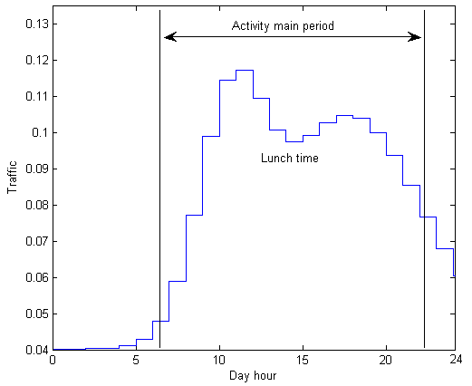
Figure 1 : Traffic evolution Vs day hour

The corresponding function associated can be expressed as a double Gaussian function [1]. It could be the concatenation or the sum of two single functions corresponding to the traffic evolution in the respective half day period. The parameters correspond to the offset C, the amplitudes C₁, C₂, the mean peak hours M1, M2 (respectively for the morning and the afternoon) and variances V₁, V₂.
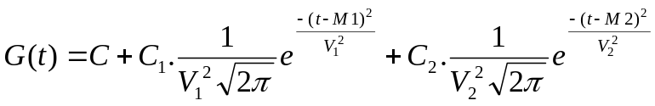

Note, that as described in the deliverable 2.2.3 [11], the parameters above can be identified easily thanks to the obtained measurements.

Burst/Packet scale models
In this section we describe microscopic models which characterize source traffic. Those models are needed to describe the traffic generated by an individual source as well as for aggregated sources.
Depending on the considered application, those microscopic models can focus on different scales, from the burst scale to the packet scale (finest time scale).
For example, the web traffic can be seen as a number of sessions initiated by users. Modeling at the session level consists in approximating the statistical behavior of the session’s interarrival time data volume. If we zoom in, a session appears as a set of flows separated by idle periods. Similarly, a flow is formed of packets that are generated in certain manner. At each level, the modeling process will try to build a statistical approximation of the data units behavior, especially their arrival process and their size.
The choice of time scales is closely related to the traffic type. If three time scales were necessary to fully describe web traffic, other traffics have different granularity levels. For example, real time traffic may be studied at two scales: the call and the packet scale. We conclude that for the simulator, we must define traffic classes and associate the adequate models to each class. The radio technologies that will be covered in the project have their own traffic classes; GSM offers two classes, UMTS have four classes, and WiFi defines multiple priority classes.
We propose defining three generic traffic classes that will be used in the simulator independently of the Radio Access Technology (RAT) in use.
- Real time traffic (conversational)
- Non real time traffic with rate constraints
- Elastic traffic.

Voice source modeling
The voice traffic, which was initially transported by traditional telecommunication networks like GSM, is now experiencing an important growth in data networks due to the proliferation of Voice over IP (VoIP) services. With the convergence of data and telecommunication networks, and the diversity of offered applications (Telephony, Audio Phony, News, Audio Conferencing, etc.), the voice traffic will be predominantly packetized. In this section, we propose an overview of the proposed models of packetized voice.

ON/OFF Model
A voice source is characterized by two alternating periods, the active period (ON period) and the inactive period (OFF period) where the source remains silent. The coders used in digitizing the voice are usually equipped with a Voice Activity Detector (VAD), which controls the frames coming out of the coder. The «silence» frames are prevented from being emitted through the network. The main objective of a voice model is to statistically characterize the ON and OFF periods.
Below is an example of the packets generated by the AMR codec [1] with activity detection. When active, the voice source generate 244 bits packets with an inter-arrival time τ of 20 ms. This period corresponds to the well known sampling frequency of 8KHz with 160 samples per packet (coded and compressed).
τ = 20ms
Silence Period
Activity Period
t
Figure 2: Example of generated voice traffic by AMR codec

The common model is a two-state Markov process, known as the ON/OFF model. The duration of the OFF and ON periods are independent exponentials with respective parameters μ and λ. In the ON period, packets are generated at a constant rate D = 1/ τ.

OFF
ON
λ
μ
D

Figure 3: ON/OFF process

And below are given the corresponding parameters values for the AMR codec.

Model | E[1/ λ]  exponential | E[1/ μ]  exponential | τ = 1/D  deterministic | Packet size (bits)  deterministic
Model #1 [3] | 650 ms | 350 ms | 20 ms | 244
Brady model [4] | 1350 ms | 1000 ms | 20 ms | 244
Table 1: ON/OFF model parameters

The table above shows the most commonly used values of the ON/OFF parameters. These values were adopted by ETSI in the UMTS standards. It is worthy to note that the parameters of the model depend on the coder in use (G.711, G.26, G.28, etc.). In fact, the VAD has a great impact on the model; the more sensible the VAD, the longer the OFF periods.
When aggregating N homogeneous independent ON/OFF sources, we obtain a finite (N+1) state birth and death process. The chain below describes this process with i, the number of sources in the active state simultaneously.
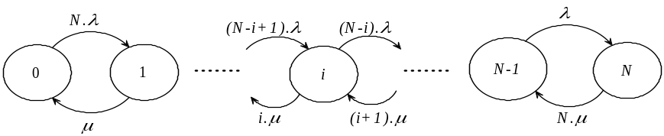
Figure 4: Aggregation of N ON/OFF sources

The duration in each state i is exponentially distributed with a mean duration Ti:
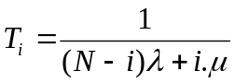
Below is an example of the obtained durations for 40 sources.
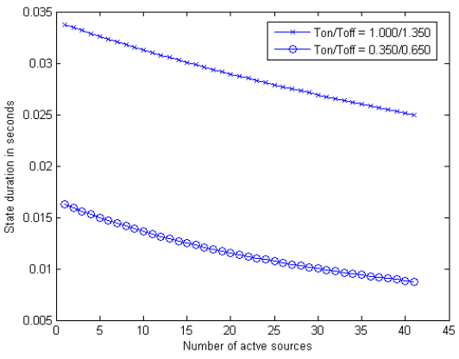
Figure 5: States durations for 40 aggregated sources

Moreover, for each state i, we can determine its corresponding probability π_{i}. Those probabilities are computed after solving the corresponding linear system obtained through the infinitesimal generator.
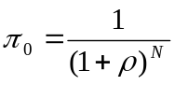
and 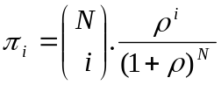 ; with 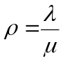
An example is given below for the states probabilities values π_{i} with N = 40 aggregated sources.
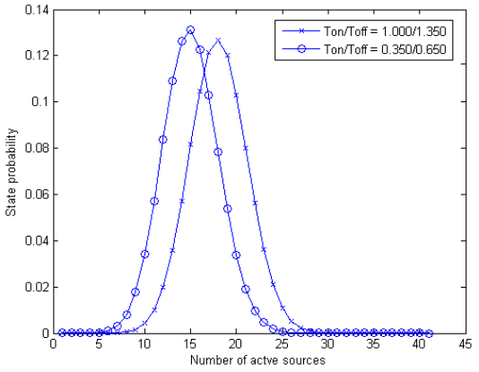
Figure 6: States probabilities for 40 aggregated sources

Another modeling approach is the Interrupted Poisson Process (IPP). IPP, like the ON/OFF model, has two exponential periods ON and OFF. The only difference is that the packets arrival in the ON period is a Poisson process of parameter D.
The IPP model has the advantage of simplicity that makes it suitable for performance analysis. Besides, aggregating N ON/OFF sources leads to a Markov Modulated Poisson Process (MMPP-N+1) which is analytically tractable. However, many studies showed the inaccuracy of the exponential assumptions, especially for the OFF period, and proposed alternative approached.
Among the several proposed models, we present in the next section the hyperexponential model, for it is a natural extension of the ON/OFF model.

Hyperexponential Modeling
In his work on the G.711 voice coder, A. Biernacki noticed in [1] that the empirical index of dispersion of the ON and OFF periods was greater than 1. He proposed to use the hyperexponential distribution to model each period. Recall that the hyperexponential (density) distribution is the weighted sum of m independent exponential (m is the number of exponential phases):
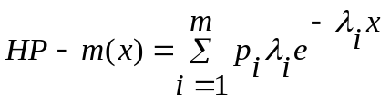
(1)

where p_{i} represents the probability to be in the phase i.

For the OFF period, a HP-3 distribution is used while 2 phases are sufficient for the ON period.

ON1
ON2
OFF1
OFF2
OFF3
λ ₁
λ ₂
λ ₃
μ₁
μ₂

Figure 7 : Hyperexponential model for VoIP

The Table 2 shows the parameter estimation of the G.711 voice coder.

 | OFF | ON
λ_{i} | λ₁ = 1.83  λ ₂ = 0.25  λ ₃ = 19.68 | μ₁ = 0.85  μ ₂ = 0.40
p_{i} | p₁ = 0.50  p₂ = 0.20  p3 = 0.30 | p₁ = 0.63  p₂ = 0.37

Table 2: Hyperexponential parameters for the VoIP G.711 coder

Integrate voice models in the simulator: combining large scale and burst scale models
Both ON/OFF and hyperexponential models use exclusively exponential distributions, which can be easily simulated. In fact, having a uniform random variable U in the interval [0, 1], the variable E = -Log(U) / λ is exponential with parameter λ.
The distribution probabilities of each state in the packet time scale could be correlated with the traffic load in the session scale, considering that the time interval is long enough comparing to the burst interval.
We propose to combine the large scale models with the burst/packet scale voice model. First, for each time period (one hour), we take the mean traffic load from the large scale model, as given by the double Gaussian function in section 2. Then, for each of those values, we compute the probability of each state represented by a number of active voice sources. We then obtain, for each day hour and for each number of active sources, the corresponding probability that will be used to generate traffic.
From those results, the mean and maximum number of active sources will be determined, this for each large scale time period. As a result, the mean and maximum throughput will also be given.

Below are given the obtained results for the typical Brady model with the following parameters:
- For the large scale function, G(t), values for the case of GSM Issy measurements (from 2.1.3 deliverable [11])
  - M1 = 9:12am, M2 = 5:20pm
  - C = 0.04; C₁ = 0.3 ; C₂ = 2.5
  - V₁ =1.9 ; V₂ = 4.3
- For the burst scale: Ton 1000 ms and Toff = 1350 ms.

The probability distribution for each day hour period and number of active sources
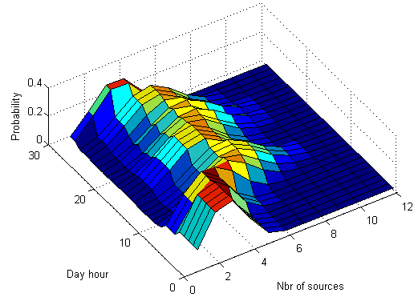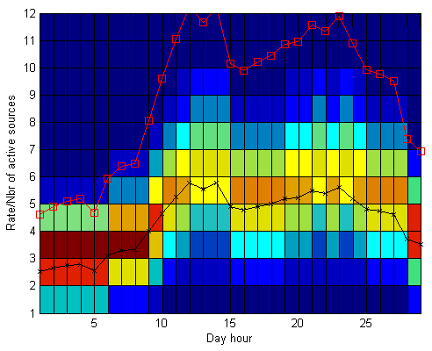
Figure 8 : (a) probability distribution for each day hour and number of sources; (b) mean (black line) and max (red line) activities

An example of the traffic bit rate generated is given below using the results above. This traffic could be used in the simulator for the time period between 5:00am and 11:00am.

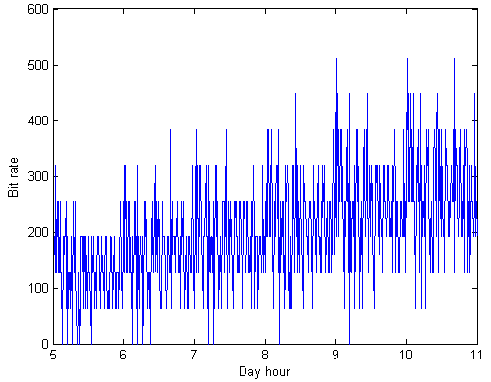
Figure 9 : traffic that could be generated in the simulator for 5:00am to 11:00am

Video modeling
With the novel compression techniques, the digital video offers multiple applications such as the digital television, video on demand, video telephony, etc. The video coders exploit the spatial and temporal dependencies that exist between consecutive images in order to compress the images. M-JPEG, MPEG-1, MPEG-2, MPEG-4, H261, and H263 are examples of standard video coders.

Voice modeling vs. Video modeling
In voice modeling, we were interested in the statistical distribution of the activity periods, which means how the packets are temporally generated. In video traffic, there are no ON/OFF periods because images are periodically generated. The modeling considers the images or Group Of Pictures (GOP) size and their correlation. Recall that in MPEG coding, the GOP is a set of pictures starting with an Intra coded (I) picture and containing Predicted coded (P) and Bidirectional predictive coded pictures.
GOP: I B B P B B P B B P BB

Rate-based video modeling
This type of modeling studies the statistical properties of the video rate D(t). Maglaris et al. noticed in [6] that a video flow can be characterized by the mean rate E[D], the variance of the rate Var[D], and the correlation function corr(τ) = e^{-aτ} . This behavior can be approximated by the MMPP-M+1 process as shown in the figure above.
0
1
2
M
Mλ
... ...
μ
(M-1)λ
(M-2)λ
λ
2μ
3μ
Mμ
D
2D
MD

Figure 10: MMPP-M process

Each state corresponds to an averaged value of the rate. The MMPP calculations give:
E[D] = MDλ/( λ+ μ)
Var(D) = MD² λ μ /( λ+ μ)²
Corr(τ) = e⁻⁽ ^{λ+ μ)τ}

Correlation-based modeling
While the markovian model is well suited for teleconferencing applications, more elaborated models are needed for the full-motion video traffic. Those models must approximate the autocorrelation function of the GOP size.
Let (Y_{k}) _{k>0} be a discrete stationary process representing the size of the k^{th} GOP in a video stream. The autocorrelation function of the process is defined by:
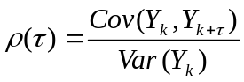
2LAR model
A model proposed to describe the GOP size is a mixture of two first-order autoregressive processes:
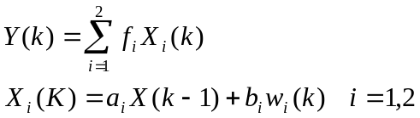
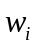 is a lognormally distributed residual with mean m_{i} and variance s_{i}. The first and second order moments of the process are easily derived:

The model parameters a_{i}, b_{i}, and f_{i} are estimated to fit both the empirical autocorrelation and the empirical probability density function of the real data.

Example of generating video traffic
In this section we propose an example of what could be generated using the Maglaris model, well adapted for the conferencing model
Knowing the rate characteristics, we can deduce the MMPP parameters, λ, μ, and D. M is chosen such as M.D will be the maximum rate.
Below an example of with the values founded in the case of video conferencing (Table 3):
λ | μ | D | M
0.78 | 3.12 | 2540 (cellls/s) | 50

Table 3: MMPP parameters of video sources
The figure below gives an example of the generated traffic from an aggregation of video sources according to the Table 3 parameters.
Note that we considered the H323 video mean bit rate of 768 Kbps per source. Moreover, the mean number of sources could be given from a large time scale model, as done for voice.

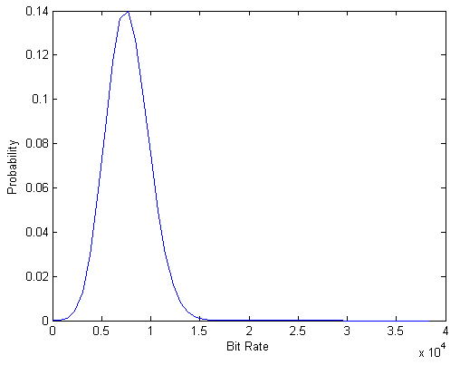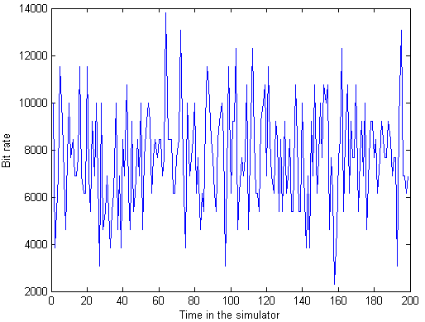
Figure 11: video H323 modeling, (a) Probability states for the bit rate, (b) Throughput generated for the simulator

Web applications models

UMTS standards
In the UMTS recommendations, a web session (see Figure 12) is constituted by a succession packet calls separated by idle periods called reading time. Initiated by a user request, a packet call contains a sequence of packets. The reading time corresponds to the time spent by the user to read the downloaded information. Note that each packet has a different packet size.
Packet call
Packet call
Reading Time
… …
Session
Packet size
Figure 12: A web session temporal trajectory

The statistical model of a session is described in Table 4 as well as the parameters

 | Session Arrival | Packet call per session  E[N_{pc}] | Reading time  E[D_{pc}] | Packets number per packet call E[N_{d}] | Packets interarrival  E[D_{d}] | Packet size  (α, k, m)
WWW UDD (kpbs) | Poisson | Geometric | Geometric | Geometric | Geometric | Truncated Pareto
8 | λ | 5 packet call | 412 s | 5 packets | 0.5 | α = 1.1  k = 81.5 bytes (minimum size)  m = maximum size
16 |  |  |  |  | 0.125 | α = 1.1  k = 81.5 bytes (minimum size)  m = maximum size
64 |  |  |  |  | 0.0625 | α = 1.1  k = 81.5 bytes (minimum size)  m = maximum size
144 |  |  |  |  | 0.0277 | α = 1.1  k = 81.5 bytes (minimum size)  m = maximum size
384 |  |  |  |  | 0.0104 | α = 1.1  k = 81.5 bytes (minimum size)  m = maximum size
2048 |  |  |  |  | 0.00195 | α = 1.1  k = 81.5 bytes (minimum size)  m = maximum size
Table 4: Web session statistical

Measurement-based UMTS web traffic modeling,
A single user traffic model can be derived for UMTS networks based on real traffic measurement. The model has three different levels: the session level, the connection level, and the packet level. The main results are:
- The session interarrival time is lognormally distributed with mean m = 0.9681 and variance σ² = 4.3846.
- The session data volume has a lognormal distribution whose parameters depend on the bandwidth class
- The interarrival times and the data volume of connections are lognormally distributed.
- Packets interarrival times are also lognormally distributed.
- For packet sizes, the model considers four size sets: 40, 576, 1500, and other sizes. For each size, the model determines the proportion of packets that have this size.
The model parameters were estimated for different web applications such as HTTP, FTP, e-mail, etc.

Example of generating web/HTTP traffic
The results below illustrate the traffic generated for an example of 150 aggregated HTTP sources. The parameters are the same as defined above for the 16 Kbps nominal bit rate.
First we describe the obtained traffic for one of the individual sources, in the session scale and then in the packet call scale.
Hence, the first plot describes the maximum packet size for each packet call according the time. After that, the second plot gives the sizes of each packet inside the same packet call (the 4th one).
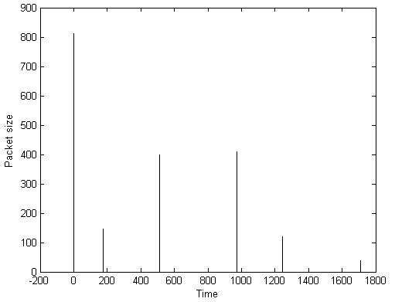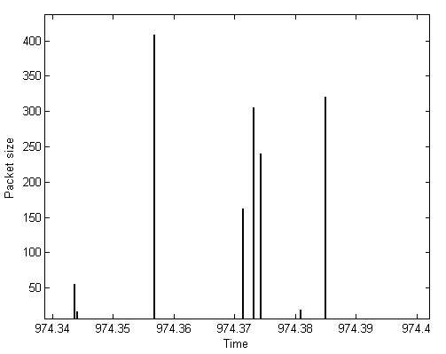
Figure 13: A web session illustrating (a) packet calls arrivals and (b) the packets sizes

For each source, the individual bit rate is calculated thanks to packets sizes and corresponding inter-arrival time.
The figure below illustrates the throughput variation for one of the defined HTTP sources for a period of 100 seconds.
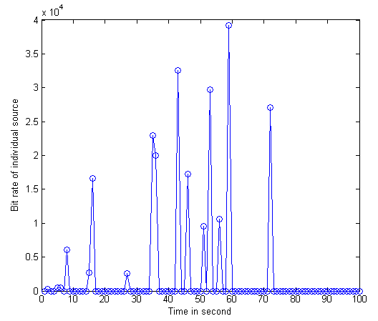
Figure 14: Throughput for one individual web source

After aggregating 150 defined web sources, we obtain the following throughput for the whole system, this for an obtained duration of 7000 seconds. Note that the dimensioning and /or the CAC should be done according the QoS required. Typically the QoS parameters will be the “comfort bit rate”, the delay and the loss rate.
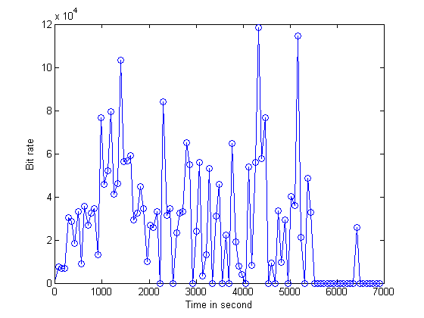
Figure 15: Throughput for 150 aggregated web sources

Illustration with the examples of SC1 and SC2
In this section we propose to illustrate the traffic characterization for the scenarios SC1 and SC2 defined in the deliverable 1.4.1. The first scenario is related to free license networks and the second one describes the wireless local loop.
Those 2 scenarios differ mainly by the importance of each service defined and by the application that corresponds to each service.
For example, the SC1 gives more importance to the video services than the SC2 scenario which considers the data applications as more important.
Hence, as described in the related deliverable, we will define 3 services for each scenario, web, video and voice, with the different defined rates. Moreover, two different applications will be considered for voice, G711 codec, well suited for Sc1 and the AMR codec for Sc2, as it integrates cellular networks.
We then considered different RATs, which determine the application to be used as well as the overhead in the lower layers, (eg, 58% for AMR/GSM and 20% for G711/802.11).
Note, that as defined in the deliverable 1.4.1, the rate of each service is as follow:
- For Sc1 :
  - voice 10%
  - video 40%
  - data 50%
- For Sc2 :
  - Voice 10%
  - Video 35%
  - Data 55%

Below is given an example of the obtained result for the throughput in the radio interface, using the aggregation of 3 types of traffic, voice, video and data.

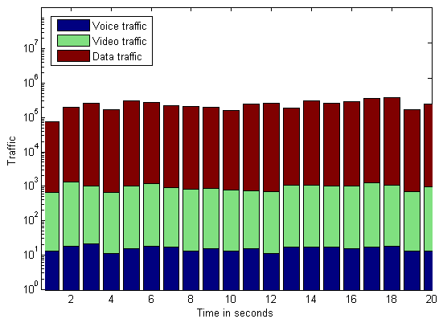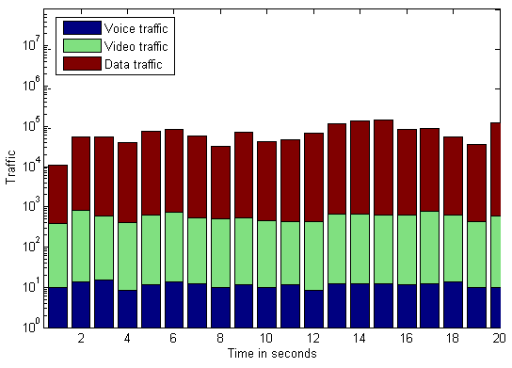
Figure 16: Total throughput for aggregated voice, video and data sources, (a) SC1, (b) SC2

From the obtained results we can see the importance of data traffic in free license bands networks, typically Wi-Fi, comparing to wireless local loop networks. Moreover, we see no difference for voice applications as the bit rate decrease in SC2 is compensated by an overhead increase before transmission in the radio interface.

Conclusion

In this deliverable we describe different traffic models, taking into account both the time scale granularity, large and small scales, and the different applications and services. The study was done for both individual and aggregated sources and, for several applications and even for a combination of large scale and packet scale models. The examples given could be helpful for traffic generation in the SP2/SP3 simulators. Finally, an application to 2 scenarios proposed in 1.4.1 was described in the last section.

References
- S. Almeida, J. Queijo, L-M Correia, “Spatial and temporal traffic distribution models for GSM”, Vehicular Technology Conference, VTC fall 1999.
- Adaptive Multi-Rate speech codec”, 3GPP, 1999
- C. E. May and T. J. Zebo, “A Model for Generating On-Off Speech Patterns in Two-Way Conversation”, AT&T Bell Lab, unpublished paper, December 1981.
- P. Brady, ‘‘A Model for Generating On-Off Speech Patterns in Two-Way Conversation”, Bell System Technology Journal, Vol. 48, September 1969.
- Biernacki, "VoIP Source Model Based On The Hyperexponential Distribution", Transactions on Engineering, Computing and Technology, February 2006.
- B. Maglaris, D. Anastassiou, P. Sen, G. Karlsson, J.D.Robbins, "Performance models of statistical multiplexing in packet videocommunications", IEEE Transactions on Communications.
- F. ALAGOZ, "Approximations on the Aggregate MPEG Video Traffic and Their Impact on Admission Control", Turk J Elec Engin, VOL.10, NO.1 2002.
- Alexander Klemm, Christoph Lindemann, and Marco Lohmann, "Traffic Modeling and Characterization for UMTS Networks", Globecom 2001.
- R. Naja, " Gestion de la mobilité et allocation de ressources dans les réseaux multiservices sans fil", 2003, ENST PhD Thesis: http://www.lb.auf.org/memoires/fiche_these.php?id=530
- H. Aouad, "Transport de Flux Temps Réels dans un Réseau IP Mobile", 2005, ENST PhD Thesis, http://www.lb.auf.org/memoires/fiche_these.php?id=530.
- URC project, D 2.2.3, “Field measurement processing”
- URC project, D 1.4.1, “Review of existing usage scenarios and their future evolution”

