IEEE P802.19
Wireless Coexistence

Project | IEEE P802.19 Coexistence TAG
Title | Data Traffic Model for Wireless Coexistence in US 3.65GHz band Simulation
Date Submitted | January 1, 2008
Source | Shahar Hauzner  Alvarion  21A HaBarzel St.  Tel-Aviv, Israel | Voice: +972 3 7674150  E-mail: shahar.hauzner@alvarion.com
Re:
Abstract | This document provides data traffic model for wireless coexistence simulation.
Purpose
Notice | This document has been prepared to assist the IEEE P802.19. It is offered as a basis for discussion and is not binding on the contributing individual(s) or organization(s). The material in this document is subject to change in form and content after further study. The contributor(s) reserve(s) the right to add, amend or withdraw material contained herein.
Release | The contributor acknowledges and accepts that this contribution becomes the property of IEEE and may be made publicly available by P802.19.
Introduction

This document provides rules for the data traffic model in 802.19 simulation for Wireless Coexistence in US 3.65GHz band. The model below is based on the web browsing (HTTP) traffic model from the IEEE 802.16m Evaluation Methodology draft (IEEE 802.16m-07/037r2).

User Level Model

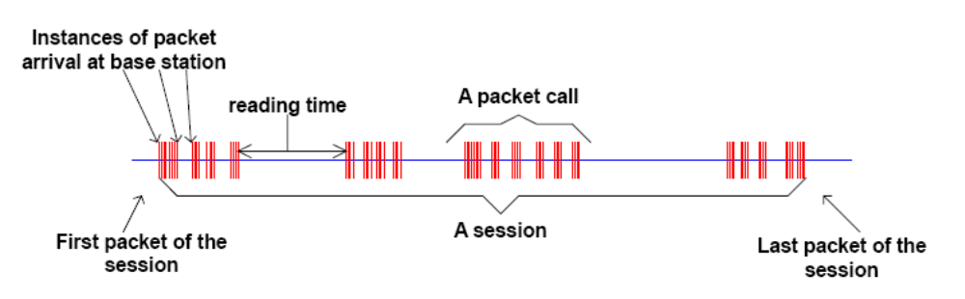
Figure 1: Packet Trace of a Typical Web Browsing Session

Figure 1 shows the packet trace of a typical web browsing session. The session is divided into ON/OFF periods representing web-page downloads and the intermediate reading times, where the webpage downloads are referred to as packet calls. These ON and OFF periods are a result of human interaction where the packet call represents a user's request for information and the reading time identifies the time required to digest the web-page.
As is well known, web-browsing traffic is self-similar. In other words, the traffic exhibits similar statistics on different timescales. Therefore, a packet call, like a packet session, is divided into ON/OFF periods as in Figure 2. Unlike a packet session, the ON/OFF periods within a packet call are attributed to machine interaction rather than human interaction. A web-browser will begin serving a user's request by fetching the initial HTML page using an HTTP GET request. The retrieval of the initial page and each of the constituent objects is represented by ON period within the packet call while the parsing time and protocol overhead are represented by the OFF periods within a packet call

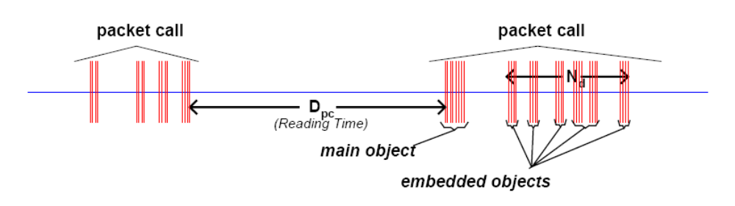
Figure 2: Contents in a Packet Call

The parameters for the web browsing traffic are as follows:
- S_{M}: Size of the main object in a page
- S_{E}: Size of an embedded object in a page
- N_{d}: Number of embedded objects in a page
- D_{pc}: Reading time
- T_{p}: Parsing time for the main page

The distributions of the parameters for the web browsing traffic model are described in Table 1.

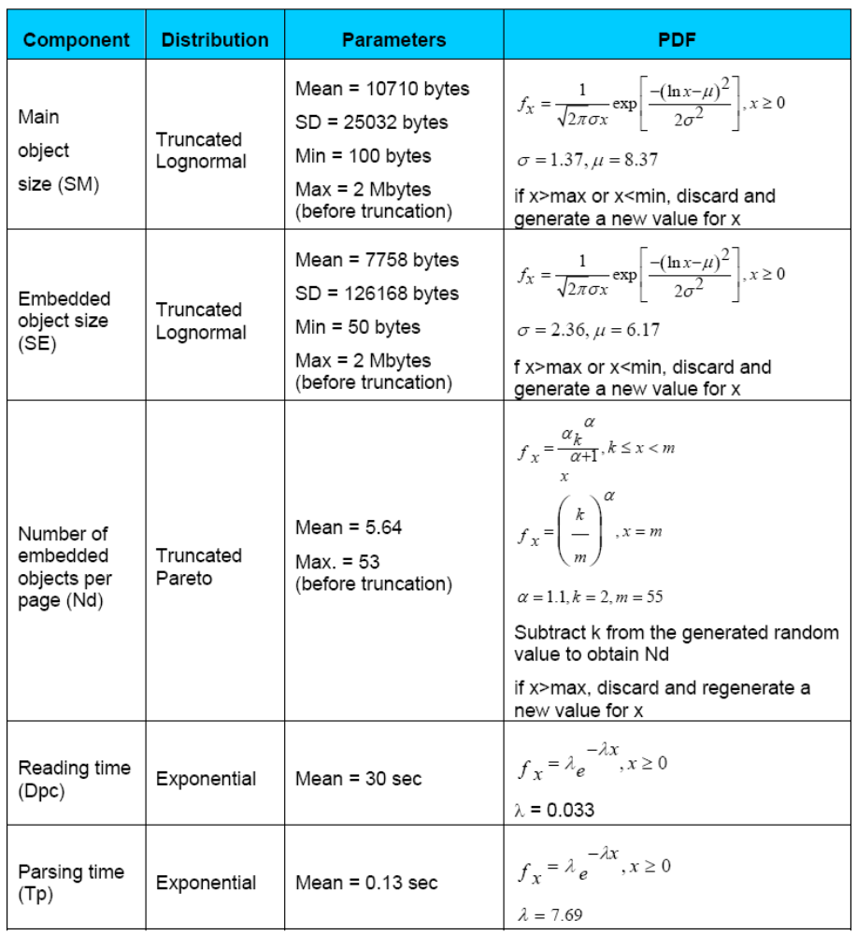
Table 1: HTTP traffic parameters

IP Packet Level Model

Based on observed packet size distributions, 76% of the HTTP packet calls should use an MTU of 1500 bytes, with the remaining 24% of the HTTP packet calls using an MTU of 576 bytes. These two potential packet sizes also include a 40 byte IP packet header (thereby resulting in useful data payloads of 1460 and 536 bytes, respectively), and this header overhead for the appropriate number of packets must be added to the object data sizes calculated from the probabilistic distributions in Table 1.

Suggested Data Traffic Model for 802.19 Simulation

DL Traffic Model

DL data is generated according to the parameters in the Table 1. The main object size, the number of embedded objects and the size of each embedded object are generated according to the distributions appearing in Table 1. Then all the objects are fragmented into packets of length 1500 bytes (1460 data bytes + 40 overhead bytes) and packets with length of 576 bytes (536 data bytes + 40 overhead bytes). The 1500 byte packets should compose about 76% of the total number of packets and the 576 byte packets the other 24%. The inter-packet arrival time (the time between the arrival of packet N and packet N+1) should be generated according to the parsing time in Table 1. The inter-session gap (the time between the last packet of session M and the first packet of session M+1) is generated according to the Reading time in Table 1.

Simplified DL Traffic Model

The Simplified DL data model uses only the mean values of the parameters that appear in Table 1.

Total Number of bytes per session:
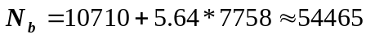
Total Number of packets:
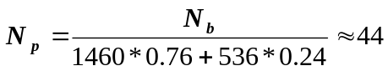
Number 1500 byte packets:
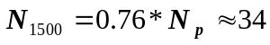
Number 576 byte packets:
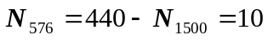

The parameters for the simplified DL traffic model are described in Table 2:

Parameter | Value
Number of 1500 byte packets in session | 34 packets
Number of 576 byte packets in session | 10 packets
The inter-packet arrival time | 0.13 sec
Inter session gap | 30 sec

UL Traffic Model

The UL traffic model is base on the page request size from Table 1. The UL traffic consists of one 350 byte packet per object (either main or embedded). The time between UL packet arrivals (time between the arrival of UL packet N to UL packet N+1) is uniformly distributed according to the DL session length:

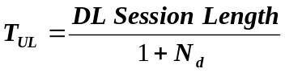

For the simplified DL traffic model, this time is:

