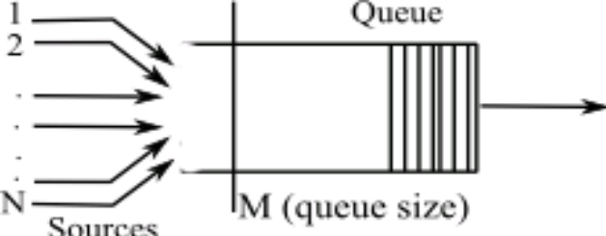

voix
model IPP
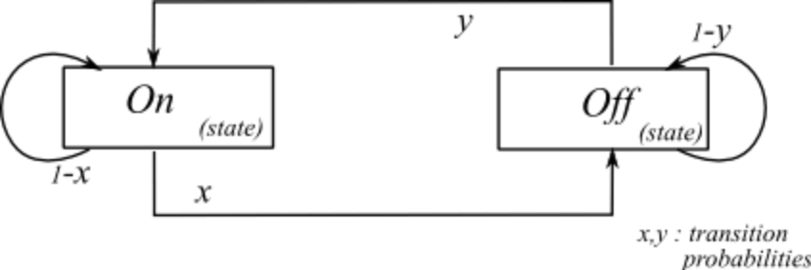

model ON/OFF
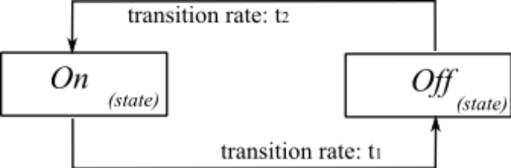

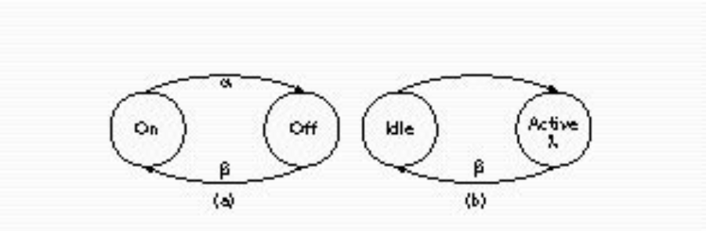

Figure 3B. 2-state voice activity Markov model

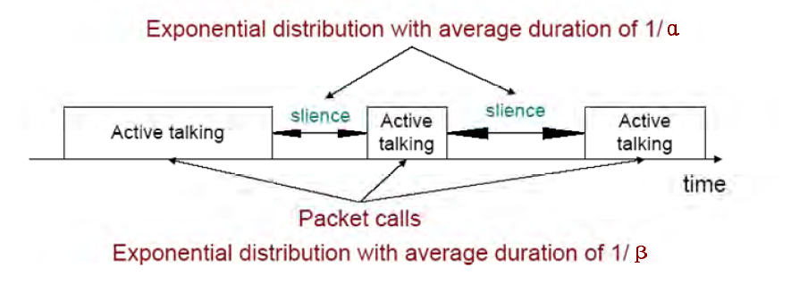

video
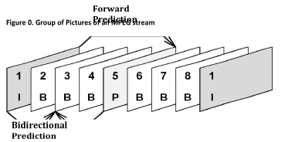
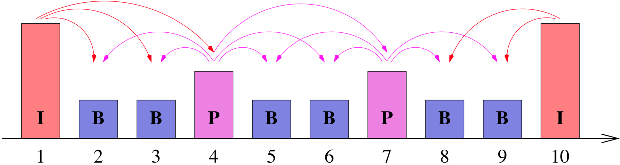

web
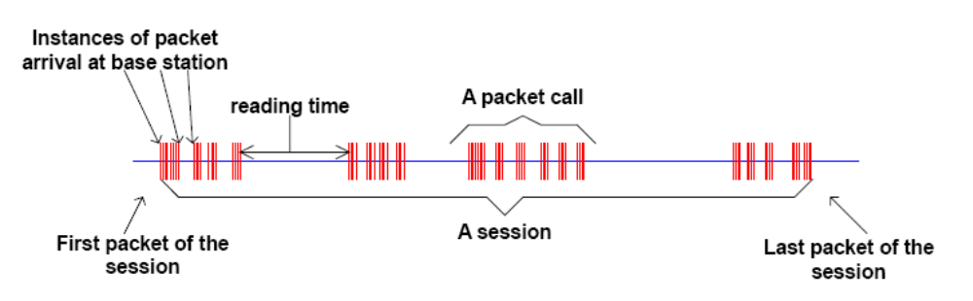
Figure 1: Packet Trace of a Typical Web Browsing Session

