voix
model IPP

model ON/OFF

Figure 3B. 2-state voice activity Markov model

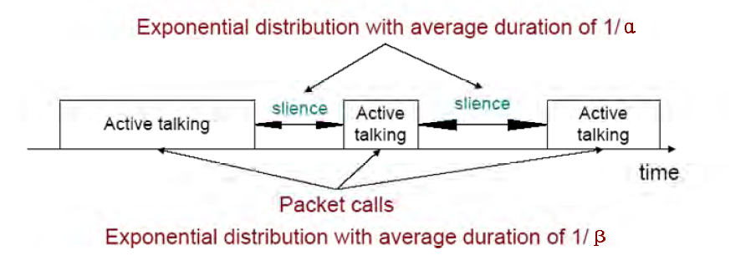

video
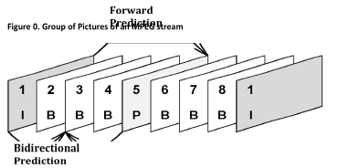
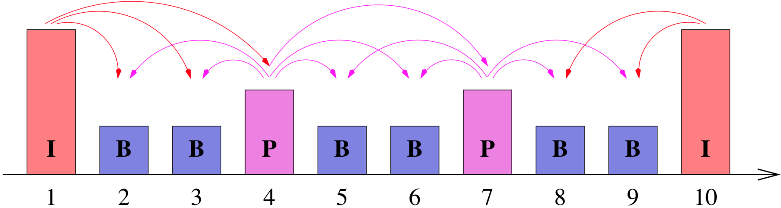

web

Figure 1: Packet Trace of a Typical Web Browsing Session

