Description des scenarios
Based on the analysis of project requirements, we can describe traffic scenarios possible so as to have 3 scenarios nominal and two adaptive simple as follows:

Nominal scenarios

Police team 1
In this scenario, we assume to have a police team on patrol in the vacation area consists of 15 entities. We consider the nature of the flow can be used will be such as streaming video buffered with obligatory or mandatory importance and medium priority. We must ensure quality of service by providing an access delay in consultation for very low because response speed is very important.

Police team 2
Recommended importance

We guarantee quality of service by providing a period of very low access for consultation.

Police team 3

Crew of police patrol in the vacation area

Adaptation scenarios

Pompiers

Sécurité civile

Je ne sais pas si vous avez déjà regardé le standards de 802.16m ou pas, mais je vous l'envoi en attaché il y a beaucoup de choses intéressantes la dessus (essentiellement à partir de la page 102 pour la voix, page 106 pour la video "MPEG4" il y a même la vidéo par téléphone en page 112).

FICHIER trafficModelsStandard pour les modèles de trafic standardisé
Voir thèse ROLA page 41 sur 225

Traffic Models (Blablabla à mettre en intro de la section)
The design of robust and reliable networks and network services is becoming increasingly difficult in today's world. The only path to achieve this goal is to develop a detailed understanding of the traffic characteristics of the network. The traffic models that we propose should allow making assumptions about the network based on existing models and current needs and also enable the prediction of performance for future needs. These traffic models can be used in two basic ways: (1) through an analytical model or (2) through a discrete event simulation (DES).

The Performance Management Network is to optimize how the networks operate by maximizing its ability to minimize latency and provide high reliability regardless of the available bandwidth. It consists of tasks such as measuring, modeling, planning and network optimization to ensure that they carry traffic with the speed, capacity and reliability expected by applications using the network or necessary in a particular scenario.

Networks to be used in this project are of different types and can be classified according to several factors. However, the factors that affect the performance of the different networks are more or less the same. These involve parameters such as packet loss, latency and throughput.
To design high performance networks or performance guarantee any type of network analysis detailed above factors is a crucial step. Often, the foremost step in this analysis is the study of the network traffic.
As a result, the type of traffic model used to understand the flow of traffic in the network, and to what extent the model describes the characteristics of the network in real time, become essential and vital parameters. The choice of a model that does not describe the characteristics of real-time traffic in the network can be as disastrous as not all traffic analysis.

2.1 Network Performance Management
Managing performance of networks involves optimizing the way networks function in an effort to maximize capacity, minimize latency and offer high reliability regardless of bandwidth available and occurrence of failures. Network performance management consists of tasks like measuring, modeling, planning and optimizing networks to ensure that they carry traffic with the speed, capacity and reliability that is expected by the applications using the network or required in a particular scenario.
Networks are of different types and can be categorized based on several factors. However, the factors that affect the performance of the different networks are more or less the same. These involve parameters like Latency, Packet Loss and Throughput. In order to design high performance networks or guarantee performance of any type of network detailed analysis of the above factors is a crucial step. Often the foremost step in such an analysis is the study of the traffic on the network. As a consequence the type of traffic model used to understand the flow of traffic in the network, and how closely the model depicts the real-time characteristics of the network, become vital parameters. Choosing a model that doesn't describe the real-time characteristics of the traffic in the network can be as disastrous as not analysis the traffic at all.

MODELISATION DE TRAFIC 2012 par Jörg Liebeherr (http://www.comm.utoronto.ca/~jorg/)

Video
- Video Traffic (High Definition)
      - 30 frames per second
      - Frame format: 1920x1080 pixels
      - 24 bits per pixel
- Required rate: 1.5 Gbps
- Required storage: 1 TB per hour
- Video uses compression algorithm to reduce bitrate
MPEG compression
- I frames: intra-coded
- P frames: predictive
- B frames: bi-directional
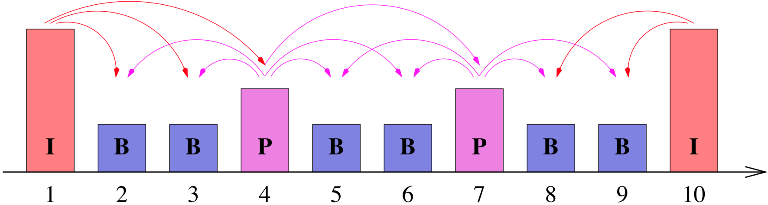
- Group of Pictures (GOP): IBBPBBPBB

- This is done by both reducing the spatial and the temporal redundancy of the video data stream.
- The spatial redundancies are reduced by transforms and entropy coding and the temporal redundancies are reduced by prediction of future frames based on motion vectors. This is achieved using three types of frames (cf.Figure1):
Bidirectional Prediction
Figure 1. Group of Pictures of an MPEG stream

Forward Prediction

- I-frames use only intra-frame coding, based on the discrete cosine transform and entropy coding;
- P-frames use a similar coding algorithm to I-frames, but with the addition of motion compensation with respect to the previous I-or P-frame;
- B-frames are similar to P-frames, except that the motion compensation can be with respect to the previous I- or P- frame, the next I- or P- frame, or an interpolation between them.

- Typically, I-frames require more bits than P-frames. B-frames have the lowest bandwidth requirement.
- After coding, the frames are arranged in a deterministic periodic sequence, e.g.\IBBPBB" or \IBBPBBPBBPBB", which is called Group of Pictures (GOP).

Voice Model
A typical phone conversation is marked by periods of active talking/talk spurts (ON periods) interleaved by silence/listening periods (or OFF periods) as show in Figure A.
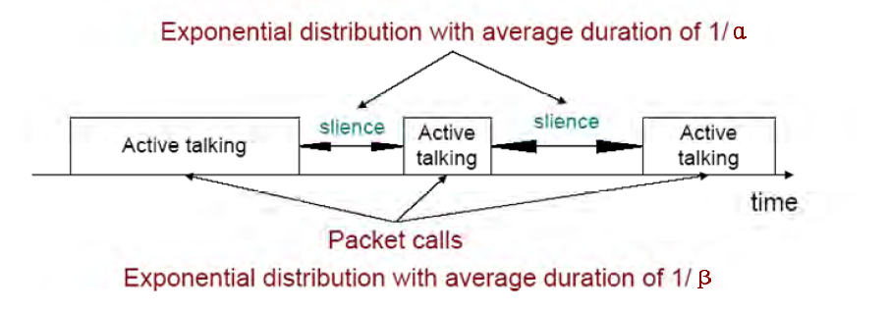
Figure 1A. Typical phone conversation profile

Consider the simple 2-state voice activity Markov model show in Figure B [54]
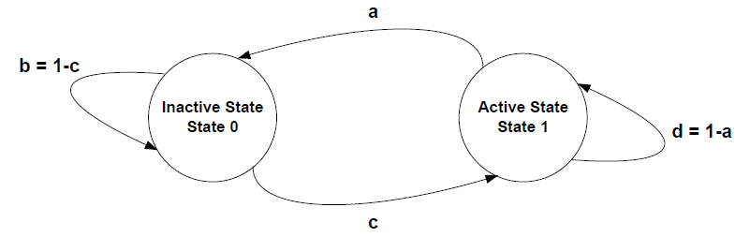
Figure 2B. 2-state voice activity Markov model

- Standard (Pulse Code Modulation) voice encoding:
      - 8000 samples per second (8 kHz)
      - 8 bits per sample
      - Bit rate: 64 kbps
- Better quality with higher sampling rate and larger samples
- CD encoding:
      - 44 kHz sampling rate
      - 16 bits per sample
      - 2 channels
      - Bit rate: 1.4 Mbps
- Packet voice collects multiple samples in once packet
- Modern voice encoding schemes also use compression and silent suppression

Data

- Data measured on an Ethernet network at Bellcore Labs with 10Mbps
- Data measures total (aggregate) traffic of all transmissions on the network
- Measurements from 1989
- One of the first systematic analyses of network measurements

FTP ()

Web Browsing (HTTP) Traffic Model
HTTP (model question-reponse)

Internet Traffic
- Data measured from a backbone link of a Tier-1 Internet Service provider
  - Link measured: Chicago – Seattle
  - Link rate: 10 Gbps (10 Gigabit Ethernet)
- Data measures total (aggregate) traffic of all transmissions on the network
- Data shown is 1ms: ~400 packets packet transmissions
  - Average rate: ~2.6 Gbps
  - Avg. packet size: 837 Bytes
  - Min. packet size: 46 Bytes
  - Max. packet size: 1504 Bytes

Naila
Caractéristiques de la voix :
Dans le livrable SP3.2 page 48/118, et 62/118 ils montrent un tableau des mesures de la voix nécessaires pour calculer le taux de remplissage des paquets LTE. Dans le quel on peut voir que pour un débit de 2.45 kbps un d’échantillonnage de à 20ms a été utilisé (temps inter arrivés des paquets de voix).
Page 53/118 table 21 : nous pouvons voir le format d’un paquet voix avant compression (60 octet d’entête + 49bits de payload voix).
Page 64/118 : table 25, nous pouvons voir les paramètres utilisés lors de la simulation des capacités de la transmission de la voix sur LTE (duré d’appel = 60s).
De plus les pages 14 et 15/118 (rédigées par Amine), on explique les critères pour avoir une bonne qualité de service, La gigue doit être comprise entre 0 et 50 ms (selon les besoins du projet) ms pour une bonne qualité de réception de la parole. (Pour pouvoir comprendre la parole).
Donc ce qui sort de l’application c’est un échantillonnage de 20ms des paquets voix, ensuite à un niveau plus bas, il peut y avoir un multiplexage ou bien une compression d’entête, à ce moment-là il va y avoir une autre modélisation.
Je peux conclure, qu’il est recommandé de proposer un de trafic source en utilisant les paramètres décris dans le présent livrable

pour l'article de la modélisation BMAP, j'en ai déjà présenté un à Tohmé, mais ce n'est pas le même, le voici en attaché,
dans le présent article, ils modélisent les arrivés au niveau MAC, lors du découpage de la vidéo en un ensemble d'image GOP, les arrivés sont groupé par batch. Ils ont rajouter la priorité préempti , grâce à la distribution "phase type". Ensuite ils ont simuler leurs travail en utilisant un codage MPEG-4 avec une file M/Gi/1.
en effet c'est très intéressant, on peut toujours l'adapter pour modéliser le trafic à la sortie de l'application source.
pour répondre à ta question sur les mesures, Amine a rédigé une partie sur ce qui es recommandé dans la littérature, et les mesures dans le cadre du projet, ont étés réalisés par TSP, et c'est à ce moment là qu'ils ont constaté le problème des petits paquets (voix) dans des gros paquets OFDMA.

ON-OFF AND IPP MODELS
The ON-OFF source model shown in Fig. 2a is the most popular source model for voice [4, 5]. In this model, packets are only generated during talk spurts (ON state) with fixed interarrival time. The time spent in ON and OFF states is exponentially distributed with mean a–1 and b–1, respectively.
The interrupted Poisson process (IPP) shown in Fig. 2b is also a two-state process. Arrivals only occur in the active state according to a Poisson distribution with rate l. Hence, IPP and ON-OFF models differ in interarrival time during the active (ON) state.

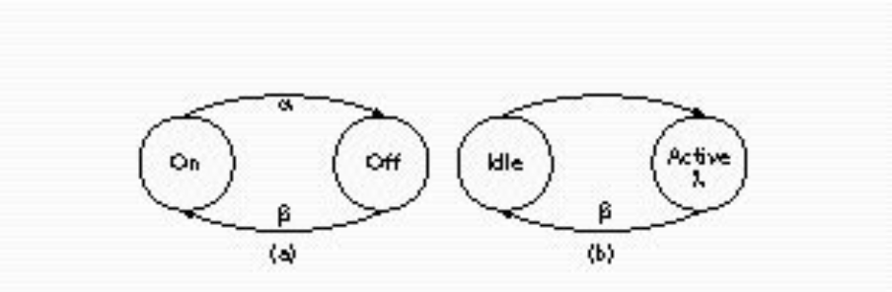
Figure 3. a) ON-OFF model and b) IPP model.

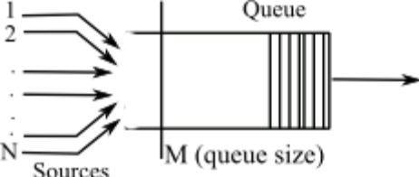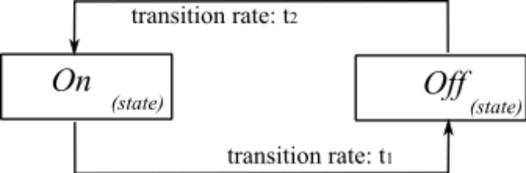

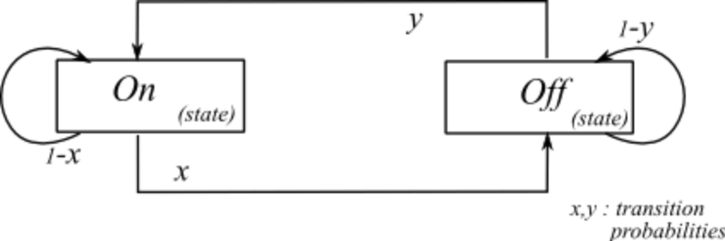

PAS NECESSAIRE JE PENSE
2.2 QOS Guarantees
The term Quality of Service, in the field of networking, refers to control procedures that can provide a guaranteed level of performance to data
flows in accordance to requests from an application/user using the network. A network that provides supports QOS usually agrees on a traffic
contract with an application and reserves a finite capacity in the network nodes, based on the contract, during the session establishment phase.
While the session is in progress, the network strives to adhere to the contract by monitoring and ensuring that the QOS guarantees are met. The
reserved capacities are released subsequently after the session.
There are several factors that might affect such QOS guarantees. Hence, to design a network to support QOS is not a easy task. The primary step
is to once again have a clear understanding of the traffic in the network. Without a clear understanding of the traffic and the applications that might
be using the network, QOS guarantees cannot be provided. Therefore, modeling of traffic becomes a crucial and necessary step.

SECTION pour le mode circuit et paquet

