Contrib. PRISM : Nora, Naila et Samir

Contrib. PRISM 1
Description des scenarios 1
Nominal scenarios 1
Police team 1 1
Police team 2 1
Police team 3 2
Crew of police patrol in the vacation area 2
Adaptation scenarios 2
Pompiers 2
Sécurité civile 2
Traffic Models (Blablabla à mettre en intro de la section) 2
MODELISATION DE TRAFIC 2012 par Jörg Liebeherr (http://www.comm.utoronto.ca/~jorg/) 3
Video Model 3
Voice Model 4
Data 6
Web Browsing (HTTP) Traffic Model 6
Internet Traffic 6
PAS NECESSAIRE JE PENSE 8

Description des scenarios
Based on the analysis of project requirements, we can describe traffic scenarios possible so as to have 3 scenarios nominal and two adaptive simple as follows:

Nominal scenarios

Police team 1
In this scenario, we assume to have a police team on patrol in the vacation area consists of 15 entities. We consider the nature of the flow can be used will be such as streaming video buffered with obligatory or mandatory importance and medium priority. We must ensure quality of service by providing an access delay in consultation for very low because response speed is very important.

Police team 2
Recommended importance

We guarantee quality of service by providing a period of very low access for consultation.

Police team 3

Crew of police patrol in the vacation area

Adaptation scenarios

Pompiers

Sécurité civile

Je ne sais pas si vous avez déjà regardé le standards de 802.16m ou pas, mais je vous l'envoi en attaché il y a beaucoup de choses intéressantes la dessus (essentiellement à partir de la page 102 pour la voix, page 106 pour la video "MPEG4" il y a même la vidéo par téléphone en page 112).

FICHIER trafficModelsStandard pour les modèles de trafic standardisé
Voir thèse ROLA page 41 sur 225

Traffic Models (Blablabla à mettre en intro de la section)

The design of robust and reliable networks and network services is becoming increasingly difficult in today's world. The only path to achieve this goal is to develop a detailed understanding of the traffic characteristics of the network. The traffic models that we propose should allow making assumptions about the network based on existing models and current needs and also enable the prediction of performance for future needs. These traffic models can be used in two basic ways: (1) through an analytical model or (2) through a discrete event simulation (DES). The Performance Management Network is to optimize how the networks operate by maximizing its ability to minimize latency and provide high reliability regardless of the available bandwidth. It consists of tasks such as measuring, modeling, planning and network optimization to ensure that they carry traffic with the speed, capacity and reliability expected by applications using the network or necessary in a particular scenario.The networks used in this project are of different types and can be classified according to several factors. However, the factors that affect the performance of the different networks are more or less the same. These involve parameters such as Packet Loss, Latency and Throughput. In order to design high performance networks or performance guarantee of any type of network detailed analysis the above factors is a crucial step. Often, the foremost step in this analysis is the study of the network traffic. As a result, the type of traffic model used to understand the flow of traffic in the network, and to what extent the model describes the characteristics of the network in real time, become essential and vital parameters. The choice of a model that does not describe the characteristics of real-time traffic in the network can be as disastrous as not all traffic analysis.

MODELISATION DE TRAFIC 2012 par Jörg Liebeherr (http://www.comm.utoronto.ca/~jorg/)

Video Model
- Video Traffic (High Definition)
      - 30 frames per second
      - Frame format: 1920x1080 pixels
      - 24 bits per pixel
- Required rate: 1.5 Gbps
- Required storage: 1 TB per hour
- Video uses compression algorithm to reduce bitrate
MPEG compression
- I frames: intra-coded
- P frames: predictive
- B frames: bi-directional
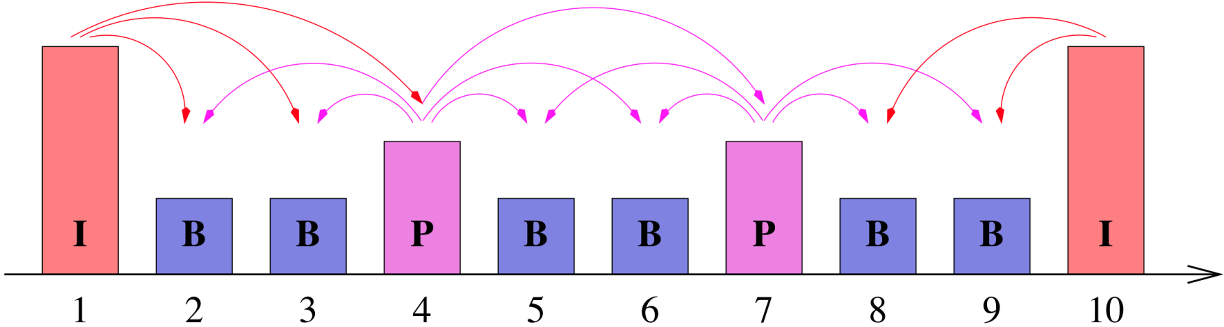
- Group of Pictures (GOP): IBBPBBPBB

- This is done by both reducing the spatial and the temporal redundancy of the video data stream.
- The spatial redundancies are reduced by transforms and entropy coding and the temporal redundancies are reduced by prediction of future frames based on motion vectors. This is achieved using three types of frames (cf.Figure1):
Bidirectional Prediction
Figure 1. Group of Pictures of an MPEG stream

Forward Prediction

- I-frames use only intra-frame coding, based on the discrete cosine transform and entropy coding;
- P-frames use a similar coding algorithm to I-frames, but with the addition of motion compensation with respect to the previous I-or P-frame;
- B-frames are similar to P-frames, except that the motion compensation can be with respect to the previous I- or P- frame, the next I- or P- frame, or an interpolation between them.

- Typically, I-frames require more bits than P-frames. B-frames have the lowest bandwidth requirement.
- After coding, the frames are arranged in a deterministic periodic sequence, e.g.\IBBPBB" or \IBBPBBPBBPBB", which is called Group of Pictures (GOP).

Voice Model
A typical phone conversation is marked by periods of active talking/talk spurts (ON periods) interleaved by silence/listening periods (or OFF periods) as show in Figure A.
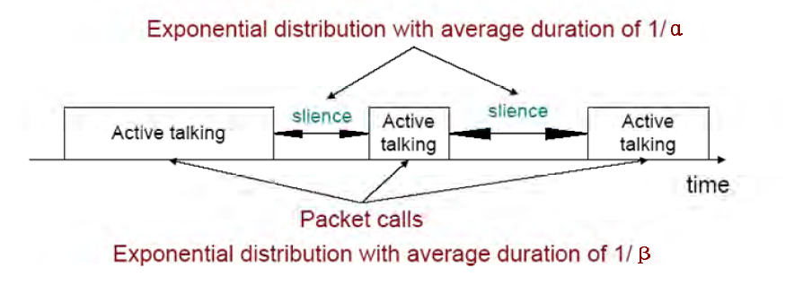
Figure 1A. Typical phone conversation profile

Consider the simple 2-state voice activity Markov model show in Figure B [54]
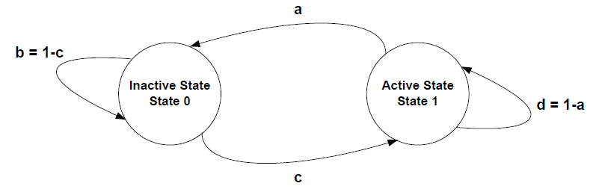
Figure 2B. 2-state voice activity Markov model

- Standard (Pulse Code Modulation) voice encoding:
      - 8000 samples per second (8 kHz)
      - 8 bits per sample
      - Bit rate: 64 kbps
- Better quality with higher sampling rate and larger samples
- CD encoding:
      - 44 kHz sampling rate
      - 16 bits per sample
      - 2 channels
      - Bit rate: 1.4 Mbps
- Packet voice collects multiple samples in once packet
- Modern voice encoding schemes also use compression and silent suppression

Data model

- Data measured on an Ethernet network at Bellcore Labs with 10Mbps
- Data measures total (aggregate) traffic of all transmissions on the network
- Measurements from 1989
- One of the first systematic analyses of network measurements

FTP ()

Web Browsing (HTTP) Traffic Model
The HTTP traffic can be modeled by “question-answer” model as shown in Figure XXXX. This figure shows the transmission of packets during a typical session of web browsing. The meeting was divided into periods ON / OFF representative downloads web pages and intermediate readings where web downloads are designated by packet calls. These ON and OFF periods are the result of human interaction where the packet call represents a user request for information and reading time identifies the time to digest the web page. As we know, the navigational traffic on the Internet (web-browsing traffic) is self-similar. In other words, the traffic exhibits similar statistics on different time scales. Therefore, a packet call, like a packet session, is divided into ON / OFF periods as shown in Figure 2. Unlike a packet session, the ON/OFF periods within a packet call are attributed to the machine interaction rather than human interaction. A web browser will begin serving a user’s request by fetching the initial HTML page using an HTTP GET request. The recovery of the original (initial) page and each of the constituent objects is represented by ON period within the packet call while the parsing (analysis) time and protocol overhead are represented by the OFF periods within a packet call.

IP Packet Level Model

Based on observed packet size distributions, 76% of the HTTP packet calls should use an MTU of 1500 bytes, with the remaining 24% of the HTTP packet calls using an MTU of 576 bytes. These two potential packet sizes also include a 40 byte IP packet header (thereby resulting in useful data payloads of 1460 and 536 bytes, respectively), and this header overhead for the appropriate number of packets must be added to the object data sizes calculated from the probabilistic distributions in Table 1.

Internet Traffic
- Data measured from a backbone link of a Tier-1 Internet Service provider
  - Link measured: Chicago – Seattle
  - Link rate: 10 Gbps (10 Gigabit Ethernet)
- Data measures total (aggregate) traffic of all transmissions on the network
- Data shown is 1ms: ~400 packets packet transmissions
  - Average rate: ~2.6 Gbps
  - Avg. packet size: 837 Bytes
  - Min. packet size: 46 Bytes
  - Max. packet size: 1504 Bytes

Naila
Caractéristiques de la voix :
Dans le livrable SP3.2 page 48/118, et 62/118 ils montrent un tableau des mesures de la voix nécessaires pour calculer le taux de remplissage des paquets LTE. Dans le quel on peut voir que pour un débit de 2.45 kbps un d’échantillonnage de à 20ms a été utilisé (temps inter arrivés des paquets de voix).
Page 53/118 table 21 : nous pouvons voir le format d’un paquet voix avant compression (60 octet d’entête + 49bits de payload voix).
Page 64/118 : table 25, nous pouvons voir les paramètres utilisés lors de la simulation des capacités de la transmission de la voix sur LTE (duré d’appel = 60s).
De plus les pages 14 et 15/118 (rédigées par Amine), on explique les critères pour avoir une bonne qualité de service, La gigue doit être comprise entre 0 et 50 ms (selon les besoins du projet) ms pour une bonne qualité de réception de la parole. (Pour pouvoir comprendre la parole).
Donc ce qui sort de l’application c’est un échantillonnage de 20ms des paquets voix, ensuite à un niveau plus bas, il peut y avoir un multiplexage ou bien une compression d’entête, à ce moment-là il va y avoir une autre modélisation.
Je peux conclure, qu’il est recommandé de proposer un de trafic source en utilisant les paramètres décris dans le présent livrable

pour l'article de la modélisation BMAP, j'en ai déjà présenté un à Tohmé, mais ce n'est pas le même, le voici en attaché,
dans le présent article, ils modélisent les arrivés au niveau MAC, lors du découpage de la vidéo en un ensemble d'image GOP, les arrivés sont groupé par batch. Ils ont rajouter la priorité préempti , grâce à la distribution "phase type". Ensuite ils ont simuler leurs travail en utilisant un codage MPEG-4 avec une file M/Gi/1.
en effet c'est très intéressant, on peut toujours l'adapter pour modéliser le trafic à la sortie de l'application source.
pour répondre à ta question sur les mesures, Amine a rédigé une partie sur ce qui es recommandé dans la littérature, et les mesures dans le cadre du projet, ont étés réalisés par TSP, et c'est à ce moment là qu'ils ont constaté le problème des petits paquets (voix) dans des gros paquets OFDMA.

ON-OFF AND IPP MODELS
The ON-OFF source model shown in Fig. 2a is the most popular source model for voice [4, 5]. In this model, packets are only generated during talk spurts (ON state) with fixed interarrival time. The time spent in ON and OFF states is exponentially distributed with mean a–1 and b–1, respectively.
The interrupted Poisson process (IPP) shown in Fig. 2b is also a two-state process. Arrivals only occur in the active state according to a Poisson distribution with rate l. Hence, IPP and ON-OFF models differ in interarrival time during the active (ON) state.

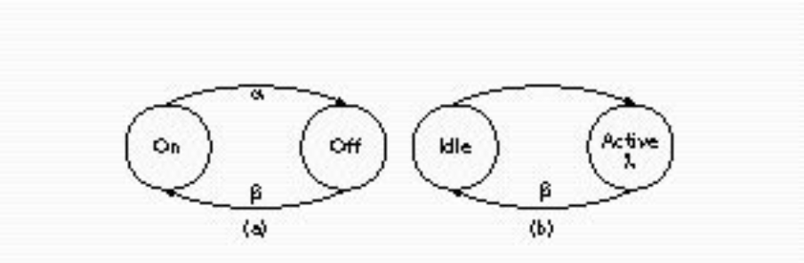
Figure 3. a) ON-OFF model and b) IPP model.

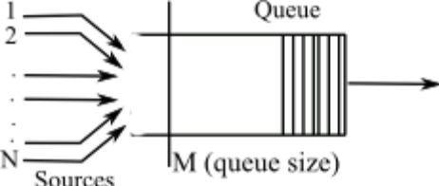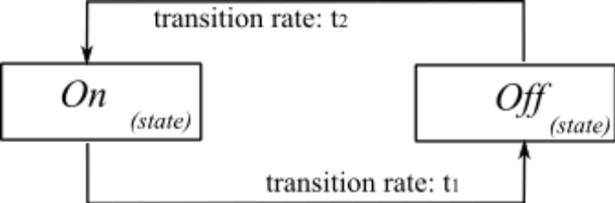

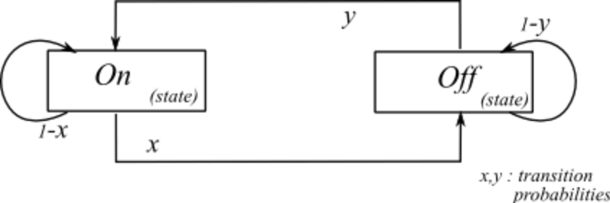

PAS NECESSAIRE JE PENSE
2.2 QOS Guarantees
The term Quality of Service, in the field of networking, refers to control procedures that can provide a guaranteed level of performance to data
flows in accordance to requests from an application/user using the network. A network that provides supports QOS usually agrees on a traffic
contract with an application and reserves a finite capacity in the network nodes, based on the contract, during the session establishment phase.
While the session is in progress, the network strives to adhere to the contract by monitoring and ensuring that the QOS guarantees are met. The
reserved capacities are released subsequently after the session.
There are several factors that might affect such QOS guarantees. Hence, to design a network to support QOS is not a easy task. The primary step
is to once again have a clear understanding of the traffic in the network. Without a clear understanding of the traffic and the applications that might
be using the network, QOS guarantees cannot be provided. Therefore, modeling of traffic becomes a crucial and necessary step.

HTTP (version init)
Figure XXXX shows the packet trace of a typical web browsing session.
The session is divided into ON/OFF periods representing web-page downloads and the intermediate reading times, where the webpage downloads are referred to as packet calls. These ON and OFF periods are a result of human interaction where the packet call represents a user's request for information and the reading time identifies the time required to digest the web-page. As is well known, web-browsing traffic is self-similar. In other words, the traffic exhibits similar statistics on different timescales. Therefore, a packet call, like a packet session, is divided into ON/OFF periods as in Figure 2. Unlike a packet session, the ON/OFF periods within a packet call are attributed to machine interaction rather than human interaction. A web-browser will begin serving a user's request by fetching the initial HTML page using an HTTP GET request. The retrieval of the initial page and each of the constituent objects is represented by ON period within the packet call while the parsing time and protocol overhead are represented by the OFF periods within a packet call

SECTION pour le mode circuit et paquet

