Contrib. PRISM : Nora, Naila et Samir

Contrib. PRISM : Nora, Naila et Samir 1
Description des scenarios 2
Nominal scenarios 2
Police team 1 2
Police team 2 2
Police team 3 2
Crew of police patrol in the vacation area 2
Adaptation scenarios 2
Pompiers 2
Sécurité civile 2
Traffic Models (Blablabla à mettre en intro de la section) 3
Voice Model 3
Basic Voice 3
VoIP Model 5
MODELISATION DE TRAFIC 2012 par Jörg Liebeherr (http://www.comm.utoronto.ca/~jorg/) 5
Video Model 5
Video Telephony 7
Video Streaming 7
Data model 7
Web Browsing (HTTP) Traffic Model 7
Internet Traffic (ref ) 8
FTP Traffic () 8
SECTION pour le mode circuit et paquet 11

Description des scenarios
Based on the analysis of project requirements, we can describe traffic scenarios possible so as to have 3 scenarios nominal and two adaptive simple as follows:

Nominal scenarios

Police team 1
In this scenario, we assume to have a police team on patrol in the vacation area consists of 15 entities. We consider the nature of the flow can be used will be such as streaming video buffered with obligatory or mandatory importance and medium priority. We must ensure quality of service by providing an access delay in consultation for very low because response speed is very important.

Police team 2
Recommended importance

We guarantee quality of service by providing a period of very low access for consultation.

Police team 3

Crew of police patrol in the vacation area

Adaptation scenarios

Pompiers

Sécurité civile

Je ne sais pas si vous avez déjà regardé le standards de 802.16m ou pas, mais je vous l'envoi en attaché il y a beaucoup de choses intéressantes la dessus (essentiellement à partir de la page 102 pour la voix, page 106 pour la video "MPEG4" il y a même la vidéo par téléphone en page 112).

FICHIER trafficModelsStandard pour les modèles de trafic standardisé
Voir thèse ROLA page 41 sur 225

Traffic Models (Blablabla à mettre en intro de la section)

The design of robust and reliable networks and network services is becoming increasingly difficult in today's world. The only path to achieve this goal is to develop a detailed understanding of the traffic characteristics of the network. The traffic models that we propose should allow making assumptions about the network based on existing models and current needs and also enable the prediction of performance for future needs. These traffic models can be used in two basic ways: (1) through an analytical model or (2) through a discrete event simulation (DES).
The Performance Management Network is to optimize how the networks operate by maximizing its ability to minimize latency and provide high reliability regardless of the available bandwidth. It consists of tasks such as measuring, modeling, planning and network optimization to ensure that they carry traffic with the speed, capacity and reliability expected by applications using the network or necessary in a particular scenario.The networks used in this project are of different types and can be classified according to several factors. However, the factors that affect the performance of the different networks are more or less the same. These involve parameters such as Packet Loss, Latency and Throughput. In order to design high performance networks or performance guarantee of any type of network detailed analysis the above factors is a crucial step. Often, the foremost step in this analysis is the study of the network traffic. As a result, the type of traffic model used to understand the flow of traffic in the network, and to what extent the model describes the characteristics of the network in real time, become essential and vital parameters. The choice of a model that does not describe the characteristics of real-time traffic in the network can be as disastrous as not all traffic analysis.
In this section, we present traffic models that should be used for the QoS and operator performances measurement. Each traffic model should be related to the appropriate application, service defined according to the scenario defined in the section above. In this project, we can see that we have three types of major traffic: voice, video and data. Each of these types will be divided into sub-categories as shown below.

➔ voir le delivrable SP1 URC à partir de la page 49

Voice Model
We can consider two types of voice: basic voice and VOIP.

A voice source is characterized by two alternating periods, the active period (ON period) and the inactive period (OFF period) where the source remains silent.

Basic Voice
A typical phone conversation is marked by periods of active talking/talk spurts (ON periods) interleaved by silence/listening periods (or OFF periods) as show in Figure A [1, 3]. The ON periods represent the sequence of packets in which the web-page is being transferred from source to destination; while the OFF periods represent the time the user spends reading the web-page before transitioning to another page. This time is also known as Reading Time. ➔ URC

The amount of information passed from the source to destination during the ON period is governed by the web page structure. A web-page is usually composed of a main object and several embedded objects. The size of the main object, in addition to the number and size of the embedded objects define the amount of traffic passed from source to destination.

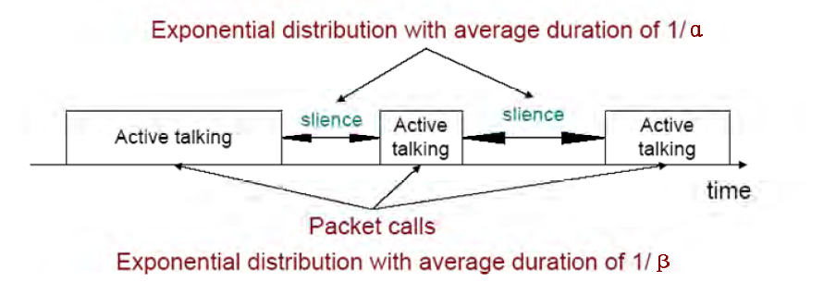
Figure 1A. Typical phone conversation profile

Consider the simple 2-state voice activity Markov model show in Figure B
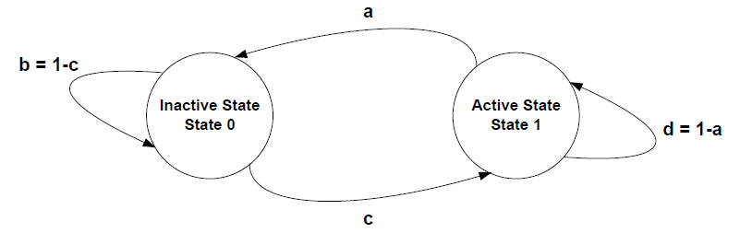
Figure 2B. 2-state voice activity Markov model

ON-OFF AND IPP MODELS (ref: Traffic Models in Broadband Networks., Abdelnaser Adas, IEEE Communications Magazine • July 1997) + ref : Survey of Network Traffic Models., B. Chandrasekaran, "Survey of Network Traffic Models", http://www.cs.wustl.edu/~jain/cse56706/ftp/traffic-models3/index.html.

The ON-OFF source model shown in Fig. 2a is the most popular source model for voice. In this model, packets are only generated during talk spurts (ON state) with fixed interarrival time. The time spent in ON and OFF states is exponentially distributed with mean a–1 and b–1, respectively.

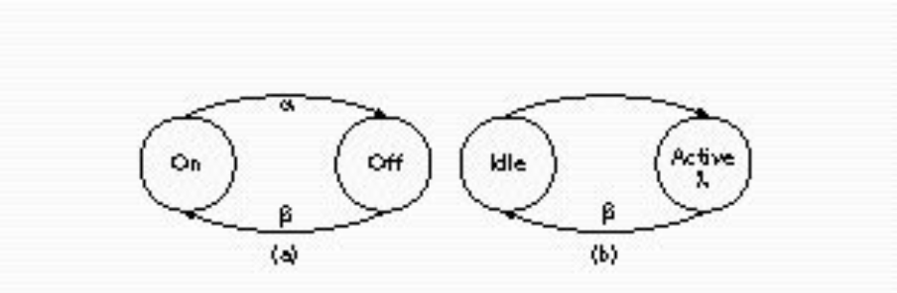
Figure 2 a) ON-OFF model and b) IPP model.

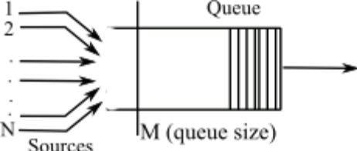
fig. Example queueing analysis for ON-OFF models

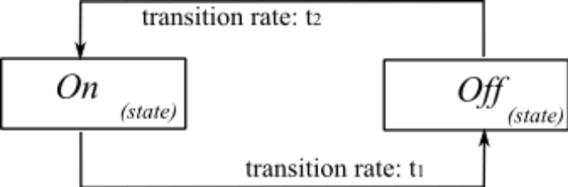
fig. Simple ON-OFF Model with transitional rates t1 & t2

- Standard (Pulse Code Modulation) voice encoding:
      - 8000 samples per second (8 kHz)
      - 8 bits per sample
      - Bit rate: 64 kbps
- Better quality with higher sampling rate and larger samples
- CD encoding:
      - 44 kHz sampling rate
      - 16 bits per sample
      - 2 channels
      - Bit rate: 1.4 Mbps
- Packet voice collects multiple samples in once packet
- Modern voice encoding schemes also use compression and silent suppression
Below is an example of the packets generated by the AMR codec with activity detection. When active, the voice source generate 244 bits packets with an inter-arrival time τ of 20 ms. This period corresponds to the well known sampling frequency of 8KHz with 160 samples per packet (coded and compressed).

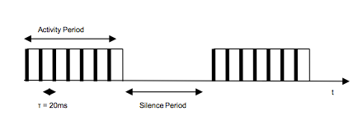

Figure 4.1 – Example of generated voice traffic by AMR codec
The common model is a two-state Markov process, known as the ON/OFF model. The duration of the OFF and ON periods are independent exponentials with respective parameters μ and λ. In the ON period, packets are generated at a constant rate D = 1/ τ. The parameters below are the most commonly used.

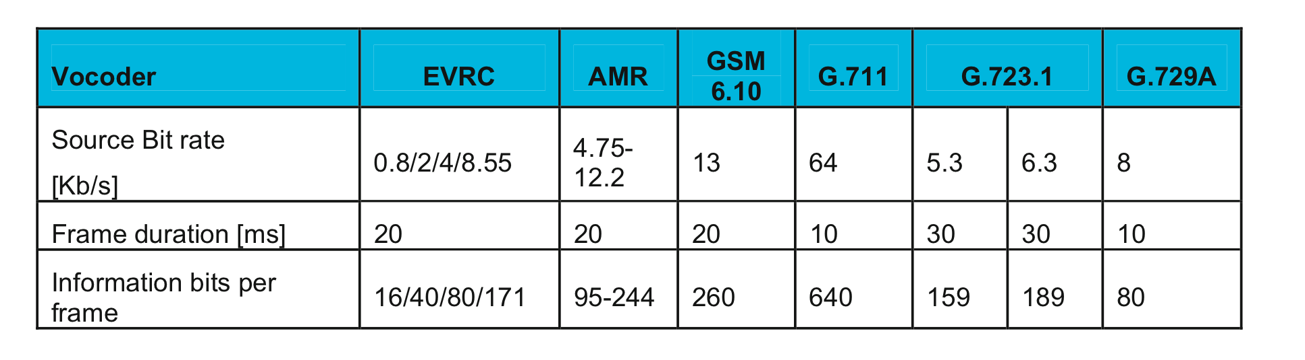
Tab. Information on various vocoders (standard IEEE C802.16m)

VoIP Model
IPP
[2]
The interrupted Poisson process (IPP) shown in Fig. 2b is also a two-state process. Arrivals only occur in the active state according to a Poisson distribution with rate l. Hence, IPP and ON-OFF models differ in interarrival time during the active (ON) state.

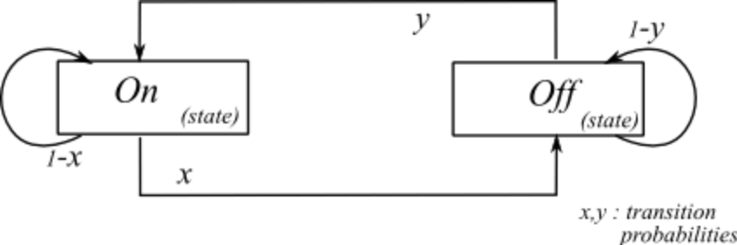

fig. IPP Model framework

Another modeling approach is the Interrupted Poisson Process (IPP). IPP, like the ON/OFF model, has two exponential periods ON and OFF. The only difference is that the packets arrival in the ON period is a Poisson process of parameter D.
The IPP model has the advantage of simplicity that makes it suitable for performance analysis. Besides, aggregating N ON/OFF sources leads to a Markov Modulated Poisson Process (MMPP-N+1) which is analytically tractable. However, many studies showed the inaccuracy of the exponential assumptions, especially for the OFF period, and proposed alternative approached.
Among the several proposed models, we present in the next section the hyperexponential model, for it is a natural extension of the ON/OFF model.

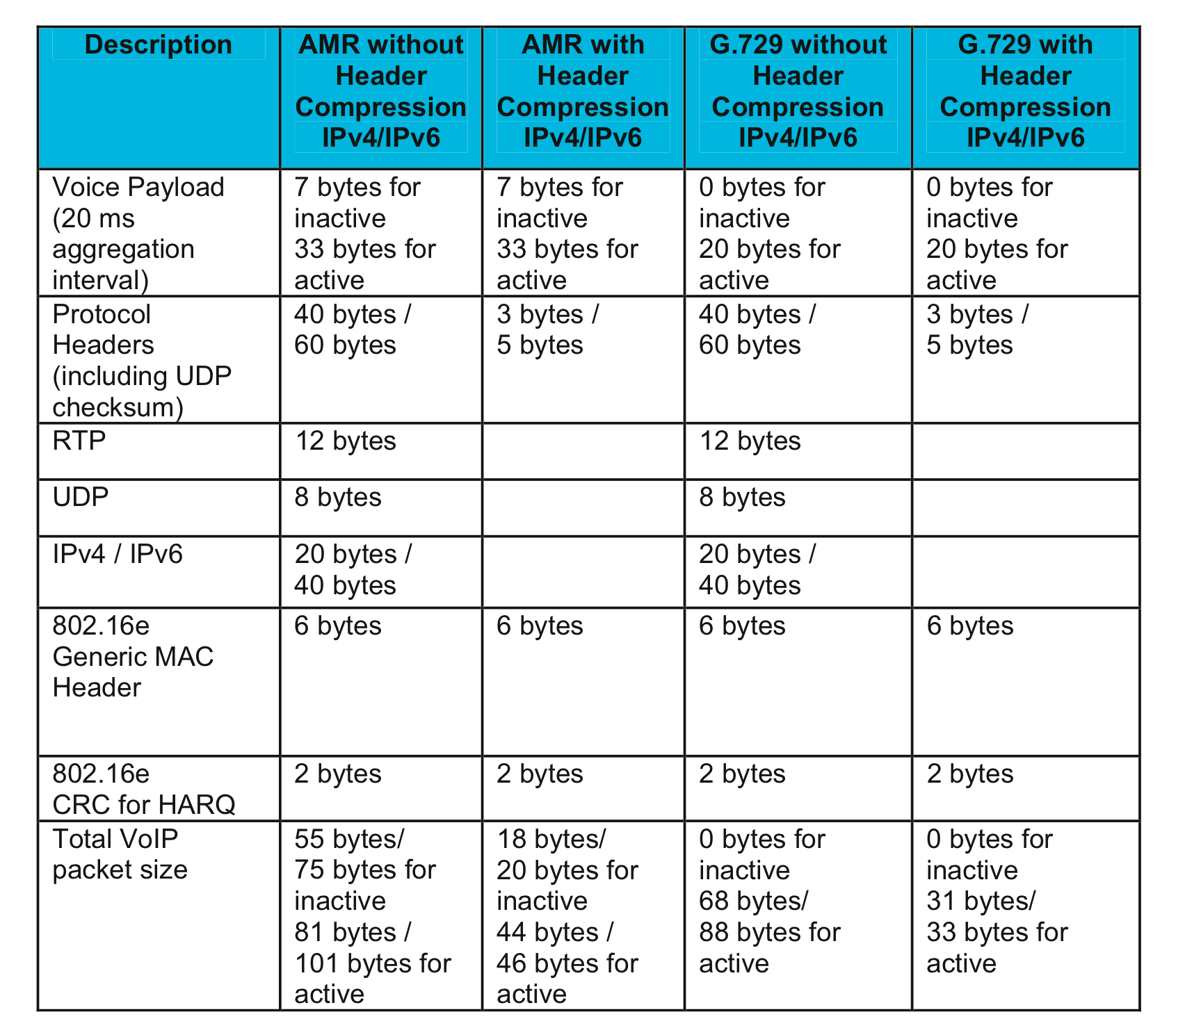
tab. VoIP packet calculation for AMR and G.729 (standard IEEE C802.16m)

AMR (Adaptative Multi-Rate)

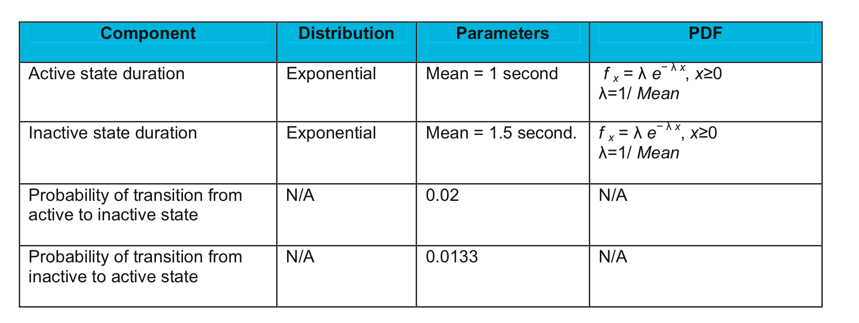
Tab. VoIP trafic model parameters spécification (standard IEEE C802.16m)

MODELISATION DE TRAFIC 2012 par Jörg Liebeherr (http://www.comm.utoronto.ca/~jorg/)

Video Model
In video traffic, there are no ON/OFF periods because images are periodically generated. The modeling considers the images or Group Of Pictures (GOP) size and their correlation. Recall that in MPEG coding, the GOP is a set of pictures starting with an Intra coded (I) picture and containing Predicted coded (P) and Bidirectional predictive coded pictures.
GOP: I B B P B B P B B P BB

- Video Traffic (High Definition)
      - 30 frames per second
      - Frame format: 1920x1080 pixels
      - 24 bits per pixel
- Required rate: 1.5 Gbps
- Required storage: 1 TB per hour
- Video uses compression algorithm to reduce bitrate
MPEG compression
- I frames: intra-coded
- P frames: predictive
- B frames: bi-directional
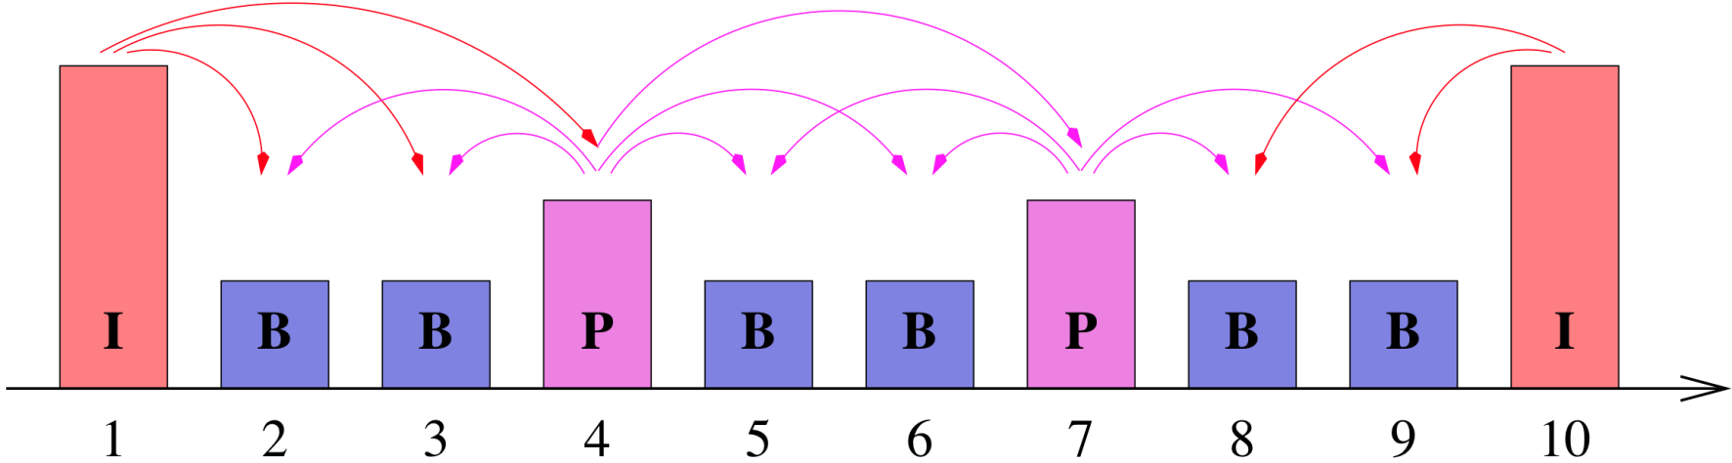
- Group of Pictures (GOP): IBBPBBPBB

- This is done by both reducing the spatial and the temporal redundancy of the video data stream.
- The spatial redundancies are reduced by transforms and entropy coding and the temporal redundancies are reduced by prediction of future frames based on motion vectors. This is achieved using three types of frames (cf.Figure1):

Bidirectional Prediction
Figure 1. Group of Pictures of an MPEG stream

Forward Prediction

- I-frames use only intra-frame coding, based on the discrete cosine transform and entropy coding;
- P-frames use a similar coding algorithm to I-frames, but with the addition of motion compensation with respect to the previous I-or P-frame;
- B-frames are similar to P-frames, except that the motion compensation can be with respect to the previous I- or P- frame, the next I- or P- frame, or an interpolation between them.

- Typically, I-frames require more bits than P-frames. B-frames have the lowest bandwidth requirement.
- After coding, the frames are arranged in a deterministic periodic sequence, e.g.\IBBPBB" or \IBBPBBPBBPBB", which is called Group of Pictures (GOP).

Video Telephony
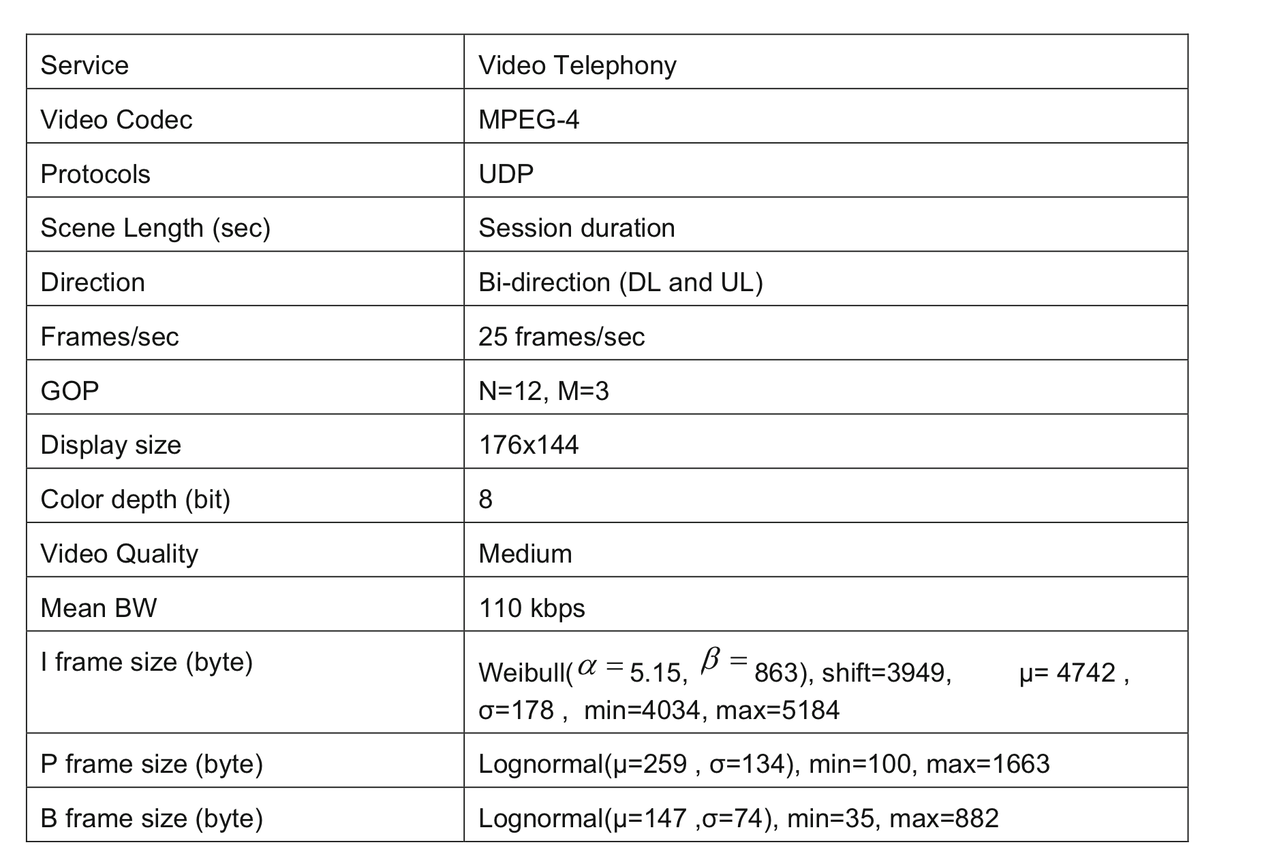
Tab. Video telephony trafic model (standard IEEE C802.16m)

Video Streaming
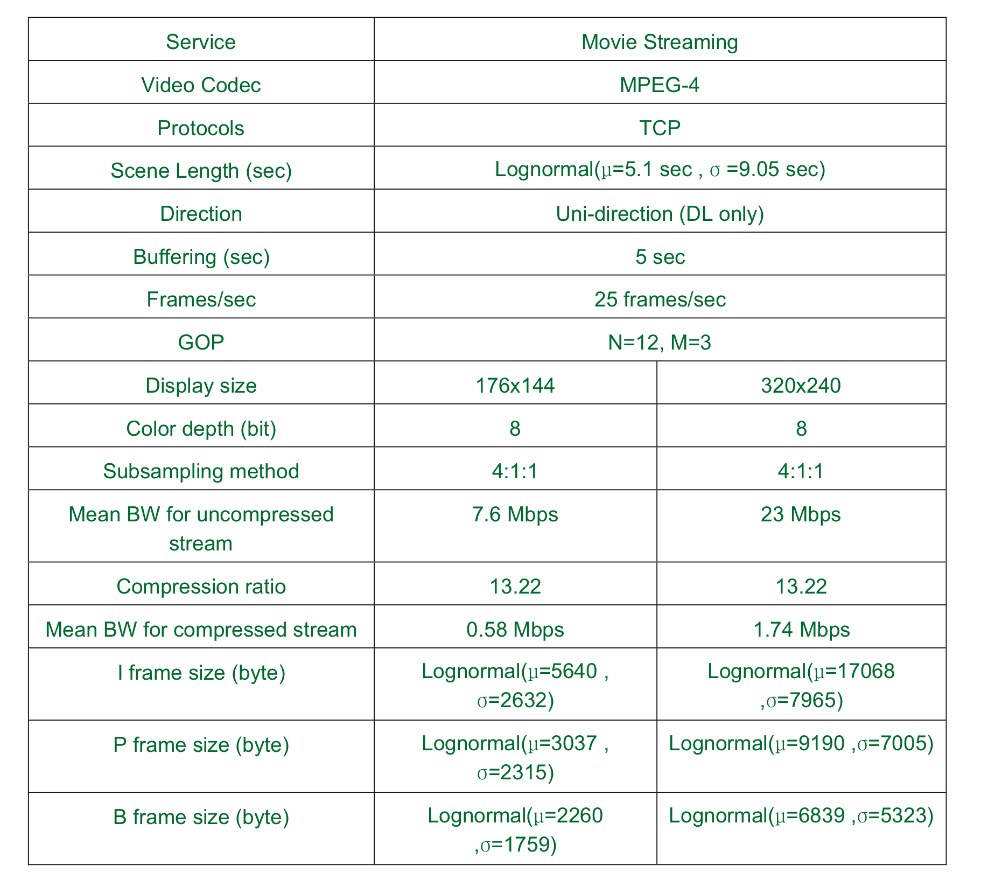
Tab. Video Streaming trafic model (standard IEEE C802.16m)
Examples :
Harry Potter: 30 minutes
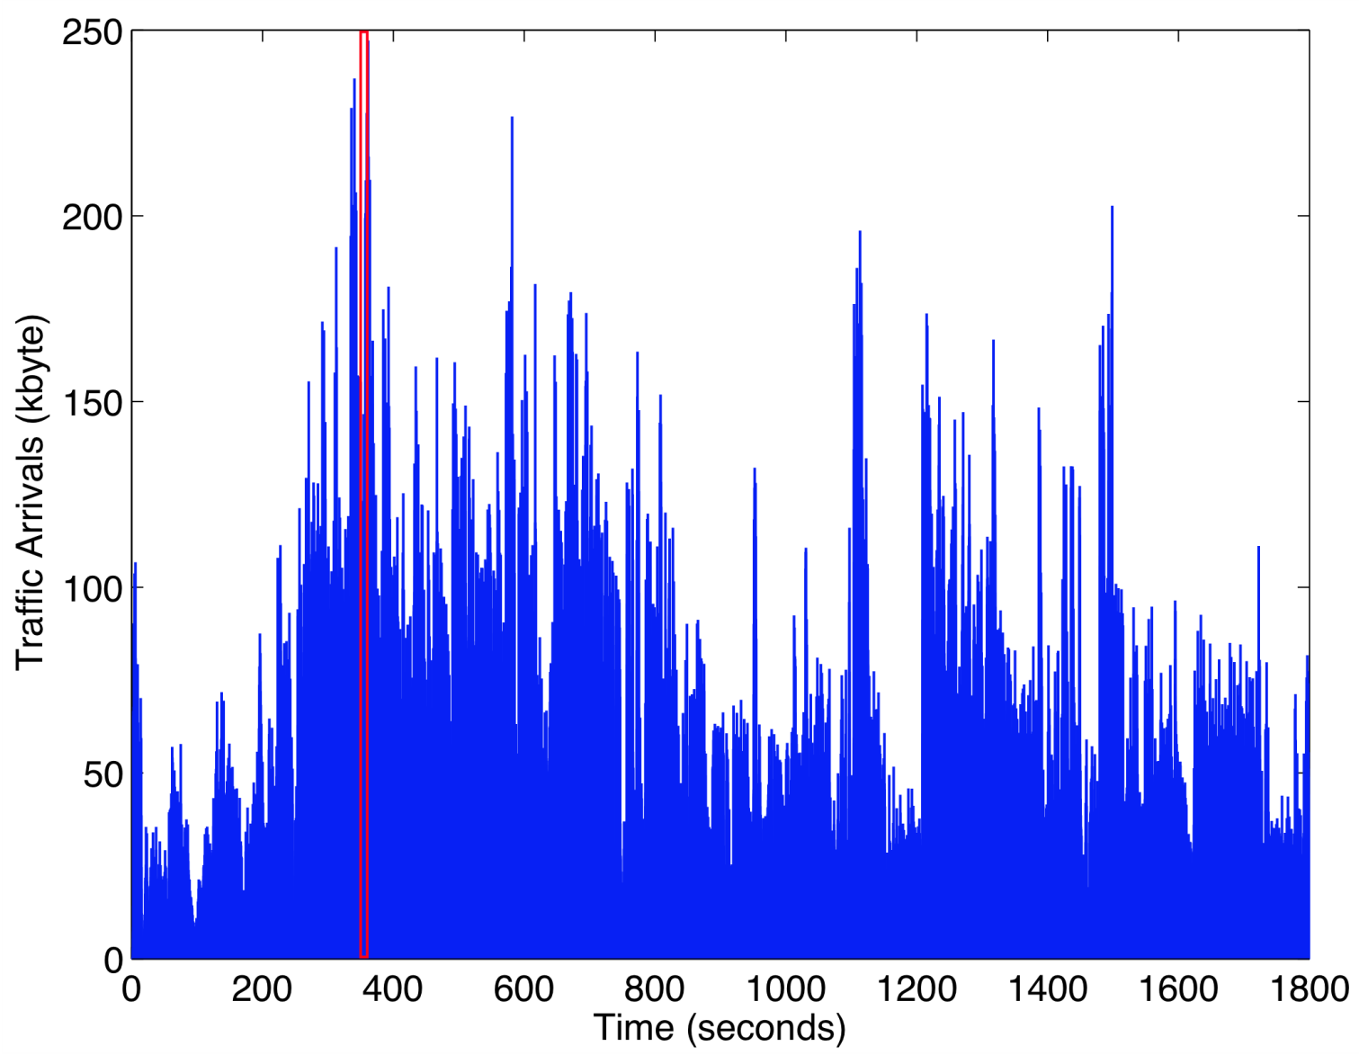
Harry Potter: 20 seconds

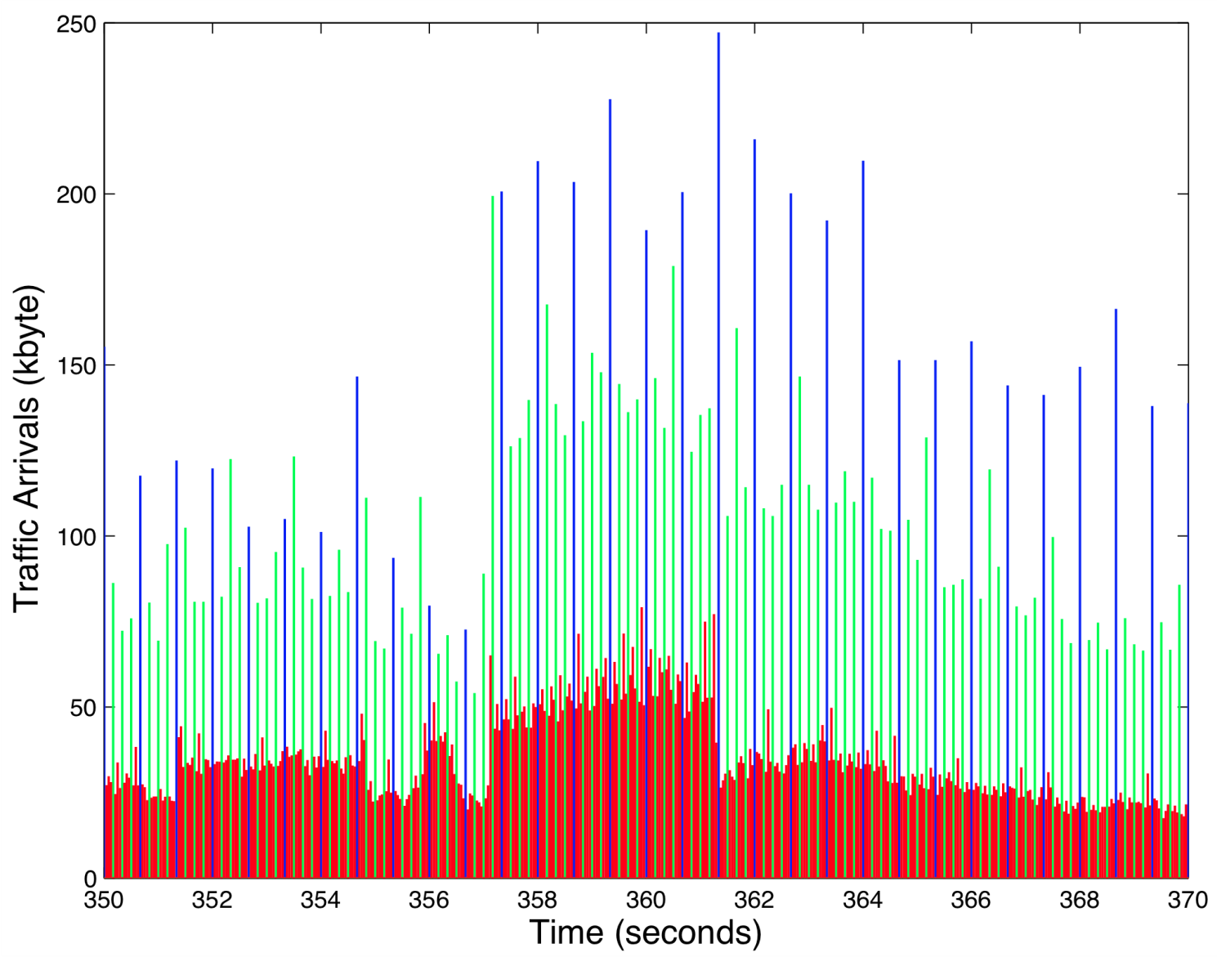
http://trace.eas.asu.edu/vtraces2_scripts/trace_options.php?id=2&gopid=G16B3&fps=24&qI=22&qP=22&qB=24&path=/trace/traceWeb/htdocs/videotraces2/svc_single/1080/harrypotter/harrypotter1080_G16B3/222224

Data model

Web Browsing (HTTP) Traffic Model
HTTP traffic characteristics are governed by the structure of the web pages on the World Wide Web (WWW), and the nature of human interaction. The nature of human interaction with the WWW causes the HTTP traffic to have a bursty profile. The HTTP traffic can be modeled by “question-answer” model as shown in Figure XXXX. This figure shows the transmission of packets during a typical session of web browsing [7].

// PLACEMENT DE LA FIGURE XXXX
The session was divided into ON/OFF periods representative web-pages downloads and intermediate readings, where web-page downloads are designated by packet calls. These ON and OFF periods are the result of human interaction where the packet call represents a user request for information and reading time identifies the time to digest the web-page. As we know, the navigational traffic on the Internet (web-browsing traffic) is self-similar. In other words, the traffic exhibits similar statistics on different time scales. Therefore, a packet call, like a packet session, is divided into ON/OFF periods as shown in Figure YYYY. Unlike a packet session, the ON/OFF periods within a packet call are attributed to the machine interaction rather than human interaction.
// PLACEMENT DE LA FIGURE YYYY
A web browser will begin serving a user’s request by fetching the initial HTML page using an HTTP GET request. The recovery of the original (initial) page and each of the constituent objects is represented by ON period within the packet call while the parsing (analysis) time and protocol overhead are represented by the OFF periods within a packet call.

IP Packet Level Model [7]
Based on observed packet size distributions, 76% of the HTTP packet calls should use an MTU of 1500 bytes, with the remaining 24% of the HTTP packet calls using an MTU of 576 bytes. These two potential packet sizes also include a 40 byte IP packet header (thereby resulting in useful data payloads of 1460 and 536 bytes, respectively), and this header overhead for the appropriate number of packets must be added to the object data sizes calculated from the probabilistic distributions in Table 1.

Examples Internet Traffic (ref )
- Data measured from a backbone link of a Tier-1 Internet Service provider
  - Link measured: Chicago – Seattle
  - Link rate: 10 Gbps (10 Gigabit Ethernet)
- Data measures total (aggregate) traffic of all transmissions on the network
- Data shown is 1ms: ~400 packets packet transmissions
  - Average rate: ~2.6 Gbps
  - Avg. packet size: 837 Bytes
  - Min. packet size: 46 Bytes
  - Max. packet size: 1504 Bytes
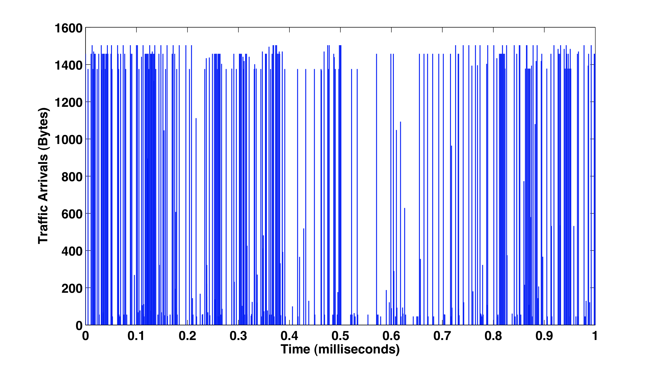

FTP Traffic ()
The FTP traffic is modeled as the HTTP traffic. However, we consider that there is one packet call per session.
Pour les parameters voir la these de ROLA
Naila
Caractéristiques de la voix :
Dans le livrable SP3.2 page 48/118, et 62/118 ils montrent un tableau des mesures de la voix nécessaires pour calculer le taux de remplissage des paquets LTE. Dans le quel on peut voir que pour un débit de 2.45 kbps un d’échantillonnage de à 20ms a été utilisé (temps inter arrivés des paquets de voix).
Page 53/118 table 21 : nous pouvons voir le format d’un paquet voix avant compression (60 octet d’entête + 49bits de payload voix).
Page 64/118 : table 25, nous pouvons voir les paramètres utilisés lors de la simulation des capacités de la transmission de la voix sur LTE (duré d’appel = 60s).
De plus les pages 14 et 15/118 (rédigées par Amine), on explique les critères pour avoir une bonne qualité de service, La gigue doit être comprise entre 0 et 50 ms (selon les besoins du projet) ms pour une bonne qualité de réception de la parole. (Pour pouvoir comprendre la parole).
Donc ce qui sort de l’application c’est un échantillonnage de 20ms des paquets voix, ensuite à un niveau plus bas, il peut y avoir un multiplexage ou bien une compression d’entête, à ce moment-là il va y avoir une autre modélisation.
Je peux conclure, qu’il est recommandé de proposer un de trafic source en utilisant les paramètres décris dans le présent livrable

pour l'article de la modélisation BMAP, j'en ai déjà présenté un à Tohmé, mais ce n'est pas le même, le voici en attaché,
dans le présent article, ils modélisent les arrivés au niveau MAC, lors du découpage de la vidéo en un ensemble d'image GOP, les arrivés sont groupé par batch. Ils ont rajouter la priorité préempti , grâce à la distribution "phase type". Ensuite ils ont simuler leurs travail en utilisant un codage MPEG-4 avec une file M/Gi/1.
en effet c'est très intéressant, on peut toujours l'adapter pour modéliser le trafic à la sortie de l'application source.
pour répondre à ta question sur les mesures, Amine a rédigé une partie sur ce qui es recommandé dans la littérature, et les mesures dans le cadre du projet, ont étés réalisés par TSP, et c'est à ce moment là qu'ils ont constaté le problème des petits paquets (voix) dans des gros paquets OFDMA.

SECTION pour le mode circuit et paquet

