1 17.Packets are not blocked when they arrive into the system (i.e. queue depths are 2 infinite). Packets are scheduled with a packet scheduler using the required 3 fairness metric. 4 5 Sequences of simulation are run, each with a different random seed. A sufficient 6 number of runs are simulated to ensure convergence in the performance metrics.
7 10.Traffic Models 8 Editor: Jeongho Park, jeongho.jh.park@samsung.com 9
Sources | Document Reference
Dan Gal et al. | IEEE C802.16m-07_063
Sassan Ahmadi et al. | IEEE C802.16m-07_072
Robert Novak et al. | IEEE C802.16m-07_074r1
Wookbong Lee et al. | IEEE C802.16m-07_075
Bong Ho Kim | IEEE C802.16m-07_105 IEEE C802.16m-07_106
Hua Xu et al. | IEEE C802.16m-07_144
Ricardo Fricks et al. | IEEE C802.16m-07_145r1

10 11 This section describes traffic models in detail. A major objective of system simulations is 12 to provide the operator with a view of the maximum number of active users that can be 13 supported for a given service under a specified configuration at a given coverage level. 14 The traffic generated by a service should be accurately modeled in order to evaluate the 15 performance of a system. This may be a time consuming exercise. Traffic modeling can 16 be simplified, as explained below, by not modeling the user arrival process and 17 assuming full queue traffic which is considered as the baseline. Modeling non-full-queue 18 traffic is also discussed in the subsections that follow. 19 20 Modeling of user arrival process: Typically all users are not active at a given time and 21 even the active users might not register for the same service. In order to avoid different 22 user registration and demand models, the objective of the proposed simulation model is 23 restricted to evaluate the performance with the users that are maintaining a session with 24 transmission activity. This model can be used to determine the number of such 25 registered users that can be supported. This document does not address the arrival 26 process of such registered users, i.e. it does not address the statistics of subscribers 27 that register and become active. 28 29 Full Queue model: In the full queue user traffic model, all the users in the system always 30 have data to send or receive. In other words, there is always a constant amount of data 31 that needs to be transferred, in contrast to bursts of data that follow an arrival process. 32 This model allows the assessment of the spectral efficiency of the system independent 33 of actual user traffic distribution type. A user is in outage if residual PER after HARQ 34 retransmissions exceeds TBD. 35
1 | In the following sections, we will concentrate on traffic generation only for the non-full
2 | queue case. In addition, the interaction of the generated traffic with the higher layer
3 |  | protocol |  | stack | such | as | TCP |  | is |  | not | fully | included | here. | Instead, | we | will | provide
4 | references to document which provide the detailed TCP transport layer implementation
5 | and its interaction with the various traffic models.
6
7 | The models described in this section shall be used for evaluating 802.16m proposals.
8 | Optionally, for liaison with NGMN, statistical traffic models and associated parameters
9 | defined in [69] or its latest revision may be used for system performance evaluation.
10 | 10.1. |  | Web Browsing (HTTP) Traffic Model
11 | HTTP traffic characteristics |  |  |  |  |  |  | are |  | governed by the structure of the web pages |  |  |  |  |  |  |  |  | on | the
12 | World Wide Web (WWW), and the nature of human interaction. The nature of human
13 | interaction with the WWW causes the HTTP traffic to have a bursty profile, where the
14 | HTTP traffic is characterized by ON/OFF periods as shown in Figure 17.
15

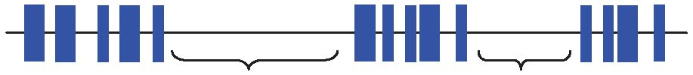
First Packet of Reading Time Reading Time Last Packet of Session Session
16 17 Figure 17: HTTP Traffic Pattern
18 19 The ON periods represent the sequence of packets in which the web page is being 20 transferred from source to destination; while the OFF periods represent the time the 21 user spends reading the webpage before transitioning to another page. This time is also 22 known as Reading Time [43][44]. 23 24 The amount of information passed from the source to destination during the ON period 25 is governed by the web page structure. A webpage is usually composed of a main 26 object and several embedded objects. The size of the main object, in addition to the 27 number and size of the embedded objects define the amount of traffic passed from 28 source to destination. 29 In summary, the HTTP traffic model is defined by the following parameters: 30 SM: Size of main object in page 31 Nd: Number of embedded objects in a page 32 SE: Size of an embedded object in page 33 Dpc: Reading time 34 Tp: Parsing time for the main page 35 36 In addition to the model parameters, HTTP traffic behavior is also dependent on the 37 HTTP version used. Currently HTTP 1.0 and HTTP 1.1 are widely used by servers and 38 browsers [45]-[48]. In HTTP 1.0, also known as burst mode transfer, a distinct TCP 39 connection is used for each object in the page, thereby facilitating simultaneous transfer 40 of objects. The maximum number of simultaneous TCP connections is configurable, 41 with most browsers using a maximum of 4 simultaneous TCP connections. In HTTP/1.1,
1 also known as persistent mode transfer, all objects are transferred serially over a single
2 persistent TCP connection. Recent measurement and analysis for web page structures
3 can be found in [58]. These measurements have been performed using a recent online
4 traffic analysis provided by market research firm ComScore Media Metrix, which
5 examined the number of visitors among the 50 top Web sites on January 2007 [59].
6 The paper [58], includes web page sizes and compositions of the 50 top web sites after
7 analyzing 25000 measurements, and each web site has been visited 500 times for three
8 weeks from April 7 to April 23 in 2007. Web site visits are about one minute apart, and
9 visits to the same website are about an hour apart. Table 27 provides the model 10 parameters for HTTP traffic for downlink and uplink connections based on the 11 measurements in [59] and the model in [48]-[49].
12 16 Figure 18: HTTP Traffic Profiles 17 18 A user is defined in outage for HTTP service if the average packet call throughput is 19 less than the minimum average throughput requirement of 128 kbps. The system 20 outage requirement is such that no more than 3% of users can be in outage. The air link 21 PER of MAC SDUs for HTTP traffic should be not be greater than 1%.
Component |  | Distribution |  | Parameters |  |  | PDF
 |  |  | Downlink |  |  |  |  | Uplink
Main object size (SM) |  | Truncated Lognormal |  | Mean = 52390bytes SD= 49591bytes Min = 1290bytes Max = 0.25Mbytes 0.8, 10.55 V P |  | Mean = 9055 bytes SD = 13265 bytes Min = 100 bytes Max = 100 Kbytes 1.37, 8.35 V P | 21 ln exp , 0 22 2 x f xx x PSV V t ª º « »¬ ¼ if x>max or x<min, discard and generate a new value for x
Embedded object size (SE) |  | Truncated Lognormal |  | Mean = 8551bytes SD = 59232bytes Min = 5bytes Max = 6Mbytes 1.97, 7.1 V P |  | Mean = 5958 bytes SD = 11376 bytes Min = 50 bytes Max = 100 Kbytes 1.69, 7.53 V P | 21 ln exp , 0 22 2 x f xx x PSV V t ª º « »¬ ¼ if x>max or x<min, discard and generate a new value for x
Number of embedded objects per page (Nd) |  | Truncated Pareto |  | Mean = 51.1 Max. = 165 1.1, 2, 55 k mD |  | Mean = 4.229 Max. = 53 1.1, 2, 55 k mD | ,1 , k k x mf x x k x mf x m D D D D d § ·¨ ¸© ¹ Subtract k from the generated random value to obtain Nd if x>max, discard and regenerate a new value for x
Reading time (Dpc) |  | Exponential |  | Mean = 30 sec |  | Mean = 30 sec | , 0 x xf ex OO t

 |  |  | O = 0.033
Parsing time (Tp) | Exponential | Mean = 0.13 sec | Mean = 0.13 sec 7.69O | f x | 0, t x e xOO

1
2 | Table 27: HTTP Traffic Parameters
3
4 | To request an HTTP session, the client sends an HTTP request packet, which has a
5 | constant size of 350 bytes. From the statistics presented in the literature, a 50%-50%
6 | distribution of HTTP versions between HTTP 1.0 and HTTP 1.1 has been found to
7 | closely approximate web browsing traffic in the internet [49].
8
9 | Further studies also showed that the maximum transmit unit (MTU) sizes most common
10 | to in the internet | are | 576 bytes and 1500 bytes (including the TCP header) with | a
11 | distribution of 24% and 76% respectively. Thus, the web traffic generation process can
12 | be described as in Figure 18.
13

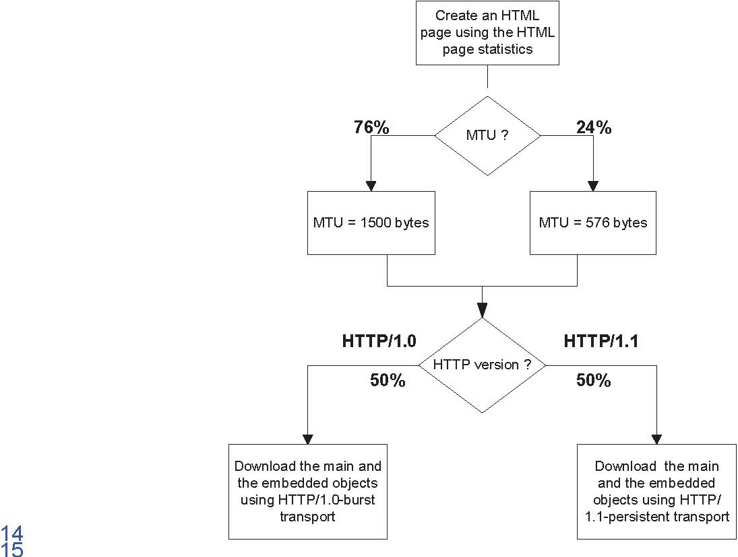
1 10.1.1. HTTP and TCP interactions for DL HTTP traffic 2 Two versions of the HTTP protocol, HTTP/1.0 and HTTP/1.1, are widely used by 3 servers and browsers. Users shall specify 50% HTTP/1.0 and 50% HTTP/1.1 for HTTP
4 traffic. For people who have to model the actual interaction between HTTP traffic and 5 the underling TCP connection, refer to 4.1.3.2, 4.2.4.3 of [50] for details.
6 10.1.2. HTTP and TCP interactions for UL HTTP traffic
7 HTTP/1.1 is used for UL HTTP traffic. For details regarding the modeling of the 8 interaction between HTTP traffic and the underling TCP connection, refer to 4.2.4.1,
9 4.2.4.2 of [50].
10 10.2. File Transfer Protocol Model 11 File transfer traffic is characterized by a session consisting of a sequence of file 12 transfers, separated reading times. Reading time is defined as the time between end of 13 transfer of the first file and the transfer request for the next file. The packet call size is 14 therefore equivalent to the file size and the packet call inter-arrival time is the reading 15 time. A typical FTP session is shown in Figure 19.
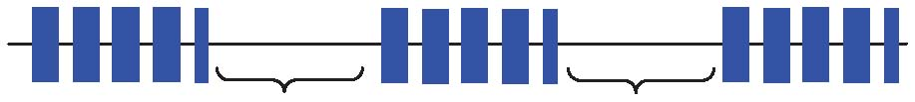
First Transfer Second Transfer Third Transfer
Reading Time Reading Time
16 17 Figure 19: FTP Traffic Patterns 18 19 Table 28 provides the model parameters for FTP traffic that includes file downloads as 20 well as uploads [51]-[52].In the case of file uploads, the arrival of new users is Poisson 21 distributed and each user transfers a single file before leaving the network. 22 23 The FTP traffic generation process is described in Figure 20. Based on the results on 24 packet size distribution, 76% of the files are transferred using and MTU of 1500 bytes 25 and 24% of the files are transferred using an MTU of 576 bytes. Note that these two 26 packet sizes also include a 40 byte IP packet header and this header overhead for the 27 appropriate number of packets must be added to the file sizes calculated from the 28 statistical distributions in Table 28. For each file transfer a new TCP connection is used 29 whose initial congestion window size is 1 segment. 30 31 A user is defined in outage for FTP service if the average packet call throughput is less 32 than the minimum average throughput requirement of 128 kbps. The system outage 33 requirement is such that no more than 3% of users can be in outage. The air link PER of 34 MAC SDUs for FTP traffic should be not be greater than 1%. 35
Component | Distribution |  | Parameters |  |  |  | PDF
Component | Distribution | DL |  |  |  |  |  | UL

File size (S) | Truncated Lognormal | Mean = 2Mbytes SD = 0.722 Mbytes Max = 5 Mbytes 14.45 0.35VP | Min = 0.5 Kbytes Max = 500 Kbytes Mean = 19.5 Kbytes SD = 46.7 Kbytes 0.9385 2.0899VP | 0, 22 ln 2 exp 2 1t0»»¼º ««¬ª x x x xfV PSV if x>max or x<min, discard and generate a new value for x
Reading time (Dpc) | Exponential | Mean = 180 sec. 0.006 O | N/A | Download: 0,t x e x f x OO Upload: N/A

1 2 Table 28: FTP Traffic Parameters 3
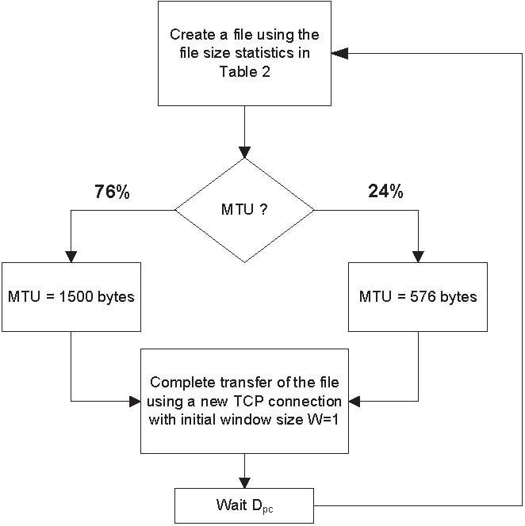
4
5 6 Figure 20: FTP Traffic Profiles
7 10.2.1. TCP Modeling 8 The widespread use of TCP as a transport protocol in the internet requires an accurate 9 model of TCP behavior to better characterize traffic flow. The major behaviors that need
10 to be accounted for in the TCP model are the session establishment and release and 11 TCP slow start.
1 | 10.2.1.1. | TCP Session Establishment and Release
2 | TCP uses a 3-way handshake to establish and release a TCP session. The sequences
3 | of establishing and releasing a TCP session on the downlink and the uplink are shown
4 | in Figure 21 and Figure 22 respectively.
5
6 | A TCP session is established by the transmitter sending |  | a | 40 byte SYNC control
7 | segment to the remote server. In response, the server sends a 40 byte SYNC/ACK
8 | control segment. The final acknowledgement is sent by the transmitter by setting the
9 | ACK flag in the first TCP segment of the TCP session, which is then started in slow start
10 | mode [62].
11
12 | The TCP session is released by the transmitter setting the FIN flag in the last TCP
13 | segment. In response, the receiver sends by a FIN/ACK control segment. |  |  |  | The session
14 | is concluded by the transmitter sending a final ACK message [62].

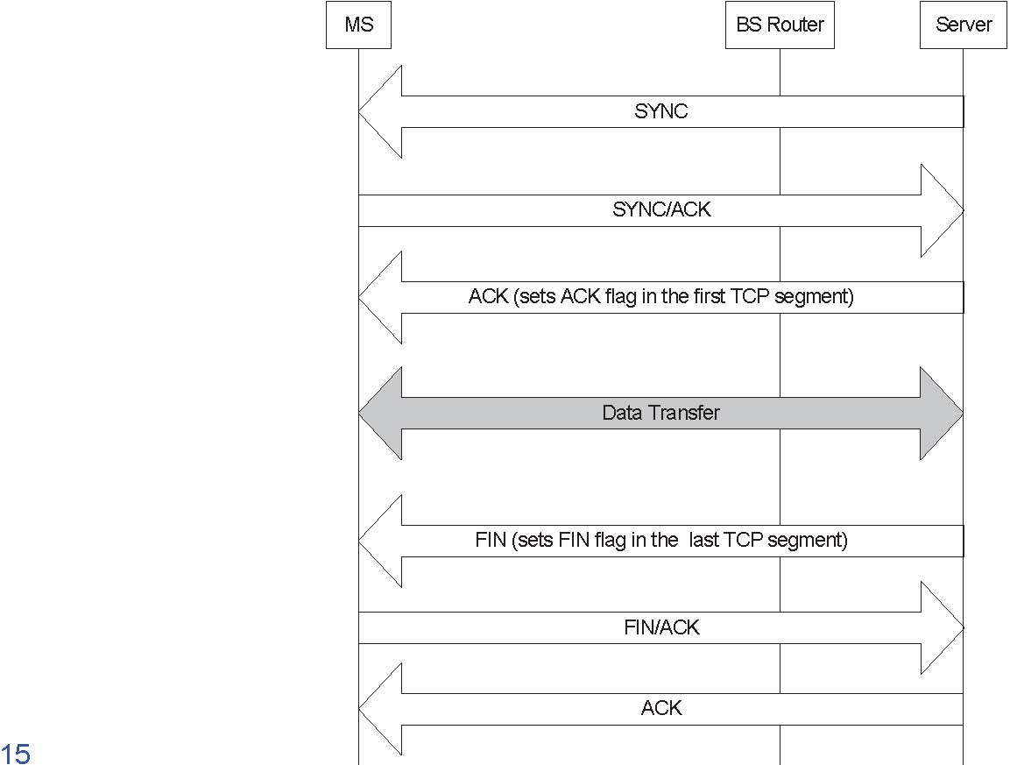
Figure 21: TCP Connection establishment and release on the downlink
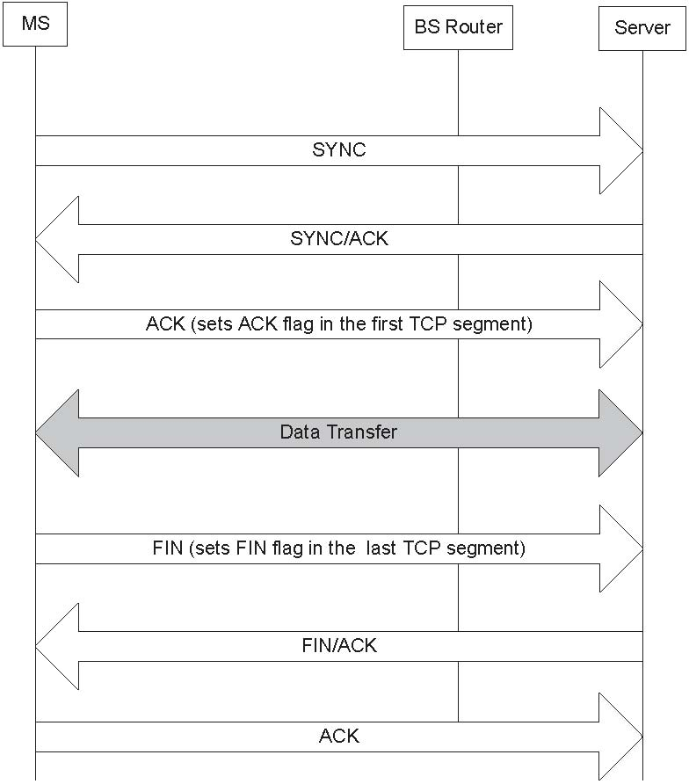
1 2 Figure 22: TCP Connection establishment and release on the uplink
3 10.2.1.2. TCP Slow Start Modeling 4 TCP slow start is part of the congestion control mechanism implemented in the TCP 5 protocol. Congestion control is implemented using a window flow control mechanism, 6 which tracks the maximum amount of unacknowledged or outstanding data at the 7 transmitter. 8 9 The amount of outstanding data that can be sent without receiving an acknowledgement 10 (ACK) is determined by the minimum of the congestion window size and the receiver 11 window size. After the TCP session is established, the transfer of data starts in slow12 start mode with an initial congestion window size of 1 segment. The congestion window 13 size is subsequently increased by one with each arriving ACK for a successfully 14 received packet. This increase occurs regardless of whether the packet is correctly 15 received or not, and regardless of whether the packet is out of order or not. This results 16 in an exponential growth of the congestion window. 17 18 Figure 23 explains the packet transmission sequence in a TCP session. The round trip
19 time (RTT) for the TCP slow start model consists of: 20 21 RTT= W1+ W2 where:
W1: Time taken by an ACK packet to travel from the client (server) to Base Station + Time taken by an ACK packet to travel from Base Station to server (client) + Time taken by TCP segment to travel from server (client) to Base Station.
W2: Time taken by ACK segment to travel from Base Station to Client (server).
W1 is assumed to be a random variable of exponential distribution, while W2 is determined by the air link throughput . This model only accounts for the slow start process, while congestion control and avoidance have not been modeled. Additionally, the receiver window size is assumed to be large, and thus not a limiting factor.
Client Base
Server
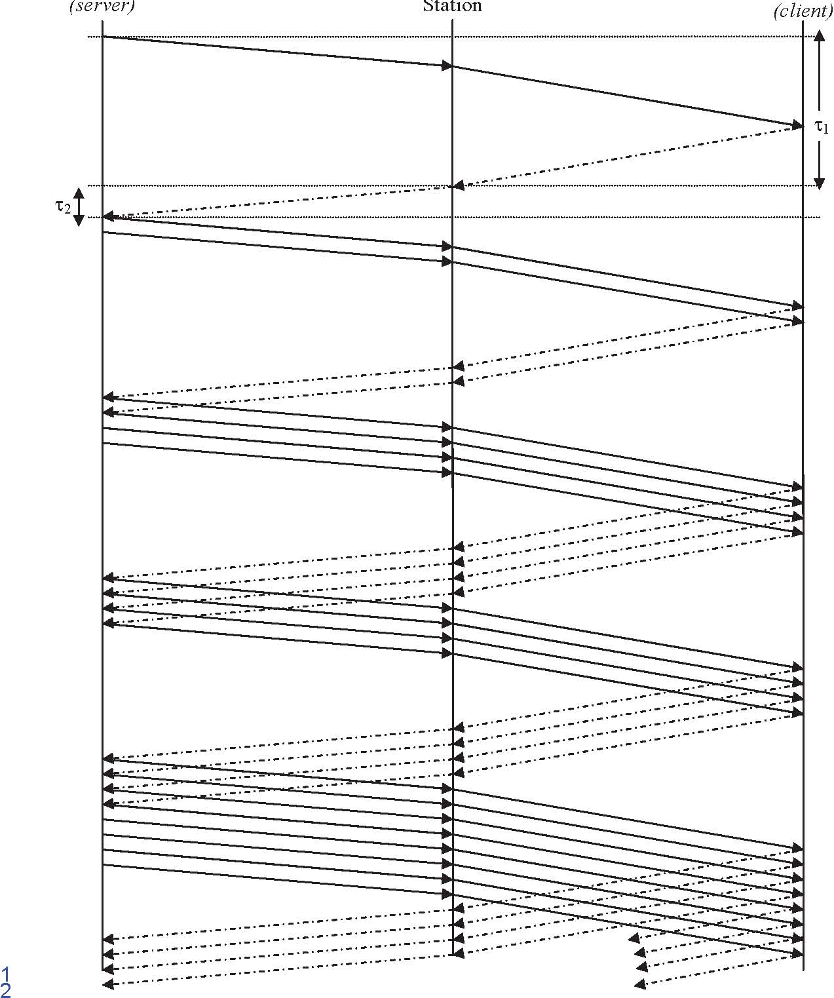
Figure 23: TCP Slow Start Process
34

1 10.3. Speech Source Model (VoIP) 2 Source Document Authors | Document Reference
Dan Gal, et al. | IEEE C802.16m-07/063
Sassan Ahmadi, et al. | IEEE C802.16m-07/072
Robert Novak, et al. | IEEE C802.16m-07/074r1
Wookbong Lee, et al. | IEEE C802.16m-07/075
Xin Chang, et al. | IEEE C802.16m-07/067

3
4 | VoIP refers to real-time delivery of voice packet |  |  |  |  |  |  |  |  |  |  |  |  |  |  |  |  |  | across |  |  |  | networks using the Internet
5 | protocols. A VoIP session is defined |  |  |  |  |  |  |  |  |  |  |  | as | the entire |  |  |  |  |  |  | user |  | call time and VoIP session
6 | occurs during the whole simulation period.
7
8 |  | There | are |  | a | variety | of | encoding |  |  | schemes |  |  |  |  | for |  | voice |  |  |  | (i.e., G.711, G.722, G.722.1,
9 |  | G.723.1, G.728, G.729, |  |  |  |  |  |  | and | AMR) |  | that |  |  | result |  | in |  |  | different |  |  |  | bandwidth | requirements.
10 | Including the protocol overhead, it is very common for a VoIP call to require between 5
11 | Kbps and 64 Kbps of bi-directional bandwidth.
12 | 10.3.1. |  |  | Basic Voice Model
13 | A typical phone conversation is marked by periods of active talking / talk spurts (ON
14 | periods) interleaved by silence / listening periods (or OFF periods) as shown in Figure

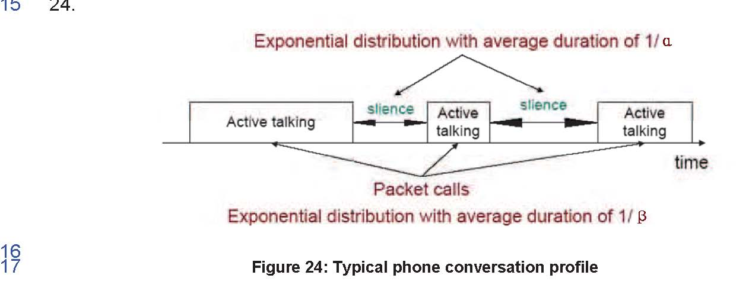
18 19 Consider the simple 2-state voice activity Markov model shown in Figure 25 [54].
a
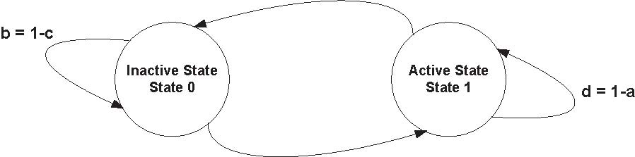
c
20 21 Figure 25: 2-state voice activity Markov model
1 2 In the model, the conditional probability of transitioning from state 1 (the active speech 3 state) to state 0 (the inactive or silent state) while in state 1 is equal to a, while the 4 conditional probability of transitioning from state 0 to state 1 while in state 0 is c. The 5 model is assumed to be updated at the speech encoder frame rate R=1/T, where T is 6 the encoder frame duration (typically, 20 ms). During the active state, packets of fixed 7 sizes are generated at a regular interval. The size of packet and the rate at which the 8 packets are sent depends on the corresponding voice codecs and compression 9 schemes. Table 29 provides information on some common vocoders.
10
Vocoder | EVRC |  | AMR |  | GSM 6.10 |  | G.711 |  | G.723.1 |  |  |  | G.729A
Source Bit rate [Kb/s] |  | 0.8/2/4/8.55 |  | 4.7512.2 |  | 13 |  | 64 |  | 5.3 | 6.3 | 8
Frame duration [ms] |  | 20 |  | 20 |  | 20 |  | 10 |  | 30 | 30 | 10
Information bits per frame |  | 16/40/80/171 |  | 95-244 |  | 260 |  | 640 |  | 159 | 189 | 80

11 12 Table 29: Information on various vocoders 13 14 Among the various vocoders in Table 29, a simplified AMR (Adaptive Multi-Rate) audio 15 data compression model can be used to simplify the VoIP modeling process. AMR is 16 optimized for speech coding and was adopted as the standard speech codec by 3GPP 17 and widely used in GSM. The original AMR codec uses link adaptation to select from 18 one of eight different bit rates based on link conditions. If the radio condition is bad, 19 source coding is reduced (less bits to represent speech) and channel coding (stronger 20 FEC) is increased. This improves the quality and robustness of the network condition 21 while sacrificing some voice clarity. In the simplified version in this document, link 22 adaptation has been disabled and the full rate of 12.2 kbps is used in the active state. 23 This model captures the worst case scenario.
1 2 3
4
6 7 8 9
11 12 13 14
16 17 18 19
21 22 23 24
26 27 28 29
Description | AMR without Header | AMR with Header | G.729 without Header | G.729 with Header
 | Compression IPv4/IPv6 | Compression IPv4/IPv6 | Compression IPv4/IPv6 | Compression IPv4/IPv6
Voice Payload | 7 bytes for | 7 bytes for | 0 bytes for | 0 bytes for
(20 ms | inactive | inactive | inactive | inactive
aggregation | 33 bytes for | 33 bytes for | 20 bytes for | 20 bytes for
interval) | active | active | active | active
Protocol | 40 bytes / | 3 bytes / | 40 bytes / | 3 bytes /
Headers | 60 bytes | 5 bytes | 60 bytes | 5 bytes
(including UDP
checksum)
RTP | 12 bytes |  | 12 bytes
UDP | 8 bytes |  | 8 bytes
IPv4 / IPv6 | 20 bytes / |  | 20 bytes /
 | 40 bytes |  | 40 bytes
802.16e | 6 bytes | 6 bytes | 6 bytes | 6 bytes
Generic MAC
Header
802.16e CRC for HARQ | 2 bytes | 2 bytes | 2 bytes | 2 bytes
Total VoIP packet size | 55 bytes/ 75 bytes for inactive 81 bytes / 101 bytes for active | 18 bytes/ 20 bytes for inactive 44 bytes / 46 bytes for active | 0 bytes for inactive 68 bytes/ 88 bytes for active | 0 bytes for inactive 31 bytes/ 33 bytes for active

Table 30: VoIP Packet Calculation for AMR and G.729
31
32 | Table 30 shows the VoIP packet size calculation for simplified AMR operation with or
33 | without header compression when using IPv4 or IPv6. In the table, the MAC CRC of 4B
34 | for ARQ is not included and only CRC for HARQ is included because the ARQ process
 | can be assumed to be disabled for VoIP services.
36
37 | To calculate the total packet size, MAC headers and CRC need to be accounted for
38 | (example: there are 6 bytes of MAC header and 2 bytes of HARQ CRC in IEEE 802.16e
39 |  | reference | system). | Without | header |  |  | compression, | an | AMR | payload | of | 33 | bytes | is
 | generated in the active state every 20 ms and an AMR payload of 7 bytes is generated
41 | in the inactive state every 160 |  |  |  |  | ms. | Assuming IPv4 and uncompressed headers, the
42 | resulting VoIP packet size is 81 bytes in the active mode and 55 bytes in the inactive
43 | mode.
44

1 The voice capacity assumes a 12.2. kbps codec with a 40% activity factor such that the 2 percentage of users in outage is less than 3% where a user is defined to have 3 experienced voice outage if more than 3% of the VoIP packets are dropped, erased or 4 not delivered successfully to the user within the delay bound of 50 ms. 5 6 The packet delay is defined based on the 97 percentile of the CDF of all individual users 7 97 packet delay percentiles (i.e., first for each user the 97 percentile of the packet delay 8 CDF is determined then the 97 percentile of the CDF that describes the distribution of 9 the individual user delay percentiles is obtained). 10 11 VoIP capacity is measured in Active Users/MHz/Sector. The number of active users is 12 divided by total bandwidth occupied by the system accounting for frequency reuse. For 13 an FDD configuration, the bandwidth is calculated as the sum of the uplink and downlink 14 channel bandwidths. For a TDD configuration, the bandwidth is simply the channel 15 bandwidth.
16 10.3.2. VoIP Traffic Model Parameters
17 During each call (each session), a VoIP user will be in the Active or Inactive state. The 18 duration of each state is exponentially distributed. In the Active/Inactive state, packets of 19 fixed sizes will be generated at a fixed interval. Hence, both the datagram size and 20 datagram arrival intervals are fixed within a packet call. Table 31 shows parameters 21 associated with the VoIP traffic model.
22
Component | Distribution | Parameters | PDF
Active state duration | Exponential | Mean = 1 second | f x = Ȝ e í Ȝ x , x0 Ȝ=1/ Mean
Inactive state duration | Exponential | Mean = 1.5 second. | f x = Ȝ e í Ȝ x , x0 Ȝ=1/ Mean
Probability of transition from active to inactive state | N/A | 0.02 | N/A
Probability of transition from inactive to active state | N/A | 0.0133 | N/A

23 24 Table 31: VoIP traffic model parameters specification
25 26 Link adaptation of AMR codec is disabled in order to evaluate performance under worst 27 case, and to simplify the voice traffic model. 28 29 During the inactive state, we have chosen to generate comfort noise with smaller packet 30 sizes at regular intervals instead of no packet transmission. This simplified model does 31 not include a feature called hangover, which generates additional seven frames at the 32 same rate as speech to ensure the correct estimation of comfort noise parameters at 33 the receiver side even if there is a silence period at the end of a talk spurt (ON state),
1 | and after the hangover period, | a | SID_FIRST frame is sent. The voice traffic model
2 | specifies only one rate during the ON state (talk spurt) of the AMR codec (12.2 kbps)
3 | and another rate for the comfort noise (SID_UPDATE) during the OFF state of the AMR
4 | codec. SID_UPDATE frames are generated every 8th frame during the silence period.
5
6 | Table 32 provides the relevant parameters of the VoIP traffic that shall be assumed in
7 | the simulations. The details of the corresponding traffic model are described below:
8

Parameter | Characterization
Codec | RTP AMR 12.2, Source rate 12.2 kbps
Encoder frame length | 20 ms
Voice activity factor (VAF) | 40%
Payload | Active: 33 bytes (Octet alignment mode)Inactive: 7 bytes SID packet every 160 ms during silence
Protocol Overhead with compressed header | RTP/UDP/IP (including UDP check sum): 3 bytes 802.16 Generic MAC Header: 6 bytes CRC for HARQ: 2 bytes
Total voice payload on air interface | Active: 44 bytes Inactive: 18 bytes

9 10 11 | Table 32: Detailed description of the VoIP traffic model for IPv4
12 | 10.4. | Near Real Time Video Streaming
13 14 | [Editor’s note: We need to choose one of the following subsections as the mandatory model.]
15 | [
16 | 10.4.1. |  | Statistical Model
17 18 19 | This section describes a model for streaming video traffic for DL direction. Figure 26 illustrates the steady state of video streaming traffic from the network as observed by the base station. Call setup latency and overhead are not considered in this model.
20

Video Streaming Session (= simulation time)
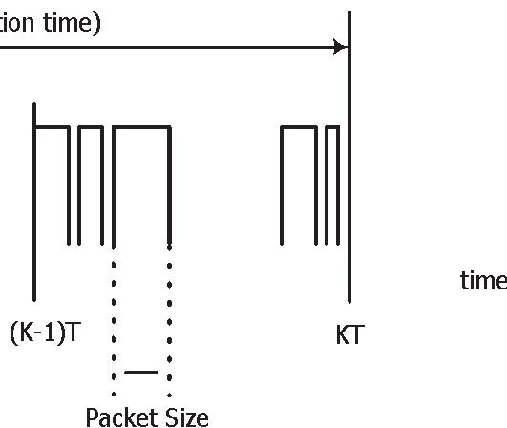
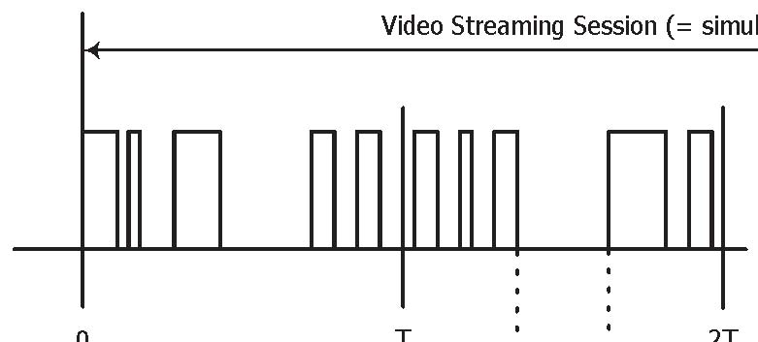time
0T 2T (K-1)T
KT T(Buffering Window)
B

D(Packet
C
Coding Delay)
1
2

3 Figure 26: Video Streaming Traffic Model
4 5 Each frame of video data arrives at a regular interval T. Each frame can be treated as a 6 packet call and there will be zero OFF duration within a session. Within each frame 7 (packet call), packets (or datagrams) arrive randomly and the packet sizes are random 8 as well. 9
10 To counter the jittering effect caused by the random packet arrival rate within a frame at 11 the MS, the MS uses a de-jitter buffer window to guarantee a continuous display of 12 video streaming data. The de-jitter buffer window for video streaming service is 5 13 seconds. At the beginning of the simulation, the MS de-jitter buffer shall be full with 14 video data. During simulation, data is leaked out of this buffer at the source video data 15 rate and filled as DL traffic reaches the MS from the BS. As a performance criterion, the 16 simulation shall record the length of time, if any, during which the de-jitter buffer runs 17 dry. 18 19 The packet sizes and packet inter-arrival rate can be found in when using a source rate 20 of 64 kbps. 21 22
Information types | Inter-arrival time between the beginning of each frame | Number of packets (slices) in a frame | Information types | Packet (slice) size
Distribution | Deterministic (Based on 10 fps) | Deterministic | Truncated Pareto (Mean=50 bytes, Max=125 bytes) | Truncated Pareto (Mean=6 ms, Max=12.5 ms)
Distribution parameters | 100 ms | 8 | K=20 bytesD = 1.2 | K = 2.5 ms D = 1.2

1 2 Table 33 : Near Real Time Video Streaming Traffic Model Parameters 3 4] 5 6[
7 10.4.2. Hybrid Statistical- Trace Based Model 8 A typical business-quality video streaming run can deliver TV-quality video at 25 to 30 9 frames per second. There are several types of video compression technologies such as 10 H.264, H.263 and H.261. H.264 is the next-generation video compression technology in 11 the MPEG-4 standard, and it surpasses H.261 and H.263 in terms of video quality, 12 effective compression and resilience to transmission losses, giving it the potential to 13 halve the required bandwidth for digital video services over the internet or wireless 14 networks. H.264 is likely to be used in applications such as Video Streaming, Video 15 Conferencing Mobile devices, Tele-Medicine etc and current 3G mobiles use a derivate 16 of MPEG-4. 17 18 MPEG compressed videos are composed of pictures (frames) that are separated into 19 three different types: I, B, and P. I frames are intraframes that encode the current 20 picture, while B and P frames interpolate from previous and future frames. MPEG-4 21 video traffic modeling with separate set of I, B, and P frames form a final model that 22 looks very similar to the original [63][64]. 23 24 An important feature of common MPEG encoders is the manner in which frame types 25 are generated. Although not required by the standards, typical encoders use a fixed 26 Group-of-Pictures (GOP) pattern when compressing a video sequence (the GOP 27 pattern specifies the number and temporal order of P and B frames between two 28 successive I frames). Quite often the fixed GOP pattern is “regular” in the sense that the 29 number of B frames between two reference frames (I or P) is fixed. Such a GOP pattern 30 can be characterized by two parameters: the I-to-I frame distance (N), and the I-to-P 31 frame distance (M) (if no P frames are used, then M = N).
1 10.4.2.1. I Frame 2 It is observed that I frames exhibit different VBR dynamics at different time scales. At a 3 time scale of the order of few seconds, the bit rate fluctuates in small amounts about 4 some mean level, which itself varies drastically at a larger time scale. The fluctuations in 5 the mean levels at the larger time scale are often attributed to “scene” changes. 6 Incorporating a “scenic” component in a traffic model gives the VBR dynamics a 7 physical interpretation and often leads to better performance predictions, and the scene 8 length distribution can be appropriately fitted by an exponential (or geometric) 9 distribution [65]. Summary statistics of the computed scene lengths for the trace of 10 Silence of the Lambs are given in Table 34. 11 12
Trace |  | Number of Computed Scenes | Scene Length Statistic (in consecutive I frames)
 |  |  | Mean | Std. dev | Max | Min
Silence of the Lambs | 327 |  | 10.2 (5.1 sec) | 18.1 | 209 | 1

13 14 Table 34: Summary statistics of the computed scene lengths (Source: [63])
15 10.4.2.2. P and B Frames 16 The sizes of P and B frames can be appropriately characterized by lognormal
(P ,V )(P ,V )
17 distributions with parameters PP and BB respectively. Although the empirical 18 frame sizes for P frames (also B frames) are correlated, these correlations are 19 negligible compared to the correlations between different types of frames [63].
20 10.4.2.3. Video Streaming Traffic Model 21 For the video streaming traffic model, a high quality movie trace, Silence of the Lambs 22 [66], is used and two different resolutions for the display have been considered; 23 176x144 for a small device and 320x240 for a large device. The required bandwidth for 24 the uncompressed video stream with 176x144 pixels and 8 bit color depth is about 7.6 25 Mbps and with 320x240 pixels and 8 bit color depth is about 23 Mbps. To minimize the 26 effects of the non-uniform delay between the packets, a buffer is used at the user 27 device to guarantee a continuous and smooth display of the video streaming data. For 28 video streaming services, this buffer is set to 5 seconds. The algorithm generating 29 synthetic MPEG stream is described in [63]. 30
Service | Movie Streaming
Video Codec | MPEG-4
Protocols | TCP
Scene Length (sec) | Lognormal(Ɇ=5.1 sec , ɍ =9.05 sec)
Direction | Uni-direction (DL only)
Buffering (sec) | 5 sec
Frames/sec | 25 frames/sec
GOP | N=12, M=3
Display size | 176x144 | 320x240
Color depth (bit) | 8 | 8
Subsampling method | 4:1:1 | 4:1:1
Mean BW for uncompressed stream | 7.6 Mbps | 23 Mbps
Compression ratio | 13.22 | 13.22
Mean BW for compressed stream | 0.58 Mbps | 1.74 Mbps
I frame size (byte) | Lognormal(Ɇ=5640 , ɍ=2632) | Lognormal(Ɇ=17068 ,ɍ=7965)
P frame size (byte) | Lognormal(Ɇ=3037 , ɍ=2315) | Lognormal(Ɇ=9190 ,ɍ=7005)
B frame size (byte) | Lognormal(Ɇ=2260 ,ɍ=1759) | Lognormal(Ɇ=6839 ,ɍ=5323)

1 2 Table 35: Video Streaming Traffic Model
3 <references [63] to[66] correspond to this section only>
4 10.4.2.4. Performance Criteria for Near Real Time Video 5 Video playout buffers introduce a delay between the receipt of frames and the frame 6 playout. This absorbs variations in the data arrival pattern and permits a continuous 7 playout of the frames. The actual design of these playout buffers involves a number of 8 factors (including reset policies when the buffer runs dry) and is specific to the mobile. 9 To avoid modeling such implementation details, we focus on what the BS scheduler 10 must do to generally accommodate this continuous playout. Therefore, the scheduler 11 should transmit an entire video frame within 5 second of receipt of the entire frame (i.e., 12 receipt of the last octet of the last slice of the frame). If a frame exceeds the 5-second 13 requirement, the scheduler discards the remainder of the frame that has not yet been
14 transmitted. The size and arrival statistics for the video frames are defined in 15 Table 35.
1 The performance requirement is that the fraction of video frames that are not completely
2 transmitted within 5 seconds of their arrival at the scheduler shall be less than 2% for
3 each user. The system outage requirement is such that no more than 3% of users can
4 be in outage.
]
6
7[
8 10.4.3. Trace Based Model 9 There is no silver bullet on the synthetic traffic generation for streaming video. Multiple analytical algorithms are proposed but no single reference algorithm is ideal for the task. 11 Generally, long rang dependency is recognized for the probability distributions of frame 12 sizes. By using self-similar traffic generator, some of the characteristics of the 13 streaming video traffic can be reproduced. However, the synthetic video traces 14 generated by the analytical model are so different from the reference traces that it is difficult to convince people that synthetic traces have captured the core characteristics 16 of the streaming video traffic. 17 18 Since the streaming video traces are easy to get and they are easy to use in the 19 simulation environment, a trace based streaming video traffic model is recommended. In this model, a set of 12 MPEG4 traces are selected from the ASU video library. They 21 are representative of the typical mix supported in the network. Among the 12 traces, 6 22 of them are from the major movie genre, such as drama, action, SciFi, and carton; 2 of 23 them are from major sport events; 1 is from MTV, 2 are from talk show with and without 24 commercial, and 1 is from TV sitcom. The key characters of these streaming video traces are listed in the table below.
MPEG4 Video Library*
 | Name | Hurst Parameter | Mean Bit Rate (Kbps) | Quantizatio n (I-P-B) | CBR/V BR
Movie
1 | Citizen Kane | 0.84 | 52 | 30-30-30 | VBR
2 | Citizen Kane |  | 128 |  | CBR
3 | Die Hard | 0.72 | 70 | 30-30-30 | VBR
4 | Jurassic Park | 0.61 | 78.5 | 24-24-24 | VBR
5 | Star War IV | 0.78 | 65 | 24-24-24 | VBR
6 | Aladdin | 0.86 | 91 | 30-30-30 | VBR
Sports
7 | Football With Commercials | 0.74 | 267.5 | 24-24-24 | VBR
8 | Baseball With Commercials | 0.58 | 74.2 | 30-30-30 | VBR
MTV
9 | MTV | 0.85 | 212.4 | 24-24-24 | VBR
Talk Show
10 | Tonight Show With Commercials (Jay Leno) | 0.8 | 482 | 24-24-24 | VBR
11 | Tonight Show Without Commercials (Jay Leno) | 0.93 | 55 | 24-24-24 | VBR
Sitcom
12 | Friends vol4 | 0.77 | 53 | 24-24-24 | VBR

* From ASU video library. URL: http://trace.eas.asu.edu/
1
2 3 Table 36 MPEG4 video library 4]
5 10.5. Video Telephony 6 Based on the compression efficiency and market acceptance as described in the 7 section 10.4, MPEG 4 has been selected for the video codec. The estimated values for 8 the parameters to model a video stream vary from one trace to another. For parameters 9 associated with the statistical distributions, the estimates depend strongly on the 10 dimensions of the captured frames. For the video telephony traffic model, medium 11 quality of an Office Cam trace is used and the trace library is available at [60]. For the 12 traffic model two different qualities for the video have been considered; high and 13 medium quality. For the medium quality encoding the quantization parameters for all 14 three frame types were fixed at 10, and for the high quality encoding the quantization 15 parameters for all three frame types were fixed at 4 [61]. 16
17 The scene length for the video telephony is assumed to be the entire application 18 session since the background or the main subject may not be so dynamic.
19
Service | Video Telephony
Video Codec | MPEG-4
Protocols | UDP
Scene Length (sec) | Session duration
Direction | Bi-direction (DL and UL)
Frames/sec | 25 frames/sec
GOP | N=12, M=3
Display size | 176x144
Color depth (bit) | 8
Video Quality | Medium
Mean BW | 110 kbps
I frame size (byte) | Weibull(D 5.15, E 863), shift=3949, ȝ= 4742 , ı=178 , min=4034, max=5184
P frame size (byte) | Lognormal(ȝ=259 , ı=134), min=100, max=1663
B frame size (byte) | Lognormal(ȝ=147 ,ı=74), min=35, max=882

1 2 Table 37: Video Telephony Traffic Model
3 10.6. Gaming traffic model 4 Gaming is a rapidly growing application embedded into communication devices, and 5 thus wireless gaming needs to be considered. Games in different genre, such as First 6 Person Shooter (FPS), Role Play Game (RPG), etc., show dramatic different traffic 7 behaviors. FPS model is recommended to represent the gaming traffic model in this 8 document because it posts additional requirements to the system performance, such as 9 real time delay with irregular traffic arrivals. 10 11 First Person Shooter (FPS) is a genre of video games. It is a good representation of the 12 modern Massively Multiplayer Online (MMO) game. Due to the nature of the FPS 13 game, it has stringent network delay requirement. For the FPS game, if the client to 14 server to client round trip delay (i.e., ping time, or end to end delay) is below 150 ms, 15 the delay is considered excellent. When the delay is between 150 ms to 200 ms, the 16 delay is noticeable especially to the experienced player. It is considered good or 17 playable. When ping time is beyond 200 ms, the delay becomes intolerable. 18 19 This end to end delay budget can be break down into internet delay, server processing 20 delay, cellular network delay, air interface delay, and client processing delay, etc. Let 21 the IP packet delay be the time that the IP packet entering the MAC SDU buffer to the 22 time that the IP packet is received by the client HARQ and reassembled into IP packet. 23 The IP packet delay is typically budgeted as 50 ms to meet the 200 ms end to end
1 | delay. | A gamer is considered in outage if 10% of its packet delay is either lost or
2 | delayed beyond the budget, i.e., 50 ms.
3
4 | The FPS traffic can be modeled by the Largest Extreme Value distribution. The starting
5 | time of a network gaming mobile is uniformly distributed between 0 and 40 ms to
6 | simulate the random timing relationship between client traffic packet arrival and reverse
7 | link frame boundary. The parameters of initial packet arrival time, the packet inter
8 | arrival time, and the packet sizes are illustrated in Table 38.
9

Component | Distribution |  |  |  |  | Parameters |  |  |  |  | PDF
 |  |  | DL |  | UL |  |  |  | DL |  |  | UL
Initial packet arrival |  | Uniform |  | Uniform |  | a=0, b=40 ms |  | a=0, b=40 ms |  | bxa ab xf d d1 ( )
Packet arrival time |  | Extreme |  | Extreme |  | a=50 ms, b=4.5 ms |  | a=40 ms, b=6ms |  | 0, 1 ( ) ! bee b xf b ax eb ax [ 0ln ln X a b Y« » ¬ ¼] U (0,1)Y 
Packet size |  | Extreme |  | Extreme |  | a=330 bytes, b=82 bytes |  | a=45 bytes, b = 5.7 bytes |  | 0, 1 ( ) ! bee b xf b ax eb ax [ ¬ ¼ 2ln ln 0 YbaX ,] [ 0ln ln X a b Y« » ¬ ¼] U (0,1)Y 

10 11 Table 38: FPS Internet Gaming Traffic Model
12 10.7. Traffic Mixes
13 A mobile broadband wireless system is expected to support a mix of simultaneous 14 traffic types. There can be different types of usage scenarios (multi-service v. single15 type), different types of devices (notebook PCs, vs. PDAs or smart phones), different 16 usage levels (intense vs. light) and different delay/latency requirements (real-time vs. 17 best-effort).
18 The previous sections are primarily concerned with the traffic models for each of the 19 potential traffic types. As discussed in the previous section, these models are based on 20 statistical analysis of measured traffic that yielded some invariant patterns that are not 21 very dependant on the specific system. It is more difficult to describe a similar invariant 22 mix of traffic types since these tend to depend more heavily on the type of system and 23 the actual deployment mix of user device types.
24 In the context of system performance evaluation, using traffic models, the specific 25 traffic-mix should emphasize different aspects of the system performance, e.g.
sustained throughput for file downloads v. faster response times for interactive applications.
Table 39 contains traffic mixes that should be used in system evaluations For system level simulation purposes, “traffic mix” refers to the percentage of users in the system generating a particular type of traffic. In this context, each user is assumed to be generating only one type of traffic, recognizing that in an actual network a single user’s terminal could support multiple applications and generate several types of traffic simultaneously.
 | VoIP | FTP | HTTP | NRTV | Gaming | VT | Full Buffer | Mandatory/ Optional
Voice only | 100% [#users = Nv*] | 0% | 0% | 0% | 0% | 0% | 0% | Mandatory
FTP only | 0% | 100% | 0% | 0% | 0% | 0% | 0% | [TBD]
Full Buffer only | 0% | 0% | 0% | 0% | 0% | 0% | 100% | Mandatory
HTTP only | 0% | 0% | 100% | 0% | 0% | 0% | 0% | [TBD]
NRTV only | 0% | 0% | 0% | 100% | 0% | 0% | 0% | [TBD]
Gaming only | 0% | 0% | 0% | 0% | 100% | 0% | 0% | [TBD]
VT only | 0% | 0% | 0% | 0% | 0% | 100% | 0% | [TBD]
Traffic Mix | 30% | 10% | 20% | 20% | 20% | 0% | 0% | Mandatory
VoIP & Full Buffer Mix 1 | 0.5 of Nv | 0% | 0% | 0% | 0% | 0% | 16 Users | Mandatory
VoIP & Full Buffer Mix 2 | 0.75 of Nv | 0% | 0% | 0% | 0% | 0% | 16 Users | [TBD]

1 2 3 4 5 | Table 39: Traffic Mixes * Nv is the system voice capacity that satisfy outage criteria at system and user level
6 | 11.Simulation Procedure and Flow
7 | Editor: Roshni Srinivasan, roshni.m.srinivasan@intel.com

Sassan Ahmadi et al. | C80216m-07_069
Dan Gal et al. | C80216m-07_063
Robert Novak et al. | C80216m-07_074r1
Wookbong Lee et al. | C80216m-07_075r1

1 2 3 The nineteen-cell network topology with wrap-around (as shown in Appendix G) shall be 4 used as the baseline network topology for all system-level simulations. The system 5 simulation flow required in this evaluation methodology is illustrated in Figure 27. 7 9 Load System with
11 k>=1 Mobile Stations
13
15
17
19
21
23
25
27
29
31
33
35
37
39
41
43
45
47
49 . 50 51 Figure 27: Simulation Procedure 52 53 * As defined in Sections 10 and 13 54
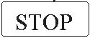
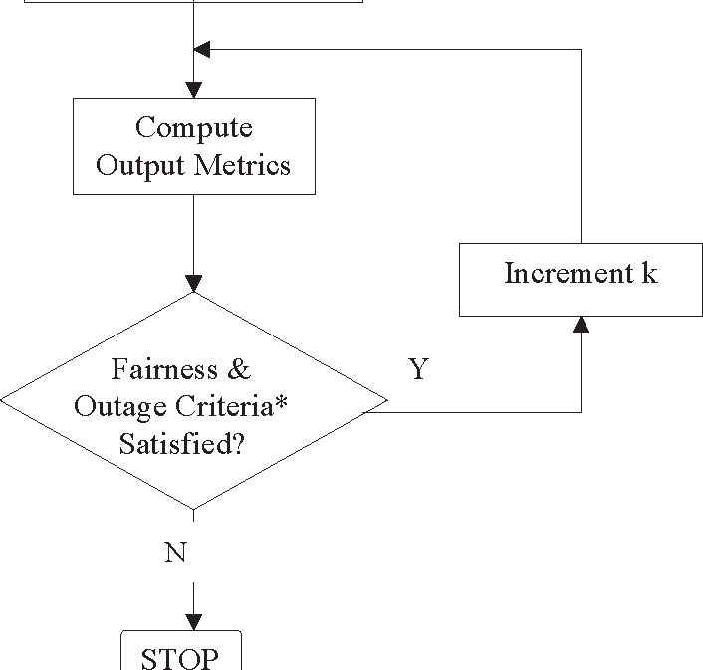
55 1. The system is modeled as a network of 7 clusters. Each cluster has 19 56 hexagonal cells with six cells of the first tier and twelve cells of the second tier 57 surround the central cell of each cluster. Each cell has three sectors. Frequency 58 reuse is modeled by planning frequency allocations in different sectors in the 59 network
60 2. MSs are dropped uniformly throughout the system. Each mobile corresponds to 61 an active user session that runs for the duration of the drop.
62 3. Mobiles are randomly assigned channel models. Depending on the simulation, 63 these may be in support of a desired channel model mix, or separate statistical 64 realizations of a single type of channel model.
1 4. MSs are dropped according to the specified traffic mix. The simulation runs are 2 done with an increment of MSs per sector until a termination condition is met as 3 shown in Figure 27.
4 5. For sectors belonging to the center cluster, sector assignment to an MS is based 5 on the received power at an MS from all potential serving sectors. The sector 6 with best path to MS, taking into account slow fading characteristics (path loss, 7 shadowing, and antenna gains) is chosen as the serving sector.
8 6. Mobile stations are randomly dropped over the 57 sectors such that each sector 9 has the required numbers of users. Although users may be in regions supporting 10 handover each user is assigned to only one sector for counting purposes. All 11 sectors of the system shall continue accepting users until the desired fixed 12 number of users per sector is achieved everywhere. Users dropped within 35 13 meters of a sector antenna shall be redropped. MS locations for six wrapping 14 clusters are the same as the center cluster.
15 7. Fading signal and fading interference are computed from each mobile station into 16 each sector and from each sector to each mobile for each simulation interval.
17 8. Packets are not blocked when they arrive into the system (i.e. queue depths are 18 infinite).Users with a required traffic class shall be modeled according to the 19 traffic models defined in this document. Start times for each traffic type for each 20 user should be randomized as specified in the traffic model being simulated.
21 9. Packets are scheduled with a packet scheduler using the required fairness 22 metric. Channel quality feedback delay, PDU errors and ARQ are modeled and 23 packets are retransmitted as necessary. The ARQ process is modeled by 24 explicitly rescheduling a packet as part of the current packet call after a specified 25 ARQ feedback delay period. 26 10..Simulation time is chosen to ensure convergence in user performance metrics. 27 For a given drop the simulation is run for this duration, and then the process is 28 repeated again, with the MSs dropped at new random locations. A sufficient 29 number of drops are simulated to ensure convergence in the system 30 performance metrics. 31 11.Performance statistics are collected for MSs in all cells according to the output 32 matrix requirements. 33 12.All 57 sectors in the system shall be dynamically simulated.
34 12. Interference Modeling 35 Editor: Roshni Srinivasan, roshni.m.srinivasan@intel.com 36
Sources | Document Reference
Sassan Ahmadi et al. | C80216m-07_069
Kelvin Au et al. | C80216m-07_135r2

37 The reuse of frequencies through planned allocation enables a cellular system to 38 increase capacity with a limited number of channels. The interference model due to 39 frequency reuse should accurately represent the time-frequency selective nature of 40 OFDMA interference. The channel matrices for the desired and interfering signals shall 41 be generated according to the models in Section 3 which account for the pathloss, BS
118
1 antenna gain, shadowing, and fast fading variations. For simplicity, the same fast 2 fading channel model but a different realization shall be assigned to each link between 3 an MS & all BSs in the network. This time-frequency modeling can create significant 4 computational complexity in network simulations. To reduce complexity, pathloss and shadowing are calculated to determine the I strongest interferers. The strongest
strong
6 interferers are modeled as spatially correlated processes and their channel matrices 7 include pathloss, BS antenna gain, shadowing and fast fading components. The 8 remaining I weak interferers are modeled as spatially white spectrally flat processes. It has 9 been shown that this modeling procedure results in negligible loss in performance.
The procedure for downlink simulations is summarized below:
11 1. Determine the pathloss, BS antenna gain, and shadowing from all interfering 12 sectors to MS.
13 2. Rank the interfering sectors in order of received power (based on pathloss, BS 14 antenna gain, and shadowing).
3. Model the channels of the strongest ( I ) interferers as described in Section 3.
strong
16 The channel matrices of the strongest interfering sectors account for the 17 pathloss, BS antenna gain, shadowing, and fast fading variations. For downlink 18 baseline simulations with Matrix A and Matrix B, the value of I shall be set to
strong
19 8.
4. Model the remaining sectors as spatially white Gaussian noise processes whose 21 variances are based on a spectrally flat Rayleigh fading process. The power of 22 the Rayleigh fading process includes the effects of pathloss, BS antenna gain, 23 and shadowing. The fading processes for all links between MS and BS are 24 assumed to be independent, and the Doppler rate is determined by the speed of the mobile. At any instant in time, the total received interference power is the 26 summation of the receive power from of all weak interferers. Hence, the 27 interference power is varying in time during a simulation drop.
28 13.Performance Metrics 29 Editor: Roshni Srinivasan, roshni.m.srinivasan@intel.com
Sources | Document Reference
Sassan Ahmadi et al. | C80216m-07_069
Dan Gal et al. | C80216m-07_063
Robert Novak et al. | C80216m-07_074r1
Wookbong Lee et al. | C80216m-07_075r1
Liu Ying et al. | C80216m-07_064r1
Mark Cudak et al. | C80216m-07_061

