Models for Video Traffic

Jahangir H. Sarker

Communications Laboratory
Institute of Radio Communications
Helsinki University of Technology
P. O. Box 2300, FIN-02015 HUT, Finland.
Tel: +358 9 451 2347/ Fax: +358 9 451 2345
E-mail: Jahangir.Sarker@hut.fi

08.11.99

Abstract

Modeling of the Variable Bit Rate (VBR) video sources is the main purpose of this report. Various factors impact the characteristics and requirements of video traffic. In ATM networks, both Constant Bit Rate (CBR) and real time VBR services can be obtained to support the video traffic. Two types of video traffic modeling technique called The VBR modeling techniques using Markov modulated fluid models and transform-expand-sample (TES) are described.

1. Introduction

Broad band communications networks are expected to support a wide range of multimedia applications, including entertainment video on demand (VOD), high definition TV (HDTV), and multimedia teleconferencing. These applications generate video and audio streams that must be transported in timely manner to ensure coherent reception and playback at the receiver. Video streams are typically compressed before being transported over a network.

For constant-quality video, the video encoder generates a sequence of variable-size compressed frames. When the frame generation rate is constant, the output of the encoder constitutes a variable bit rate (VBR) stream.

The objective of this report is to give an overview of the various types of video traffic models. Several factors effect the nature of video traffic and its transport requirements. Chiefs among these are the target quality (constant or variable), compression technique, coding time (on or offline), adaptiveness of the video application, and supported level of interactivity

2. Factors Impact the Nature of Video Traffic

2.1 VBR and CBR Coding

There is a complicated tradeoff between the minimum achievable coding bit rate R and the distortion D of the decoded images, described in the information theory by the rate distortion function R(D) [1]. The entropy rate (in bits/s) of a source determine the maximum compression (or minimum bit rate) achieved for lossless (D = 0) coding. For a moving image it will be time varying, depending roughly on the instantaneous activity or motion. Higher activity sources will have large R(D) for the same D (Fig 1).

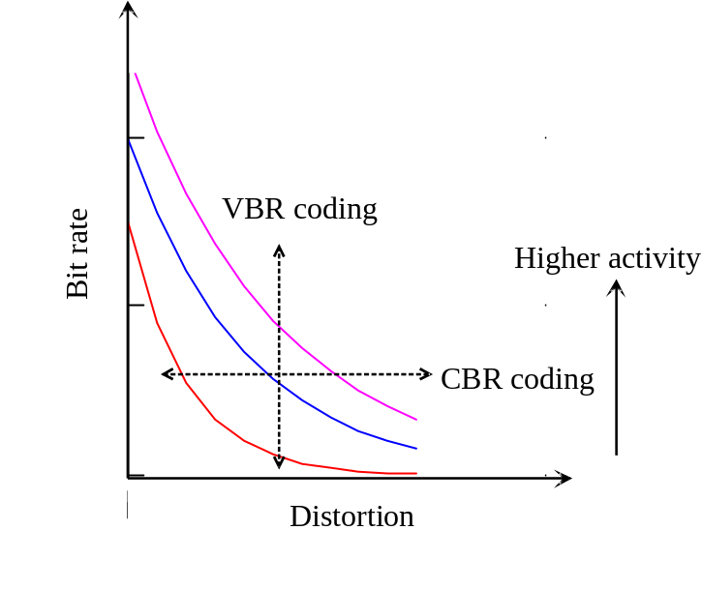
Fig 1: Rate-distortion function.

The rate distortion curves in Fig. 1 defines a region of operation for video encoders. This region is bounded by two orthogonal lines of operation: (1) VBR coding (vertical line), which maintain constant quality throughout the video session. (2) Constant bit rate (CBR) coding (horizontal line), in which a CBR (or frame size) is maintained throughout the video session.

CBR coding is easier to handle from network point of view. Most of practical case like video shows VBR type of traffic and is the choice for high class video.

2.2 Compression Scheme

VBR depends a lot on the compression scheme. In recent years, the standardization committees have been working on providing a set of generic compression standards that can be used for a variety of video applications. These include
- H. 216 for video teleconferencing,
- JPEG for still images, and
- MPEG for full-motion video.

MPEG has been widely accepted.

2.3 Online and Offline Compression

In real time video, the online compression is performed on the fly. On the other hand in case of VOD based services, offline compression is performed.

2.4 Interactivity

Interactivity is an important issue. At one extreme, the video session can be stopped. In another extreme, the video can be transmit as like VCR- fast forward, rewind, play etc. In case of fast forward many video frames must be shown at the same time. The bandwidth requirements will also be higher in this situation.

2.5 Adaptiveness

Some times video sources are designed to adopt the network adaptability. In that case the QoS might be interrupted. The encoder could vary the equalization factors that are used in frame encoding. It could also reduce the rate at which the frames are generated. Some compression techniques provide several modes for scalability that can be exploited in rate adaptation.

3. Various Bandwidth Reducing Methods [2]

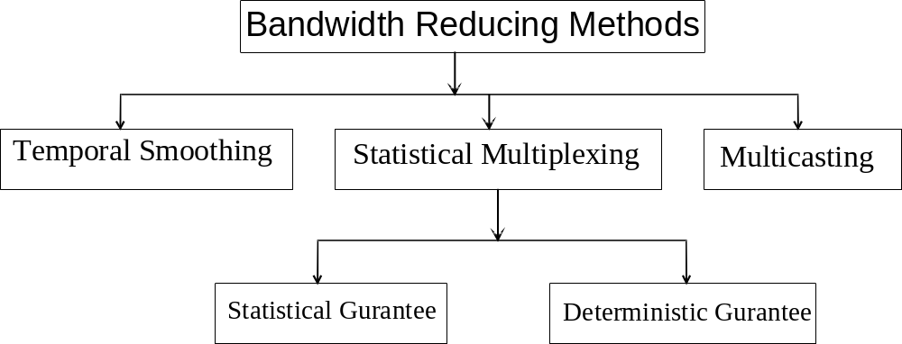

4. Models for Video Traffic

4.1 Markov Modulated Fluid Models

We consider digital video sources, which are compressed using, interframe variable rate coding. The coded bit stream from each source is stored in a separate prebuffer, which assembles the data into blocks and packetizeds the blocks.
Prebuffering eliminates complicated properties in the nature of the source model [3].

The packets from the all the prebuffers join a common buffer in the multiplexer, where the packets are queued for transmission over a high-speed communication line as shown in Fig. 2.

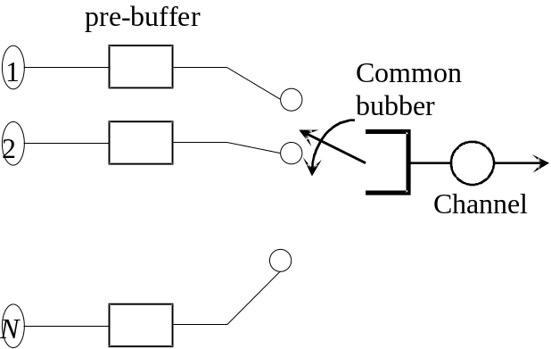
Fig. 2: Statistical Multiplexer.

For the situation we consider, the data rates will be on the order of megabits per second, where the packet length will be less than a kilobit. Thus, it is possible to ignore the discrete packet nature. As a result, the sources can be modeled as producing continuous bit stream at quantized data rate levels, with probabilistic transmissions between the various rate levels. Correspondingly, it is also possible to model the statistical multiplexer queue as a fluid-flow pipe, which takes in bits from the various prebuffers and serves them at a constant rate. The fluid-flow approximation is a powerful tool, which allows the use of the analytical models, taking into account the source correlations in the queueing analysis.

The experiment results indicates that an exponential correlation model for the data rate process is a very good approximation for video phone scenes with a uniform activity level, e.g., showing a person talking.

For other types of video traffic, such as broadcast, television, videoconferencing and long video phonesequences (showing persons talking and listening), indicates the following structure. If we consider an environment where the video sources feeding the network are a mix of these types, then two important correlations are evident:
- a relatively fast-decaying short term correlation corresponding to uniform activity levels, with a time constant on the order of a few hundred millisecond, and
- a slow decaying long term correlation corresponding to sudden changes in the gross activity level of the scene (e.g., scene changes in broadcast TV or change between listener and talker models in a video telephone conversation), with a time constant on the order of a few seconds.

The video modeling capturing only short-term correlation is described in [4]. The birth-death Markov chain shown in Fig. 3 is used for its simplicity in [4]. In this model, the bit rate while in state i is constant and is given be iA, where A is the quantization step size. The transition rate is chosen such that lower bit-rate-states tend to jump to higher-bit-rate states and vice versa. Moreover, jumps are only allowed to neighboring states in birth-death Markov chain, so the model lakes the ability to capture abrupt changes in the arrival rate between frames.

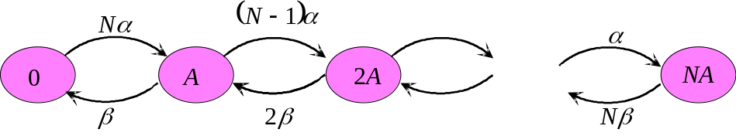
Fig. 3: State transition diagram for birth-death Markov chain.

In order to capture scene changes in the above model, extended the model by allowing the rate to be integer multiples of two basic levels: high level 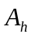, and low level 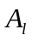 [5]. It uses a two-dimensional Markov chain in which the state is defined by two indices i and j, where 0” i” M and 0” j” N. While in state (i, j)), the flow rate is 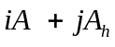. Fig. 4 illustrates the case of a single user.

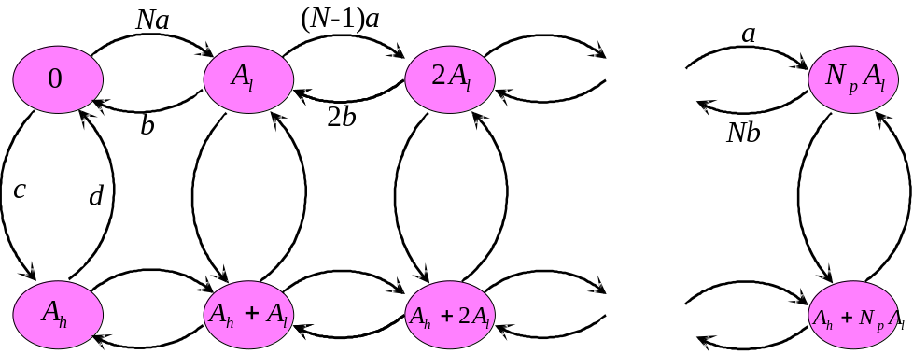

Fig. 4: Fluid flow model for two levels of active VBR sources.

4.2 Transform-Expand-Sample (TES) Models

The VBR compression encoder considered in this study is based on MPEG-1 syntax applied to a CCIR 601 (i.e., 720x480 pixels/interlaced frame) video input, but without the customary rate control algorithm specified in the MPEG reference model. In MPEG, an input video sequence is divided into unites of group-of picture (GOP) consisting of an intra-coded (I) predictive (P) and bidirectional (B). An example of an GOP with parameters N = 9 and M = 3 is: IBBPBBPBB.

In its nominal “open loop” operating mode, the VBR encoder operates with a fixed set of quantizers (one for each frame type: I, B, P), resulting in uniform image quality and variable bit rate. Each encoded frame of video is collected in over the next frame interval (33 ms). Thus, the inter-cell spacing associated with the VBR ATM codec will very from frame to frame in a stochastic manner that depends upon scene content.

In addition to the nominal open loop mode, a particular VBR codec for ATM may have limited rate control in order to comply with call set-up parameters such as peak rate, long term average rate, peak continuos time etc.

The MPEG has a particular fine structure that includes the encoding priority, and relative high open-loop peak-to-average ratio, mainly due to I frames. The periodicity of the bit-rate traces causes the correlogram or periodogram to follow a similar trend and this periodicity is difficult to capture, for example, with a single low order autoregressive model. However, higher order linear autoregressive models could capture the autoregressive structure using a combination of decaying exponentials. On the other hand, autoregressive models assume normal sample marginal distribution. The marginal distribution of the MPEG VBR bit rate differs considerably from normal distributions, and thus AR models are not able to accurately match the empirical marginal distributions. Alternatively, TES modeling may be used to obtained a accurate match for the marginal distribution and autocorrelation function, simultaneously, and will be describe next.

The model was constructed as a deterministic superposition of three component (stochastic) source models, one each sequence of I-frames, P-frames and B-frames. The component bit-rates were then interleaved (superposed) in the appropriate MPEG cycles. Each component subsequence was accurately modeled as a TES process.

TES Modeling of Component Frame Types

This part will describe first the TES model construction of component bit-rate subsequences for each type of frame. TES modeling differs from other modeling approaches in that it aims to fit a prescribed marginal distribution and prescribed auto-correlation function simultaneously, via a stationary stochastic process, thereby capturing both first-order and second order statistics of empirical time series.

The construction of TES models is a two-phase procedure. In the first phase, one defines a background TES process 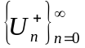 or 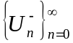 of the form

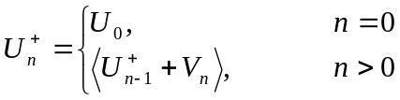 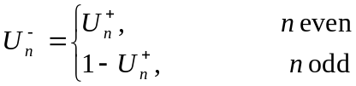 (1)

Here, 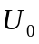 is distributed uniformly on [0, 1); 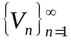 is a sequence of iid random variables, independent of , called the innovation sequence; and angular brackets denotes the modulo-1 (fractional part). BACKGROUNDS TES sequence serve an auxiliary role. The superscript notation in (1) is motivated by the fact that 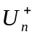 and 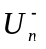 can generate lag-1 autocorrelations in the range [0,1] and 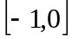 respectively.

TES process in (1) has a simple geometric interpretation as random walks on a circle of circumference 1 (unit circle), with random stem size 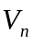. The walk will have zero, positive or negative drift around the unit circle, according as 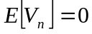, 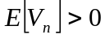 and 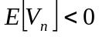 respectively.

In the second phase, the background sequence is transformed into a corresponding foreground sequence 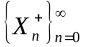 or 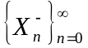 respectively,
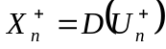, 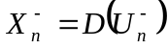, (2)
Where D is the transformation from [0,1) to the reals, called a distortion. Eq. (2) defines two classes of TES models, denoted TES+ and TES-, respectively, and those foreground sequence are the end product TES models.

THE TES modeling methodology used by us employed a composite distortion of the form
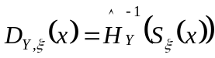, 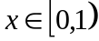 (3)

Here the inner transformation, 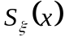, is a smoothing operation, called a stitching transformation, parameterized by 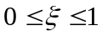, and given by

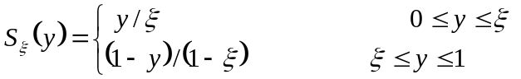 (4)

The outer transformation, 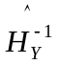, is the inverse of the empirical (histogram) distribution function computed from an empirical time series 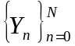 as

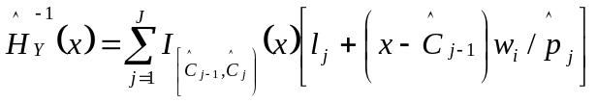 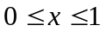 (5)

where 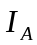 is the indicator function of set A, J is the number of histogram cells, 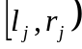 is the support of cell j with width 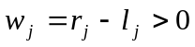, 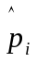 is the probability estimator of cell j and 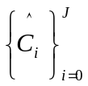 is the cdf of 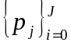, i.e., 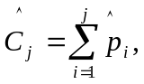 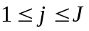 (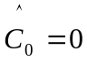 and 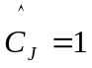).
To understand the modeling procedure sketched above, we take note of the following facts.

- It can be shown that all TES background sequences are stationary Markovian, and their marginal distribution is uniform on 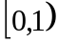, regardless of the probability law of the innovations .

- The inversion method allows us to transform any uniform variegate to others with arbitrary distributions: if U is uniform on and F is a prescribed distribution, then 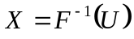 has distribution F. In particular, 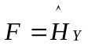 is just a special case.

- For , the effect of is the render the sample paths of background TES sequence more “continuos looking”. Because stitching transformations preserve uniformity, the inversion method can still be used on stitched background process 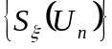.

It follows that any foreground TES sequence of the form
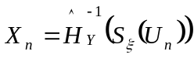 (6)
obtained from any background sequence 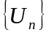, is always guaranteed to have the empirical (histogram) distribution 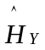, regardless of the innovation density, 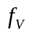, and stitching parameter, selected. Thus, choice of a pair 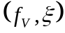 will determine the dependence structure of (6), and in particular, its autocorrelations function. Thus, TES modeling decouples the fitting of the empirical distribution from the fittings of the empirical autocorrelations function. Since the former is guaranteed, one can concentrate on the later. In practice, approximating the empirical autocorrelation structure is carried out via a heuristic search for a suitable pair, , under software support.

A Composite TES Model for MPEG-Coded Video

In order to faithfully model MPEG Video, the correct interleaving of frame types should be effected. Consider IBBPBBPBB (i.e., N= 9, M= 3). The modeling procedure proceeded into two stages. In the first stage, each frame type (I, P and B) was modeled by a TES process, of the form (6), as described previously. The construction utilization empirical bit rate measurements of the MPEG-encoded video sequences. For each test video sequence, a separate TES+ model was fitted to the I-frame and B-frame subsequence, while a TES- model was fitted to the P-frame subsequence. These will be denoted by 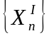, 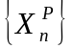 and 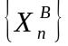 respectively, and, the corresponding background sequence will be similarly denoted by 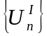, 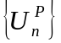 and 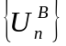. All TES models matched the corresponding empirical distributions, and approximated well the respective empirical autocorrelation functions.

In the second stage, the three TES models were interleaved in the correct order above. However cross-correlations were induced into bit rates comprising individual cycles as follows. The inaugurating I-frame bit rate, 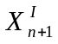, for the next cycle was guaranteed via, 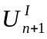, from its I-subsequence process, 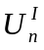, in the normal way. The next bit rate, 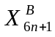 (recall that there are 6 B-frames in a cycle) did not use 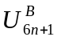; rather, it set 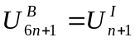. The remaining B-frames in that cycle were generated normally from their predecessors within the cycle via the TES model for B-frames. Similarly, the first P-frame bit rate in the cycle 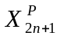 (recall that there are 2 P-frames in a cycle) set 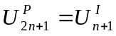 and the remaining P-frames were again generated normally from their predecessors within the cycle via the TES model for P-frames.

Thus, rather than having independent bit rates for different frame types within cycles and across them, the inaugurating I-frame of each cycle and the corresponding P-frames and B-frames within the cycle were rendered depending random variables; the B-frame and P-frame bit rates fluctuated within each cycle around a baseline set by the inaugurating I-frame, and dependence among cycles was driven primarily by I-frames.

Conclusions

Various factors impact the characteristics and requirements of video traffic, including the target quality, compression scheme, client interactivity and adaptivity of the video application. These factors influence the choice of the network transport service. The VBR modeling techniques using Markov modulated fluid models and transform-expand-sample (TES) was discussed. Markov modulated fluid flow is used when pre buffer is used in each source as well as in combined buffer are used before network transmission system. The QoS of the transmitted video traffic is more statistical dependent. On the other hand, the deterministic type of guaranteed statistical multiplexing method is MPEG video streams. This type of video can be modeled by transform-expand-sample (TES) method.

REFERENCES

[1] T. Berger, “Rate distortion theory, a mathematical basis for data compression”, Engleweed Cliffs, NJ: Prentice Hall, 1971.
[2] M. Krunz, “Bandwidth allocation strategies for transporting variable bit rate video traffic”, IEEE Comm. Mag., January 1999, pp. 40-46.
[3] B. G. Haskell, Buffer and channel sharing by several interframe picturephone coders”, Bell Sys. Tech. J., January, 1972, pp. 261-289.
[4] B. Maglaris, et. al., “Performance models of statistical multiplexing in packet video communications”, IEEE Tran. Comm., July, 19998, pp.834-844.
[5] P. Sen, et.al. “Models for packet switching of variable-bit-rate video sources”, IEEE Sel. Area on Comm., June, 1989, pp. 865-869.
[6] D. Raininger et. al., “variable bit rate MPEG video: characterestics, modeling and multiplexing”, ITC 14, 1994, pp. 295-305.

