UniversityofWü
urzburg InstituteofComputerScience ResearchReportSeries

Statisticalpropertiesof MPEGvideotrafcand theirimpactontrafc modelinginATMsystems
O.Rose
ReportNo.101 February1995
InstituteofComputerScience,UniversityofWWurzburg AmHubland,97074WWurzburg,Germany Tel.:+49-931-8885507,Fax:+49-931-8884601 e-mail:rose@informatik.uni-wuerzburg.de
Abstract
MPEGvideotrafcisexpectedtocauseseveralproblemsinATMnetworks,bothfrom performanceandfromarchitecturalviewpoint.Forthesolutionofthesedifculties, appropriatevideotrafcmodelsareneeded.Adetailedstatisticalanalysisofnewly generatedlongMPEGencodedvideosequencesispresentedandtheresultsarecompared tothoseofexistingdatasets.Basedontheresultsoftheanalysis,alayeredmodeling schemeforMPEGvideotrafcissuggestedwhichwillsimplifythefndingofappropriate modelsforalotperformanceanalysistechniques.

1Introduction
InB-ISDNs,amajorpartofthetrafcwillbeproducedbymultimediasourceslike teleconferencingterminalsandvideo-on-demandservers.Thesenetworkswillworkon thebasisofATMandmostofthevideoencodingwillbedoneusingtheMPEGstandard (ISOMovingPictureExpertGroup).
ThereareanumberofopenissuesconcerningthetransmissionofMPEGvideoonhighspeednetworkslikefndingoftheappropriateATMadaptionlayer,dimensioningofthe multiplexerbufers,shapingofvideotrafc,andmonitoringofvideocellstreams.To solvetheseproblemsseveralperformanceanalyseshastobedoneandthereforemodels forMPEGvideotrafcstreamshavetobedeveloped.Thefrststepofthemodeldevelopmentisathoroughanalysisofthestatisticaldatasetsofalreadyencodedvideos.
AtinstituteofComputerScienceatWüurzburg,weencodedavarietyofvideosequences andcarriedoutathoroughstatisticalanalysistogetadetailedpictureofthevideodata stream:moments,histograms,QQ-plots,autocorrelationfunctionsofframeandGOP sizes,R/S-plots.BasedonthisinformationandtheknowledgeabouttheMPEGcoding technique,weproposealayeredvideomodelingscheme.ThemodelcanconsistofGOP, frame,andcelllayer,dependingontherequirementsoftheanalysis.Foreachlayer certainstochasticprocessesaresuggested,whichmaybeusedformodeling.
InSection2,weoutlinetheMPEGvideoencodingtechnique.Section3.1isaboutthe statisticalanalysisoftheencodedsequencesandinSection3.2thelayeredmodeling schemeispresented.Section4concludesthepaper.

2MPEGvideoencoding
Duetothehighbandwidthneedsofuncompressedvideodatastreams,severalcoding algorithmsforthecompressionofthesestreamsweredeveloped.
Atthemoment,theMPEGcodingschemeiswidelyusedforanytypeofvideoapplications.Therearetwoschemes,MPEG-I[7,6]andMPEG-II[2],wheretheMPEG-I functionalitiesareasubsetoftheMPEG-IIones.Themaindiferencewithrespectto videotransmissiononATMisthatMPEG-IIallowsforlayeredcoding.Thismeansthe videodatastreamconsistsofabaselayerstream,whichcontainsthemostimportant videodata,andofoneormoreenhancementlayers,whichcanbeusedtoimprovethe qualityofthevideosequence.
Inthispaper,wefocusonone-layervideodatastreamsofMPEG-Itype.Mostofthe encoderswillusethisschemeandincaseofmulti-layerencodingthestatisticalproperties ofthebaselayerwillbealmostidenticaltothistypeofstream.
TheMPEGencoderinputsequenceconsistsofaseriesofframes,eachcontainingatwodimensionalarrayofpictureelements,calledpels.Thenumberofframespersecondas wellasthenumberoflinesperframeandpelsperlinedependonnationalstandards. Foreachpel,bothluminanceandchrominanceinformationisstored.Thecompression algorithmisusedtoreducethedataratebeforetransmittingthevideostreamover communicationnetworks.
forward prediction
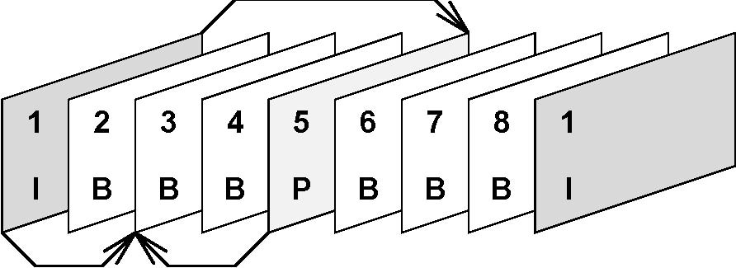
bidirectional prediction
Figure1:GroupofPicturesofanMPEGstream
Thisisdonebybothreducingthespatialandthetemporalredundancyofthevideodata stream.Thespatialredundanciesarereducedbytransformsandentropycodingand thetemporalredundanciesarereducedbypredictionoffutureframesbasedonmotion vectors.Thisisachievedusingthreetypesofframes(cf.Figure1):
I-framesuseonlyintra-framecoding,basedonthediscretecosinetransformandentropy coding;
P-framesuseasimilarcodingalgorithmtoI-frames,butwiththeadditionofmotion compensationwithrespecttothepreviousI-orP-frame;
B-framesaresimilartoP-frames,exceptthatthemotioncompensationcanbewith
respecttothepreviousI-orP-frame,thenextI-orP-frame,oraninterpolation
betweenthem.
Typically,I-framesrequiremorebitsthanP-frames.B-frameshavethelowestbandwidth requirement.
Aftercoding,theframesarearrangedinadeterministicperiodicsequence,e.g.\IBBPBB"or\IBBPBBPBBPBB",whichiscalledGroupofPictures(GOP).

3ModelingofMPEGvideotrafc
Thereareseveralreasonstodevelopmodelsforvideotrafcandtousethemforthe performanceanalysisofATMnetworks.
Thefrstreasonistoextractthestatisticalpropertiesofvideotrafcwhichhavea remarkableimpactonthenetworkperformance.Wegainalotofinsight,ifweareableto reducethestatisticalcomplexityoftheempiricalvideodatasets.Itistrue,thatonlythe framesizetracefromtheoutputofaMPEGencodercontainsallstatisticalinformation abouttheencodedvideo,butontheotherhandthelargenumberofpropertiesmakesit difculttodecidewhichoneiscausingperformanceproblems.
Movies(buycassettes)
dino | JurassicPark
lambs | TheSilenceoftheLambs
TVsportsevents(recordedfromcableTV)
soccer | SoccerWorldCup1994Final:Brazil-Italy
race | Formula1carraceatHockenheim/Germany1994
atp | ATPTennisFinal1994:Becker-Sampras
OtherTVsequences(recordedfromcableTV)
terminator | Terminator2
talk1 | Germantalkshow
talk2 | Politicaldiscussion
simpsons | Cartoon
asterix | Cartoon
mr.bean | Threeslapstickepisodes
news | Germannewsshow
mtv | Musicclips
Settopcamera
settop | Studentsittinginfrontofworkstation

Table1:Overviewofencodedsequences
Thesecondreasonisthecomputationalcomplexityofsimulations,particularlyoncell level,ofATMnetworks.Itoftentakeslongsimulationrunstoobtainresultsofhigh accuracy.Insomecasesthenumericalcomplexitycanbeconsiderablyreducedusing trafcmodelsandstandardanalyticaltoolslikematrixanalysisordiscretetimeanalysis.
Thethirdreasonistheneedforconnectiontrafcdescriptorsforvideotrafc.Ifthe trafcmodelissimple,i.e.ithasonlyasmallnumberofparameters,theseparameters canbeusedastrafcdescriptorsforCACandUPCofvideoconnections.
Forthedevelopmentofvideotrafcmodelswecanbothusetheknowledgeaboutthe codingtechnique,MPEG-IorMPEG-IIinourcase,andthestatisticalanalysisofthe framesizesequencewhichweobtainfrommeasurements.
3.1StatisticalanalysisofMPEGvideosequences
Inthefollowing,wewillpresentsomestatisticalmeasurementsfromseveralmovies,TV sportevents,andTVshows1 ,whichweencodedatourinstituteusingtheUCBerkeley MPEG-Isoftwareencoder[5].Table1showsthesequenceswhichweusedtoproduce thedatasets.
Allsequencesmentionedbelowwereencodedusingthefollowingparameterset:
1Toavoidanyconfictwithcopyrightlaws,wewanttopointout,thatallimageprocessing,encoding, andanalysisworkwasmadeforscientifcpurposes.Theencodedsequenceshavenoaudiostreamand willnotbemadepubliclyavailable.Onlystatisticaldatasetswillbemadeavailabletocolleagues.
Sequence | Compr.rateX:1 |  | Frames |  |  |  | GOPs |  |  |  |  | Bitrate
Sequence |  |  |  | Mean[bits] | CoV | Peak/Mean |  | Mean[bits] | CoV |  | Peak/Mean |  | Mean[Mbps] | Peak [Mbps]
asterix |  | 119 |  | 22,348 | 0.90 | 6.6 |  | 268,282 | 0.47 |  | 4.0 |  | 0.59 | 1.85
atp |  | 121 |  | 21,890 | 0.93 | 8.7 |  | 262,648 | 0.37 |  | 3.0 |  | 0.55 | 1.58
dino |  | 203 |  | 13,078 | 1.13 | 9.1 |  | 156,928 | 0.40 |  | 4.0 |  | 0.33 | 1.01
lambs |  | 363 |  | 7,312 | 1.53 | 18.4 |  | 87,634 | 0.60 |  | 5.3 |  | 0.18 | 0.85
mr.bean |  | 150 |  | 17,647 | 1.17 | 13.0 |  | 211,368 | 0.50 |  | 4.1 |  | 0.44 | 1.76
mtv |  | 134 |  | 19,780 | 1.08 | 12.7 |  | 237,378 | 0.70 |  | 6.1 |  | 0.49 | 2.71
news |  | 173 |  | 15,358 | 1.27 | 12.4 |  | 184,299 | 0.47 |  | 6.0 |  | 0.38 | 2.23
race |  | 86 |  | 30,749 | 0.69 | 6.6 |  | 369,060 | 0.38 |  | 3.6 |  | 0.77 | 3.24
settop |  | 305 |  | 6,031 | 1.92 | 7.7 |  | 72,379 | 0.18 |  | 2.0 |  | 0.15 | 0.27
simpsons |  | 143 |  | 18,576 | 1.11 | 12.9 |  | 222,841 | 0.43 |  | 3.8 |  | 0.46 | 1.49
soccer |  | 106 |  | 25,110 | 0.85 | 7.6 |  | 301,201 | 0.48 |  | 3.9 |  | 0.63 | 2.29
starwars |  | 130 |  | 15,599 | 1.16 | 11.9 |  | 187,185 | 0.39 |  | 5.0 |  | 0.36 | 4.24
talk1 |  | 183 |  | 14,537 | 1.14 | 7.3 |  | 174,278 | 0.32 |  | 2.7 |  | 0.36 | 1.00
talk2 |  | 148 |  | 17,914 | 1.02 | 7.4 |  | 214,955 | 0.27 |  | 3.1 |  | 0.49 | 1.40
terminator |  | 243 |  | 10,904 | 0.93 | 7.3 |  | 130,865 | 0.35 |  | 3.1 |  | 0.27 | 0.74

Table2:Simplestatisticsoftheencodedsequences
�Eachframeconsistsofoneslice;
�GOPpattern:IBBPBBPBBPBB(12frames);
�Quantizerscales:10(I),14(P),18(B);
�Motionvectorsearch:logarithmic/simple;window:halfpel,10;referenceframe: original;
�Encoderinput:384x288pelswith12bitcolorinformation;
�Numberofframespersequence:40000(abouthalfanhourofvideo)
SomeparametersmightnotbeoptimalwithrespecttothequalityoftheMPEGvideo sequence,becauseofsomehardwarelimitations.WeusedaSunSparc20fortheimage processingandencoding,andcapturedthesequencefromaVCRwithaSunVideoSBus board.
3.1.1Overview
Table2showsthecompressionratesandthemostimportantmomentsoftheframesizes, theGOPsizes,andthecorrespondingbitratesoftheMPEGsequences.
ForthesakeofcomparisonthestatisticaldatafromMarkGarrett'sStarWarssequence [4]isalsopresented.
theFromTable2weconclude,thattypicalTVsequenceslikesports,news,andmusic clipsleadtoMPEGsequenceswithahighpeakbitrateandahighpeak-to-meanratio comparedtomoviesequences.Thesepropertiesresultfromtherapidmovementsofalot ofsmallobjects,whichincreasetheamountofdatanecessarytoencodethesequence.
Unfortunately,eventhestatisticalpropertiesofthesequencesofthesamecategory,like moviesorcartoons,arenotingoodagreement.Forexample,themeasurementsofterminatorandlambsorofsimpsonsandasterixhavenomomentslyingclosetogether.This willleadtodifcultiesinfndingtrafcclassesforMPEGvideo,whichcanbeusedfor CACandUPC.
Intheremainderofthissection,wewillpresentadetailedanalysisofthestatisticaldata ofthedino,soccer,andstarwarssequences.
3.1.2Frametraces
Figures3,4,and5showtheframesizetracesofthedino,soccer,andstarwarssequences. TheIframesizesarelightgray,thePframesizesblack,andtheBframesizesdarkgray. Theappearanceofthethreetracesisverydiferent.Thedinotraceisrathersmooth, whereastheothertwotracesshowalargenumberofrapidchangesintheframesizesof eachtypeofframes.Butalthoughbothtraceshavethisproperty,theylookdiferent. ThePframesofthestarwarstracearelargecomparedtotheIframes.Thesoccertrace, however,showsverylargechangesinanytypeofframes,andtheBframesareoftenof thesamesizeasthePframes.Thisindicatesalotofmovementintheinputsequenceof theencoder,sincetheBframesonlybecomelarge,ifthepredictedimagewillbepoor becauseoftheamountofmovementandadditionaldatahastobeencodedtocorrect thesepredictionerrors.Thiswillbethecaseforsoccermatchesandforalotofother sportsevents.
3.1.3Distributions
TheFigures6,7,and8showtheframesizehistogramsoftheI,P,andBframesofthe dinosequence.ThedashedcurveisaGammapdf,whichhasthesamemeanandvariance asthehistogramframesizes.ThegoodagreementofthehistogramandtheGammacurve fortheIandPframesbecomesmoreobviousifweuseaQQ-plot(quantile-quantile-plot), wheretheGammaquantilesareplottedagainstthehistogramquantiles.Anagreement withthedottedlineindicatesthatbothpdf'sareequal.ThesolidlineisfortheGamma pdfandthedashedlineisfortheLognormalpdf,whichhasthesameparametersasthe Gammapdf.FortheIframesizes(Figure9)boththeGammaandtheLognormalpdf aregoodtoverygoodapproximationsofthehistogrampdf.IncaseofthePframes (Figure10)theGammapdfisingoodagreement,whereasfortheBframes(Figure11) theLognormalpdfshowsbetterperformance.
Foralmostallencodedsequences,eithertheGammaortheLognormalpdfisanuseful approximationoftheframesizehistogrampdf'sofeithertypeofframe.Thediferences betweenGammaandLognormalapproximationperformancearenottoolargeinmost cases.Perfectagreementofhistogramandapproximationcannotbeachieveddueto fniteframesizes.
Thisleadstotheconclusion,thatforthemodelingoftheframesizes,eitherhistograms, Gamma,orLognormalpdf'scanbeused.
IfwelookattheGOPsizedistributions,weobtainsimilarresults.Figures12,13,and14 showtheQQ-plotforthedino,soccer,andstarwarssequence.Again,theGammaand Lognormalquantilesareplottedagainstthehistogramquantiles.Forthesequencesconsidered,theLognormaldistributionisagoodapproximationoftheGOPsizehistogram, buttheGammadistributionwillalsobeadequate.
3.1.4Correlations
Time-dependentstatisticsareimportantinthecaseofvideotrafc,becausecorrelations ofthedatastreamsmaycauseperformanceproblemsoftheATMnetwork.
First,autocorrelationfunctionsoftheframesizesandoftheGOPsizesarepresented.The frame-by-framecorrelationsaredependingonthepatternoftheGOP,and,inprinciple, alwayslooklikeFigure15,ifthesameGOPpatternisusedforthewholesequence.The largerpositivepeaksstemfromtheIframes,thesmallerpositiveonesfromthePframes, andthenegativeonesfromtheBframes.Thisshaperefectstherelationshipofthe meanframesizesoftheframetypes.AlargeIframeisfollowedbytwosmallBframes. ThenamidsizePframeisproducedbytheencoder,whichisfollowedbytwosmallB framesagain.ThepatternbetweentwoIframepeaksisrepeatedwithslowlydecaying amplitudeofthepeaks.
Ifamodelisneededwhichrefectstheframe-by-framecorrelationsofanMPEGvideo trafcstream,theGOP-patternbasedshapeoftheautocorrelationfunctionhastobe considered.Anapproximationoftheautocorrelationsfunctionispresentedin[3].
Basedontheframelevelcorrelations,itisdifculttogetaclearpictureofthelong-range correlationsofthevideotrafcstream.Thus,theautocorrelationfunctionsoftheGOP sizes,i.e.thesumoftheframesizesofoneGOP,areconsidered.
Figures16,17,and18showtheautocorrelationfunctionsoftheGOPsizesofthesequencesdino,soccer,andstarwars.Inaddition,thedashedlineshowstheexponential function,whichismatchedtotheempiricalautocorrelationfunctionofthefrstfewlags. AcurveofthistypeappearsiftheGOPsizeprocessismemoryless.Iftheautocorrelation functionofthestatisticaldataisabovetheexponentialfunction,thisindicatesdependencesintheGOPsizeprocess.InFigures16and18thisisclearlythecase,whereas theautocorrelationcurveandtheexponentialcurvearematchingwellinFigure17.
ThisresultmakesitdifculttofndaGOPlayermodelwhichisappropriateforalltypesof videosequences.Ontheotherhand,itisoftensufcienttohaveamodelwhichisaccurate intermsofcorrelationsintheorderofframes,i.e.tensofmilliseconds.Therefore,it ispossibletoneglecttheGOP-by-GOPcorrelationsandtouseonlydistributionsand momentsoftheGOPsizestomodeltheGOPsizeprocess,e.g.withaMarkovchain, anautoregressiveprocess,orsimplydrawingGOPsizesamplesbasedontheGOPsize histogram.
Anotherwaytodetectlong-rangedependencesistousevariance-timeplots,R/Splots, orperiodograms[1,8].Here,wefocusontheR/Splots,becauseitisarobustmethod
Sequence | HurstexponentH
race | 0.99
soccer | 0.91
lambs | 0.89
terminator | 0.89
mtv | 0.89
simpsons | 0.89
talk1 | 0.89
dino | 0.88
atp | 0.88
mr.bean | 0.85
asterix | 0.81
news | 0.79
starwars | 0.74
talk2 | 0.73
settop | 0.53

Table3:Hurstexponentsoftheencodedsequences
todeterminetheasymptoticHurstexponentHoflongtimeseries.Anintroductionin R/Sanalysiscanbefoundin[9].
Figures19,20,and21showtheR/Splots,strictlyspeakingthepoxplots,oftheframe sizesequencesofdino,soccer,andstarwars.Theslopeofthestreetofpointsonthe diagramsisanestimatefortheHurstexponentH.Theslopeiscomputedusingaleast squaresft,wherethefrstrowandthelasttworowsofR/Svaluesisnotconsidered. Thefrstrowmayrefecttoomanyshort-rangedependenceefects,andthenumberof R/Svaluesofthelastrowistoosmall.
TheestimatedparameterHforthedinosequenceis0.88,forthesoccersequenceitis 0.91,andforthestarwarssequence0.74isestimated.Timeserieswithoutanylong-range dependencesownaHurstexponentof0.5,whereastimeseriesofcomputertrafccan haveH-valuesupto1.0[4].Itisinterestingtonoticethatthesoccersequencehasalarge H-value,butthattheautocorrelationfunctionoftheGOPsisdecayingexponentially.
Itisassumed,thatincaseofvideotrafcalargerH-valuerefectsalargeramount ofmovementinthevideosequence[1].ThisiscorroboratedbyTable3formostof theencodedsequences.OnlytheH-valuesoftalk1andstarwarsdonotgowiththis assumption.InthecaseofstarwarstheH-valueislowcomparedtotheothermovies. However,besidesthesettopsequence,allsequenceshaveH-values,whicharehigherthan 0.73,andtheexistenceoflong-rangedependenciescanbeassumed.
Ifthemodelofthevideotrafcshouldhavelong-rangedependenceproperties,aclass ofprocessescalledfractionaldiferencingprocessesmaybeused[4].Theseprocesses generatetimeserieswithgivenH-values,butitmaybedifculttomatchagivenmarginal distributionforthegeneratedsamples.
3.2Layeredmodelingscheme
Inthissection,wearegoingtopresentalayeredmodelingschemeforthedevelopment ofMPEGvideotrafcmodels2 .
ThemaininformationforthemodeldevelopmentwhichwereceivefromtheMPEGway ofcodingcanbeconcludedasfollows:
�Therearethreeframetypes:I,P,andBframes.
�Apatternofframetypes,calledGOP,isrepeatedcontinuouslytocreatetheencodedframesequence.
�TheframesofonesingleGOPstronglydependoneachother.
Moreover,ifwewanttocreateamodeloncelllevel,boththeAALwhichisusedforthe transmissionofthevideoandtheinformation,whetherthecellstreamisshapedbefore itentersthenetworkornot,shouldbetakenintoaccount.
Basedontheinformationpresenteduptothispoint,wearealreadyabletodevelopa schemewiththreelayers(cf.Figure2):
�GOPlayer,
�Framelayer,
�Celllayer.
Atthemoment,higherlayers,likescenes,arenotunderconsiderationfortworeasons. First,eachadditionallayeraddssomecomplexitytothemodelandwewanttohave simplemodels.Second,inmostcasesthetimescaleofoneGOP,i.e.abouthalfa second,islargeenoughintheATMcontext.
Havingdecidedonthelayers,wehavetodefnethestatisticalpropertiesofeachlayer andofthewaythelayersinteract.
BasedontheresultsofSection3.1,weareabletoselectastochasticprocessforeach layer,whichisappropriateforourpurposesoranalysistechnique,respectively.
Afterthisstep,wehavetolaydownthewaythelayersdependoneachother.
Forexample,ifwewanttogenerateaframesizesequencebasedontheGOPsizeprocess, wehavetoconsiderthestructureoftheGOPpattern,whichtellsustheorderofthe typesofframes.ThesimplestwaytofndtheframesizesbasedonaGOPsizesample istouseascalingfactorforeachframeoftheGOP,wherethescalingfactorsarethe meansizesoftheframesofoneGOPdevidedbythemeanGOPsizeofagivendataset. Morecomplexmodelsmayuseframesizehistogramsorapproximatepdf'stogenerate theframesizesequence(cf.Figure2).
2Anoverviewofthevideomodelingliteraturecanbefoundin[10]
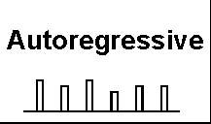
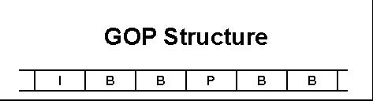
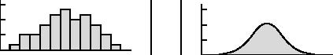

GOP Sizes
Frame Sizes
ATM Layer Adaption (AAL1/5)
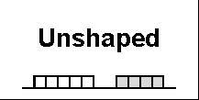
Shaped
Cell Stream
Figure2:Layeredvideotrafcmodelingscheme
Markov
Histogram Approximate
Ifwewanttoobtainacelllevelmodel,wehavetomakeupourmindonthewaythe framesarebrokenintocells.ThiswilldependontheconsideredATMAdaptionLayer (AAL)andontheexistenceofshapingfacilitiesbetweenvideosourceandATMnetwork. Ifastatisticalanalysisofvideocellstreammeasurementsisavailable,itwillbepossible tobasemodelsdirectlyonthismaterial.Thismayleadtosimplermodelsforthecell process.
Thepresentedmodeldevelopmentschemeisnotarecipetogetaperfectvideotrafc model.Itismorelikeanoutlineofavarietyofstochasticmodulesandthedescription howtheyinteractinthecaseofvideotrafc.Themodeldeveloperwillhavetochoose themodules,whichareappropriateforhisanalysis.
Wewanttopointout,thatanymodelshouldbevalidated.Anymodel,evencomplex ones,arebasedonsimplifyingassumptions,likeindependenceassumptions.Thus,to obtainusefulandreliableperformanceanalysisresults,itisimportanttoknowhow theseassumptionsafecttheresultsoftheanalysis.

Conclusions
ModelingofVBRvideotrafcisoftendifcult,becauseofthestatisticalcomplexityof theempiricaldatasets,forexampletheirlayeredstructureandthecorrelationsonseveral timescales.
Inthispaper,wepresentadetailedstatisticalanalysisofnewMPEGsequences,which weencodedatourinstitute.Eachsequenceconsistsof40000frames.Wewereableto corroborateseveralresults,whichareknownfromtheanalysisofothervideosequences: 1.theframeandGOPsizescanbeapproximatedbyGammaorLognormalPDF's,2. therearelong-rangedependencesintheframesequences,whichleadtoHurstexponents from0.7uptoabout1.0.
ThenewdatasetsarealsocomparedtothewellknownStarWarsdatasetfromMark Garrett.ItcanbeconcludedthatwithrespecttothestatisticalpropertiestheStarWars sequenceisagoodrepresentativeoftheclassofMPEGvideotrafc,butthatitwillbe misleadingtodimensionATMnetworksbasedonlyonthisdataset.Therearesequences likeTVbroadcastsofsportsevents,whereperformanceproblemslikebuferoverfows aremorelikelythanwiththeStarWarssequence.
Basedonthestatisticalanalysis,alayeredmodelingschemeforMPEGvideotrafc ispresented.Wedescribethepropertiesofeachlayerandthewaytheyinteract.In addition,someguidanceisgivenonhowtodevelopvideomodels.

Acknowledgement
TheauthorswouldliketothankMarkGarrett(Bellcore,Morristown,NJ)forproviding theStarWarsdata.TheauthorsappreciatethesupportoftheDeutscheBundespost Telekom(FTZ).

References
[1]J.Beran,R.Sherman,M.S.Taqqu,andW.Willinger.Variable-bit-ratevideo trafcandlong-rangedependence.IEEETransactionsonCommunications,1994 (7).Acceptedforpublication.
[2]DraftInternationalStandard:ISO/IECDIS13818-2.GenericCodingofMoving PicturesandAssociatedAudioPart2,Video,1993.
[3]J.Enssle.ModellingandstatisticalmultiplexingofVBRMPEGcompressedvideoin ATMnetworks.InProceedingsofthe4thOpenWorkshoponHighSpeedNetworks, Brest,Sept.1994.
[4]M.W.Garrett.Contributionstowardreal-timeservicesonpacketswitchednetworks. PhDthesis,ColumbiaUniversity,1993.
[5]K.L.Gong.BerkeleyMPEG-1VideoEncoder,User'sGuide.UniversityofCalifornia,Berkeley,ComputerScienceDivision-EECS,Mar.1994.
[6]InternationalStandard:ISO/IECIS11172-2.CodingofMovingPicturesandAssociatedAudioforDigitalStorageMediaupto1.5Mbit/sPart2,Video,1993.
[7]D.LeGall.MPEG:Avideocompressionstandardformultimediaapplications. CommunicationsoftheACM,34(4):46{58,Apr.1991.
[8]W.E.Leland,W.Willinger,M.S.Taqqu,andD.V.Wilson.Statisticalanalysisand stochasticmodelingofself-similardatatrafc.InProceedingsoftheITC14,pages 319{328,1994.
[9]B.B.MandelbrotandM.S.Taqqu.RobustR/Sanalysisoflong-runserialcorrelation.InProc.42ndSessionISI,Vol.XLVIII,Book2,pages69{99,1979.
[10]O.RoseandM.R.Frater.AcomparisonofmodelsforVBRvideotrafcsourcesin B-ISDN.InIFIPTransactionsC-24:BroadbandCommunications,II,pages275{ 287.North-Holland,1994.
200000
Framesize[bit] Framesize[bit]
I
P
B
150000
100000
50000
0
0 | 5000 | 10000 |  | 15000 | 20000 |  |  | 25000 |  | 30000 | 35000 |  | 40000
 |  |  |  |  | Frameno.
 | Figure3: | Framesizetraceofthedinosequence
200000
 |  |  |  |  |  |  |  |  |  |  | I
 |  |  |  |  |  |  |  |  |  |  | P
 |  |  |  |  |  |  |  |  |  |  | B
150000
100000
50000
0
0 | 5000 |  | 10000 | 15000 |  | 20000 | 25000 |  | 30000 |  | 35000 | 40000

Frameno. Figure4:Framesizetraceofthesoccersequence
Framesize[bit]
150000 200000 | I P B
100000
50000
0 0 5000 Figure5: | 10000 15000 20000 25000 30000 35000 Frameno. Framesizetraceofthestarwarssequence | 40000

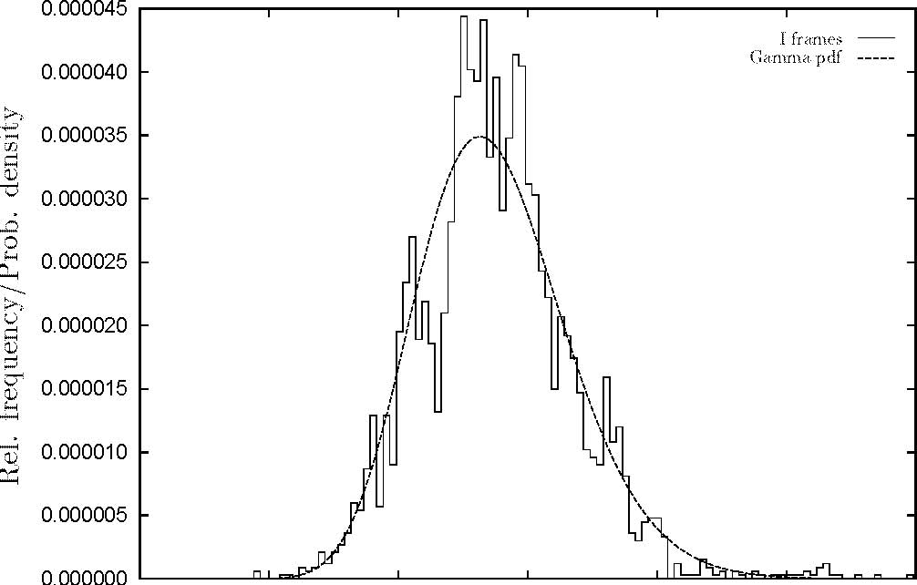
0 20000 40000 60000 80000 100000 120000
Framesize[bit]
Figure6:HistogramoftheIframesizesofthedinosequence
Preprint-Reihe
InstituturInformatik
füUniversitüatWüurzburg
Verantwortlich:DieandeInstitutesurVorstüdesfüInformatik.
[1]K.Wagner.Boundedqueryclasses.Februar1989.
[2]P.Tran-Gia.Applicationofthediscretetransformsinperformancemodelingandanalysis. Februar1989.
[3]U.Hertrampf.Relationsamongmod-classes.Februar1989.
[4]K.W.Wagner.Number-of-queryhierarchies.Februar1989.
[5]E.W.Allender.Anoteonthepowerofthresholdcircuits.Juli1989.
[6]P.Tran-GiaundTh.Stock.ApproximateperformanceanalysisoftheDQDBaccessprotocol. August1989.
[7]M.KowalukundK.W.Wagner.DieVektor-Sprache:EinfachsteMittelzurkompaktenBeschreibungendlicherObjekte.August1989.
[8]M.KowalukundK.W.Wagner.Vektor-Reduzierbarkeit.August1989.
[9]K.W.Wagner(Herausgeber).9.WorkshopüKomplexitü
uberatstheorie,efzienteAlgorithmenund Datenstrukturen.November1989.
[10]R.Gutbrod.Atransformationsystemforchaincodepicturelanguages:Propertiesand algorithms.Januar1990.
[11]Th.StockundP.Tran-Gia.Adiscrete-timeanalysisoftheDQDBaccessprotocolwithgeneral inputtrafc.Februar1990.
[12]E.W.AllenderundU.Hertrampf.Onthepowerofuniformfamiliesofconstantdepth thresholdcircuits.Februar1990.
Rel.frequency/Prob.density Rel.frequency/Prob.density
0.000070
0.000060
0.000050
0.000040
0.000030
0.000020
0.000010
0.000000
Figure
0.000140
0.000120
0.000100
0.000080
0.000060
0.000040
0.000020
0.000000
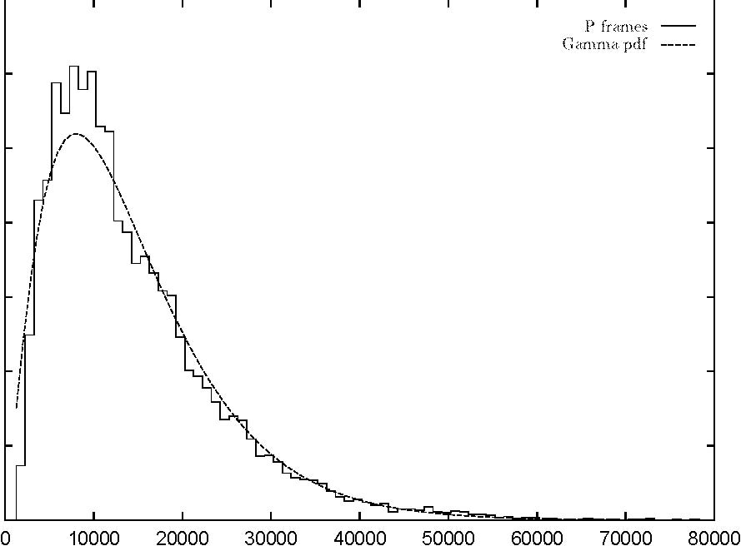
Framesize[bit] 7:HistogramofthePframesizesofthedinosequence
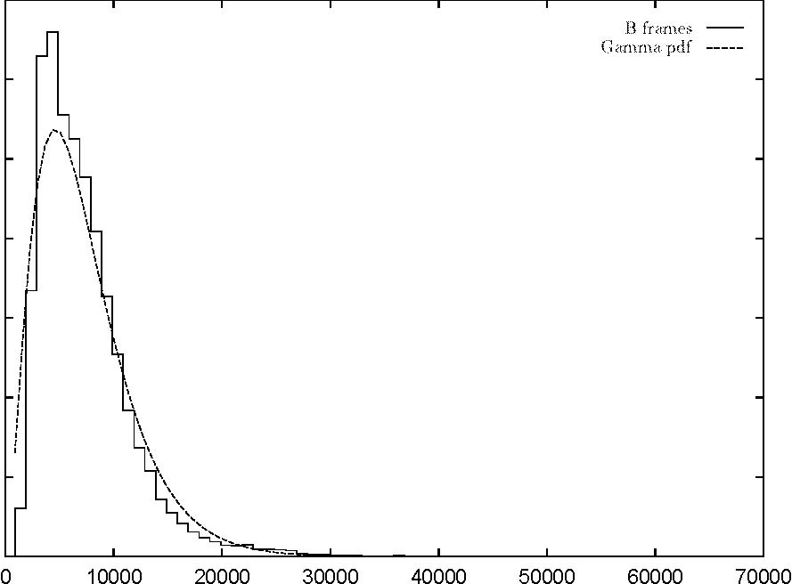
Framesize[bit]
Figure8:HistogramoftheBframesizesofthedinosequence
Dataquantiles Dataquantiles
120 100 80 60 40 20 0
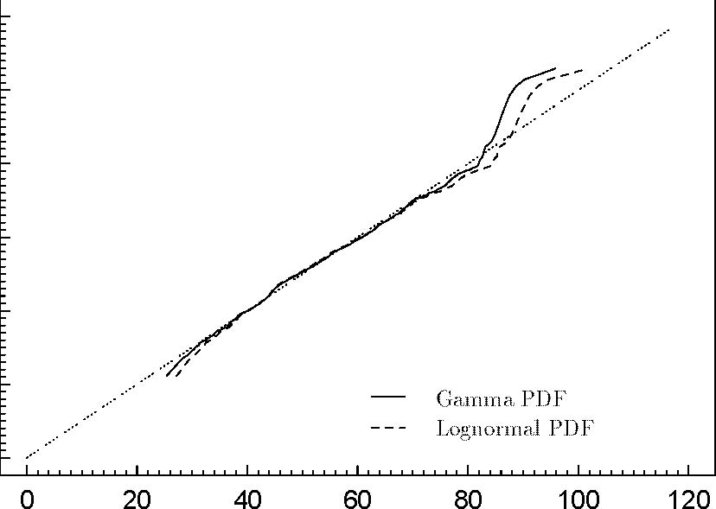
ApproximatePDFquantiles Figure9:QQ-plotfortheIframesizesofthedinosequence
80 70 60 50 40 30 20 10 0
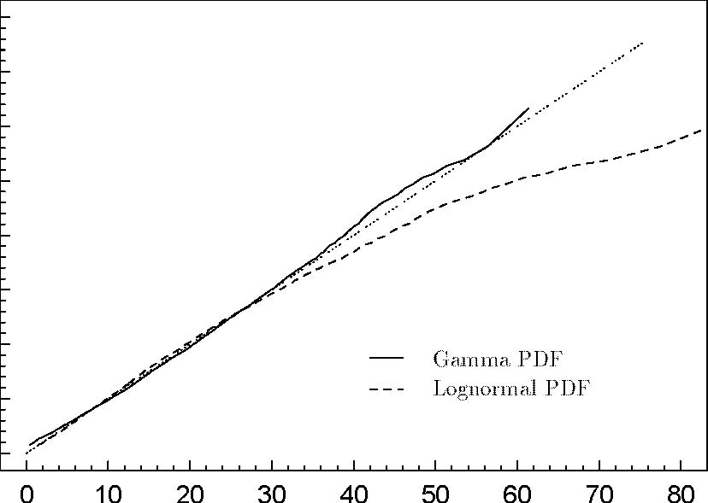

ApproximatePDFquantiles Figure10:QQ-plotforthePframesizesofthedinosequence
Dataquantiles Dataquantiles
40
30
20
10
0
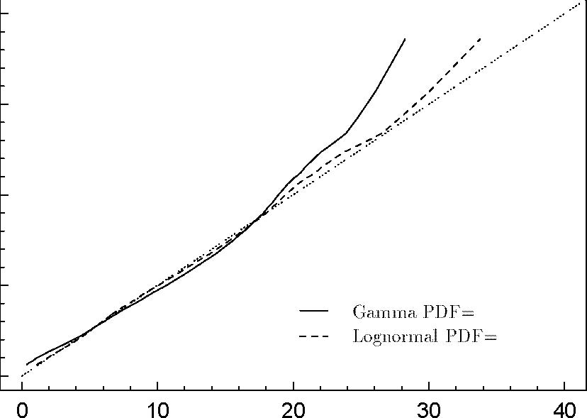
ApproximatePDFquantiles Figure11:QQ-plotfortheBframesizesofthedinosequence
600 500 400 300 200 100 0
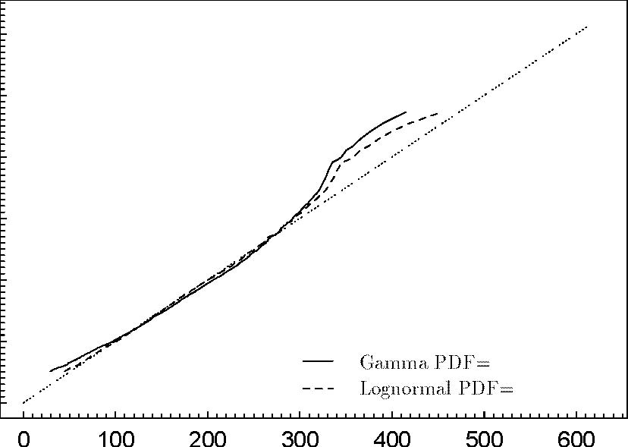
ApproximatePDFquantiles Figure12:QQ-plotfortheGOPsizesofthedinosequence
Dataquantiles Dataquantiles
1200 1000 800 600 400 200 0
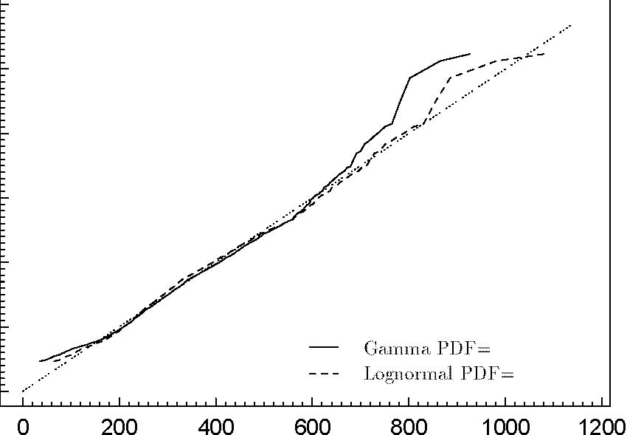
ApproximatePDFquantiles Figure13:QQ-plotfortheGOPsizesofthesoccersequence
600
400
200
0
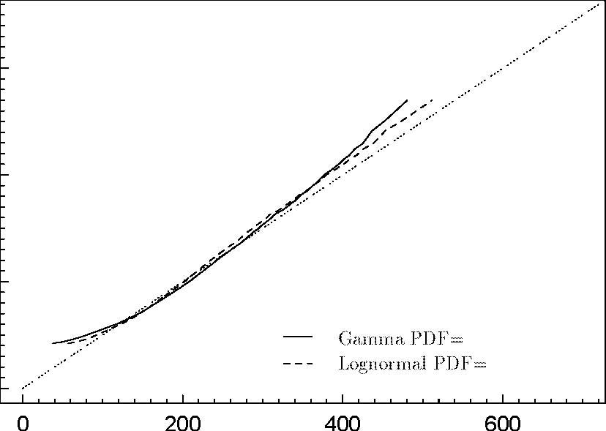

ApproximatePDFquantiles Figure14:QQ-plotfortheGOPsizesofthestarwarssequence
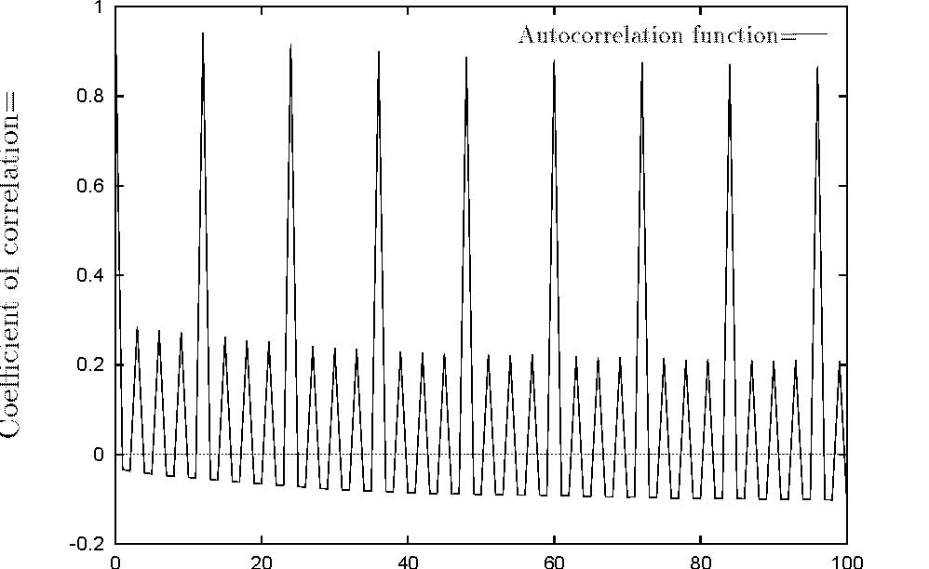
Lag[frames] Figure15:Autocorrelationfunctionoftheframesizesofthedinosequence
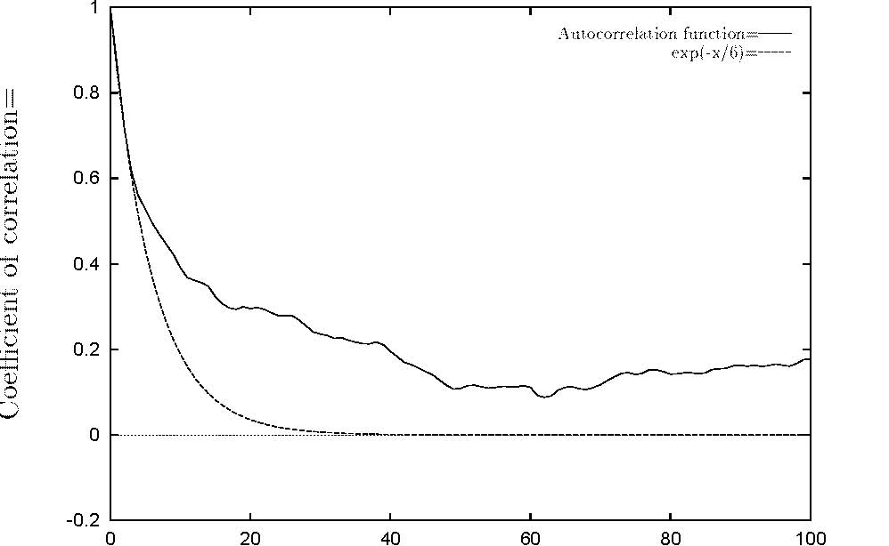
Lag[GOPs] Figure16:AutocorrelationfunctionoftheGOPsizesofthedinosequence
19
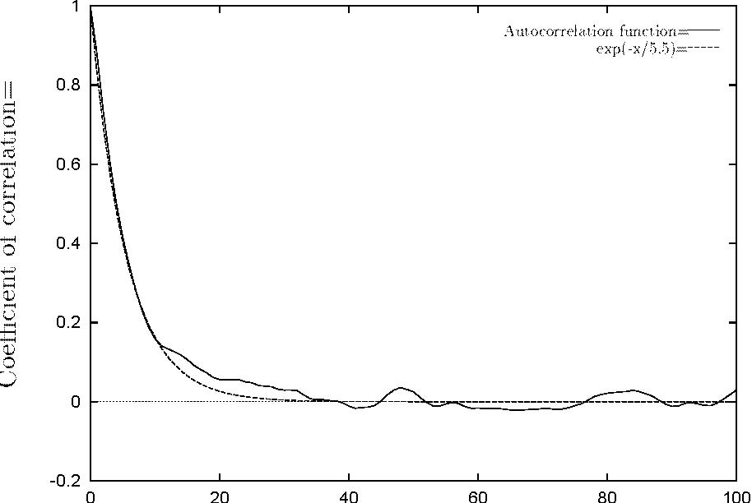
Lag[GOPs] Figure17:AutocorrelationfunctionoftheGOPsizesofthesoccersequence
1

Coefcientofcorrelation
0.8
0.6
0.4
0.2
0
-0.2
Lag[GOPs]
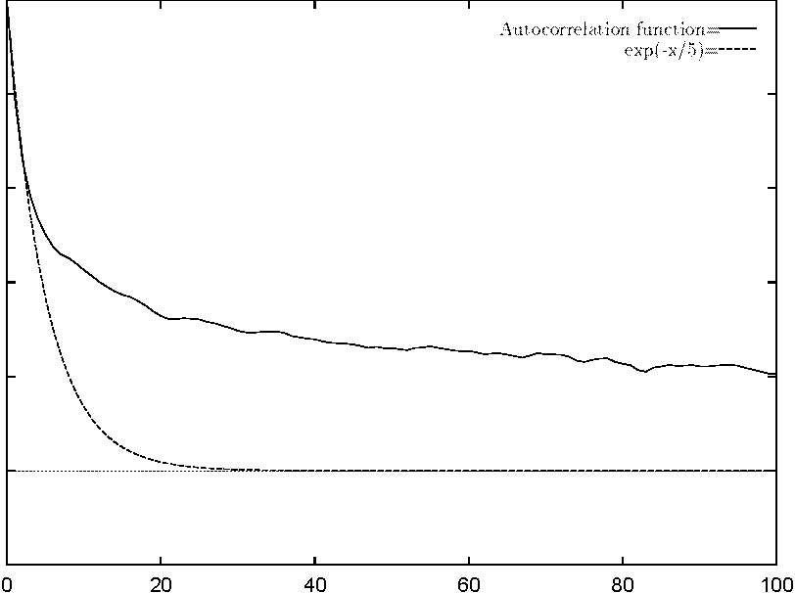
Figure18:AutocorrelationfunctionoftheGOPsizesofthestarwarssequence
20
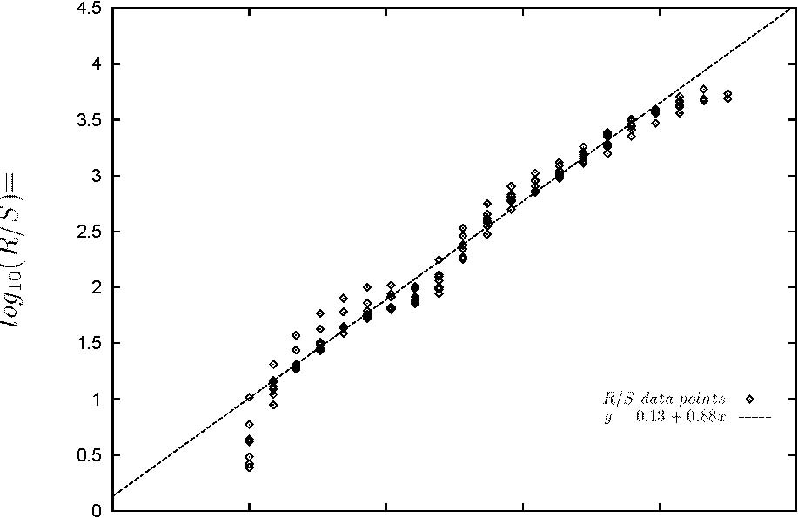
012345

log10(d) Figure19:R/Splotoftheframesizesofthedinosequence
4.5 4

3.5 3
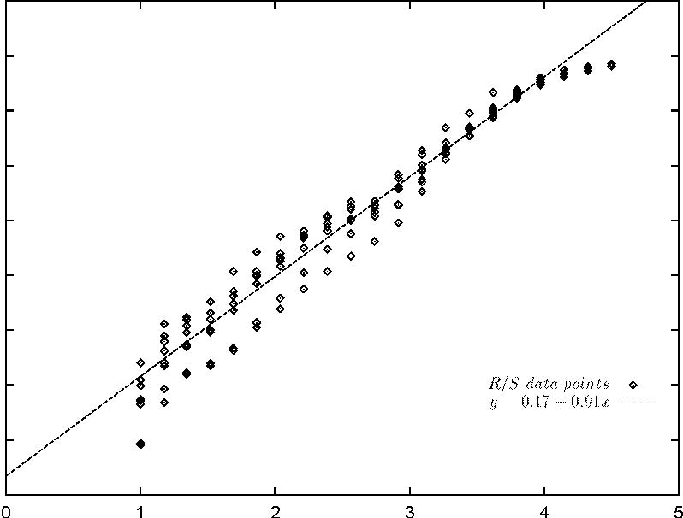
2.5 2
1.5 1
0.5 0
log10(d)
Figure20:R/Splotoftheframesizesofthesoccersequence
21
log 10(RIS)
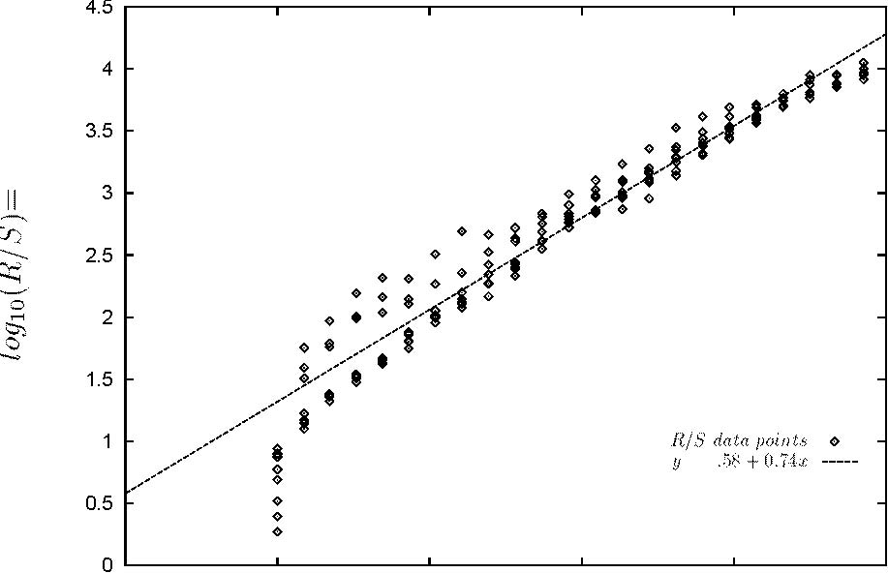
012345
log10(d)
Figure21:R/Splotoftheframesizesofthestarwarssequence

[13]G.Buntrock,L.A.HemachandraundD.Siefkes.Usinginductivecountingtosimulate nondeterministiccomputation.April1990.
[14]F.HüAnalysisofa!nitecapacitasynchronousmultiplexerwithperiodicsources.Juliubner.y1990.
[15]G.Buntrock,C.Damm,U.HertrampfundC.Meinel.StructureandimportanceoflogspaceMOD-classes.Juli1990.
[16]H.GoldundP.Tran-Gia.Performanceanalysisofabatchservicequeuearisingoutof manufacturingsystemsmodeling.Juli1990.
[17]F.ubnerundPTran-Gia.Quasi-stationaryanalysisofa!nitecapacityasynchronous Hü.multiplexerwithmodulateddeterministicinput.Juli1990.
[18]U.Huckenbeck.Complexityandapproximationtheoreticalpropertiesofrationalfunctions whichmaptwointervalsintotwootherones.August1990.
[19]P.Tran-Gia.Analysisofpollingsystemswithgeneralinputprocessand!nitecapacity.August 1990.
[20]C.Friedewald,A.HieronymusundB.Menzel.urzburgerWUMPSWümessagepassingsystem.
Oktober1990.
[21]R.V.Book.Onrandomoracleseparations.November1990.
[22]Th.Stock.InfuencesofmultipleprioritiesonDQDBprotocolperformance.November1990.
[23]P.Tran-GiaundR.Dittmann.PerformanceanalysisoftheCRMA-protocolinhigh-speed
networks.Dezember1990. [24]C.Wrathall.Confuenceofone-ruleThuesystems.
[25]O.GihrundP.Tran-Gia.AlayereddescriptionofATMcelltrafcstreamsandcorrelation analysis.Januar1991.
[26]H.GoldundF.ubner.Multiserverbatchservicesystemsinpushandpulloperatingmode Hü|aperformancecomparison.Juni1991.
[27]H.GoldundH.Grob.Performanceanalysisofabatchservicesystemoperatinginpullmode. Juli1991.
[28]U.Hertrampf.Locallyde!nableacceptancetypes|thethreevaluedcase.Juli1991.
[29]U.Hertrampf.Locallyde!nableacceptancetypesforpolynomialtimemachines.Juli1991.
[30]Th.FritschundW.Mandel.Communicationnetworkroutingusingneuralnets{numerical aspectsandalternativeapproaches.Juli1991.
[31]H.VollmerundK.W.Wagner.Classesofcountingfunctionsandcomplexitytheoretic operators.August1991.
[32]R.V.Book,J.H.LutzundK.W.Wagner.Oncomplexityclassesandalgorithmicallyrandom languages.August1991.
[33]F.HüQueueinganalysisofresourcedispatchingandschedulinginmulti-mediasystems. ubner.September1991.
[34]H.GoldundG.Bleckert.Analysisofabatchservicesystemwithtwoheterogeneousservers. September1991.
[35]H.VollmerundK.W.Wagner.Complexityoffunctionsversuscomplexityofsets.Oktober 1991.
[36]F.HüDiscrete-timeanalysisoftheoutputprocessofanubner.ATMmultiplexerwithperiodic input.November1991.
[37]P.Tran-GiaundO.Gropp.Structureandperformanceofneuralnetsinbroadbandsystem admissioncontrol.November1991.
[38]G.BuntrockundK.Loryss.Ongrowingcontext-sensitivelanguages.Januar1992.
[39]K.W.Wagner.Alternatingmachinesusingpartiallyde!ned\AND"and\OR".Januar1992.
[40]F.ubnerundP.Tran-Gia.Ananalysisofmulti-servicesystemswithtrunkreservation Hümechanisms.April1992.
[41]U.Huckenbeck.Onageneralizationofthebellman-ford-algorithmforacyclicgraphs.Mai 1992.
[42]U.Huckenbeck.Cost-boundedpathsinnetworksofpipeswithvalves.Mai1992.
[43]F.HüAutocorrelationandpowerdensityspectrumofATMmultiplexeroutputprocesses. ubner.September1992.
[44]F.HüundM.Ritter.Multi-servicebroadbandsystemswithCBRandVBRubnerinputtrafc. Oktober1992.
[45]M.MittlerundP.Tran-Gia.Performanceofaneuralnetschedulerusedinpacketswitching interconnectionnetworks.Oktober1992.
[46]M.KowalukundK.W.Wagner.Vectorlanguage:Simpledescriptionofhardinstances. Oktober1992.
[47]B.MenzelundJ.WolfvonGudenberg.KommentierteSyntaxdiagrammfurC++.Novembereü
1992.
[48]D.Emme.Akernelforfuntionde!nableclassesanditsrelationstolowness.November1992. ü1992.
[49]S.Ohring.OndynamicandmodularembeddingsintohyperdeBruijnnetworks.November
[50]K.PoeckundM.Tins.Anintelligenttutoringsystemforclassi!cationproblemsolving. November1992.
[51]K.PoeckundF.Puppe.COKE:Efcientsolvingofcomplexassignmentproblemswiththe propose-and-exchangemethod.November1992.
[52]Th.Fritsch,M.MittlerundP.Tran-Gia.Arti!cialneuralnetapplicationsintelecommunication systems.Dezember1992.
[53]H.VollmerundK.W.Wagner.Thecomplexityof!ndingmiddleelements.Januar1993.
[54]O.Gihr,H.GoldundS.Heilmann.Analysisofmachinebreakdownmodels.Januar1993. ü1993.
[55]S.Ohring.OptimaldynamicembeddingsofarbitrarytreesindeBruijnnetworks.Februar
[56]M.Mittler.Analysisoftwo!nitequeuescoupledbyatriggeringscheduler.Müarz1993.
[57]J.Albert,F.Duckstein,M.LautnerundB.Menzel.Message-passingauftransputer-systemen. Mü1993.arz
[58]Th.StockundP.Tran-Gia.Basicconceptsandperformanceofhigh-speedprotocols.Müarz 1993.
[59]F.ubner.Dimensioningofapeakcellratemonitoralgorithmusingdiscrete-timeanalysis.HüMü1993.arz
[60]G.BuntrockundK.Loryss.Thevariablemembershipproblem:Succinctnessversuscomplexity. April1993.
[61]H.GoldundB.FrüPerformanceanalysisofabatchservicesystemworkingwithotschl.a combinedpush/pullcontrol.April1993.
[62]H.Vollmer.Ondiferentreducibilitynotionsforfunctionclasses.April1993. ücubes.Mai1993.
[63]S.OhringundS.K.Das.FoldedPetersenCubeNetworks:NewCompetitorsfortheHyeper
üMai1993.
[64]S.OhringundS.K.Das.IncompleteHypercubes:EmbeddingsofTree-RelatedNetworks.
üNetworks.Mai1993.
[65]S.OhringundS.K.Das.MappingDynamicDataandAlgorithmStructuresonProduct
[66]F.HüundPTran-Gia.ADiscrete-TimeAnalysisofCellSpacinginATMSystems.Juniubner.1993.
[67]R.DittmannundF.ubner.Discrete-TimeAnalysisofaCyclicServiceSystemwithHüGated LimitedService.Juni1993.
[68]M.FrischundK.Jucht.Pascalli-P.August1993.
[69]G.Buntrock.GrowingContext-SensitiveLanguagesandAutomata.September1993.
[70]S.OhringundS.K.Das.Networks. üEmbeddingsofTree-RelatedTopologiesinHyperPetersenOktober1993. üOktober1993.
[71]S.OhringundS.K.Das.OptimalCommunicationPrimitivesontheFoldedPetersenNetworks.
[72]O.RoseundM.R.Frater.AComparisonofModelsforVBRVideoTrafcSourcesinB-ISDN. Oktober1993.
[73]M.MittlerundN.Gerlich.ReducingtheVarianceofSojournTimesinQueueingNetworks withOvertaking.November1993.
[74]P.Tran-Gia.Discrete-TimeAnalysisTechniqueandApplicationtoUsageParameterControl ModellinginATMSystems.November1993.
[75]F.ubner.OutputProcessAnalysisofthePeakCellRateMonitorAlgorithm.Januar1994. Hü
[76]K.Cronauer.ACriteriontoSeparateComplexityClassesbyOracles.Januar1994.
[77]M.Ritter.AnalysisoftheGenericCellRateAlgorithmMonitoringON/OFF-Trafc.Januar 1994.
[78]K.Poeck,D.Fensel,D.LandesundJ.Angele.CombiningKARLandCon!gurableRole LimitingMethodsforCon!guringElevatorSystems.Januar1994.
[79]O.Rose.ApproximateAnalysisofanATMMultiplexerwithMPEGVideoInput.Januar 1994.
[80]A.Schüomig.UsingKanbaninaSemiconductorFabricationEnvironment|aSimulation Study.Mü1994.arz
[81]M.Ritter,S.KornprobstundF.HüPerformanceAnalysisofSourcePolicingArchitectures ubner.inATMSystems.April1994.
[82]U.Hertrampf,H.VollmerundK.W.Wagner.OnBalancedvs.UnbalancedComputation Trees.Mai1994.
[83]M.MittlerundA.Schüvon \{WarteschlangendisziplinenzurOpti-
omig.EntwicklungDue{Date
"
mierungvonProduktionssystemen.Mai1994.
[84]U.Hertrampf.ComplexityClassesDe!nedviak-valuedFunctions.Juli1994.
[85]U.Hertrampf.LocallyDe!nableAcceptance:ClosureProperties,Associativity,Finiteness. Juli1994.
[86]O.RoseundM.R.Frater.DeliveryofMPEGVideoServicesoverATM.August1994.
[87]B.Reinhardt.KritikvonSymptomerkennungineinemHypertext-Dokument.August1994.
[88]U.Rothaug,E.YanenkoundK.Leibnitz.Arti!cialNeuralNetworksUsedforWayOptimizationinMulti-HeadSystemsinApplicationtoElectricalFlyingProbeTesters.September 1994.
[89]U.Hertrampf.FiniteAcceptanceTypeClasses.Oktober1994.
[90]U.Hertrampf.OnSimpleClosurePropertiesof#P.Oktober1994.
[91]H.VollmerundK.W.Wagner.RecursionTheoreticCharacterizationsofComplexityClasses ofCountingFunctions.November1994.
[92]U.HinsbergerundR.Kolla.OptimalTechnologyMappingforSingleOutputCells.November 1994.
[93]W.NüothundR.Kolla.OptimalSynthesisofFanoutfreeFunctions.November1994.
[94]M.MittlerundR.MüSojournTimeDistributionoftheAsymmetricM1M1111N
uller.{ SystemwithLCFS-PRService.November1994.
[95]M.Ritter.PerformanceAnalysisoftheDualCellSpacerinATMSystems.November1994.
[96]M.Beaudry.RecognitionofNonregularLanguagesbyFiniteGroupoids.Dezember1994.
[97]O.RoseundM.Ritter.ANewApproachfortheDimensioningofPolicingFunctionsfor MPEG-VideoSourcesinATM-Systems.Januar1995.
[98]T.DabsundJ.SchoofAGraphicalUserInterfaceForGeneticAlgorithmsFebruar1995.
[99]M.R.FraterundO.Rose.CellLossAnalysisofBroadbandSwitchingSystemsCarryingVBR VideoFebruar1995.
[100]U.Hertrampf,H.VollmerundK.W.Wagner.OnthePowerofNumber-TheoreticOperations withRespecttoCountingJanuar1995
[101]O.Rose.StatisticalPropertiesofMPEGVideoTrafcandtheirImpactonTrafcModeling inATMSystemsFebruar1995.

