SENG6220 Assignment 3 – Written Report

Time Spent
The time spent modifying the assignment to implement the changes never exceeded a few short hours. Not many problems were encountered in making the changes, and the modifications were pretty straight-forward.

Errors Experienced
There was mainly just logic errors experienced. For instance: in the Timed compareTo method when first designed it wasn’t taking into account not set or 0 values, so obviously it was just redesigned to make sure it included conditional tests for those.

Design Log
PA3A
The first part was first done by changing the Event into an abstract class, and removing anything specific to the Distance Event. The Distance class was then created (which extended the Event) and all the contents that were taken out of the original Event were placed into it. The abstract methods were then implemented. The setData implemented method was just the original addAttempt method renamed. The lessThan implemented method just returns a Boolean version of the comparison between the objects compareTo.
The factory method was then created and placed into the PA3A, which just returned an instance of the Distance Event depending on the int value received. The method also received the athlete’s name, and country code – which is passed into the Distance constructor. The instance is then returned, or a null value (depending on whether the int value matched).
The factory method was then placed over the original code where the Event object was being instantiated. The int value was then read by placing a readLine at the beginning of where the file contents were being loaded (converting the value to an int). The noAttempts for the Event was going to be placed into the factory method (as suggested by the assignment), but since it only supports one type of attempt at a time being loaded, then it was figured to be better to just do it once through a simple conditional ternary statement.
The OlympicEventException was then decided to be implemented, since the lessThan method accepts an Event and it will need to be downcast to the derived sub type.
PA3B
The second part just involved in copying the files, and then creating a new class called Timed which extended Event. In this class it just contained one double attribute (for just one attempt) representing seconds. The compareTo method was firstly implemented, which just involved in comparing the two objects (the lesser the time the better) and also taking into account that it may not have been set with a value (-1 placeholder) and also foul attempts being 0. The other abstract methods were than just implemented.
The PA3A class was then just renamed to PA3B and the factory method was then expanded to take into consideration the new sub type. The line of code to determine the noAttempts just had another conditional clause added with the value being 1.

Further Extension
The system could be extended to process Combined Events (such as Decathlons and Heptathlons) by redesigning the system in the following way.

Possibility 1
In the event that the points are actually being supplied, then the data can be stored within a double array. A new class can be simply created called CombinedEvent, which will extend Event and implement comparable. The size of the array will depend on the EventType (an enumerated type), with the type being passed into the constructor. The enumerated values will be Decathlon and Heptathlon. The double array will then be initialised to all -1 values (which will symbolise the value being not set).
The class will have a method called calcPoints which will calculate the points stored in the array (skipping any -1 values). It will also implement the lessThan method, which will compare the two objects using the compareTo.
The compareTo will just compare the values calculated from invoking the calcPoints method on both of the objects. The one that is greater than the other is better.
The setData method is implemented, and that will just receive a double value. It will iterate throughout the array, and will add the value to the first empty position.
The toString will just display a String representation of the object, including the total points.
The factory method will then be changed to include an instantiation of the CombinedEvent for both the Decathlon and Heptathlon types. Also, the line of code to determine the number of attempts for each athlete will be changed.
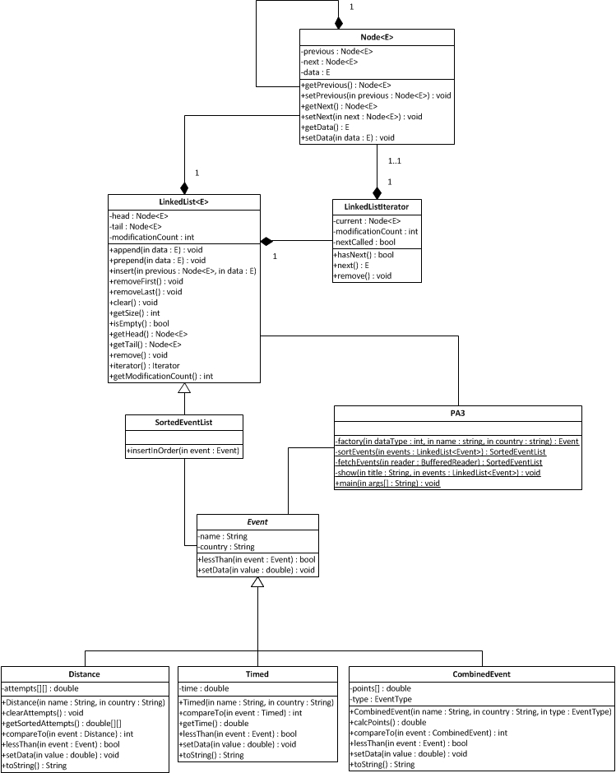
public class CombinedEvent extends Event implements Comparable<CombinedEvent> {
public enum EventType {Decathlon, Heptathlon};
private EventType type;
private double[] points;

public CombinedEvent(String name, String country, EventType type) {
super(name, country);
this.points = new double[((type == EventType.Decathlon) ? 10 : 7)];
for (int i = 0; i < this.points.length; i++) {
this.points[i] = -1;
}
}

public double calcPoints() {
double total = 0;
for (double point : points) {
if (point > -1) {
total += point;
}
}
return total;
}

public int compareTo(CombinedEvent event) {
double points = this.calcPoints();
double other = event.calcPoints();
return ((points > other) ? -1 : (other > points) ? 1 : 0);
}

public EventType getEventType() {
return this.type;
}

public boolean lessThan(CombinedEvent event) throws OlympicEventException {
if (this.getEventType() == event.getEventType()) {
return (this.compareTo(event) >=0);
} else {
throw new OlympicEventException();
}
}

public void setData(double value) {
for (int i = 0; i < this.points.length; i++) {
if (this.points[i] == -1) {
this.points[i] = value;
break;
}
}
}

public String toString() {
StringBuilder builder = new StringBuilder();
char[] name = this.name.toCharArray();
for (int i = 0; i < 15; i++) {
builder.append((i < name.length) ? name[i] : SPACE);
}
builder.append(SPACE);
builder.append(this.country);
builder.append(SPACE);
builder.append(String.format("%7.2f", this.calcPoints()));
builder.append(SPACE);
return builder.toString();
}
}

The following change is made to the PA3 class, which alters the factory method to have an instantiation for the CombinedEvent (for both the Decathlon and Heptathlon type).

private static Event factory(int dataType, String name, String country) {
return ((dataType == 1) ? new Distance(name, country) :
(dataType == 2) ? new Timed(name, country) :
(dataType == 3) ? new CombinedEvent(name, country,
CombinedEvent.EventType.Decathlon) :
(dataType == 4) ? new CombinedEvent(name, country,
CombinedEvent.EventType.Heptathlon) : null);
}

The noAttempts line is then changed (within the method fetchEvents) to have a conditional clause for both the Decathlon (10) and Heptathlon (7) types.

int noAttempts = ((dataType == 1) ? 6 : (dataType == 2) ? 1 : (dataType == 3) ? 10 : (dataType == 4) ? 7 : 0);

Since the CombinedEvent class extends from Event and implements the lessThan method, all other classes including the ‘SortedEventList’ can remain the same without issue. The input file will just have to be modified with a number up the top being either 3 or 4, and then it will just need to have 10 double values or 7 for each athlete (depending on the EventType).
Possibility 2
In the circumstance that the points will actually have to be calculated from an Event, then it requires a redesign of the system. The following changes will however limit the system to only process CombinedEvent objects.
A new abstract class will be created called CombinedEvent, which will store the athlete’s information (such as their name and country code). It will then have an abstract method called calcTotalPoints() . The CombinedEvent will then have the children Decathlon and Heptathlon extending of that which will hold pre-instantiated Event objects in the array. The pre-instantiated array of Event objects allows for the types of Events to be held. The calcTotalPoints() methods will then be implemented in both children, and it will iterate through the Event objects calculating then returning the total sum.
The Event class will then be abstract and it will have the name of the event, and declare a few method signatures for implementation. It is assumed that both types of CombinedEvents have a different way for calculating the points, so therefore each Event will be enforced to implement a method for calculating both ways. The Distance and the Timed will then extend from the Event, and implement the calculation methods. If they are too generic then they could be extended again to override the calculation methods in the derived classes.

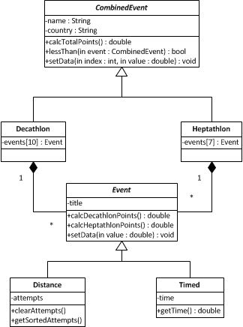

public abstract class CombinedEvent implements Comparable<CombinedEvent> {
private String name; // The athlete's name.
private String country; // The country of the athlete.

public int compareTo(CombinedEvent event) {
double points = this.calcTotalPoints();
double other = event.calcTotalPoints();
return ((points > other) ? -1 : (other > points) ? 1 : 0);
}

public boolean lessThan(CombinedEvent event) {
return (this.compareTo(event) >=0);
}

public abstract double calcTotalPoints();
public abstract setData(int index, double value);
public abstract Event[] getEvents();
}

public class Decathlon extends CombinedEvent {
private Event[] events;

public Decathlon(String name, String country) {
super(name, country);
this.initEvents();
}

private void initEvents() {
this.events = new Event[10];
this.events[0] = new Timed("100 metres");
this.events[1] = new Distance("Long Jump");
this.events[2] = new Distance("Shot Putt");
this.events[3] = new Distance("High Jump");
this.events[4] = new Timed("400 metres");
this.events[5] = new Timed("110 metre hurdles");
this.events[6] = new Distance("Discuss Throw");
this.events[7] = new Distance("Pole Vault");
this.events[8] = new Distance("Javelin");
this.events[9] = new Timed("1500 metres");
}

public double calcTotalPoints() {
double total = 0;
for (Event event: this.events) {
total += event.calcDecathlonPoints();
}
return total;
}

public setData(int index, double value) {
if (index >= 0 && < this.events.length) {
this.events[index].setData(value);
} else {
throw new IllegalArgumentException("Invalid index");
}
}

public Event[] getEvents() {
return this.events;
}
}

public class Heptathlon extends CombinedEvent {
private Event[] events;

public Decathlon(String name, String country) {
super(name, country);
this.initEvents();
}

private void initEvents() {
this.events = new Event[7];
this.events[0] = new Timed("100 metres Hurdles");
this.events[1] = new Distance("High Jump");
this.events[2] = new Distance("Shot Putt");
this.events[3] = new Timed("200 metres");
this.events[4] = new Distance("Long Jump");
this.events[5] = new Distance("Javelin");
this.events[6] = new Timed("800 metres");
}

public double calcTotalPoints() {
double total = 0;
for (Event event: this.events) {
total += event.calcHeptathlonPoints();
}
return total;
}

public setData(int index, double value) {
if (index >= 0 && < this.events.length) {
this.events[index].setData(value);
} else {
throw new IllegalArgumentException("Invalid index");
}
}

public Event[] getEvents() {
return this.events;
}
}

public abstract class Event {
private String title;

public Event(String title) {
this.title = title;
}

public String getTitle() {
return this.title;
}

public abstract double calcDecathlonPoints();
public abstract double calcHeptathlonPoints();
public abstract void setData(double value);
}

public class Distance extends Event {
public Distance(String title) {
super(title);
}

public void setData(double value) {
// Adds the attempt to the data structure.
}

public double calcDecathlonPoints() {
double value = 0;
// Implement calculation.
return value;
}

public double calcHeptathlonPoints() {
double value = 0;
// Implement calculation.
return value;
}
}

public class Timed extends Event {
private double time;

public Distance(String title) {
super(title);
}

public void setData(double value) {
this.time = value;
}

public double calcDecathlonPoints() {
double value = 0;
// Implement calculation.
return value;
}

public double calcHeptathlonPoints() {
double value = 0;
// Implement calculation.
return value;
}
}

